Bubble in the correct response on the Scantron sheet.

- It currently costs $3 per hour to park on a street in the city of Chiclesburg. Unfortunately, it is very difficult to find an available parking spot. That indicates
  - all parkers would be better off if the price were higher.
  - the city could collect more parking fees if it raised the price to park.
  - the market for street parking is in equilibrium.
  - a and b

- “People who earn the minimum wage in Washington, DC, do not make enough money to afford the average rent for a 2-bedroom apartment.” This statement is
  - positive.
  - normative.
  - transitive.
  - [a and b]

- Grimshaw is considering attending law school in DC. Tuition for law school will cost Grimshaw $50,000 each year for three years, and room and board in DC will cost him $25,000 each year for three years. If Grimshaw doesn’t go to law school in DC, he will work in Columbus, where he will make $50,000 each year for the next three years and room and board will cost him $15,000 a year for the next three years. Assume there are no other differences in costs or benefits to Grimshaw. The total economic (opportunity) cost of attending law school to Grimshaw, expressed in dollars, is
  - $150,000
  - $225,000
  - $330,000
  - [None of the above]

- Stevie is just outside the gate of a sold-out concert. The “official price” of a ticket was $50 when tickets first went on sale. However, Stevie bought his ticket two weeks ago, when he paid $70 for it. He also just paid $20 to take an Uber to get to the concert. Just before Stevie enters the concert, someone offers to pay him $100 for his ticket.
  - Stevie will definitely sell his ticket for $100.
  - Stevie will definitely not sell his ticket for $100.
  - If Stevie thinks he will enjoy the show more than $90, he will not sell his ticket.
  - Stevie will sell the ticket only if he expects to get less than $100 of benefit from attending the concert.

- The rational rule—that a person keeps doing something as long as the marginal benefit of the thing is greater than or equal to its marginal cost—is another way of saying
  - people maximize their total economic surplus.
  - marginal benefits decrease and marginal costs increase.
  - people are completely selfish.
  - everything has a dollar value.

- An individual’s current demand curve for cookies is probably affected by
  - the current price of cookies.
  - the individual’s current income.
  - the individual’s current level of hunger.
  - [b and c]

- Balthasar’s WTP for a certain bicycle was $500; Jamiroquai was willing to sell that bicycle for $200. Balthasar paid $400 to Jamiroquai for the bicycle, which Jamiroquai happily received. The total economic surplus from that transaction was
  - $100
  - $200
  - $300
  - Less than $100

- During the pandemic, the price of N-95 masks went up and the quantity of masks purchased increased. That is an example of
  - an exception to the law of demand.
  - positive price elasticity of demand.
  - the ceteris paribus assumption not being satisfied.
  - [All of the above]

- Demand curves are downward sloping because
  - as people buy more goods, manufacturers can make the goods for cheaper.
  - some stores offer bulk discounts.
  - diminishing marginal benefits of consumption.
  - [None of the above]

- Your friend got a new phone today and she had two options to pay for it: she could have paid $500 today, or she could have chosen to make three annual payments of $200 each (the first payment is due one year from today). Your friend chose the three-annual-payment plan. Therefore it is necessarily the case that
  - your friend was being irrational.
  - your friend did not have $500 today.
  - your friend did not expect any good investment options for the next three years.
  - [None of the above is necessarily true.]

- Leather goods and beef are complements-in-production. Therefore, when there was an increase in the demand for leather goods,
  - there was an increase in demand for beef.
  - there was a decrease in the demand for beef.
  - there was an increase in the price of beef.
  - there was a decrease in the price of beef.

- The supply curve for Simone’s Pie Shop is upward-sloping. That could be because
  - the marginal costs of ingredients increase as the shop buys more ingredients.
  - the marginal cost of the low-skill labor the shop employs increases as the shop hires more labor.
  - The marginal cost of hiring an additional workers was constant, but newly added workers weren’t as productive as the workers who were hired first.
  - [All of the above.]

- Suppose you know the part of Rebekah’s supply curve shown in Table 1 (last page). Then it is possible that Rebekah’s MC of producing a second unit is
  - 9.99
  - 10.50
  - 11
  - [b and c are both possible]

- Suppose you know the part of Rebekah’s supply curve as shown in Table 1. If the price is 11, what quantity would Rebekah sell to maximize her profits?
  - 1
  - 2
  - It depends on fixed costs.
  - Can’t say with the given information.

- Suppose, just after opening her business for the day, Rebekah was fined $20 by the food inspector. That would
  - force Rebekah to close her business before using up all her inputs.
  - cause Rebekah to raise the price at which she sells cookies.
  - shift Rebekah’s supply curve in.
  - reduce Rebekah’s profits (i.e. reduce “total benefits minus total costs”) but would not otherwise affect Rebekah’s business decisions.

- Uncle JJ’s Bottled Water Company operates in the perfectly competitive market for bottled water. The market price for a bottle of water is $2.00. At Uncle JJ’s current production quantity, the marginal cost for producing one more bottle of water is $0.50. What price should Uncle JJ charge for a bottle of water in order to maximize his company’s profits?
  - Exactly $2.00.
  - Anything above $0.50 but below $2.00.
  - Something just above $2.00.
  - Something just below $2.00.

- Consider the ECON 1001 market for homecooked meals (where each meal is identical, and some students are sellers and some buyers). Suppose the equilibrium price is 12. But instead the authority dictates the price at which meals can be bought and sold is 10 (and he has the power to enforce this). Compare the P = 10 situation to the P = 12 situation. When P = 10
  - some buyers are worse off (than if P = 12).
  - some sellers are worse (than if P = 12).
  - not as many meals are actually bought and sold (as if P = 12).
  - [All of the above.]

- Tom H.’s willingness to pay for a sandwich is $12. Zendaya’s WTP for the same sandwich is $10. Which statement is necessarily true?
  - Tom H. is hungrier than Zendaya.
  - Tom H. is wealthier than Zendaya.
  - Zendaya probably already purchased and ate a sandwich before this one.
  - [None of the above.]

- Recent fires in Canada increased gasoline prices in Nevada, a place that was otherwise unaffected by the Canadian fires. That means
  - the demand for gasoline in Nevada shifted out because people will be willing to pay more because the price is higher.
  - the demand curve for gasoline shifted in because people are deterred from buying gasoline at the higher prices.
  - there was an upward movement along the demand curve, indicating Nevadans were buying less gasoline.
  - there was a downward movement along the demand curve, indicating Nevadans were buying more gasoline.

- Suppose peanut butter and jelly are complements (in demand). For some reason, the price of peanut butter increased. At the same time, the technology used to produce jelly improves, so that jelly could be made more efficiently. As the result of those changes, what happened to the equilibrium quantity of jelly?
  - It decreased.
  - It increased.
  - It stayed the same.
  - [Need more information]

- Tesla has a factory that can produce cars and trucks. Figure 1 (last page) shows Tesla’s production possibilities frontier (PPF). Currently, Tesla operates at point A (at the point-A production levels, it sells cars for $30k and trucks for $50k). That PPF shows
  - the marginal cost of producing cars (measured in terms of foregone trucks) declines as the factory makes more cars.
  - the marginal cost of producing cars (measured in terms of foregone trucks) increases as the factory makes more cars.
  - Tesla should focus on selling trucks.
  - Tesla should focus on selling cars.

- David’s Co. sells two goods at prices David set a long time ago; at those prices one good is demanded inelastically and the other is demanded elastically. Axel tries to convince David it is time to change his prices. David is very cautious, but gives Axel permission to lower the price for just one of the two goods. Axel, an economics genius whose goal is to help increase David’s Co.’s profitability, chooses
  - to definitely lower the price for the good that is demanded elastically.
  - to definitely lower the price for the good that is demanded inelastically.
  - to maybe lower the price for the good that is demanded elastically.
  - to maybe lower the price for the good that is demanded inelastically.

- Based on the bottom two rows in Rebekah’s supply curve in Table 1, what is a measure of the elasticity of supply that everyone can agree on? [You can trust that I simplified the expressions below.]
  - $1$
  - $-1$
  - $\frac{\frac{1}{1.5}}{\frac{1}{10.5}}=\frac{10.5}{1.5}=7$

  - $\frac{\frac{1}{10.5}}{\frac{1}{1.5}}=\frac{1.5}{10.5}≈.142$

- Consider the graph in Figure 2 (last page). Suppose that point B is directly below point A and the two demand curves are parallel. What can you say about the price elasticity of demand at those two points?
  - Demand is more elastic at point A than at point B.
  - Demand is more elastic at point B than at point A.
  - Demand is equally elastic at both points.
  - The good demanded is a normal good.

- Suppose in a particular market demand is given by $Q_{D}=11-P$ and supply is given by $Q_{S}=.5P-1$. What is the equilibrium quantity in this market?
  - 1
  - 2
  - 3
  - 8

- Suppose in a particular market demand is given by $Q_{D}=11-P$ and supply is given by $Q_{S}=.5P-1$. At $P=4$,
  - there is a shortage of 7 units
  - there is a shortage of 6 units
  - there is a surplus of 6 units
  - suppliers are happy.

- Bubble in A

Please do not turn this exam over until instructed to.

While you are waiting, you can enter your name and your Canvas ID number on your Scantron sheet. If you do not know your Canvas ID number, you can enter it when you hand the exam in.

Good luck!

Table 1
P | Q
9 | 1
10 | 1
11 | 2

Figure 1
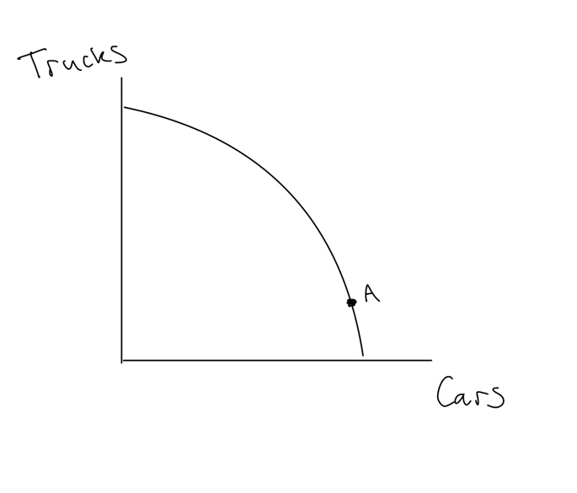
Figure 2
