ECON 2110 — Midterm 2 Grading Note
Spring 2026

Midterm 2 had 112 total possible points. In Canvas, you will see your Midterm 2 — Raw Score (out of 112) and your Midterm 2 — Curved Score (out of 100). I will use your curved score when computing your course grade.
You can interpret the curved score on the usual 0–100 scale. (I do not assign letter grades until the end of the course, but as a rough guide: 93+ ≈ A, 90–93 ≈ A-, 87–90 ≈ B+, and so on.)

Raw Scores (out of 112): Summary Statistics
Statistic | Value
N | 231
Mean | 84.2
Standard deviation | 14.8
Minimum | 40.0
10th percentile | 64.0
25th percentile | 76.0
Median (50th percentile) | 86.0
75th percentile | 96.0
90th percentile | 100.0
Maximum | 112.0
Number of perfect scores | 1

Raw Score Distribution
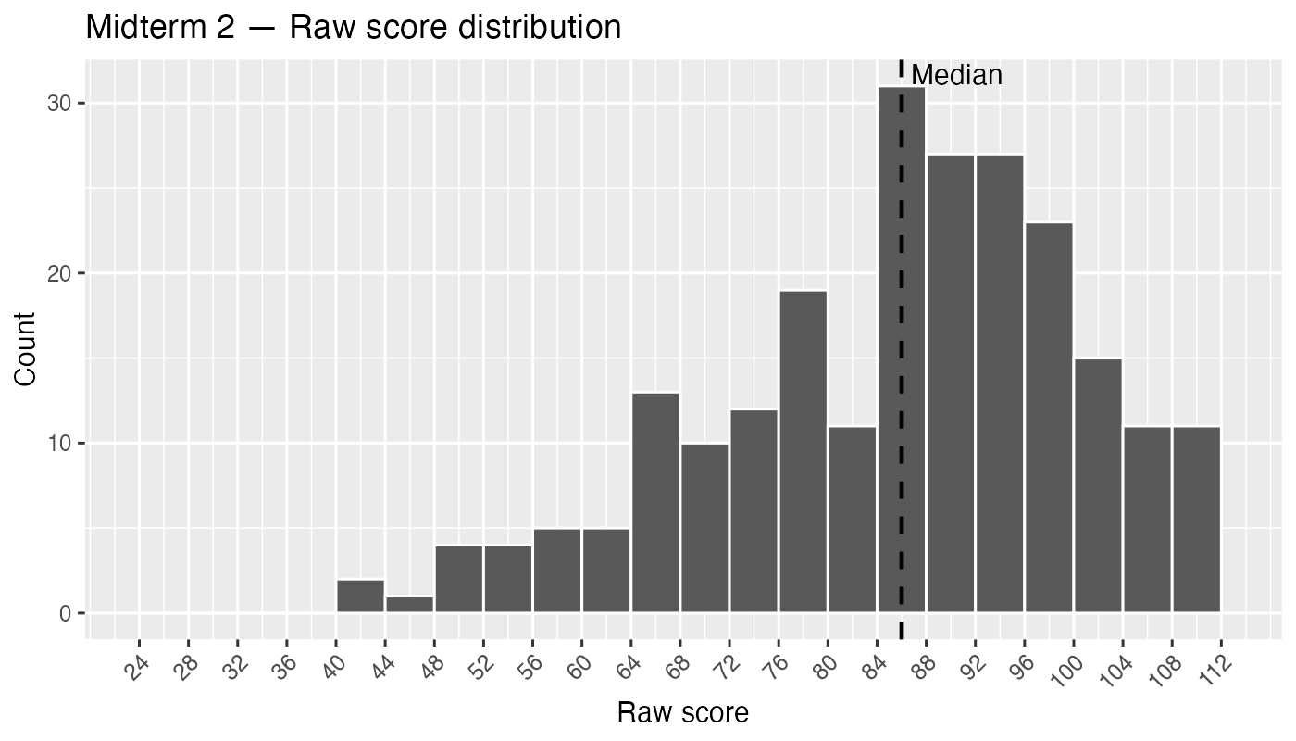

Curved Scores (out of 100): Summary Statistics
Statistic | Value
N | 231
Mean | 84.0
Standard deviation | 8.5
Minimum | 58.5
10th percentile | 72.3
25th percentile | 79.2
Median (50th percentile) | 85.0
75th percentile | 90.8
90th percentile | 93.1
Maximum | 100.0

Curved Score Distribution
