Chapter 5. Half-Plane Intersections

5.1 Definition and Properties
A line in a two-dimensional plane divides the entire plane into two half-planes. A half-plane is thus defined by a line and one of its sides. The half plane defined by the line AB and containing a point P not on the line, is referred to as the half-plane of the line AB towards P.
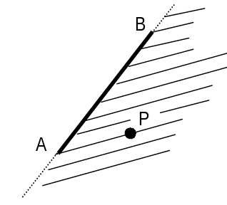

The analytical equation of a half-plane is either
ax + by + c ≥ 0 or ax + by + c ≤ 0
where a, b, c are constants. To determine which formula is correct, evaluate the formula at any point in the desired half-plane.
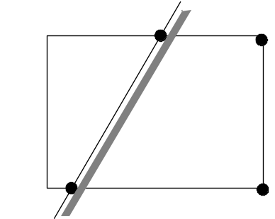

Every half-plane is a convex region with only one edge of infinite extent. Pictorially it is represented by a line, and a shaded region towards the side where the half-plane lies. For computational purposes, a half-plane can be approximated by a convex polygon by taking the intersection of the line with a large bounding box. This will ensure that every half-plane has a finite representation and a well-defined boundary.
Before considering the half-plane intersection problem, we consider the special case of convex polygon intersection.

5.2 Convex Polygon Intersection
Determining the intersection of two or more convex polygons is one of the fundamental problems in computational geometry. The direct method to compute the intersection of two convex polygons is given in the following steps.

Naive Algorithm for Convex Polygon Intersection:
Step 1: Compute all of the intersection points between the edges of the two polygons. Save the intersection points in a set of points.
Step 2: Add to this set of points all of the vertices of one polygon that are inside the other polygon. (Use a point inclusion test for convex polygons.)
Step 3: Given this set of points, compute its convex hull. This orders the points in a clockwise or counterclockwise direction such that they define a convex polygon. This convex hull is the desired intersection.

Algorithm Analysis
In the following analysis, assume that polygon 1 has n edges, polygon 2 has m edges, and the resulting convex polygon that is their intersection has p edges. Note that the intersection polygon can potentially have twice the number of edges as the smaller of the two polygons. (That is, the maximum value of p is 2*min{n,m}.)
Step 1: The direct method compares each edge in polygon 1 with every edge in polygon 2. Using this naïve method requires O(nm) line-segment intersection calculations.
Step 2: To find the vertices from polygon 1 inside polygon 2 requires O(nm) line-point relationship calculations. Similarly, to find the vertices from polygon 2 inside polygon 1 requires O(nm) line-point relationship calculations.
Step 3: Finding the convex hull can be done in O(plog₂p) time using the incremental algorithm.
Therefore, the complexity of the entire method is dominated by the edge intersection calculations and is O(nm). More efficient algorithms exist for this problem, but their development is left to the reader.

5.3 Intersection of a Set of Half-Planes

The intersection of a collection of half-planes is closely associated with many regions in computational geometry such as the kernel, Voronoi cell, etc. The problem is to determine the intersection of a set of n half-planes H, where H={h₀, h₁, ... h_{n−1}}. An efficient method for accomplishing this can be constructed using a divide and conquer approach. Before a solution to the half-planes intersection problem is given, we review the general approach to divide and conquer algorithms.

5.3.1 Divide and Conquer Algorithms (A Review and an Example)
A divide and conquer problem solving approach divides a problem into several subprograms, solves these problems recursively, and then combines their solutions into a solution for the original problem. In its most common form, it divides a problem into two subprograms, each approximately half as large as the original. The merge sort algorithm is a classical example of this problem solving approach, and the process is illustrated below with an example.

MergeSort(int a[ ], int m, int n)
CONQUER
6 7 8 2 4 5 3 1
6 7 8 2 4 5 3 1
6 7 8 2 4 5 3 1
DIVIDE
6 7 2 8 4 5 1 3
2 6 7 8 1 3 4 5
1 2 3 4 5 6 7 8
Initial Array
Sorted Array
6 7 8 2 4 5 3 1

{
int k;
if (m<n)
{
k=(m+n)/2; //truncates to an integer
MergeSort (a, m, k);
MergeSort (a, k+1, n);
Merge(a,m,k,n);
}
}

The Merge function takes two sorted lists, a[m..k] and a[k+1..n] and merges them into a single sorted list, a[m..n]. The merge operation can be done in linear time. Given n objects, the entire merge sort algorithm runs in O(n log₂ n) time.

5.3.2 Divide and Conquer Algorithm for the Intersection of a Set of Half-Planes
A divide and conquer algorithm can be efficiently used to solve the half-plane intersection problem because the problem is associative. By associative we mean the entire problem can be solved by applying pair-wise intersections in any order. The procedure is illustrated in the following figures, where the intersection of 8 half planes, {h₀, h₁, ... h₇}, is found:
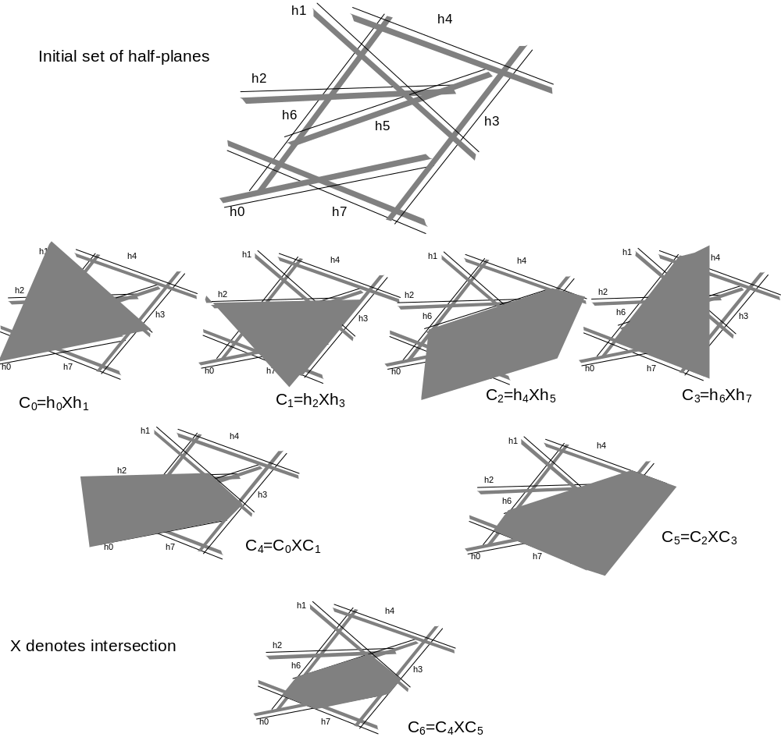

Note that the actual intersection of two half-planes is not a bounded region. However, every half-plane can be approximated by a convex polygon by combining it with a large bounding box (as discussed previously). Therefore, the intersection of two half-planes can be computed by computing the intersection of two convex polygons. The intersection of any number of half-planes is always a convex polygon. (Can you prove this?) This results in the following divide and conquer pseudo-code for computing the intersection of n half planes. The result is a single complex polygon.
ComplexPolygon HalfPlaneIntersect( HalfPlane H[ ], int m, int n)
{
int k;
ComplexPolygon C, C1, C2;
if (m<n)
{
k=(m+n)/2; // truncates to an integer
C1 = HalfPlaneIntersect (H, m, k);
C2 = HalfPlaneIntersect (H, k+1, n);
C = ComplexPolygonIntersect(C1, C2);
return C
}
else return CreateComplexPolygonFromHalfPlane( H[m] );
}

In the above code, the function ComplexPolygonIntersect computes the intersection of two convex polygons. The above algorithm runs in O(n log₂ n) time. Its overall efficiency is determined by the efficiency of the ComplexPolygonIntersect function.

Note that the intersection of the half planes may be empty. That is, there may be no region that is part of all of the half-planes. Therefore, a software implementation of this algorithm must correctly handle empty polygons; that is, polygons with no vertices.

5.4 Kernel of a Polygon
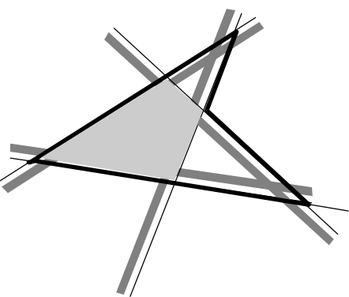
The kernel of a polygon is the intersection of the half-planes of all its edges directed towards the interior of the polygon. If the kernel exists (is non-empty), the polygon is called star-shaped.
Since half-planes are convex and the intersection of a set of convex regions is also convex, it follows that the kernel of a star-shaped polygon is convex. The kernel can be computed using the procedure in section 5.3.2.

Substituting a point to determine whether the half plane is defined by ≥ or ≤ works only if the line equation is normalized. To normalize ax + by + c = 0, divide by ±sqrt(a²+b²), where the sign is chosen as follows: c ≠ 0, same sign as c c = 0, same sign as b.

