Mean RMSE vs. Frequency spacing (Hz)

Two anti-resonances (and one resonance)

F = 500; Fbw = 100;
Z1 = 1000; Z2vect = 2000:-100:1000;
Zbw = [100 100]';
dur = .5; % in s
pNoiseVar = 10;
snr_dB = 25;
cepOrder = 15;
fs = 16e3;
plot_flag = 0;
algFlag = [0 1]; % Select 1 to run, 0 not to; [EKF EKS]
x0 = [F; Z]+0;

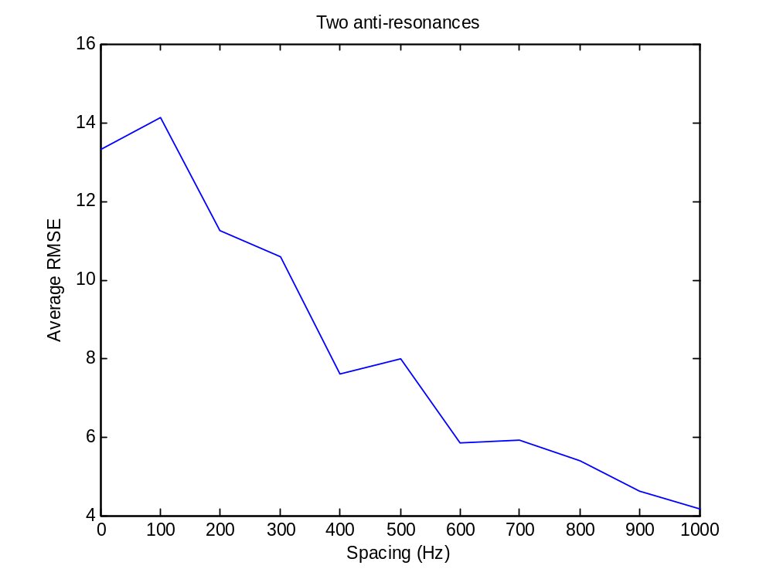
Mean RMSE vs. Frequency spacing (Hz)

Two resonances

%% parameters for pole/pole
F1 = 1000; F2vect = 2000:-100:1000;
Fbw = [100 100]';
Z = []; Zbw = [];
dur = .5; % in s
pNoiseVar = 10;
snr_dB = 25;
cepOrder = 15;
fs = 16e3;
plot_flag = 0;
algFlag = [0 1]; % Select 1 to run, 0 not to; [EKF EKS]
x0 = [F; Z]+0;

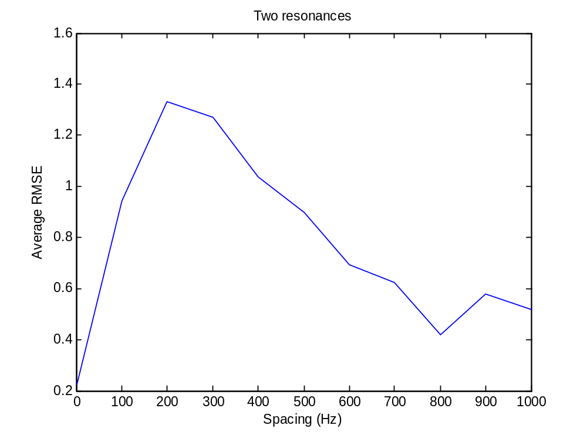
Mean RMSE vs. Frequency spacing (Hz)

One resonance, one anti-resonance

%% parameters for pole/zero
F = 1000;
Fbw = [100]';
Zvect = 2000:-100:1000; Zbw = [50];
dur = .5; % in s
pNoiseVar = 10;
snr_dB = 25;
cepOrder = 15;
fs = 16e3;
plot_flag = 0;
algFlag = [0 1]; % Select 1 to run, 0 not to; [EKF EKS]
x0 = [F; Z]+0;
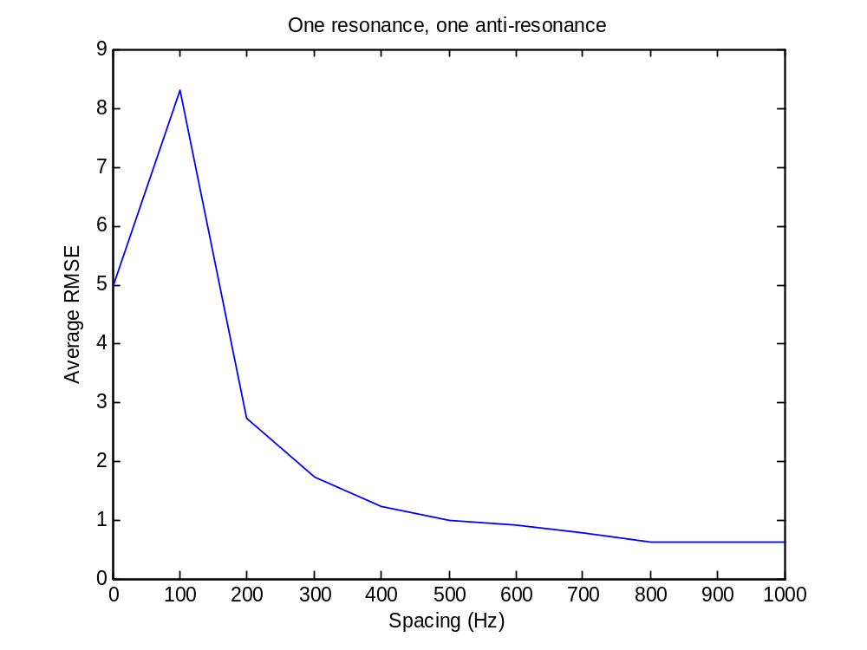
Mean RMSE vs. # Cepstral coefficients

Three resonances, one anti-resonance

F = [500 1500 2500]';
Fbw = [100 100 100]';
Z = [700]'; Zbw = [50]';
dur = .5; % in s
pNoiseVar = 10;
snr_dB = 25;
cepOrder_vect = 50:-1:8;
fs = 16e3;
plot_flag = 0;
algFlag = [1 0]; % Select 1 to run, 0 not to; [EKF EKS]
x0 = [F; Z]+100;

Takes 6 s to run each simulation.
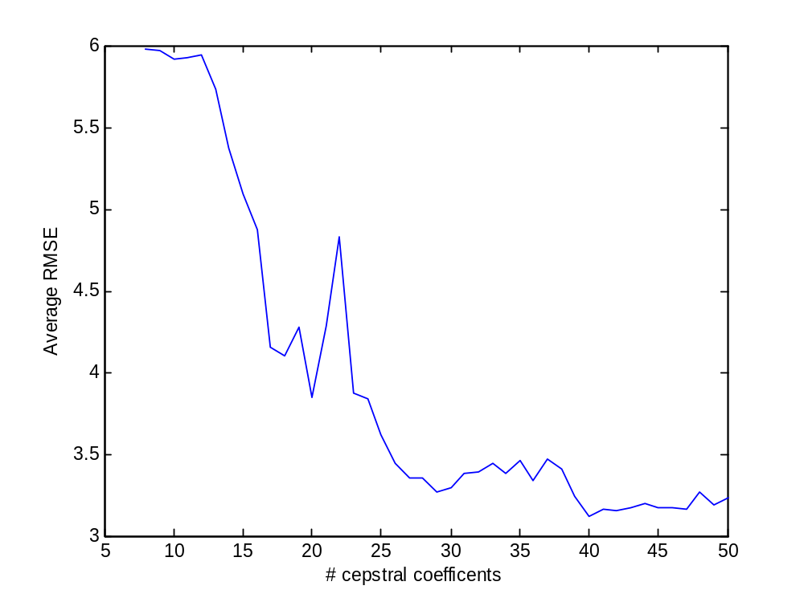
Mean RMSE vs. # Cepstral coefficients

Four resonances, one anti-resonance

%% parameters
F = [500 1500 2500 3500]';
Fbw = [100 100 100 100]';
Z = [700]'; Zbw = [50]';
dur = .5; % in s
pNoiseVar = 10;
snr_dB = 25;
cepOrder_vect = 50:-1:8;
fs = 16e3;
plot_flag = 0;
algFlag = [1 0]; % Select 1 to run, 0 not to; [EKF EKS]
x0 = [F; Z]+100;

Takes 6 s to run each simulation.

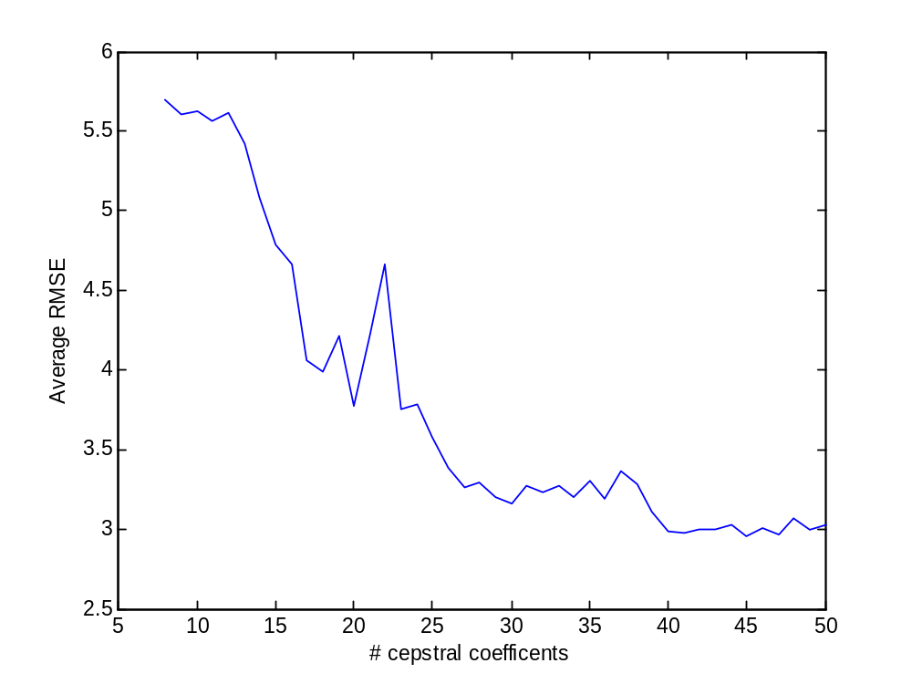
Mean RMSE vs. # Cepstral coefficients

Four resonances, Two anti-resonances

%% parameters
F = [500 1500 2500 3500]';
Fbw = [100 100 100 100]';
Z = [700 1300]'; Zbw = [50 50]';
dur = .5; % in s
pNoiseVar = 10;
snr_dB = 25;
cepOrder_vect = 50:-1:8;
fs = 16e3;
plot_flag = 0;
algFlag = [1 0]; % Select 1 to run, 0 not to; [EKF EKS]
x0 = [F; Z]+100;

Takes 7.3 s to run each simulation.

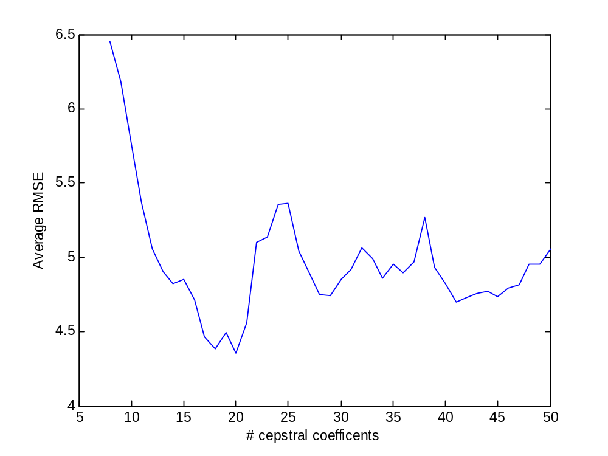
NB: for all plots above:
wType = 'hamming'; % window type
wLengthMS = 20; % Length of window (in milliseconds)
wOverlap = 0.5; % Factor of overlap of window
lpcOrder = length(F)*2; % Number of LPC coefficients
zOrder = length(Z)*2; % Number of MA coefficients
peCoeff = 0; % Pre-emphasis factor

Overlap-Add Analysis/Synthesis

Sinewave modulation (3 pole pairs, 1 zero pair)

%%%%%%%%%%%%%%%%%%%%%%%%%%%%%%%%%%%%%%%%%%%%%%%%
% SYNTHESIS
%%%%%%%%%%%%%%%%%%%%%%%%%%%%%%%%%%%%%%%%%%%%%%%%
dur = .5; % in s
snr_dB = 25;
cepOrder = 25;
fs = 16e3;
plot_flag = 1;
algFlag = [0 1]; % Select 1 to run, 0 not to; [EKF EKS]
wType = 'hanning'; % window type
wLengthMS = 20; % Length of window (in milliseconds)
wOverlap = 0.5; % Factor of overlap of window

%% sinewave modulated trajectory
Fbeg = [500 1500 2500]';
Fbw = [100 100 100]';
Fpert = 75*repmat(cos(2*pi*4*[1:numFrames]/numFrames*dur)', 1, size(Fbeg, 1));
Fcontour = interp1( [1 numFrames]', [Fbeg Fbeg]', 1:numFrames );
Fcontour = Fcontour + Fpert;

Zbeg = [800]';
Zbw = [100]';
Zpert = 100*repmat(cos(2*pi*4*[1:numFrames]/numFrames*dur)', 1, size(Zbeg, 1));
Zcontour = interp1( [1 numFrames]', [Zbeg Zbeg]', 1:numFrames );
Zcontour = Zcontour' + Zpert;

%%%%%%%%%%%%%%%%%%%%%%%%%%%%%%%%%%%%%%%%%%%%%%%%
% ANALYSIS
%%%%%%%%%%%%%%%%%%%%%%%%%%%%%%%%%%%%%%%%%%%%%%%%
wType = 'hamming'; % window type
wLengthMS = 20; % Length of window (in milliseconds)
wOverlap = 0.5; % Factor of overlap of window
lpcOrder = size(Fcontour, 2)*2; % Number of LPC coefficients
zOrder = size(Zcontour, 2)*2; % Number of MA coefficients
peCoeff = 0; % Pre-emphasis factor

See next page for plots
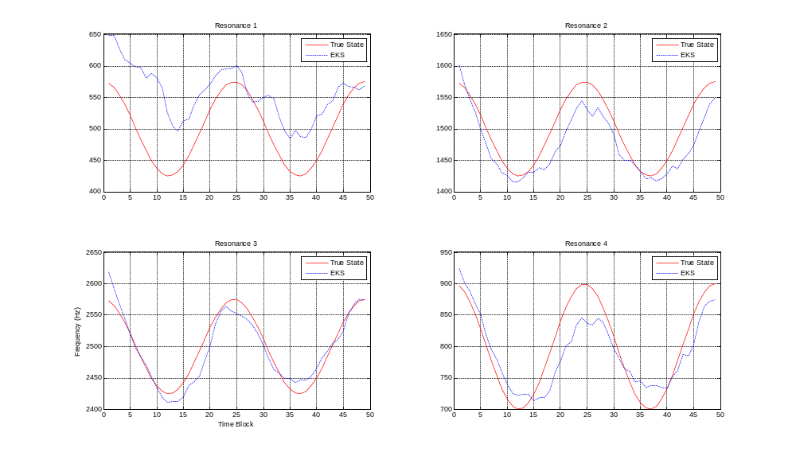
rmse_mean = 2.9598

Overlap-Add Analysis/Synthesis

Piecewise linear trajectory (3 pole pairs, 1 zero pair)

%% Piecewise linear trajectory
Fbeg = [500 1500 2500]';
Fend = [1000 1100 3000]';
Fcontour = interp1( [1 numFrames]', [Fbeg, Fend]', 1:numFrames );
Fbw = [100 100 100]';

Zbeg = [4000]';
Zend = [4000]';
Zcontour = interp1( [1 numFrames]', [Zbeg, Zend]', 1:numFrames )';
Zbw = [100]';

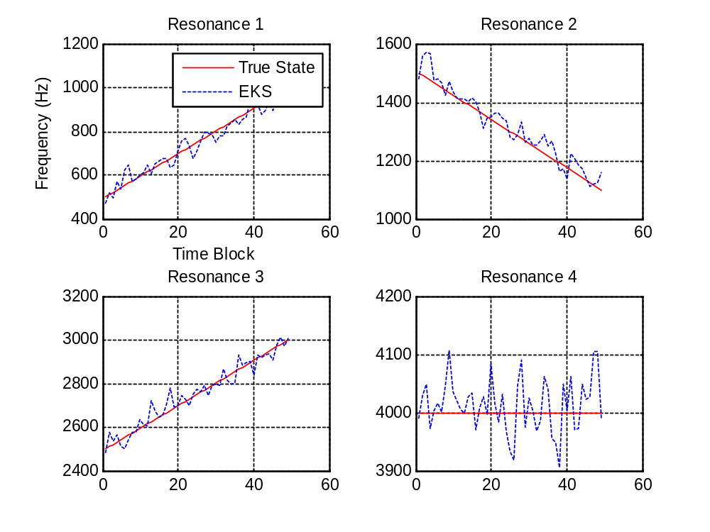
. rmse_mean = 2.9593

