QuantAlpha Tearsheet
Complete Analysis & Interpretation Guide
Every chart and table from the tearsheet, with full explanation
Diego Mella Valerio | June 2026

How to Read This Document
This guide reproduces and explains all six pages of the QuantAlpha tearsheet. Each page image is shown, followed by a plain-language explanation of what the chart or table displays, how it was computed, and what the specific numbers mean. Every metric is defined the first time it appears.
All performance figures refer to the cross-sectional momentum strategy (long the strongest assets, short the weakest, rebalanced monthly across a 56-asset universe) unless stated otherwise.

Page 1 — Equity Curves & Performance Tables
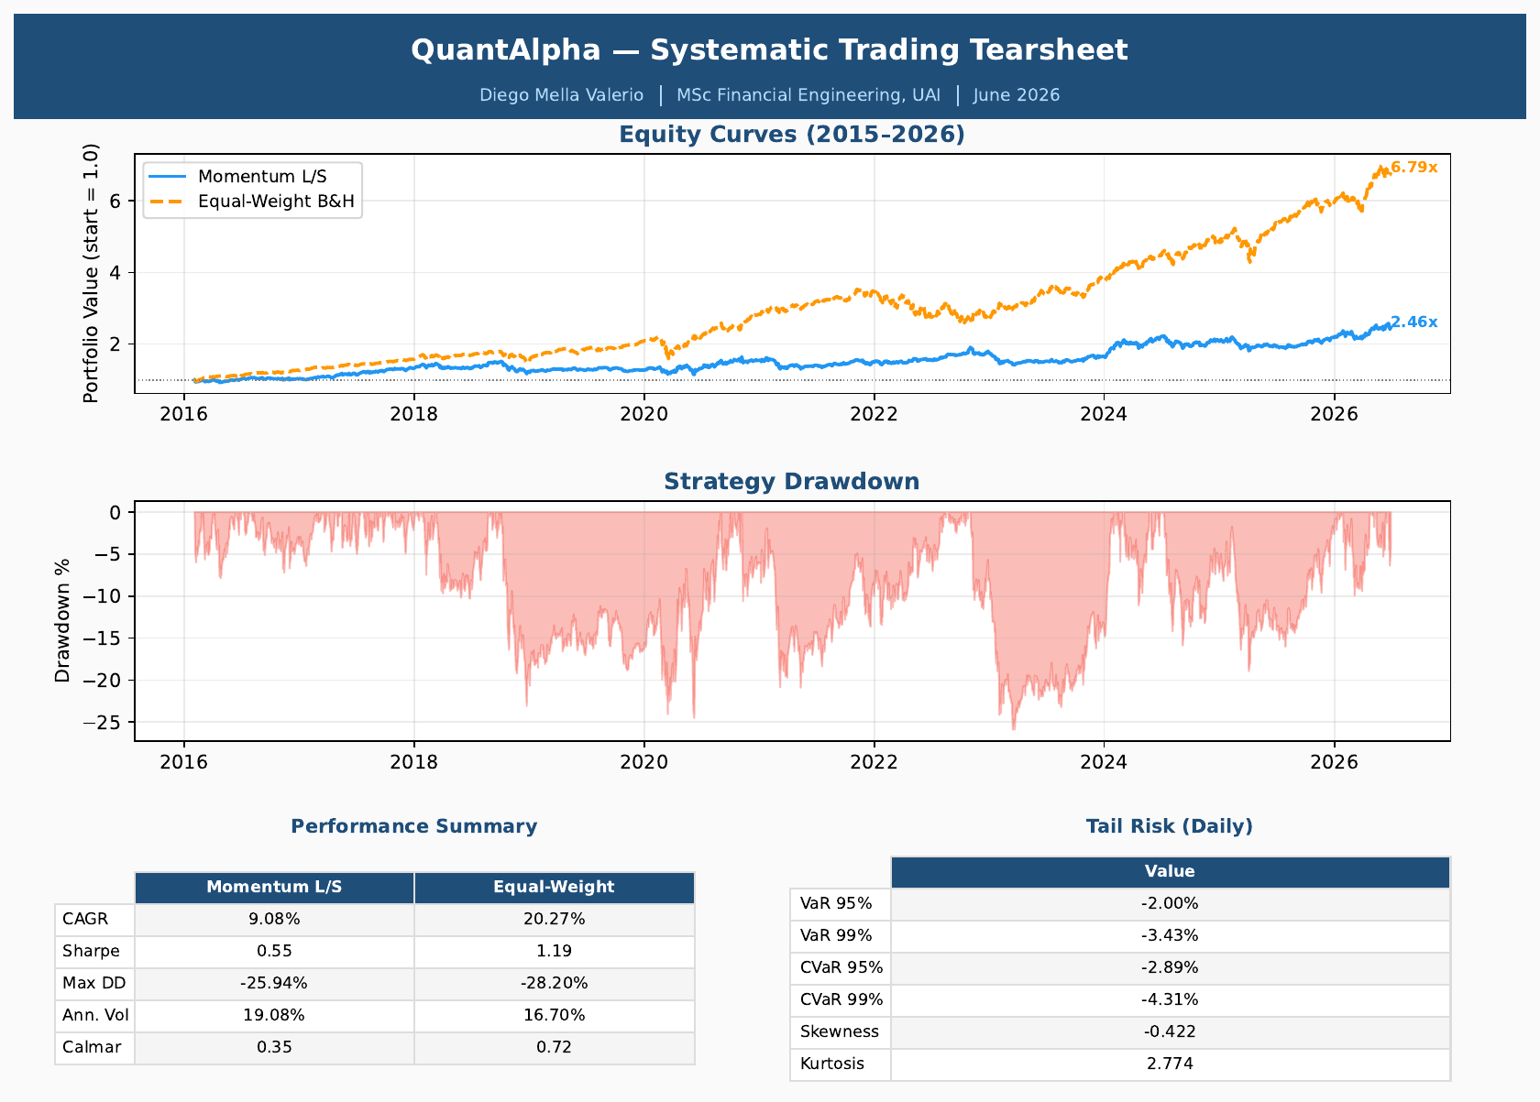
Tearsheet Page 1 — equity curves, drawdown, and performance/tail-risk tables

The Equity Curve (top chart)
Plots the growth of $1 invested at the start of 2015, compounding daily. Momentum L/S (blue) ended near 2.46x; the Equal-Weight B&H benchmark (orange) ended near 6.79x. The benchmark outpaced the strategy because the equal-weight basket is dominated by extraordinary individual stocks (NVDA, META, AAPL). Against the S&P 500 alone (~12%/yr) the strategy is far more competitive, and its line is visibly smoother.

The Drawdown Chart (bottom chart)
A drawdown is the percentage fall from the highest previous portfolio value. The deepest troughs cluster around early 2020 (COVID) and 2022 (rate hikes) — exactly when momentum strategies suffer, because sharp reversals whipsaw a trend-following signal. Drawdown is the most psychologically important risk measure because it represents real investor pain.

Performance Summary Table
- CAGR (Compound Annual Growth Rate): the smoothed annual return. 9.08% vs 20.27% benchmark.
- Sharpe Ratio: return per unit of volatility. 0.55 vs 1.19. Below 0.5 weak, 0.5–1.0 acceptable, above 1.0 good.
- Max Drawdown: worst peak-to-trough loss. −25.94% vs −28.20% — the strategy's key win.
- Annualized Volatility: how much returns fluctuate yearly. 19.08% vs 16.70%.
- Calmar Ratio: CAGR ÷ max drawdown. 0.35 vs 0.72. Above 1.0 is strong.

Tail Risk Table
- VaR 95% −2.00%: on 95% of days the strategy loses less than 2% — the daily risk budget.
- VaR 99% −3.43%: only 1 day in 100 should be worse.
- CVaR 95% −2.89%: average loss on the worst 5% of days — the Expected Shortfall, always worse than VaR.
- CVaR 99% −4.31%: average loss on the very worst 1% of days.
- Skewness −0.42: slight lean toward large losses, typical of momentum.
- Kurtosis 2.77: fat tails — extreme days happen more often than a normal curve predicts.

Page 2 — Rolling Risk Metrics (1-Year Window)
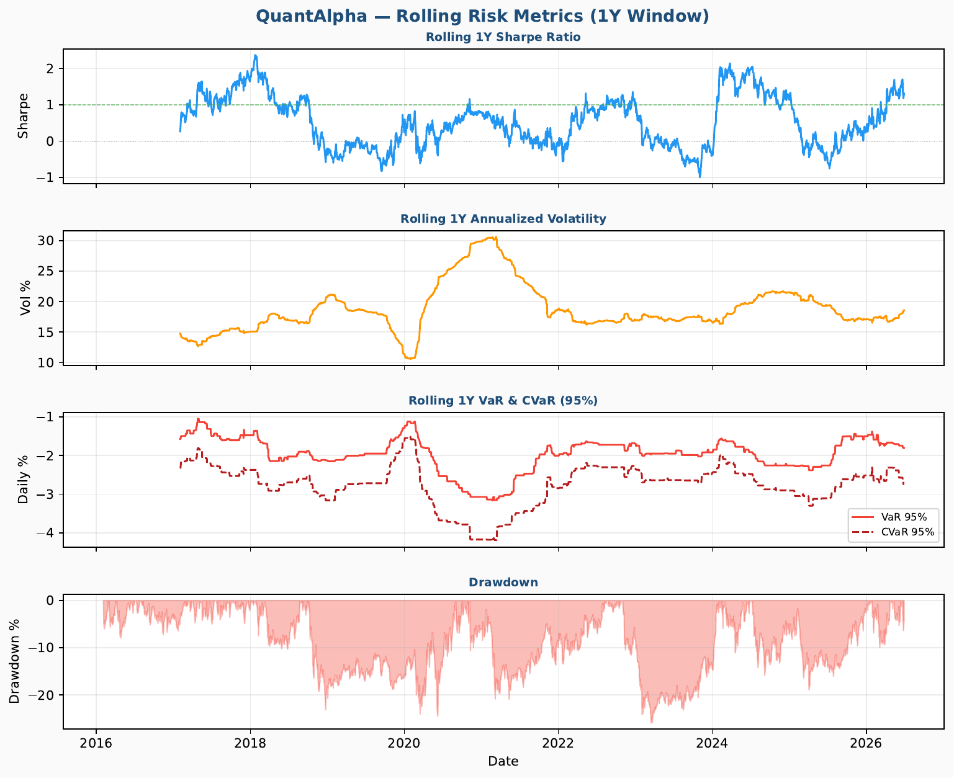
Tearsheet Page 2 — rolling Sharpe, volatility, VaR/CVaR and drawdown over time
Page 1 shows single numbers for the whole period; page 2 shows how each evolved over a moving one-year window, revealing regime changes a single average hides.

Rolling Sharpe (panel 1)
Risk-adjusted return year by year. Green dashed line = Sharpe 1.0 (institutional target). Peaks of 2.0+ in 2017 and 2024 mark strong momentum regimes; it falls below zero in the 2020 COVID reversal and the 2022 rate-hike cycle. This swing is the defining feature of momentum.

Rolling Volatility (panel 2)
The spike to ~30% in 2020 shows how risk surged during COVID. The normal range is 15–22%. Calm periods followed by violent ones (volatility clustering) are visible throughout.

Rolling VaR & CVaR (panel 3)
Both widen sharply in 2020 (CVaR near −4%), showing the risk model detected the regime change in real time. The gap between the solid VaR and dashed CVaR lines measures tail heaviness.

Drawdown (panel 4)
The same drawdown series aligned in time with the panels above, so the deep 2022–2023 drawdown can be seen coinciding with sub-zero rolling Sharpe and elevated VaR.

Page 3 — Portfolio Optimization
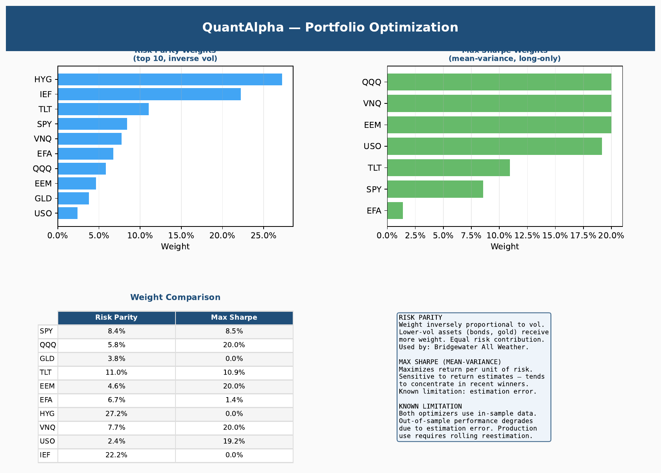
Tearsheet Page 3 — risk parity vs mean-variance weights, comparison table and notes
This page demonstrates two classic portfolio-construction methods on a 10-asset ETF subset, showing how the same assets produce very different portfolios depending on the objective.

Risk Parity Weights (left)
Allocates so each asset contributes equal risk, not equal capital. Weight is inversely proportional to volatility, so low-vol assets dominate: HYG (high-yield bonds) and IEF (Treasuries) receive the most, volatile USO (oil) the least. This is the logic behind Bridgewater's All Weather fund.

Max Sharpe Weights (right)
Mean-variance optimization seeks the single highest-Sharpe mix. It concentrates in recent best performers (QQQ, VNQ, EEM, USO hit the 20% cap). This concentration is the well-known weakness of the method — it over-fits to recent history.

Weight Comparison & Limitation
The two schemes differ sharply — GLD, HYG and IEF receive meaningful risk-parity weight but 0% from the Sharpe optimizer. Both use in-sample data, so out-of-sample performance typically degrades; production use needs rolling re-estimation and shrinkage.

Page 4 — Full Risk Report
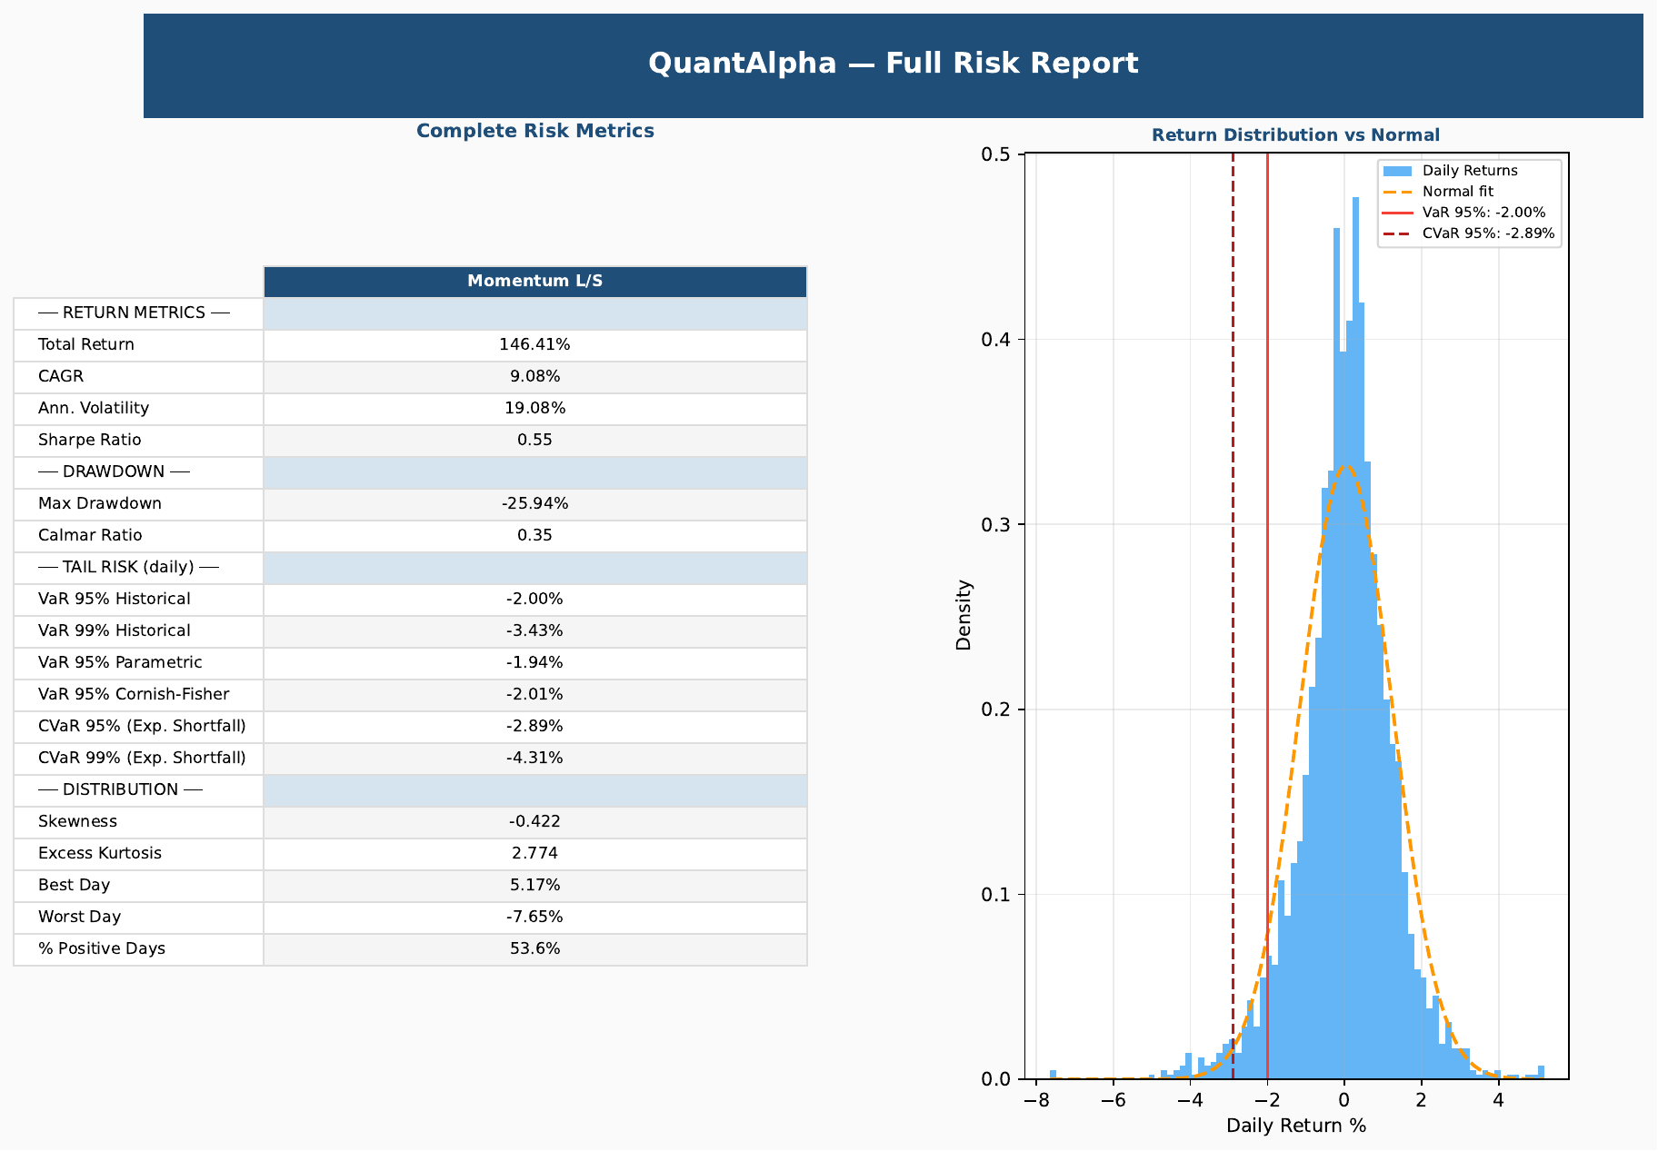
Tearsheet Page 4 — complete risk metrics table and return distribution vs normal

Complete Risk Metrics (left)
Consolidates every metric into one institutional-style report. Additional items beyond page 1:
- Total Return 146.41%: cumulative gain over the whole period (vs the annualized 9.08% CAGR).
- VaR Parametric −1.94% vs Cornish-Fisher −2.01%: the parametric version assumes a normal distribution; Cornish-Fisher corrects for skew and fat tails and is worse, confirming normality understates tail risk.
- % Positive Days 53.6%: the strategy makes money on slightly more than half of all days; small edges compound.

Return Distribution vs Normal (right)
The blue histogram is actual daily returns; the orange dashed curve is a normal distribution with the same mean and volatility. The real distribution has a taller peak and fatter tails (leptokurtosis). The red lines mark VaR 95% and CVaR 95%. Real markets produce more extreme days than a normal model predicts — which is why historical and Cornish-Fisher VaR are computed alongside the parametric one.

Page 5 — VIX Volatility Regime Analysis
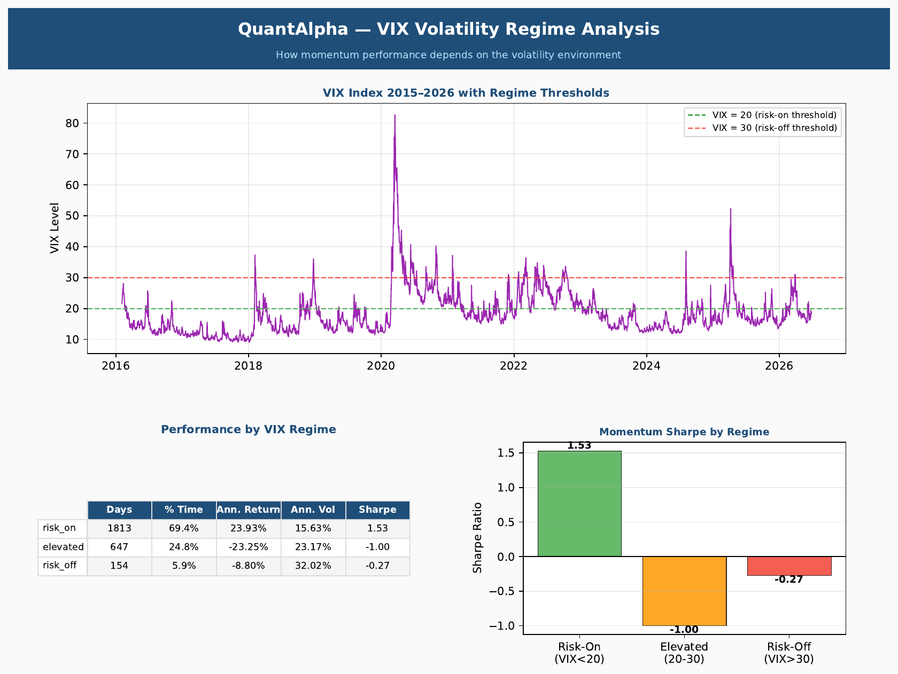
Tearsheet Page 5 — VIX index with thresholds, regime performance table and Sharpe-by-regime
Tests how momentum performance depends on the volatility environment, measured by the VIX index (implied volatility of S&P 500 options — the market's fear gauge).

VIX Index Chart (top)
VIX over the whole period with thresholds at 20 (risk-on) and 30 (risk-off). The spike to ~80 in March 2020 is the COVID panic; the 2022 cluster reflects rate-hike stress. Most of the time VIX sits below 20.

Performance by VIX Regime
Splitting the data by VIX level produces the key insight of the page:

Regime | % Time | Ann. Return | Ann. Vol | Sharpe
Risk-On (VIX < 20) | 69.4% | +23.93% | 15.63% | +1.53
Elevated (20–30) | 24.8% | −23.25% | 23.17% | −1.00
Risk-Off (VIX > 30) | 5.9% | −8.80% | 32.02% | −0.27

In calm markets (VIX < 20, ~70% of the time) the strategy is excellent: +23.93% annualized at Sharpe 1.53. Once volatility rises above 20 the edge vanishes and returns turn sharply negative. The strategy's entire profitability is concentrated in low-volatility environments — a regime-dependent alpha. A simple on/off VIX filter sacrifices too much compounding time to be worth it, but the regime breakdown itself is a powerful analytical result.

Page 6 — Factor Exposure Analysis
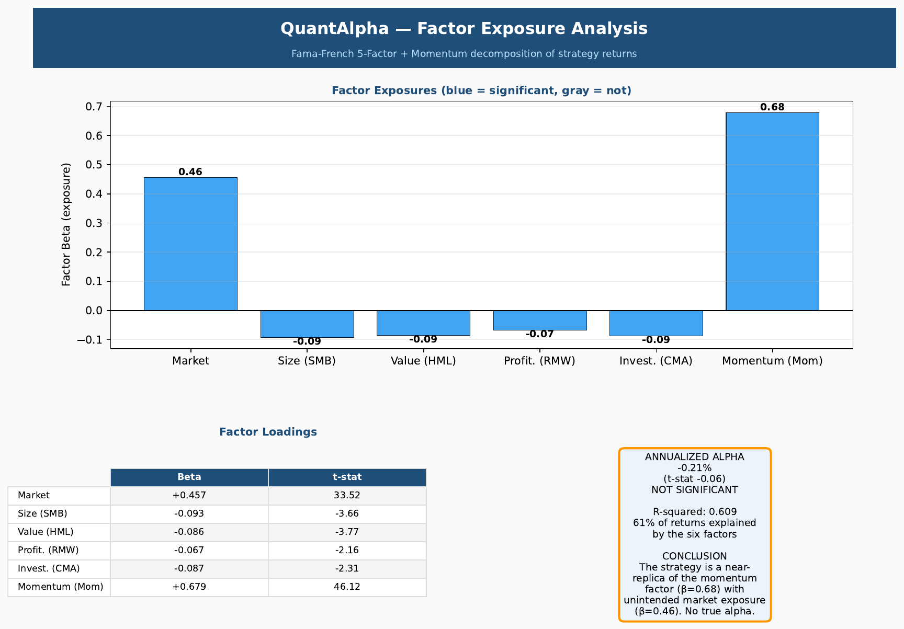
Tearsheet Page 6 — Fama-French 5-factor + momentum exposures, loadings table and alpha summary
Answers the deepest question: where does the return come from? The strategy's daily returns are regressed on the Fama-French five factors plus momentum. Each factor is a documented, cheaply-buyable source of return; anything left over is genuine skill (alpha).

The Six Factors
- Market (Mkt-RF): broad market exposure above the risk-free rate — plain market beta.
- Size (SMB): small companies tending to outperform large ones.
- Value (HML): cheap stocks tending to outperform expensive ones.
- Profitability (RMW): profitable firms outperforming weak ones.
- Investment (CMA): conservative-investing firms outperforming aggressive ones.
- Momentum (Mom): recent winners continuing to beat recent losers — the effect this strategy targets.

The Results
Factor | Beta | t-stat | Significant?
Momentum (Mom) | +0.679 | 46.12 | Yes
Market (Mkt-RF) | +0.457 | 33.52 | Yes
Size (SMB) | −0.093 | −3.66 | Yes
Value (HML) | −0.086 | −3.77 | Yes
Profitability (RMW) | −0.067 | −2.16 | Yes
Investment (CMA) | −0.087 | −2.31 | Yes
Alpha: −0.21%/yr (t-stat −0.06, not significant) │ R² = 0.609

What the Numbers Mean
- t-statistic: measures how reliably a beta differs from zero; |t| > 2 means significant. The momentum t-stat of 46 is enormous.
- Momentum beta +0.68: the dominant exposure — statistically the strategy is a near-replica of the academic momentum factor, validating the signal was built correctly.
- Market beta +0.46: an unexpected finding — despite being long/short, the strategy carries significant net-long market exposure. Part of its return came simply from the market rising; in production this would be hedged.
- Small negative tilts (SMB, HML, RMW, CMA): significant but economically small (−0.07 to −0.09) — a mild lean toward large-cap growth winners.
- Alpha −0.21%, not significant: after removing all factor exposures, no excess return remains — the honest, expected result. Finding zero alpha rather than manufacturing a positive number is a mark of rigor.
- R² = 0.61: the six factors explain 61% of return variation; the rest is asset-specific noise, not alpha.

The One-Sentence Takeaway
The momentum strategy is a faithful, well-constructed harvester of the momentum and market risk premia, with no genuine alpha and an unintended net-long market exposure that should be hedged — a conclusion that demonstrates exactly the performance-attribution thinking expected of a quant trader or portfolio manager.

Generated as part of the QuantAlpha project — companion to notebooks/QuantAlpha_Tearsheet.pdf

