Administring Anomanor

# Format of data

Each *record set* consists of two files: the manometry data file (extension *.txt*) and a *separate*  patient descriptor file (extension *.md)*. To match, both files must have the same base name. It should not have a space in it – use underscores as separators if required. The name of the file will not be visible to the user. File names will be recoded as three-character/number random strings; pat_14556.txt becomes *4ab* for CLT and *tu3 for* HRM.

Valid, at least partially :

* *pat_14568.txt for data, pat_14568.md for patient*
* *14568.txt, 14568.md*
* *du_14568.txt, du_14568.md*
* *427048;Prof.Fox;27.10.2021.txt, 427048;Prof. Fox;27.10.2021.md*

The last *good* example is only partially recommended because it is prone to typos because of the many special characters in it. This will lead to a rejection of the patient descriptor file when the names do not match exactly.

Avoid fancy decorations, use something like

* *427048_mf.txt, 427048_mf.md*

Bad:

* *pat_14568.txt, Pat_14568.md (*case matters, not considered a match)

The naming concept should be consistent, do not use *Patient_13.txt* and *pat_15.* Decide for one format and stick to it.

## The manometry data file (txt)

This is the data record in plain text format. Make sure it has the extension *.txt*, do not use the proprietary file with extension *.mvaar*.

Be cautious when you make changes in the data part of the record, i.e. the part above the text *Annotations.* Deleting lines a the beginning and the end should be uncritical though, and may be helpful cut away unneeded parts of the record. Do not remove parts in the middle.

*Do not* use Microsoft Word to make changes to data files. I recommend to install [Notepad++](https://notepad-plus-plus.org/downloads/) when you are working in Windows; using the default Notepad (without ++) makes working more difficult. At the end of the file you find the section with header *Annotation*; do not remove or modify this header, it is required to locate the markers. Example:

Annotations:

-1.00 # B1

40.00 #Rest

67.38 #Squeeze 1

77.38 # Squeeze 2

90.98 # Long Squeeze

91.10 Balloon volume for next fill30 cc not used

128.78 # Push 1

156.78 # Push 2

186.78 # Push 3

194.78 # Cough 1

210.00 Whatever, this is not used

244.78 Rectal sensory

288.78 RAIR

The numbers are in seconds from the start of the original record, but I believe that these sometimes have an offset due to truncation during export. Always try to **use a tab between the columns**; you can make separators visible in Notepad++. Having been bitten myself, I have added some corrective code to make it work with spaces as separators, but probably not all cases are handled correctly

All markers to be used must be prepended with “#“ (hash), followed by an optional space. Some markers are required, some are used when present and some are discarded, but tolerated. Table marker_classification_table in the SQLite database defines the markers; you can add or modify the definition by editing the table.

|  |  |  |
| --- | --- | --- |
| marker | classification_phase | mtype |
| Cough |  | o |
| Cough 1 |  | o |
| Long Squeeze | tone | n |
| Push 1 | coord | r |
| Push 2 | coord | r |
| Push 3 | coord | n |
| RAIR | rair | r |
| Rectal sensory high |  | o |
| Rectal sensory low |  | o |
| Rest | tone | n |
| Squeeze 1 | tone | r |
| Squeeze 2 | tone | r |

Table : Markers in manometry record. Markers should be prepended with ‘# ‘. Column mtype: Letter ‘o’: optional, but not used (classification_phase is empty). ‘n’: Not required, but permitted and displayed. ‘r’: required, you cannot upload a record without this marker.

To suppress channels, add negative time values, e.g. -1.00, -2.00, and the hashed channel number as marker; see the example above, where channel B1 is marked as missing. Valid channel numbers are # B1, # B2 and # 1 to # 10. You cannot suppress both # B1 and # B2 at the same time. Any negative number is valid as surrogate time marker, but I recommend using trailing zeroes (-1.00, not -1) because these align better with the rest; see the example in Courier font above.

Do not add patient desriptor text, e.g. ”balloon expulsion success”; all free text must be in a separate file with extension .md as described in the next chapter.

## The patient descriptor file (md)

The content of the patient descriptor file is displayed when “All” is active as the *Classification phase*.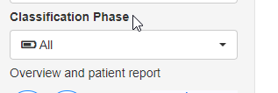

The file with extension .md is plain text file in [Markdown format](https://en.wikipedia.org/wiki/Markdown) well known from Wikipedia; in the example below, the word **Female** is bold. Do not use *Microsoft Word* to write .md files, use [Notepad++](https://notepad-plus-plus.org/downloads/), or, if you must, the standard Windows Notepad. You can use copy/paste when you need to include text from Word documents. The text should be very limited to avoid cross-method HRM/conventional cheating.

### Example of an md file

**Female**, 40+, rectal hypersensitivity, balloon expulsion not successful

# Uploading record sets

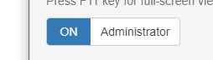To upload data, you must be logged in as an administrator and activate the admistrator functions in the lower left pane. Click on the *Upload* tab.

As administrator, you can play with classifications, save and finalize to your heart’s delight. The results will be stored, but not used for statistics. If you are both an admin and and expert, use different logins emails for administrative and classi­fi­ca­tion functions.

Always have both the manometry and the patient record at hand when you upload data sets. A warning will be issued on every startup when one of the two is missing – which can easily occur when you did not stick to the strict naming convention. In case a record is rejected which you believe should be valid, please contact [the administrator](mailto:dieter.menne@menne-biomed.de).

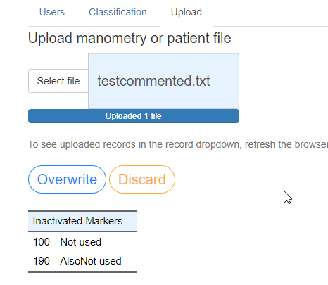To select a file for uploading, click on *Select file* or drag-drop a file from the explorer into the light-blue field. Files with extension *.md* or *.txt* will be accepted. The file will be rejected when there are errors, and you will get hopefully helpful error messages - you will get many, computers are merciless.

When the file is acceptable, click on *Upload* (new file) or *Overwrite* (replace previosly uploaded file).

A newly uploaded file will only appear in the *Record* dropdown after a refresh of the browser.

# User registration

User registration and authorization is handled by the professional level [keycloak](https://www.keycloak.org/) app. From the *anomanor* website, only registration-by-email-invitation is available. Other methods such as self-registration can be used, and users can be removed or upgraded from *trainees* to *experts* from the main Keycloak site which is currently only accessible by the author (DM), but will be made accessible later.

Users are attributed to one of three groups:

* *admins:* Can invite users, upload records and view temporary results including Krippendorff’s alpha (inter-rater match). Can play with classifications to test the functions, but these will be discarded in statistics.
* *experts:* Experts cannot access the admin features, and will not be shown classification results of other users after finalization. This restriction should reduce super-expert bias. Once expert classification is completed, by setting a flag in the app it is possible that experts also have the results displayed.
* *trainees:* Can do classification, temporarily save these for “think-overs”, and finalize each classification. As a feedback, expert classifications are shown directly after trainee finalize a classification; in case of inconsistent expert ratings, the normative classification will be indicated by an exclamation mark (!). I am not happy that alternative choices in the example below are grayed out, but I have not yet been able to let the text shiny through. It’s on the length bug list, but further below.

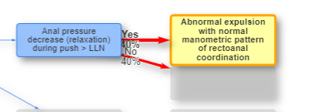

#### How it works:

* Enter the email of the user to be invited on the *Users* page when logged in as an administrator and the administrator function have been activated in the lower left pane.
* Select which user group the invited person should belong to.
* A mail will be sent to the user, with a link. This registration link is only valid
* When user clicks on the link, he or she will be asked to supply a password which is stored as an encryted hash by Keycloak following DSVGO criteria. In addition, the user must also fill in Name/Firstname.
* After this, the user can log in at hrmconsensus.org. The site is running on my private server, but since the app has become too big, I cannot install it for testing on it. I am waiting for the approval to install the dedicated server.

#### The invitation text:

The international working group for disorders of GI motility and function invites you to participate in the *IAPWG Anorectal High-Resolution Manometry Inter-Rater Agreement Study*.

Enhanced visualization of anorectal motility and function provided by anorectal high-resolution manometry with pressure topography (AR-HRM) as set out in the London Classification offers a potential diagnostic advantage over conventional line tracings (CLT). However, evidence demonstrating a significant diagnostic advantage of AR-HRM over CLT is limited. The aim of this study is to investigate whether the inter-rater agreement and/or accuracy for diagnosis of anorectal disorders is different between AR-HRM and CLT. This follows the successful model used to demonstrate the superiority of esophageal HRM for diagnosis of upper GI motility disorders.

In the first-round of inter-rater assessment a reference standard will be set by lead authors of the London Classification. In the second-round other practitioners will use the interactive platform to compare their performance against this reference standard. All those that complete the study will be acknowledged in the paper (searchable in PubMed).

If you wish to take part in this study, then please click on the link below to register your interest. You will be asked to supply a new password for the account, and enter your full name.

Link to account

This registration link will expire within 2 weeks. Please contact the administrator at [hrmconsensus.org](mailto:hrmconsensus@gmail.org%20) in case of registration failure. If you are unaware of any registration request to the site, just ignore this message.

Once registered, use <https://hrmconsensus.org> to log in.

