Project17

1- System hardening

a- what is a Patch?
A patch is a program used to upgrade, secure or fix an OS application.

b- What command would you use to install a single patch?
I would use the “yum” command--- yum install “name of single patch” –y.

c- How do enable the root password require for maintenance mode?
To enable the root password at the maintenance mode you would modify the file
/etc/sysconfig/init and by doing so you VI into the file and change where it says sunshell to sulogin. Save it and quit. Next you reboot your system to apply the changes for the root password at the maintenance mode.

d- why is the root password for maintenance is important?
First of all, it is important for security reason in making the server more harder for hackers or scammer to break through servers easily. Hackers are aware of the super user account “root” on every server and that makes it easy for them to break through a server by simply powering up the server and putting it or forcing it into maintenance mode to gain full access to the server. With that said, securing the server by putting a password at the maintenance level makes it perplex and harder to break through servers.

e- What is the danger of not having a grub password?
The danger of not having a grub password is that although a server might be requiring a password input at the maintenance mode it can still be forced through at the grub level of the system boot up. This is among the reasons why it so crucial to have a grub password to even make it more complicated for hackers.

f- What are some security measures put in place for the physical security of the servers?
-- Close circuit surveillance cameras, motion or thermal alarm system, Security guards, picture ID’s, Biometrics and locked and dead-bolted steel doors.

g- why is security so important for companies?
---Security is so important for companies because they provide a framework for keeping your company at a desired security level assessing the risks you face, deciding how you will mitigate them, and planning for how you keep the program and your security practices up to date
-----Again, security is so important that failure to protect your data’s confidentiality might result in customer credit card numbers being stolen, with legal consequences and a loss of goodwill.
----- A data integrity failure might result in a Trojan horse being planted in your software, allowing an intruder to pass corporate secrets on to your competitors. That’s why security is so important for companies.

2-In your own words describe some few raisons why a server should be constantly patched.
--A server should be constantly patched in my opinion to fix and improve it including fixing its security vulnerabilities.
--Secondly, to improve the usability and performance of server.
--Patch fix could also be in terms of source code modification consisting of textual differences between two source code files. Therefore, developers may compile the new change called service packs or software updates to change them.

4- upgrade your homecentos the kernel to the latest stable kernel version

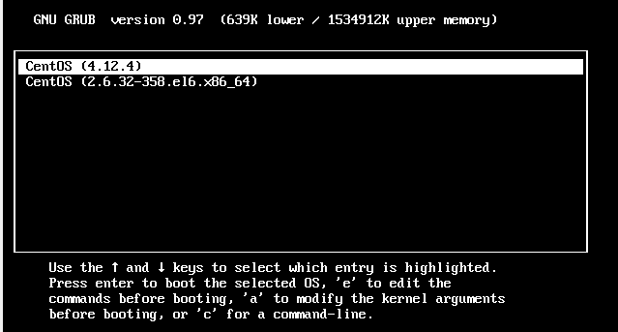

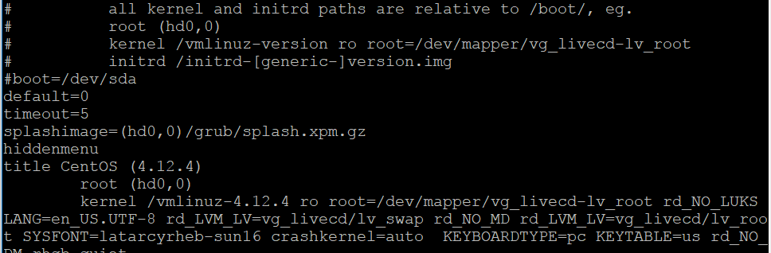

you can get the package from the kernel.org website.
5- set the new kernelas default kernel.

