Project13

1- What is a user account?

A user account is a location on a network server used to store a computer username, password, and other information. It also allows a user to connect to a network, another computer, or other share.

2- what is a user's shell?

A user’s shell is a user interface for access to an operating system's services. The operating system shells use either a command-line interface (CLI) or graphical user interface (GUI), depending on a computer's role and particular operation.

3- what is a user's home directory?

A home directory is the directory on Unix-like operating systems that serves as the repository for a user's personal files, directories and programs. It is also the directory that a user is first in after logging into the system.

4- create a user manolo with the uid of 33545

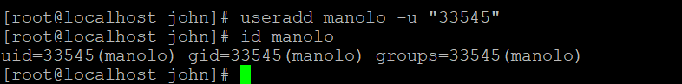

5- greate a group called sysmgrs----

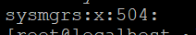

5- create a user sarah with sysmgers as subgroup ( sarah's password is redhat)
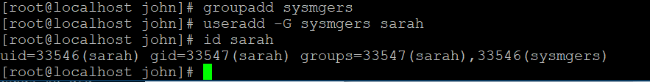

6- create a user natasha that can not access the shell

7- what is the permission 765 means?
It means the user has all the permissions on the files, the group has a read and write permission and then others have the permission to read and execute on the file.

8- how do you check the permission on a file/directory?--- you type the command ls –l for the user account. For instance, the account Natasha show the below permission on the file and directories by the user

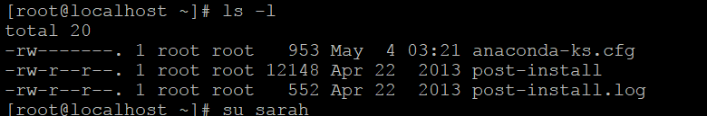

9- how do you check the owner of a file? You would check by typing the Ls- l command
10- what command would you type to change the owner of a file?
Ls- l command

11- what command would you type to change to group a file belongs to?
- You would type groupmod –n (new name) (oldname)

12- what is a softlink?--- Means a copy of a file that contains a reference to another file or directory in a different place.

13- what is the difference between a symbolic link and a hard link?

A symbolic link is a copy of a link with a different name at a different location.And when the link is deleted the original version is also deleted. However, when the link is recreated then the original link is restored again whereas a hardlink will create another file with a link to the same underlying inode in the same directory.And When you delete a file it removes one link to the underlying inode. The inode is only deleted (or deletable/over-writable) when all links to the inode have been deleted.

14- user John and user jsmith are working on a same project and need to record thier progress in the same file without accessing each other's home directory.
a- how can you help them with this?
b- consider that john's home directory is /home/ceo and that jsmith's home directory is /home/security, go ahead and right a procedure on how to accomplish that task.

To be able to accomplish the above project and access the same file without visiting each others home directory both John and Jsmith can work on the file and then after finishing the project in for instance John’s home directory they can create a softlink from John directory to jsmith’s home directory and then they should be able to access that file without necessarily visiting each other’s home directory.Please see below screenshot
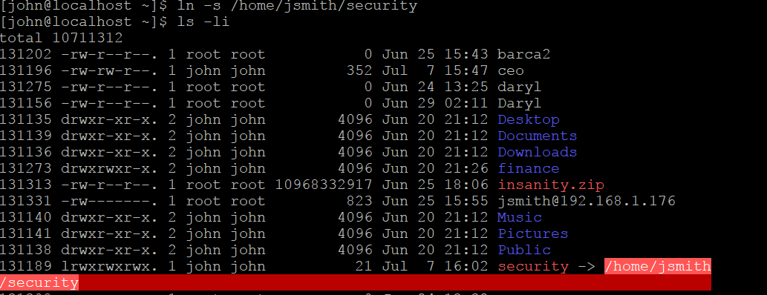

15- what command do you use to change the permission on a file.
You use the “chmod” command and then you add the permission you want to give to the file

16- what is an inode? Its an informal term that refers to an identification number that holds information pertaining to a files or directory.

17- how do you check the inode of a file? To check the inode of a file you type the command ls –li. For instance in the below screenshot the number infront of the files permission row is the inode numbers

18- set your homecentos to display the following message when the users login.

"This is a private computer system monitored 24/7, any unauthorized use will be subject to disciplinary mesure including job termination. If you do not have the proper authorization, please logout NOW!!!!"

