Project14

1- what is sticky bit?

A Sticky bit is a permission bit that is set on a file or a directory that lets only the owner of the file/directory or the root user to delete or rename the file. No other user is given privileges to delete the file created by some other user

2- what role does sticky play on a directory?

The role of sticky bit has changed over the course of years. Back in the day, sticky bit played the role of hinting the Operating System that the executed a file or anything to cache it into memory. By so doing, this accomplished the task of saving time and also loading faster. Today, it is commonly used to create a directory in which nobody else but only the owner of a file in that directory can delete it. Traditionally, anyone else could write and delete a file from it.As such, setting the sticky bit on a directory makes it so only the owner of a file can delete the file from a writable directory

3- what directory on your server has sticky bit set on it?---the tmp directory

4- what is the difference between /usr/local/* and /usr/local*

5- what is ssh?

It is called the secure socket shell. It is a network protocol that provides administrators with a secure way to access a remote computer

6- what is ssl?

This stands for Secure Socket Layer and it is the standard security technology for establishing an encrypted link between a web server and a browser. This link ensures that all data passed between the web server and browsers remain private and integral.

7- why is putty considered secured?

Putty is considered secure because has an SSH (Secure Shell) which is the now an ubiquitous program for logging into or executing commands on a remote machine. Moreso, It provides secure encrypted communications between two untrusted hosts over an insecure network.

8- what is selinux?
Security-Enhanced Linux (SELinux) is a Linux kernel security module that provides a mechanism for supporting access control security policies, including United States Department of Defense–style mandatory access controls (MAC).

9- set your server's selinux to permissive mode
To do that, first I used the find command ( find / -name selinux) to locate the path to the file selinux. The below highlighted screenshot show the path to the file selinux . Then I went into the file to change and save it.

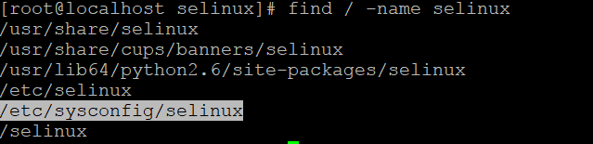

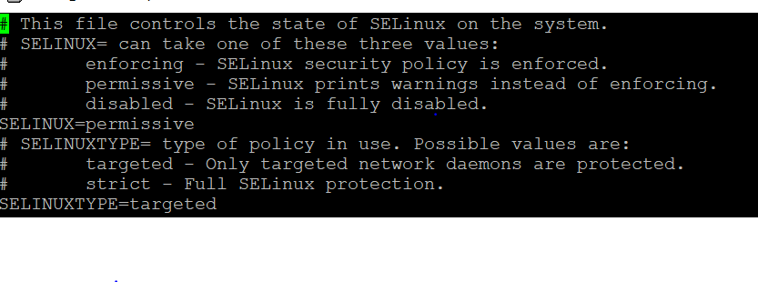

10- Create a shared directory /home/managers with the following characteristics: /home/managers belong to group sysmgrs
This directory can be read, written and accessed by members of sysmgrs.
Any files created in /home/managers, the group is automatically set as sysmgrs
All other users should not be able to access (execute) the /home/managers directory. (The user root can always read and write, no matter the permissions)

11-what happen when you type a url on the browser until the page come on?

Since computers only communicates with binary numbers ,when you type a url, the Domain Name Server(DNS) translates the domain name into an ip address for the URL that is entered in the browser. Once the ip address is located then it sends a request to the web browser. The browser opens a TCP connection in the data transfer communication. In this process, the browser sends the request through sync and acknowledges communication and returns the information through an HTML data stream and it eventually transfers into a visible web.

12- what is a tree way hand shake?
A three-way handshake is the procedure by which the TCP checks connecvity between two
devices before any data transfer. It can also be de'ned as a method used in a TCP/IP network to
create a connecon between a local host/client and server.
It is a three-step method that requires both the client and server to exchange SYN and ACK
(acknowledgement)packets before actual data communicaon begins

A three-way handshake is the procedure by which the TCP checks connecvity between two
devices before any data transfer. It can also be de'ned as a method used in a TCP/IP network to
create a connecon between a local host/client and server.
It is a three-step method that requires both the client and server to exchange SYN and ACK
(acknowledgement)packets before actual data communicaon begins
A three-way handshake is the procedure by which the TCP checks connecvity between two
devices before any data transfer. It can also be de'ned as a method used in a TCP/IP network to
create a connecon between a local host/client and server.
It is a three-step method that requires both the client and server to exchange SYN and ACK
(acknowledgement)packets before actual data communicaon begins
A three-way handshake is the procedure by which the TCP checks connecvity between two
devices before any data transfer. It can also be de'ned as a method used in a TCP/IP network to
create a connecon between a local host/client and server.
It is a three-step method that requires both the client and server to exchange SYN and ACK
(acknowledgement)packets before actual data communicaon begins.
A three-way handshake is the procedure by which the TCP checks connecvity between two
devices before any data transfer. It can also be de'ned as a method used in a TCP/IP network to
create a connecon between a local host/client and server.
It is a three-step method that requires both the client and server to exchange SYN and ACK
(acknowledgement)packets before actual data communicaon begins.
A three-way handshake is the procedure by which the TCP checks connecvity between two
devices before any data transfer. It can also be de'ned as a method used in a TCP/IP network to
create a connecon between a local host/client and server.
It is a three-step method that requires both the client and server to exchange SYN and ACK
(acknowledgement)packets before actual data communicaon begins
A three way handshake is the process in which TCP checks network connectivity between two devices before any data transfer is made. In this process,both thee client and server exchanges what is called the sync and acknowledge packets before the actual data communication begins.

13- what is the boot up process in linux ?
The boot up process is the process that when a linux server is turned on the steps that it goes through which are as follows:
. BIOS
- BIOS stands for Basic Input/Output System
- Performs some system integrity checks
- Searches, loads, and executes the boot loader program.
- It looks for boot loader in floppy, cd-rom, or hard drive. You can press a key (typically F12 of F2, but it depends on your system) during the BIOS startup to change the boot sequence.
- Once the boot loader program is detected and loaded into the memory, BIOS gives the control to it.
- So, in simple terms BIOS loads and executes the MBR boot loader.

2. MBR
- MBR stands for Master Boot Record.
- It is located in the 1st sector of the bootable disk. Typically /dev/hda, or /dev/sda
- MBR is less than 512 bytes in size. This has three components 1) primary boot loader info in 1st 446 bytes 2) partition table info in next 64 bytes 3) mbr validation check in last 2 bytes.
- It contains information about GRUB (or LILO in old systems).
- So, in simple terms MBR loads and executes the GRUB boot loader.

3. GRUB
- GRUB stands for Grand Unified Bootloader.
- If you have multiple kernel images installed on your system, you can choose which one to be executed.
- GRUB displays a splash screen, waits for few seconds, if you don’t enter anything, it loads the default kernel image as specified in the grub configuration file.
- GRUB has the knowledge of the filesystem (the older Linux loader LILO didn’t understand filesystem).
- Grub configuration file is /boot/grub/grub.conf (/etc/grub.conf is a link to this). The following is sample grub.conf of CentOS

- As you notice from the above info, it contains kernel and initrd image.
- So, in simple terms GRUB just loads and executes Kernel and initrd images

. Kernel
- Mounts the root file system as specified in the “root=” in grub.conf
- Kernel executes the /sbin/init program
- Since init was the 1st program to be executed by Linux Kernel, it has the process id (PID) of 1. Do a ‘ps -ef | grep init’ and check the pid.
- initrd stands for Initial RAM Disk.
- initrd is used by kernel as temporary root file system until kernel is booted and the real root file system is mounted. It also contains necessary drivers compiled inside, which helps it to access the hard drive partitions, and other hardware.

5. Init
- Looks at the /etc/inittab file to decide the Linux run level.
- Following are the available run levels
- 0 – halt
- 1 – Single user mode
- 2 – Multiuser, without NFS
- 3 – Full multiuser mode
- 4 – unused
- 5 – X11
- 6 – reboot
- Init identifies the default initlevel from /etc/inittab and uses that to load all appropriate program.
- Execute ‘grep initdefault /etc/inittab’ on your system to identify the default run level
- If you want to get into trouble, you can set the default run level to 0 or 6. Since you know what 0 and 6 means, probably you might not do that.
- Typically you would set the default run level to either 3 or 5.

6. Runlevel programs
- When the Linux system is booting up, you might see various services getting started. For example, it might say “starting sendmail …. OK”. Those are the runlevel programs, executed from the run level directory as defined by your run level.
- Depending on your default init level setting, the system will execute the programs from one of the following directories.
- Run level 0 – /etc/rc.d/rc0.d/
- Run level 1 – /etc/rc.d/rc1.d/
- Run level 2 – /etc/rc.d/rc2.d/
- Run level 3 – /etc/rc.d/rc3.d/
- Run level 4 – /etc/rc.d/rc4.d/
- Run level 5 – /etc/rc.d/rc5.d/
- Run level 6 – /etc/rc.d/rc6.d/

14- how do you update the Os version of your linux server?
To update your OS version of your linux server you type the command
Yum update –y

