Project15

1- what is the sed command ?

The Sed command is a stream editor which is used to modify files in Linux or unix. Sed can be used just like vi or vim command
As a text editor.

2- what is the awk command?

it is mostly used as a Unix command-line filter to reformat the output of other commands

3- what is the diff command?
The diff command is used to compare and find the difference between 2 files

4- sed command
a- create a test file with the content of passwd file,
b- Type a single command to replace all the "nologin" by "bash"

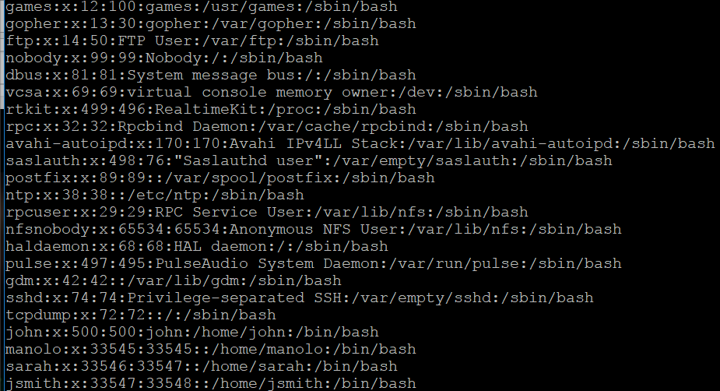

c- Type a command to insert "This file carries user accounts" at the top of your test file.

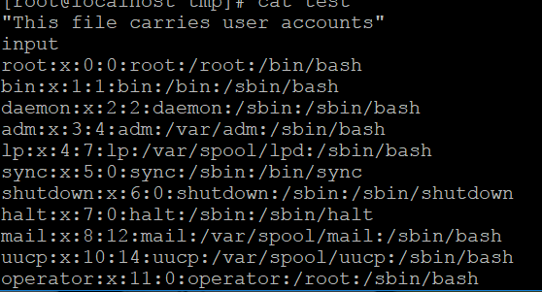

d- Type a command to insert "From here down are account created by the administrator"
right after the line with tcpdump.

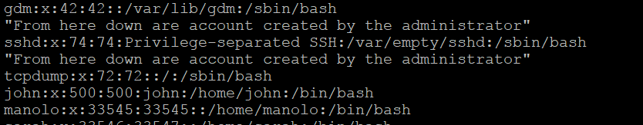

5- Type a command to display the cpu size in MHZ ( you can filter the lscpu command to accomplish this.

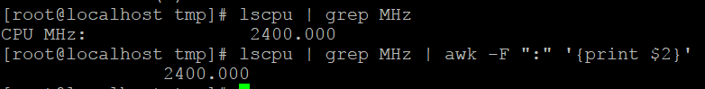

6- Type a command to display the total memory size ( just the size without any other output.

7- Type a command to display just the memory used

8- Type a command to display just the available memory

9- in which case do you use the diff command ?

The diff command is used to compare and find the difference between 2 files

10- what is an inode and how do you checkt it ?

An inode is an identification number for a file or a directory. To check for the inode of a file or directory you type the command Ls –li. This will display the inode of the files or directory.

11- what is an exit code?

When a command finishes execution, it returns an exit code.For instane,A successful command returns a 0, while an unsuccessful one returns a non-zero value that usually can be interpreted as an error code.

12- what is an exit code of 0 represent?
When an exit code has output of 0 it means that the command typed went thoroughly correct.

13- what is the sort command?
The sort command is a command line utility for sorting lines of text files. It supports sorting alphabetically, in reverse order, by number, by month and can also remove duplicates.

14- what command would you type to lock an account ?
You type the command passwd –l. To do this, you first login as root and then you type the command passwd –l (username). Next, you will get a prompt saying password successfully locked.

15- what command would you type to unlock it?
To get it unlocked you type the command passwd –u. Again to do this, login as root and then type the command passwd –u (username). You will get a prompt saying password for the specific user unlocked.

