# Quiz

## Upgrades

* How has the idea of upgrades changed from ASP to MVC5?
* What were some of the problems that ASP.NET was supposed to solve?
* How was MVC changed over time?
* What is the difference between .Net version, C# Version, VS version, ASP.NET Version, and MVC Version?

# Exercises for Learning

* Draw a diagram that shows the relationship of Visual Studio, C#,ASP.NET, and MVC 5?
* What were some challenges you have faced while upgrading items in the past?

# Quiz

## The GAC

* What is the GAC?
* What is the purpose of the GAC?
* What kind of files can be in the GAC?
* What do you need to do to see a dll in the GAC?
* What is the advantage of the GAC?
* What disadvantages are there with the GAC?
* Can you have multiple versions of a DLL in the GAC?
* How do you register a file in the GAC?
* What are the 3 parts of an assembly name?
* Do different versions of a dll have different public key tokens?

# Exercises for Learning

* Download Dot Peek and look at the following dlls:
  + System.Web
  + System.Web.MVC
* Using Dot Peek find 2 different versions of a file in the GAC and note the differences

# Quiz

## Configuration

* What is a configuration file?
* What are the three types of configuration files?
* What are the main elements of the web.config?
* What is a web transform file and when is it used?

# Quiz

## Servers

* What is IIS?
* What version of IIS should you use with MVC 5?
* How is IIS8 different from previous versions?
* What are the 2 pipelines?

# Quiz

## Assembly Unification

* *What is* assembly *unification*?
* What is automatic binding redirection?
* What are the components of automatic binding in a config file?
* Can you bind more than 1 dll version at a time?
* What is a compile-time binding references
* Where can you redirect assemblies?

# Quiz

## Nuget

* What is Nuget?
* What files can be downloaded by Nuget?
* What are the two ways to use Nuget?
* What is the command line interface called?
* What sections are there in the GUI client?
* What file controls Nuget?
* What are the downloaded files stored?
* How can you upgrade your dlls via Nuget?
* What happens if your file that Nuget references is not present?
* How can you explore what a Nuget package contains?

# Quiz

## Project Files

* How do you look at the text of a project file?
* What type of information is located in a project file?
* How does the project find a dll?
* How does Visual Studio know the project type?
* How can you set the project to check views at compile time?
* What happens if a file referenced is not present

# Quiz

## MVC

* What was the first successful web implementation of MVC?
* What are the major dlls in MVC?
* What is Web.API?
* What namespace is used for Web.API?
* What files are used for configuration?
* What is a view engine?
* What is ASP.Net?

# Quiz

## MVC 4 to 5

* What two namespaces are added to MVC 5?
* What version of Razor works with MVC 5?
* What changes are needed to change in the project file?
* What items can be configured in App_Start?
* What items can be configuraed in the global.asax?
* What file configures the view engine?
* What are the two main groups of file changed?
* What assembly redirection is required?
* What is the major configuration change from WebAPI 1 to 2?

# Quiz

## ASP.NEXT

* What is the unit of reference in asp.next?
* How are projects and nugget packages different?
* What type of compilation is used by .next?
* What items used to be in System.Web but have moved?

# Quiz

## Katana Project

* What is the Katana project?
* Why is Katana a new idea for Microsoft?
* What is OWIN and how is it different from previous Microsoft dlls?
* What ruby project inspired OWIN?
* What open source Javascript project is similar to OWIN?
* What is a OMC?
* What is Oauth?
* How is forms authentication different with OWIN?

Exercise

Install-Package Microsoft.AspNet.Razor -Version 3.0.0

Install-Package Microsoft.AspNet.WebPages -Version 3.0.0

Install-Package Microsoft.AspNet.WebPages.WebData -Version 3.0.0

Install-Package Microsoft.AspNet.WebPages.OAuth -Version 3.0.0

Install-Package Microsoft.AspNet.Mvc -Version 5.0.0

Install-Package Microsoft.AspNet.Mvc.Facebook

Install-Package Microsoft.AspNet.WebApi.Core -Version 5.0.0

Install-Package Microsoft.AspNet.WebApi.SelfHost -Version 5.0.0

Install-Package Microsoft.AspNet.WebApi.Client -Version 5.0.0

Install-Package Microsoft.AspNet.WebApi.OData -Version 5.0.0

Install-Package Microsoft.AspNet.WebApi -Version 5.0.0

Install-Package Microsoft.AspNet.WebApi.WebHost -Version 5.0.0

Install-Package Microsoft.AspNet.WebApi.Tracing -Version 5.0.0

Install-Package Microsoft.AspNet.WebApi.HelpPage -Version 5.0.0

Install-Package Microsoft.Net.Http -Version 2.2.20

Install-Package Microsoft.Data.OData -Version 5.6.0

Install-Package System.Spatial -Version 5.6.0

Install-Package Microsoft.Data.Edm -Version 5.6.0

Uninstall-Package –ID Microsoft.AspNet.Mvc.FixedDisplayModes

UnInstall-Package –ID Microsoft.AspNet.WebPages.Administration

Uninstall-Package -Id Microsoft-Web-Helpers

Install-Package Microsoft.AspNet.Web.Helpers.Mvc

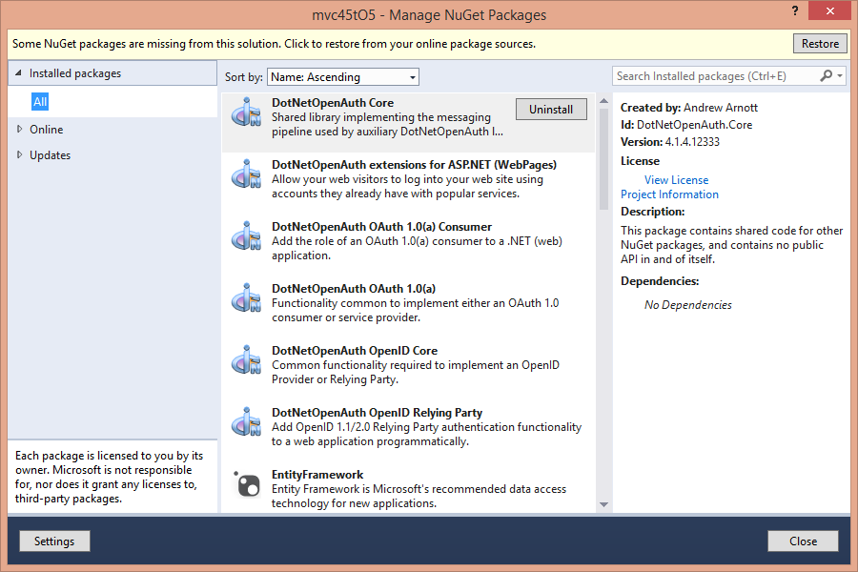

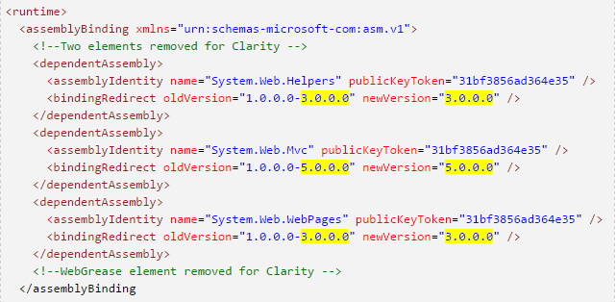

Install-Package Microsoft.AspNet.WebPages -Version 3.0.0