**Data Exploration for Stratification**

N = 1460

Average sale price = $180,921

Standard deviation of sale price = $79,415

Margin of error at 95% confidence interval = $10,000

(with CLT assuming Normal distribution) Initial sample size n0 = (z95%)2*s2 / (I90%)2 = (1.96)2*(79415)2 / (10000)2 = 242

Final sample size n = n0 / (1 + n0 /N) = 242 / (1+ 242/1460) = 208

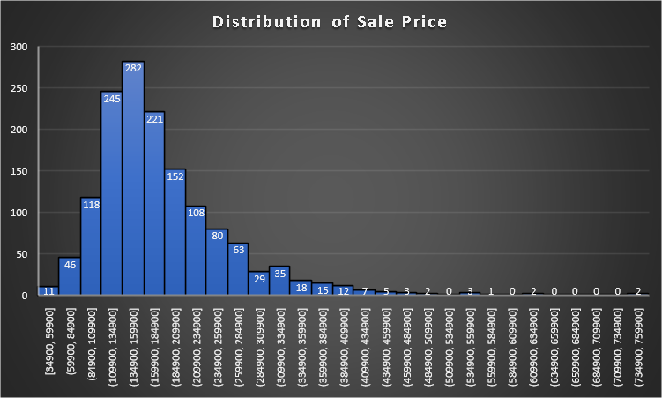

**Table 1 – By House Style**

1Story One story

1.5Fin One and one-half story: 2nd level finished

1.5Unf One and one-half story: 2nd level unfinished

2Story Two story

2.5Fin Two and one-half story: 2nd level finished

2.5Unf Two and one-half story: 2nd level unfinished

SFoyer Split Foyer

SLvl Split Level

|  |  |  |  |  |  |
| --- | --- | --- | --- | --- | --- |
| **Row Labels** | **Count of SalePrice** | **Average of SalePrice** | **StdDev of SalePrice** | **Average of GrLivArea** | **StdDev of GrLivArea** |
| 1.5Fin | 154 | 143117 | 54278 | 1565 | 445 |
| 1.5Unf | 14 | 110150 | 19036 | 896 | 110 |
| 1Story | 726 | 175985 | 77056 | 1309 | 381 |
| 2.5Fin | 8 | 220000 | 118212 | 2848 | 613 |
| 2.5Unf | 11 | 157355 | 63934 | 1908 | 445 |
| 2Story | 445 | 210052 | 87339 | 1887 | 528 |
| SFoyer | 37 | 135074 | 30481 | 973 | 280 |
| SLvl | 65 | 166703 | 38305 | 1374 | 387 |
| **Grand Total** | **1460** | **180921** | **79443** | **1515** | **525** |

**Table 2 – By Building Type**

1Fam Single-family Detached

2FmCon Two-family Conversion; originally built as one-family dwelling

Duplx Duplex

TwnhsE Townhouse End Unit

TwnhsI Townhouse Inside Unit

|  |  |  |  |  |  |
| --- | --- | --- | --- | --- | --- |
| **Row Labels** | **Count of SalePrice** | **Average of SalePrice** | **StdDev of SalePrice** | **Average of GrLivArea** | **StdDev of GrLivArea** |
| 1Fam | 1220 | 185764 | 82649 | 1539 | 544 |
| 2fmCon | 31 | 128432 | 35459 | 1561 | 578 |
| Duplex | 52 | 133541 | 27833 | 1567 | 444 |
| Twnhs | 43 | 135912 | 41013 | 1276 | 309 |
| TwnhsE | 114 | 181959 | 60626 | 1312 | 305 |
| **Grand Total** | **1460** | **180921** | **79443** | **1515** | **525** |

**Table 3 – Sample Size for Stratification**

|  |  |  |  |  |  |  |  |  |
| --- | --- | --- | --- | --- | --- | --- | --- | --- |
| **Stratum** | **House Style** | **No. Of Houses (Nh)** | **Proportion (ph)** | **Average Gross Living Area** | **Std Dev Gross Living Area (sh)** | **Nh*sh** | **Sample Size (nh) (Proportional Allocation)** | **Sample Size (nh) (Neyman Allocation)** |
| Stratum 1 | 1 Story | 726 | 0.4973 | 1309 | 381 | 276606 | 103 | 92 |
| Stratum 2 | 1.5 Fin | 154 | 0.1055 | 1565 | 445 | 68530 | 22 | 23 |
| Stratum 3 | 1.5 Unf | 14 | 0.0096 | 896 | 110 | 1540 | 2 | 0 |
| Stratum 4 | 2 Story | 445 | 0.3048 | 1887 | 528 | 234960 | 64 | 78 |
| Stratum 5 | 2.5 Fin | 8 | 0.0055 | 2848 | 613 | 4904 | 1 | 2 |
| Stratum 6 | 2.5 Unf | 11 | 0.0075 | 1908 | 445 | 4895 | 2 | 2 |
| Stratum 7 | Sfoyer | 37 | 0.0253 | 973 | 280 | 10360 | 5 | 3 |
| Stratum 8 | SLvl | 65 | 0.0445 | 1374 | 387 | 25155 | 9 | 8 |
| **Total** |  | **1460** |  |  |  | **626950** | **208** | **208** |

**Proportional Allocation Output**

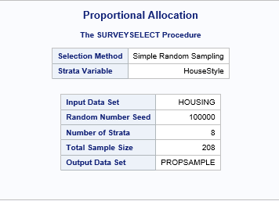

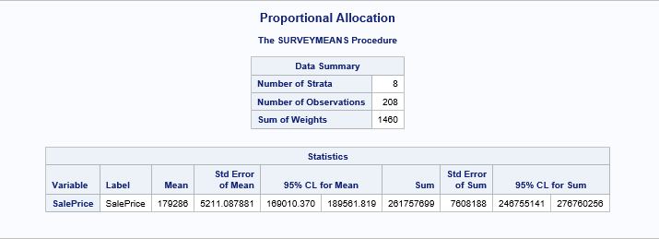

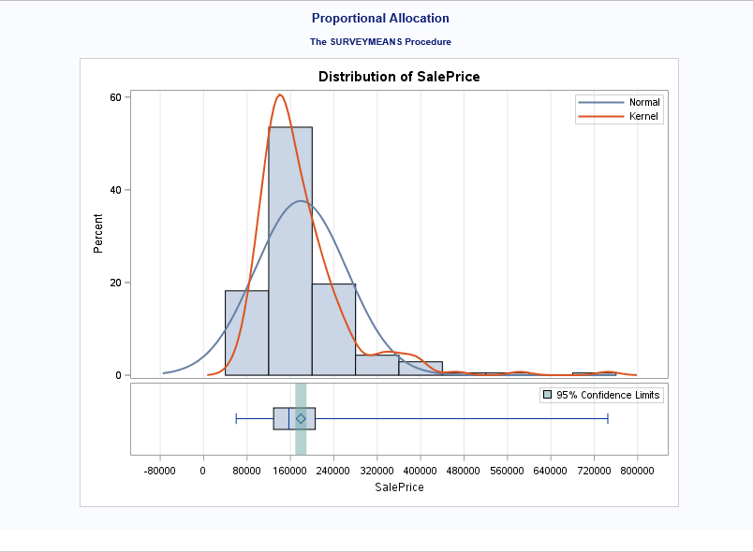

**Neyman Allocation Output**

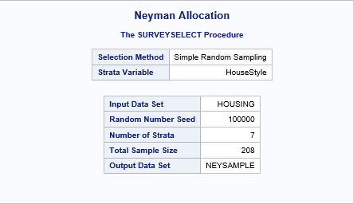

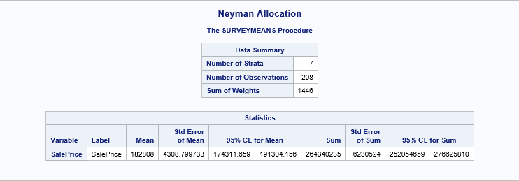

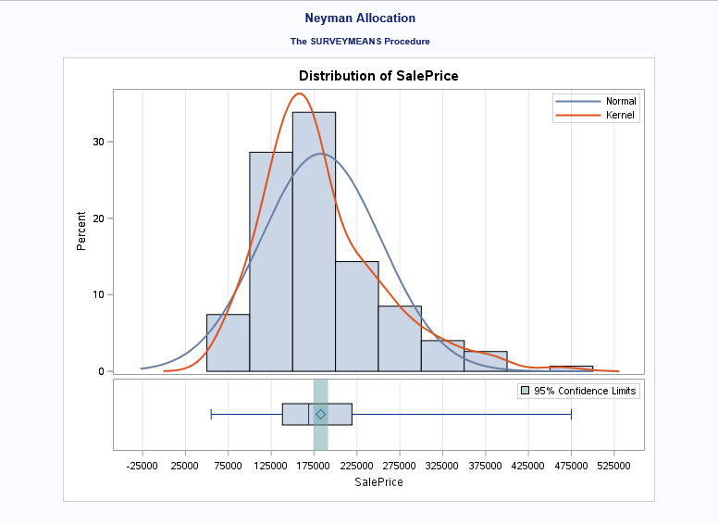

**SRS Output**

