Inventory Control/Order Fulfillment Database

Emily Foley, Cole Nelson, Debsankar Mukhopadhyay

University of Missouri – Kansas City

Note

Group Project Final Report for CS470: Introduction to Database Management Systems

Abstract

A database schema has been developed for a fictitious inventory control and order fulfillment database. A step by step study has been performed to develop the Entity Relationship Diagram, Schema Diagram, Data Definition Language (DDL), Data Manipulation Language (DML), and a simple user interface based on a set of well-defined requirements and constraints. A simple approach to database security has also been presented.

Keywords: Database Management System; Entity Relationship Diagram; Schema Diagram, Requirements; Database Security, DDL; DML.

# Introduction

The database system chosen by our group is an inventory pickup/management system. The three-tiered database system we are creating will aid inventory/pickup system employees by keeping records of product inventory quantities and their locations. This MySQL database will guide employees throughout the process of packing totes and shipping to the correct location and time, while also keeping track of inventory as the product is picked and shipped from the warehouse.

# Requirements

# The employee/order picker clocks in and logs into the tablet with their employee id. The employee has a name and id number. Each tablet also has a number. On the tablet, they select their sled number and then scan in the labels for the assignments they will be picking (usually 4 at a time but can do 1-6 assignments). (The sled is what is used to pull the totes along on rollers as you pick from the shelves.)

# The system requirements can be stated as follows:

# An employee should be identified by a unique employee ID.

# An employee must sign on one device.

# A device may or may not be assigned to an employee.

# An employee should select one sled.

# A sled may or may not be assigned to any employee.

# There must be 1-6 assignments per sled/per employee. But a sled may or may not have any assignments.

# Each assignment can have 1 to N number of totes.

# Each tote can contain 1 to N number of products.

# Each assignment should contain a product, number of items for that product, start and destination location for the product.

# Each tote is uniquely identified by a label**.**

The labels show the batch number, store number, current tote number and total number of totes for that assignment, # of items in current tote, beginning and ending location, number of items in current tote, and label number. Batch and store number are the same for all labels in that assignment. Other numbers are different for each tote/label (one label per tote).

Once assignments are scanned in and started, the tablet displays the location number and number of items to pick for each product.

Products are stored on shelves with 4-6 rows. Shelves are labeled with location stickers (one per product). Each location has the location number which is formatted like this example: A2-44-55-5. The first (A2) refers to the section. There are 3 "mods": AB, CD, and EF. Each mod has 4 floors. Each floor has two sides (for example, the A side and the B side). So A2 refers to the AB mod, 2nd floor, A side. The second number is the bay number. Each section has 44 bays (so 1-44 is the range for bays). The third number is the location from left to right/right to left (kind of like the column). It goes by 5's and not every number is present on the shelf (it just depends on how big the cases are and lots of other factors like things being removed and added) but the lowest will be 5 and the highest will be 80 (usually not that high unless the items are all really small like cosmetics). The last number is the shelf number (most bays have 5 rows of shelves; some have 4 and some 6). The shelf lowest to the ground is 1 and goes up.

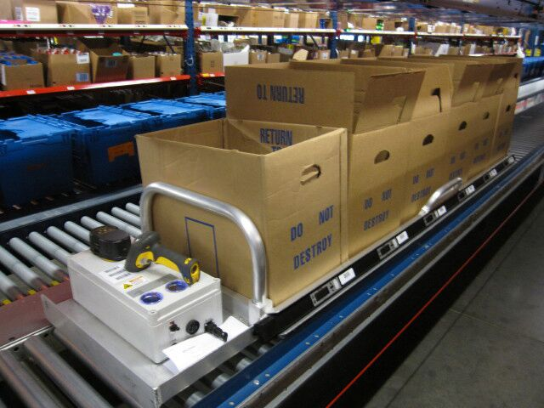A hypothetical real-world system of this kind can be envisioned as shown in Fig 1.

Figure 1: The real-world scenario of the inventory pickup/placement management system.

A basic flow of the activities shown in Fig 2.

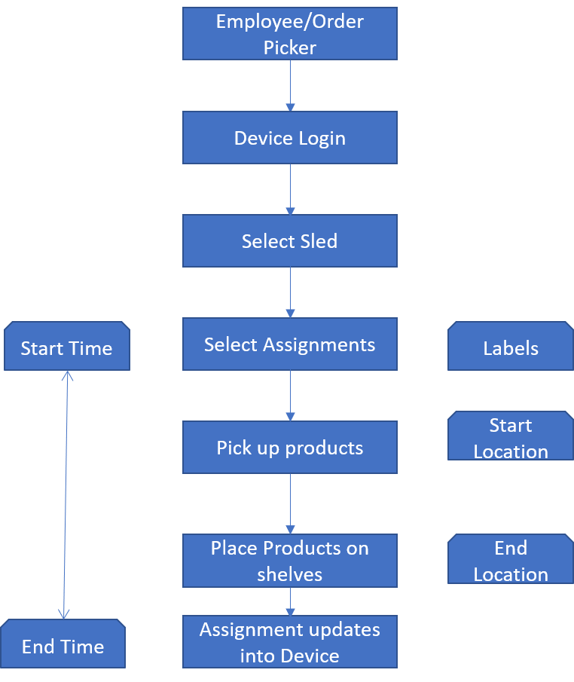

Figure 2: A simplified workflow of the system.

# Architecture

We will follow a simple three-tier Architecture (Fig 3) with a Database Server, Application Server and Client tier.

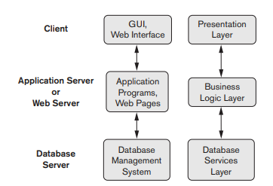

Figure 3: System Architecture

The presentation layer is a simple python program that interacts with the underlying database through an appropriate driver. The business logic is embedded in the python code as a service. The database server is the main focus of this project. We have used a SqlLite (DQLite Home Page, n.d.) database server that contains the internal and conceptual level or schema. The external schema, however, shows the entire mini-world of the order pick up management system. By using a three-schema structure we are ensuring both logical and physical data independence.

# Scopes and Constraints

Our project is restricted to the mini-world of the order pickup management system to meet the above requirements. We used a relational database management system to solve the problems in this project. We utilize DBMS Software specific utilities (like sequence generators etc.) to specify the primary keys. The constraints on the entities and relationships are enforced in the Data Definition Language Script that creates the physical schema. Our effort on the presentation and middle tiers are minimal. We have not addressed any system level performance or scaling issues. Our performance tuning is limited to basic RDBMS indexing, efficient joins, and optimized queries. The constraints are summarized in Table 1.

Table 1: List of constraints

|  |  |  |  |  |  |
| --- | --- | --- | --- | --- | --- |
| EMPLOYEE | Key | Null | | Type | Constraints |
| employee_id | Y | N | int | | 7-digits (range [1000000,9999999] |
| first_name | N | Y | varchar(30) | |  |
| last_name | N | Y | varchar(30) | |  |
| DEVICE |  |  |  | |  |
| device_id | Y | N | int | |  |
| checked_out | N | N | bit | | Default 0 |
| EMPLOYEE_ASSIGNED_DEVICE |  |  |  | |  |
| device_id | Y | N | int | | FK to device.device_id |
| employee_id | Y | N | int | | FK to employee.employee_id |
| SLED |  |  |  | |  |
| sled_id | Y | N | int | | range [1,100] |
| checked_out | N | N | bit | | Default 0 |
| EMPLOYEE_SELECT_SLED |  |  |  | |  |
| sled_id | Y | N | int | | FK to sled.sled_id |
| employee_id | Y | N | int | | FK to employee.employee_id |
| ASSIGNMENT |  |  |  | |  |
| assignment_id | Y | N | int | | 10-digits (range [1000000000,9999999999] |
| batch_num | N | N | int | | 3-digits (range [100,999] |
| store_num | N | N | int | | 5-digits (range [10000,99999] |
| assigned | N | N | bit | | Default 0 |
| completed | N | N | bit | | Default 0 |
| SLED_HOLDS_ASSIGNMENT |  |  |  | |  |
| sled_id | Y | N | int | | FK to sled.sled_id |
| assignment_id | Y | N | int | | FK to assignment.assignment_id |
| TOTE |  |  |  | |  |
| tote_id | Y | N | int | | 10-digits (range [1000000000,9999999999] |
| tote_num | N | N | int | |  |
| ASSIGNMENT_CONTAINS_TOTE |  |  |  | |  |
| assignment_id | Y | N | int | | FK to assignment.assignment_id |
| tote_id | Y | N | int | | FK to tote.tote_id |
| PRODUCT_TYPE |  |  |  | |  |
| product_id | Y | N | int | |  |
| name | N | Y | varchar(30) | | |
| floor_letter | N | N | varchar(1) | | Part of Location PK, must be A, B, C, D, E, or F |
| floor_num | N | N | int | | Part of Location PK, range [1,4] |
| bay_num | N | N | int | | Part of Location PK, range [1,44] |
| col_num | N | N | int | | Part of Location PK, range [5,85] and by 5's (col_num%5 = 0) |
| row_num | N | N | int | | Part of Location PK, range [1,6] |
| TOTE_HAS_PRODUCT |  |  |  | |  |
| tote_id | Y | N | int | | FK to tote.tote_id |
| product_id | Y | N | int | | FK to product_type.product_id |
| n_products | N | N | int | |  |

# Entity Relationship Diagram

We have defined following entities:

1. Device,
2. Employee,
3. Sled,
4. Assignment,
5. Tote,
6. Product_Type.

We have simplified our mini-world in many ways compared to an actual inventory management system. For example, we did not include any cost information, employee’s historic performance records, and any shipment related information.

The Entity-Relationship diagram is shown in Fig 4.

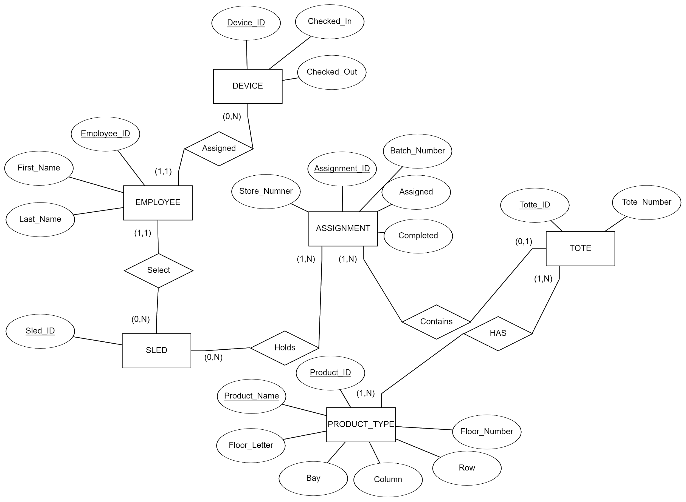Figure 4: Entity-Relationship Diagram for an order pick-up/inventory management system.

The Entity-Relationship diagram has been evolved from our initial set of diagrams through a requirement adjustment, and database normalization process.

We converted multi-valued and composite attributes either into separate schemas or included or mapped them into functionally appropriate entities. As a result, our schema passed first, second, and third normalization tests seamlessly.

# Schema Diagram

The schema diagram is displayed in Fig 5.

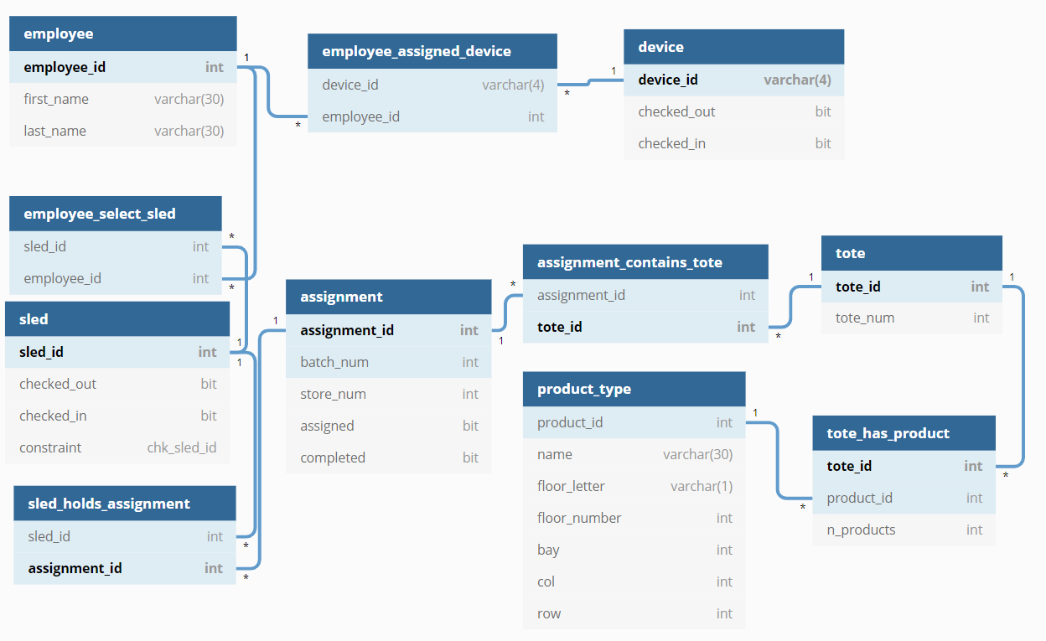

Figure 5: Schema Diagram.

As a next step to create the physical schema using the DDLs, we worked out relational algebra for the core queries (Listing 1).

Listing 1: Relational Algebra for core queries

Before step 1: all employee_ID’s are inputted into EMPLOYEE

1. A. Check if the employee_ID entered is found in EMPLOYEE

σ_Employee_ID = NNNNNNNN (EMPLOYEE)

B. If not found, an error message is displayed

C. Check if the ID entered, isn’t already signed into a device

σ_Employee_ID = NNNNNNNN (ASSIGNED)

D. If employee is already signed into a device, an error message is displayed.

E. If they aren't already signed into a device, then Emplyee_ID and Device_ID are inserted into ASSIGNED

Before step 2: All Sled_ID’s are inserted into SLED

1. A. Check if the ID entered is found in SLED

σ_Sled_ID = <current sled> (SLED)

B. if not found, error message is displayed

Before step 3: will have inserted into ASSIGNMENT

1. A. Check if the ID entered, is found in ASSIGNMENT

σ_Assignment_ID = <current assignment> (ASSIGNMENT)

B. If not found, an error message is displayed.

C. Check if the ID entered isn't already assigned to another sled

σ_Assignment_ID = <current assignment> (HAS)

D. if found, error message is displayed

E. Check if the ID entered is in progress or completed

F. σ_Assignment_ID = <current assignment> (σ_Completed = True (ASSIGNMENT))

G. If found, an error message is displayed.

H. for displaying the number Totes Required, sum of N_Totes for each assignment on the current sled (I'm struggling with the relational algebra on this one, it is fairly complex)

Π_cnt(

I. After each assignment is entered, insert Assignment_ID and Label into CONTAINS. If CLEAR is pressed, delete from CONTAINS (this will update the number Totes Required as assignments are entered or cleared).

Before step 4: all Product_IDs are inserted into PRODUCT

1. Each part of the pick display will come from the database

A. Each sled hold 1-6 assignments, the pick page displays each product and its quantity

B. matching TOTE_HAS_PRODT that each ASSIGNMENT CONTAINS by LOCATION.

C. If there are less than 6 assignments on a sled, the remaining assigned slots are filled with empty boxes

D. The number in each box is derived from the count of PRODUCTS of the same Product_Type that TOTE has (TOTE_HAS_PROD)

E. After the pick is complete assignments are automatically updated and dropped from SLED (deleted from HAS relationship between sled and assignment)

# Database Security

The most basic front security measure used is an employee ID. The ID consists of 7 numbers. The ID is needed in order for an employee to log in to a device. The log in security measures are as follows, the employee cannot access a device if the employee’s ID is not already in the system, the employee cannot log in to a device if they are already logged into another device. Employees will not be able to access the company database unless they are on a local company server. Once employee ID’s are entered, the ID’s will be encrypted and hashed in order to prevent data decryption and plain text storage in our database. All employee ID’s will be encrypted using the **aes_encrypt(‘employee_ID’, ‘key1234’)** function. The usage of this Advanced Encryption Standard (AES) (Akash & Beniwal, 2020) ensures employee_ID’s cannot be displayed in our database. The function will change the input into random numbers, letters, and symbols. For Sql Injection defense, our database uses access limitations to only allow certain employees to access employee tables and employee data. The database also uses escape code to prevent malicious input**: Employee_id = 'something' Employee_id = Employee_id.replace("'", "\\'").**Our database also uses a secure backup to make sure no data is lost and use connectors to mitigate any damage done if the application is breached. Using a connector can help limit the access to data if there was a malicious data breach. This way we can store important data outside of our breached application and prevent further damage.

|  |  |
| --- | --- |
| Login Input | Login Output |
| 346366 | “Employee_ID must be 7-digit number. Please try again.” |
| 45256A2 | “Employee_ID must be 7-digit number. Please try again.” |
| *Employee is logged into another device | “Error: This Employee_ID is already associated with another device. Please log off other device and try again.” |
| 3915663 | *Employee successfully enters system and proceed to the next step of sled selection |
| SQL injection: 3915663’  Escape code: 3915663//’ | “Employee_ID must be 7-digit number. Please try again.” |

|  |  |
| --- | --- |
| Employee ID Input | Employee ID Input After Encryption |
| 3463674 | A@e5$20%4fv$gb4# |

In our AWS/Java implementation of the MySql/JDBC based implementation, preparedstatement interface has been used to prevent SQL Injection attacks and the user credentials are retrieved from a configuration file (Fig 6).

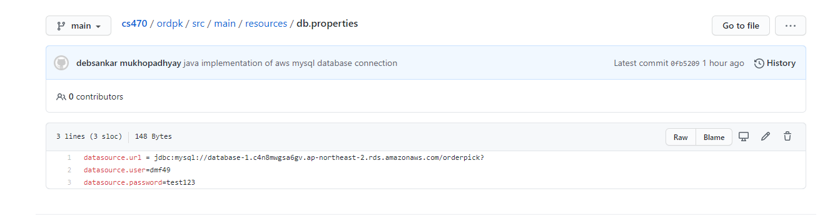

Figure 6: Java/JDBC/AWS MySql implementation configuration file is storing the credentials.

# User Interface and Associated SQL Queries

While we have not implemented a full-scale web or visual application, we have designed the application and the SQL Queries needed to extract the information from our database tables. The login page passes the employee_id into the database. A schematic diagram of the login page is shown in Fig 7.

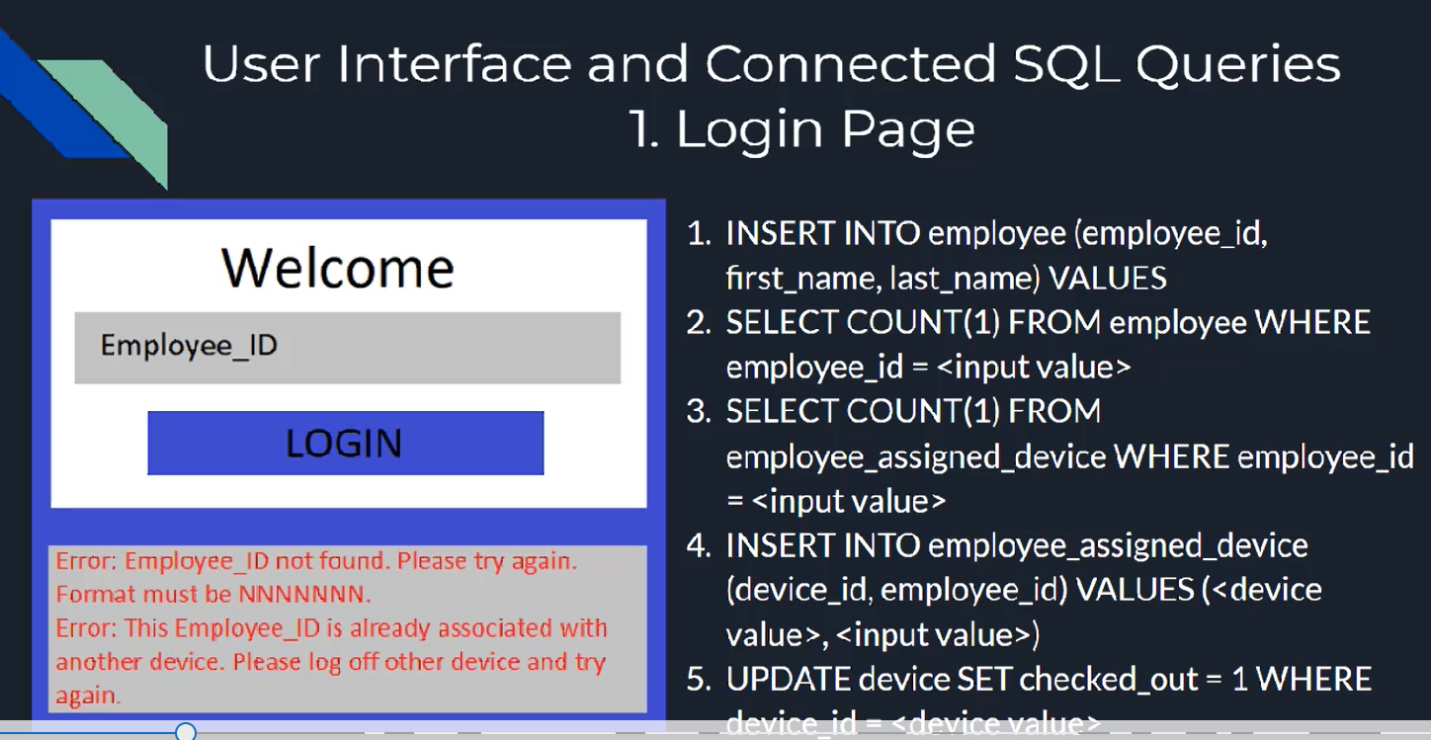

Figure 7: Login page and associated queries.

Once an employee logs into the device, we move on to the sled selection which is similar to login in terms of validating the inputs, updating the database and providing an option to the employee to logoff from a device. This is represented in Fig 8.

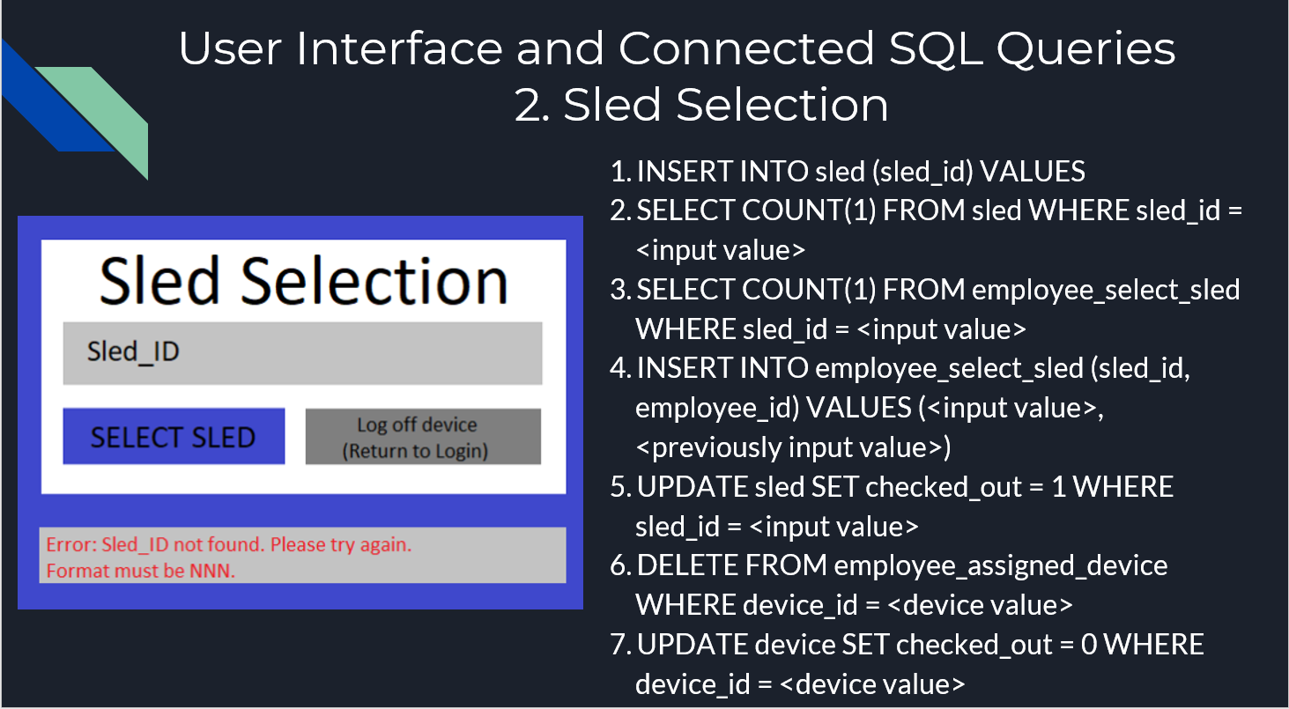

Figure 8: Sled Selection UI and Queries

Once the sled selection is completed, the workflow leads us to assignment selection. The associated queries are shown in Fig 9.

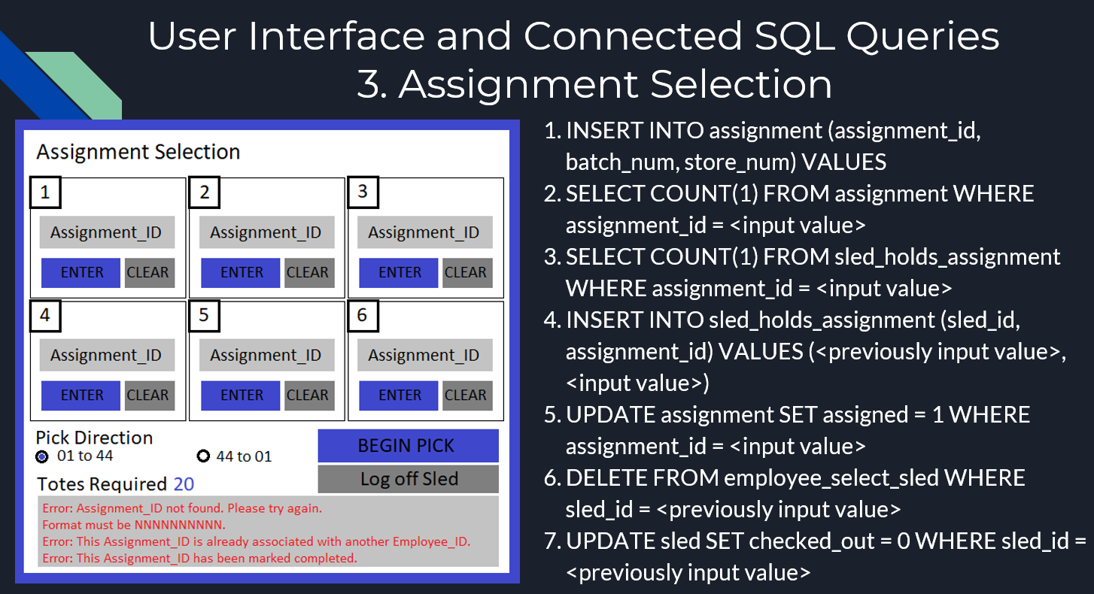

Figure 9: Sled Selection UI and queries.

Once “Begin Pick” is clicked, the Pick Pages will be displayed (Fig 10). The right-hand side shows an employee’s view of the pick page with four products in it and six small boxes represent the assignments. Once all the products are picked on that page, the employee can navigate to the next page or may go back to the previous page for any edit actions.

A comprehensive description of the UI Design and related SQL Queries are available in our project’s GitHub repository (2020).

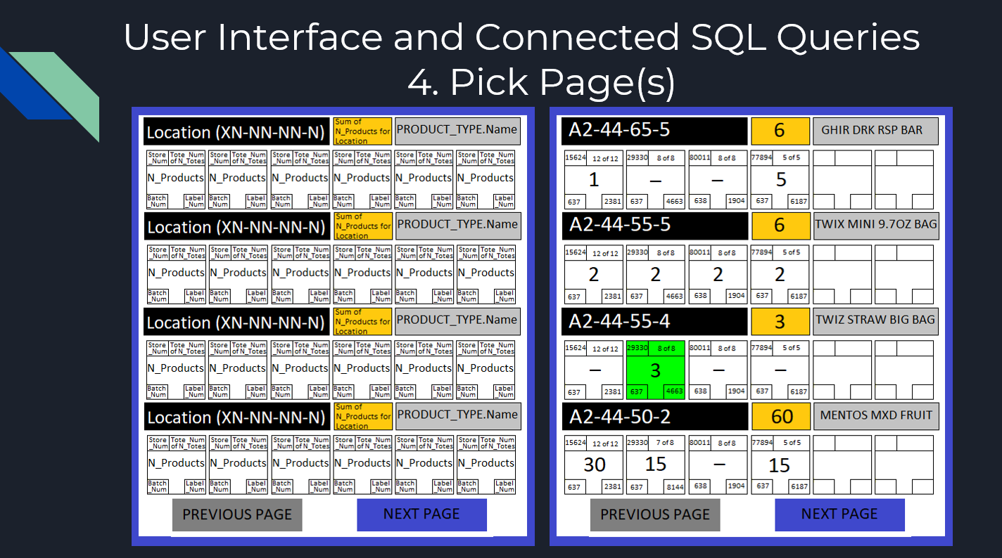

Figure 10: Pick pages.

# Test Cases and Logs

The test cases are derived out of the constraints for the tables in the database. We will divide the test cases in three categories: (a) Insert, (b) Update, and (c) Delete.

We shall reuse Table 2 (table of constraint) to create our testing log. We shall attempt to insert/update a value of a column violating its domain constraint first. For example, we can try to enter an eight digit number for employee_id or an alphanumeric value for that field, both of which will violate its domain constraint. So, each of these criteria will give us a valid test case. We can also test the integrity constraint by setting a table’s primary key NULL or a duplicate value for the primary key to construct the test cases for entity integrity constraint. We can try to violate a referential integrity by deleting a row from a table which may have its primary key to have a relationship with a foreign key in another table. In that case, our test cases will show failure due to referential integrity violation. We may also try to enter or update the duplicate keys that are supposed to be unique. In that way, we will violate the key constraint. We shall test each of these scenarios too in our test cases. Finally, we shall simulate a SQL Injection attack from our front-end to verify that our queries are protected against such attack.

Table 2: Test Cases and Logs

|  |  |  |  |  |  |  |
| --- | --- | --- | --- | --- | --- | --- |
| EMPLOYEE | Key | Null | Type | Constraints | Expected  result when Entered a value violating the constraints | Expected  Result when enter a  value satisfying  the constraint |
| employee_id | Y | N | int | 7-digits (range [1000000,9999999] | Failure | Success |
| first_name | N | Y | varchar(30) |  |  |  |
| last_name | N | Y | varchar(30) |  |  |  |
| DEVICE |  |  |  |  |  |  |
| device_id | Y | N | int |  |  |  |
| checked_out | N | N | bit | Default 0 |  |  |
| EMPLOYEE_  ASSIGNED_DEVICE |  |  |  |  |  |  |
| device_id | Y | N | int | FK to device.device_id |  |  |
| employee_id | Y | N | int | FK to employee.employee_id |  |  |
| SLED |  |  |  |  |  |  |
| sled_id | Y | N | int | range [1,100] |  |  |
| checked_out | N | N | bit | Default 0 |  |  |
| EMPLOYEE_  SELECT_SLED |  |  |  |  |  |  |
| sled_id | Y | N | int | FK to sled.sled_id |  |  |
| employee_id | Y | N | int | FK to employee.employee_id |  |  |
| ASSIGNMENT |  |  |  |  |  |  |
| assignment_id | Y | N | int | 10-digits (range [1000000000,9999999999] |  |  |
| batch_num | N | N | int | 3-digits (range [100,999] |  |  |
| store_num | N | N | int | 5-digits (range [10000,99999] |  |  |
| assigned | N | N | bit | Default 0 |  |  |
| completed | N | N | bit | Default 0 |  |  |
| SLED_HOLDS_  ASSIGNMENT |  |  |  |  |  |  |
| sled_id | Y | N | int | FK to sled.sled_id |  |  |
| assignment_id | Y | N | int | FK to assignment.assignment_id |  |  |
| TOTE |  |  |  |  |  |  |
| tote_id | Y | N | int | 10-digits (range [1000000000,9999999999] |  |  |
| tote_num | N | N | int |  |  |  |
| ASSIGNMENT_  CONTAINS_TOTE |  |  |  |  |  |  |
| assignment_id | Y | N | int | FK to assignment.assignment_id |  |  |
| tote_id | Y | N | int | FK to tote.tote_id |  |  |
| PRODUCT_TYPE |  |  |  |  |  |  |
| product_id | Y | N | int |  |  |  |
| name | N | Y | varchar(30) | |  |  |
| floor_letter | N | N | varchar(1) | Part of Location PK, must be A, B, C, D, E, or F |  |  |
| floor_num | N | N | int | Part of Location PK, range [1,4] |  |  |
| bay_num | N | N | int | Part of Location PK, range [1,44] |  |  |
| col_num | N | N | int | Part of Location PK, range [5,85] and by 5's (col_num%5 = 0) |  |  |
| row_num | N | N | int | Part of Location PK, range [1,6] |  |  |
| TOTE_HAS_  PRODUCT |  |  |  |  |  |  |
| tote_id | Y | N | int | FK to tote.tote_id |  |  |
| product_id | Y | N | int | FK to product_type.product_id |  |  |
| n_products | N | N | int |  |  |  |

# Deficiencies

Due to the learning organization structure in our project, we have designed a system in parallel with our educational evolution in the course. So, the first deficiency, is that our project execution did not structurally include the serialized processes deemed as best practices to avoid poor designs (Mmekut, 2018). The database design did not include any purchase and sell accounting system. There was no way to define a purchase system. The purchase system, in theory, could be accomplished by extending the product_type entity. The inventory placement could be categorized by departments and zones of the stores. In the original requirements, that was specified through the labels. In our design, we simplified it with an assumption that the products are placed on certain bays, floors, rows and columns. So, this design may not be scalable for a big store or warehouses. We have not included any option to shipments and receiving processes. That will prevent our system to be easily integrated with a logistic system.

# Future Scope

**AWS Implementation**

We have used a free AWS tier for doing a proof of concept for a mysql database server implementation (Fig 11).

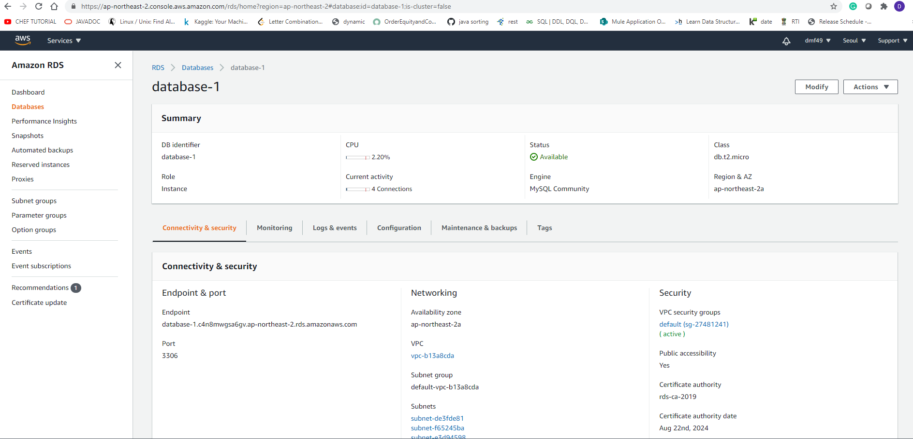

Figure 11: AWS Free Tier RDS dashboard for MySql instance

We have connected to the AWS Mysql RDS instance using a local Sql Developer IDE using following connection parameters:

**Endpoint & port**

Endpoint: database-1.c4n8mwgsa6gv.ap-northeast-2.rds.amazonaws.com

Port: 3306

Once connected, we have implemented a Java code to connect to that database and utilize JDBC’s “PreparedStatement” interface to determine the number of a given product on a Tote with information of the store number and whether that has been assigned to anyone. A reference implementation can be found in our project’s GitHub repository (Foley, Nelson, & Mukhopadhyauy, 2020).

It is to emphasize that we have used a PreparedStatement interface in our Java code to pass the parameters to the database. This process is adapted to prevent any sql injection (Fig 12).

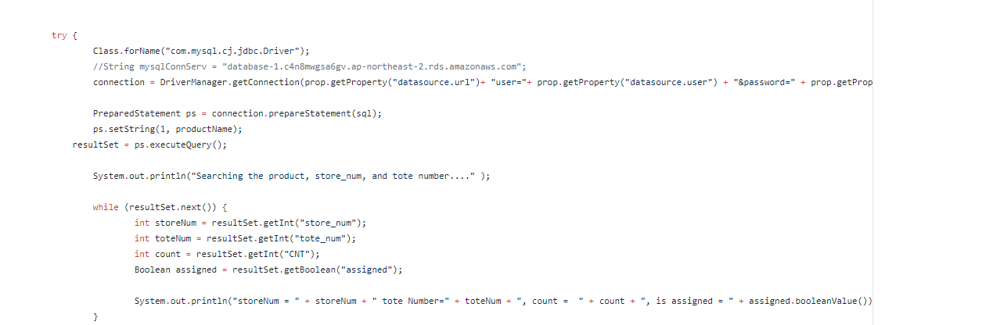

Figure 12: Code snippet showing jdbc connection handling to prevent SQL Injection.

RDS utility in AWS comes with features to create regular backup of our database. AWS identifies backups as snapshots. We have created a manual data backup or manual snapshot as shown in the screenshot in Fig 13-14.

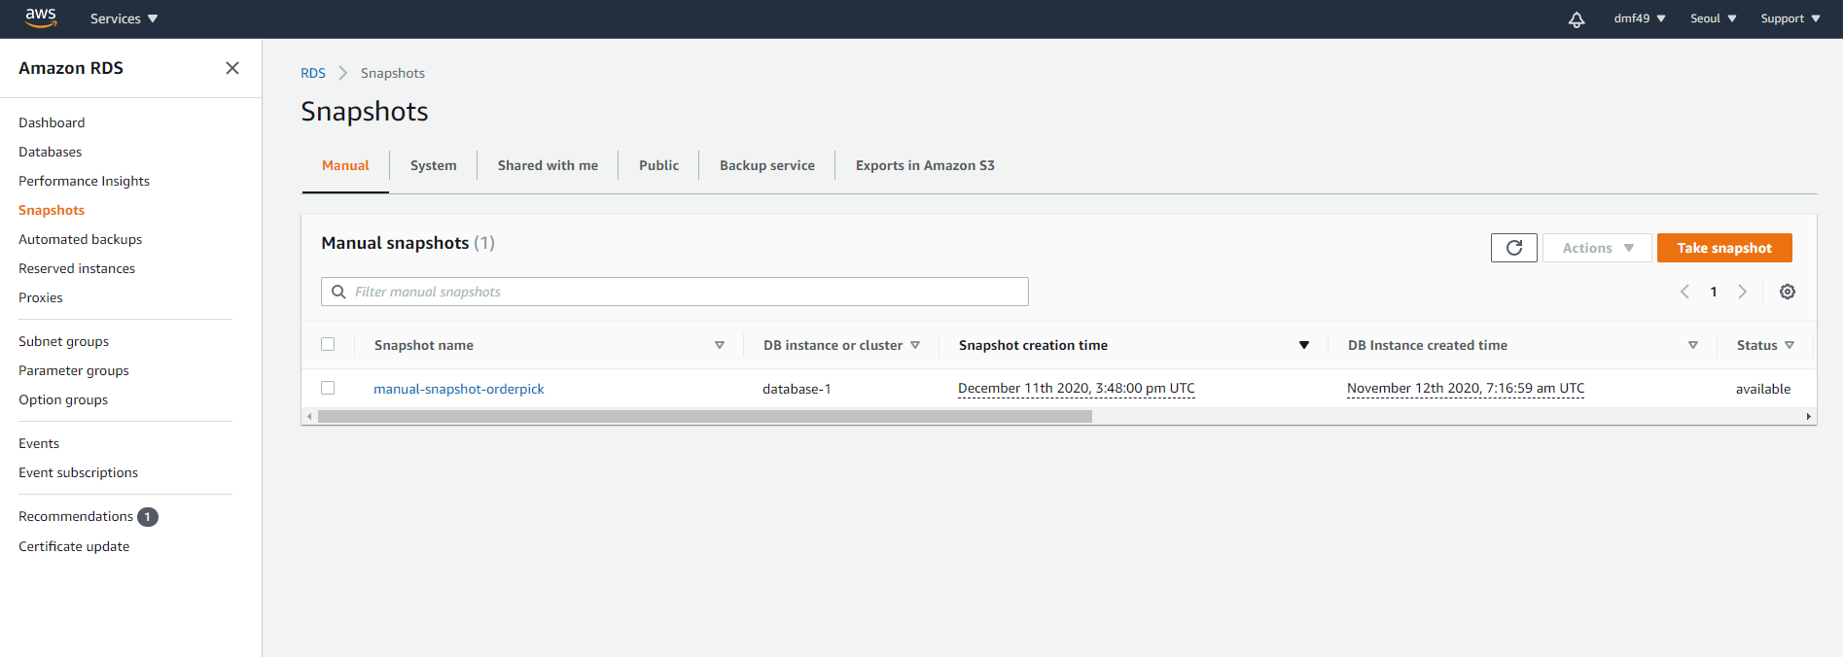

Figure 13: Database backup at the AWS.

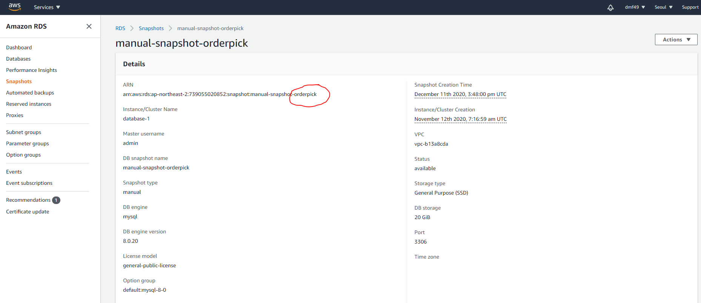

Figure 14: Backup details

**Functional Opportunities**

We have opportunities to extend our current design to include departments, register locations, inventory purchase and sell systems. We will need to identify the possible relational aspects with those entities with the currently included entities. It may be meaningful to expand the integrability of this schema by defining possible relation tables with potential entities available for integration in future. We will have opportunity to extend the current schema to NoSQL type of design to accommodate scalable analytics development.

# Summary and Conclusions

We have implemented a relational database representing an inventory control and order fulfillment workflow using the principles of Database Management System Design. We established the Entity Relationship Diagram based on the requirements. The Entity Relationship diagram was translated into the logical database schema using the principles of database normalization. Two implementations of the physical schema has been accomplished. Our detail study was focused on a physical schema on a SQLite server while we established our footprint into the AWS RDS system using a free tier by creating and implementing a MySql database schema. We established our data security with AES Algorithm and using a config file with JDBC Connection schemes (for AWS/Java). We presented processes to prevent SQL Injection attacks by using escape codes, and PreparedStatement interface for JDBC (for AWS/Java implementation). Our front-end successfully demonstrated the details of the order pickup processes fulfilling the underlying workflows. The proof-of-concept implementation of AWS MySql database with a nominal Java front end successfully extracted a report of the products. Our future outlook involves extension of the design to integrating other layers of the inventory system, and extending the AWS implementation to a visual web based front end with a RESTful service layers for the business services and rules.

# References

(2020, December 11). Retrieved from https://github.com/dmf49/cs470/blob/main/User%20Interface%20Front%20End%20Design%20and%20SQL%20Queries.docx

Akash, & Beniwal, D. (2020). ENHANCEMENT IN AES ALGORITHM. *International Research Journal of Engineering and Technology (IRJET), 7*(4), 1435 - 1439.

*DQLite Home Page*. (n.d.). Retrieved from https://www.sqlite.org/index.html

Foley, E., Nelson, C., & Mukhopadhyauy, D. (2020, December). Retrieved from https://github.com/dmf49/cs470

Mmekut, E. (2018, October 8). *How To Avoid Poor Design /Planning In Database Design*. Retrieved from https://medium.com/@mmekutmfonedet/how-to-avoid-poor-design-planning-in-database-design-798fa606fb31