1. Design: Class Diagram

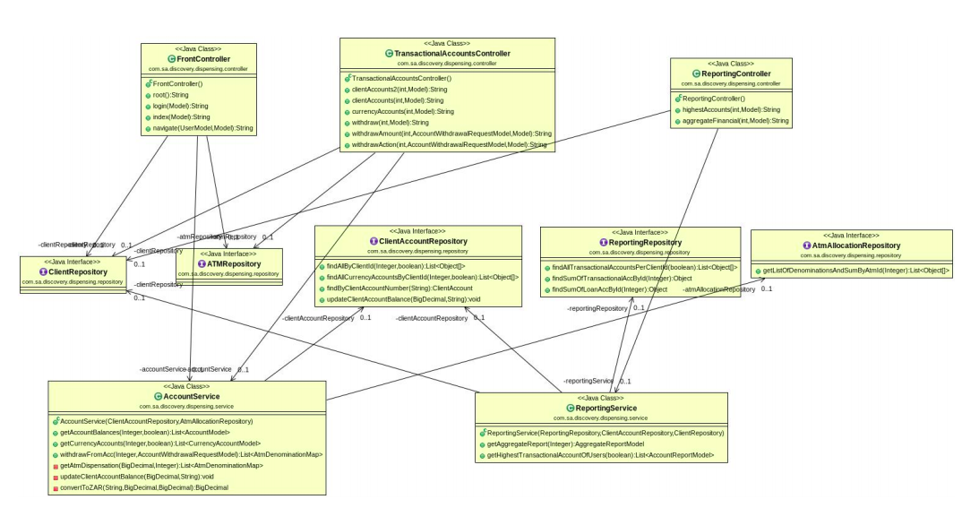

1. Run using docker:

docker run -p 8080:8080 dineshmetkari/bankbalancedispensing:1.0

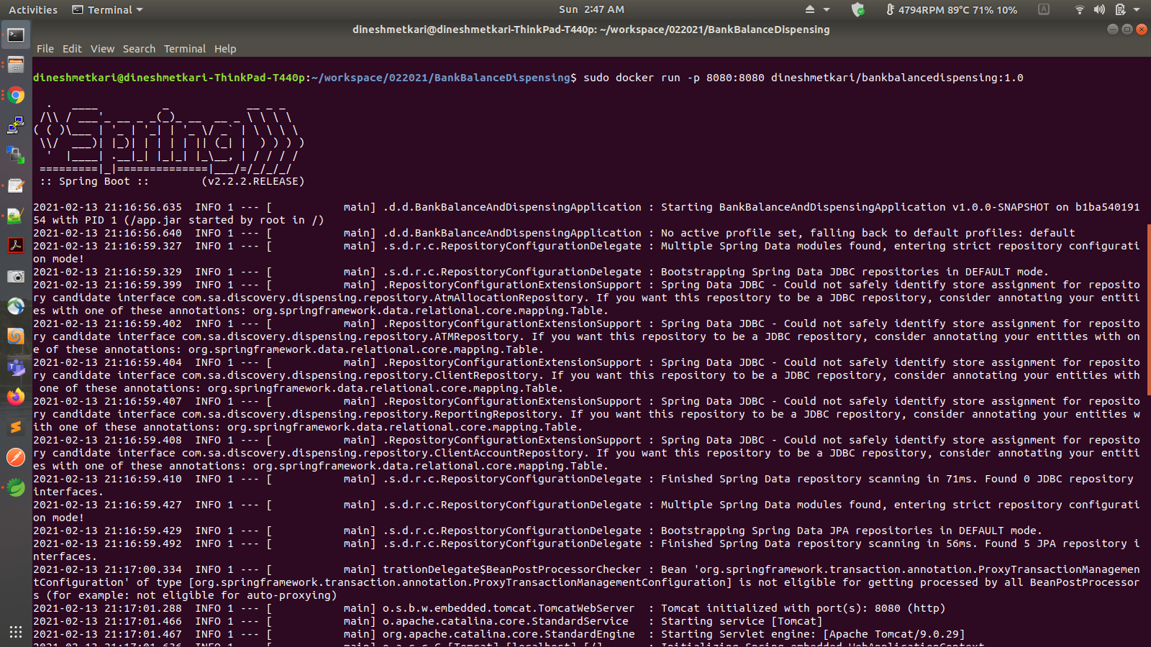

1. Run using Gradle

gradle clean build bootRun

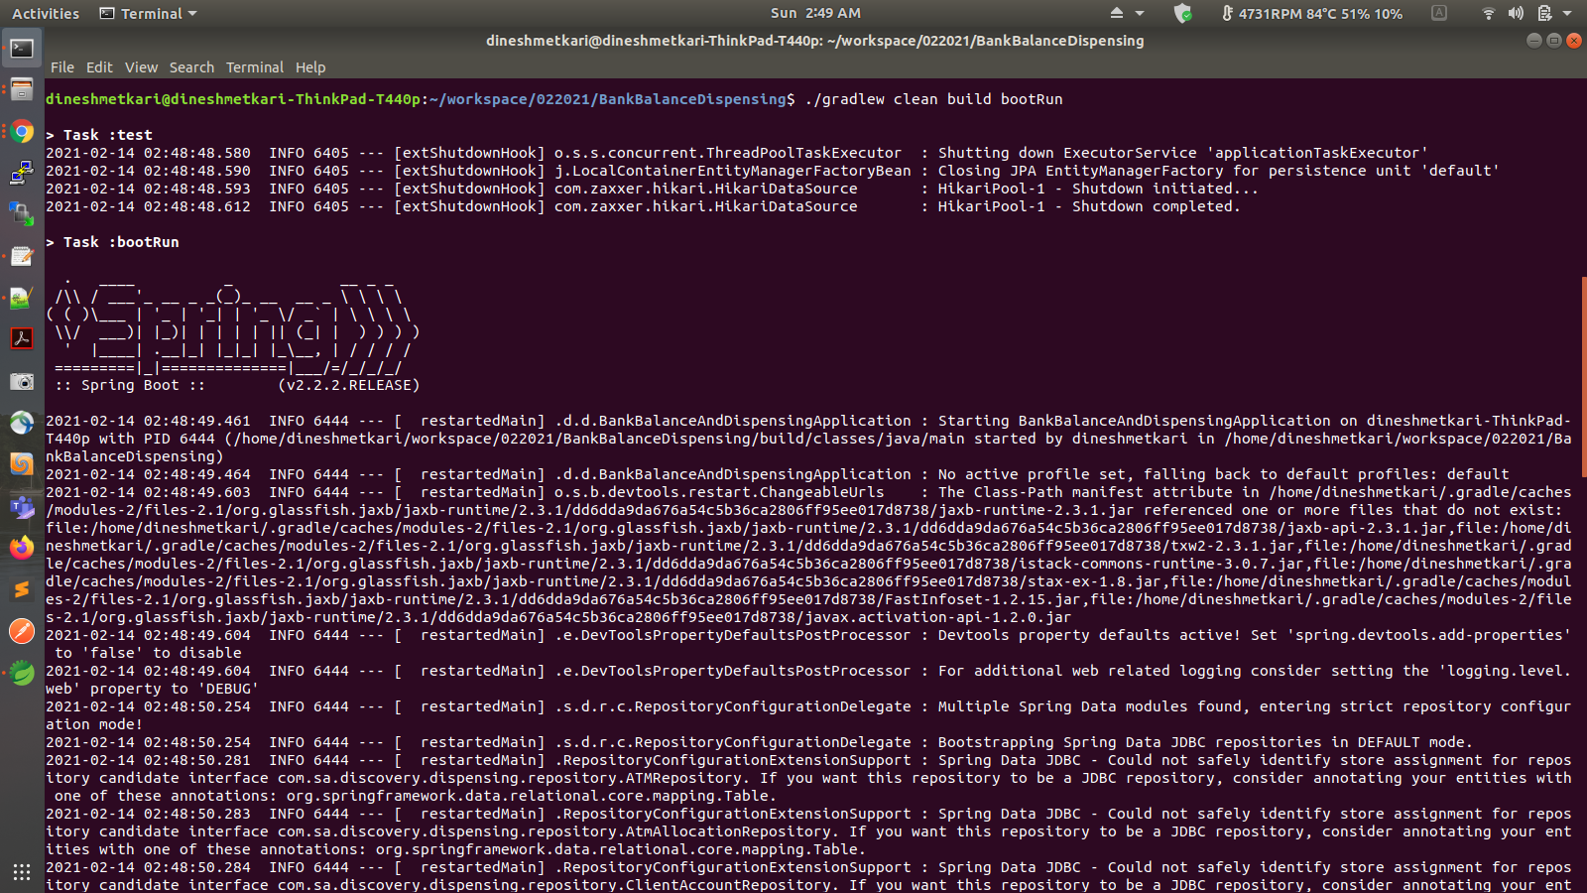

1. Run using Maven

mvn clean install spring-boot:run

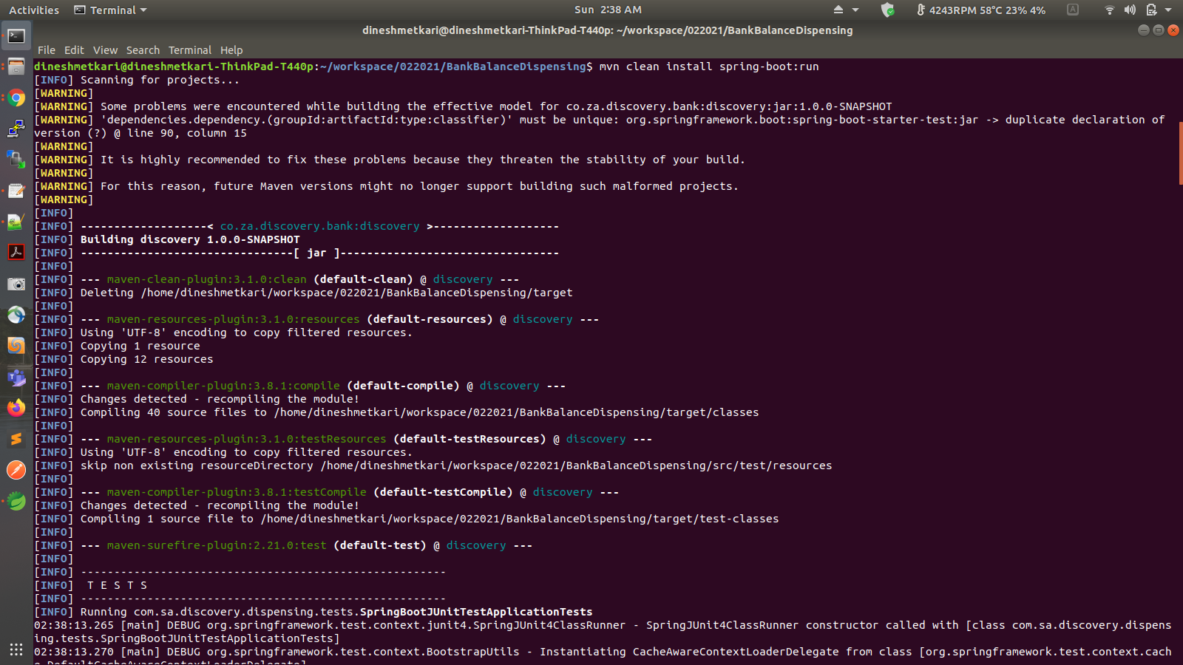

1. Swagger-UI

http://localhost:8080/swagger-ui.html

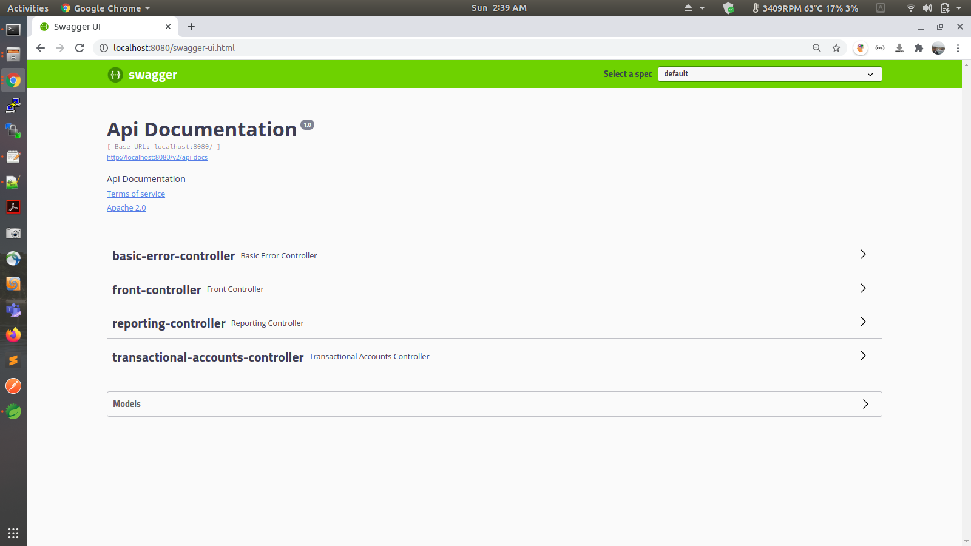

1. Main application:

http://localhost:8080/

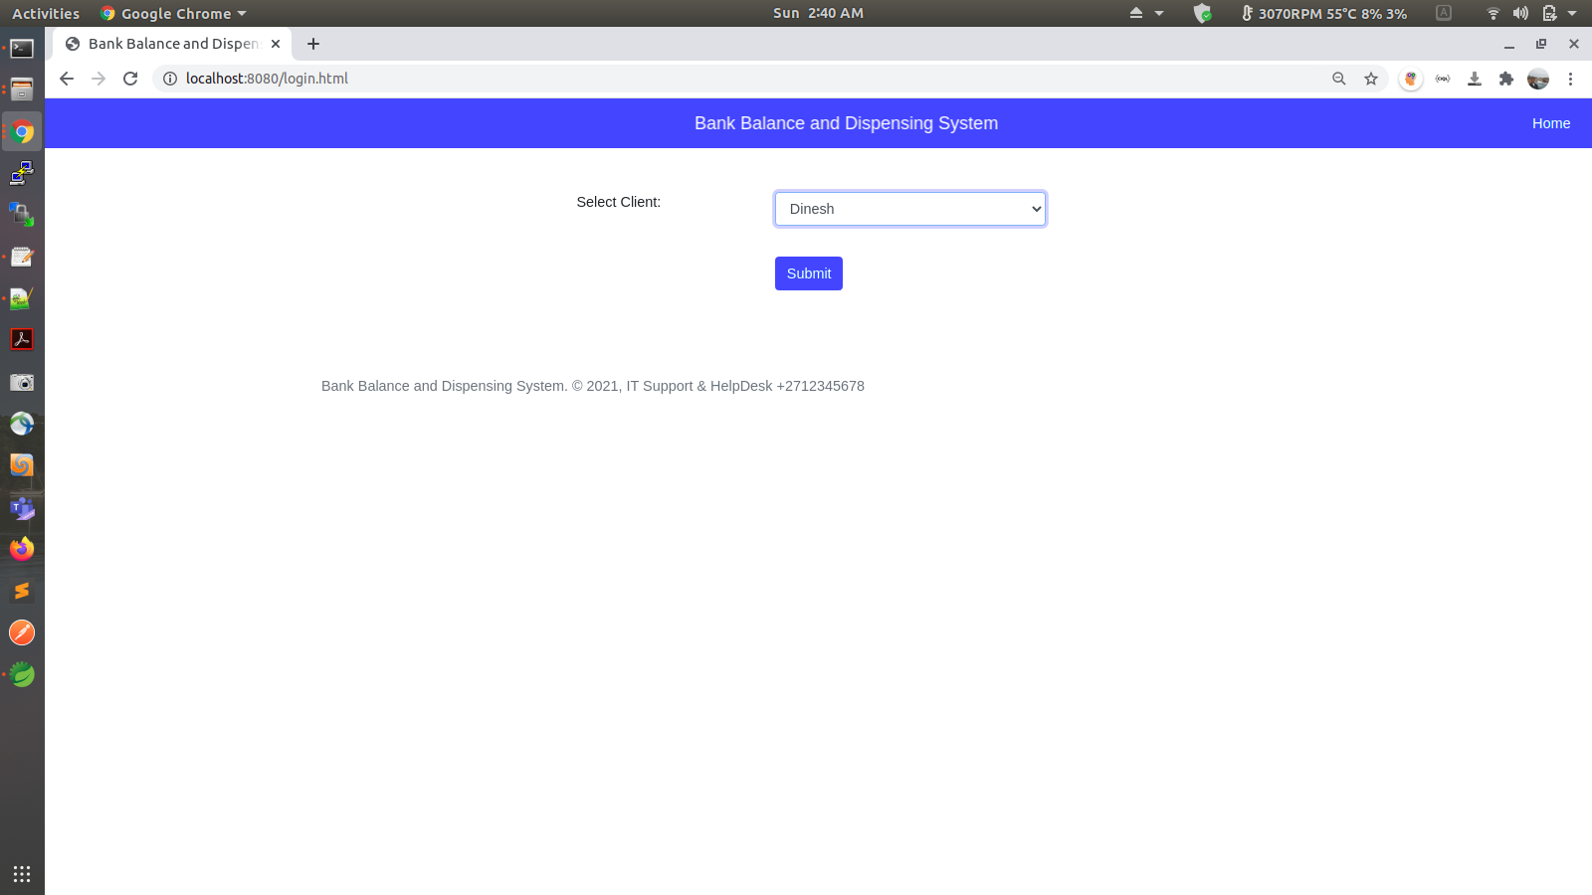

1. Transaction Account Balances

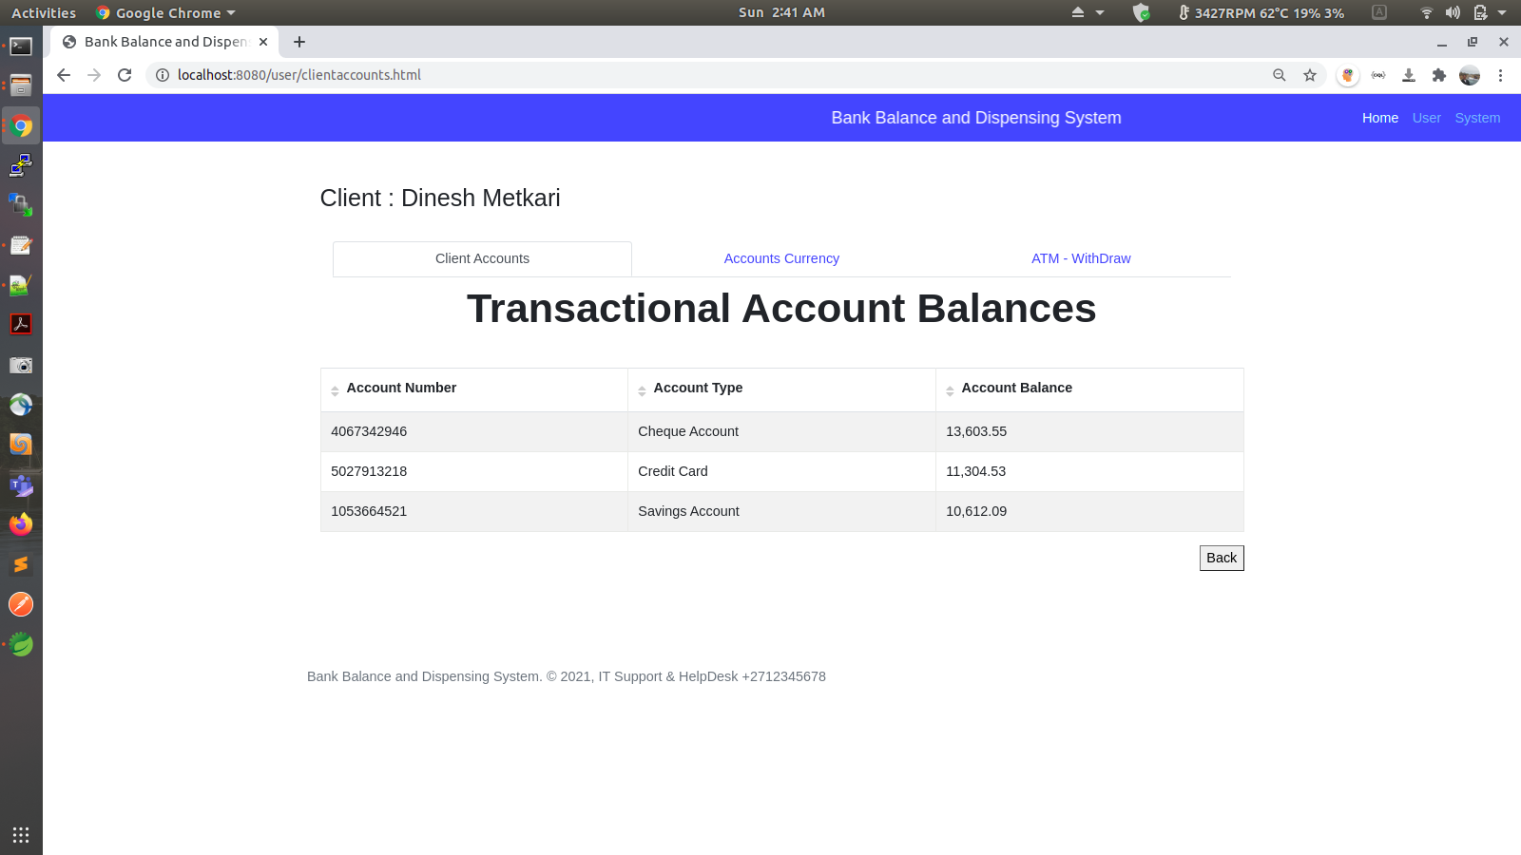

1. Currency Account Balances

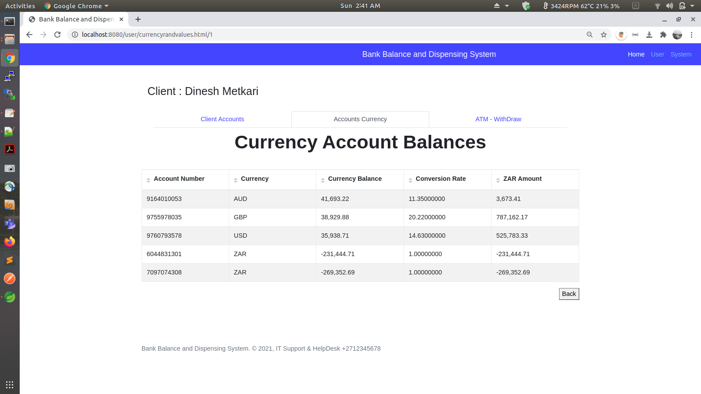

1. Withdraw from ATM

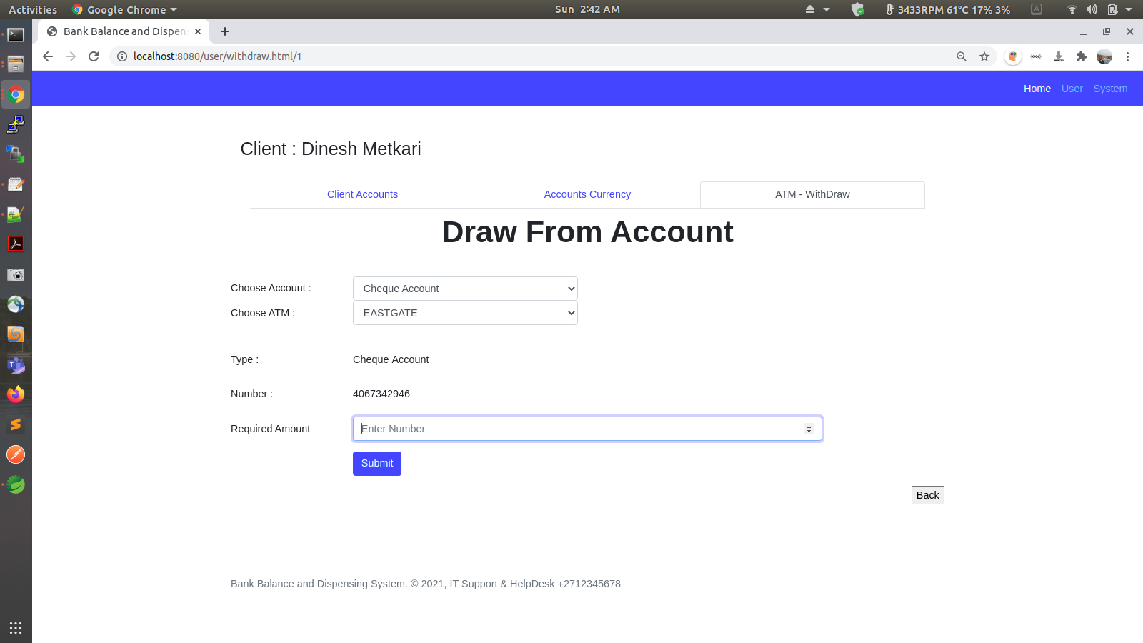

1. Draw from Account: Success

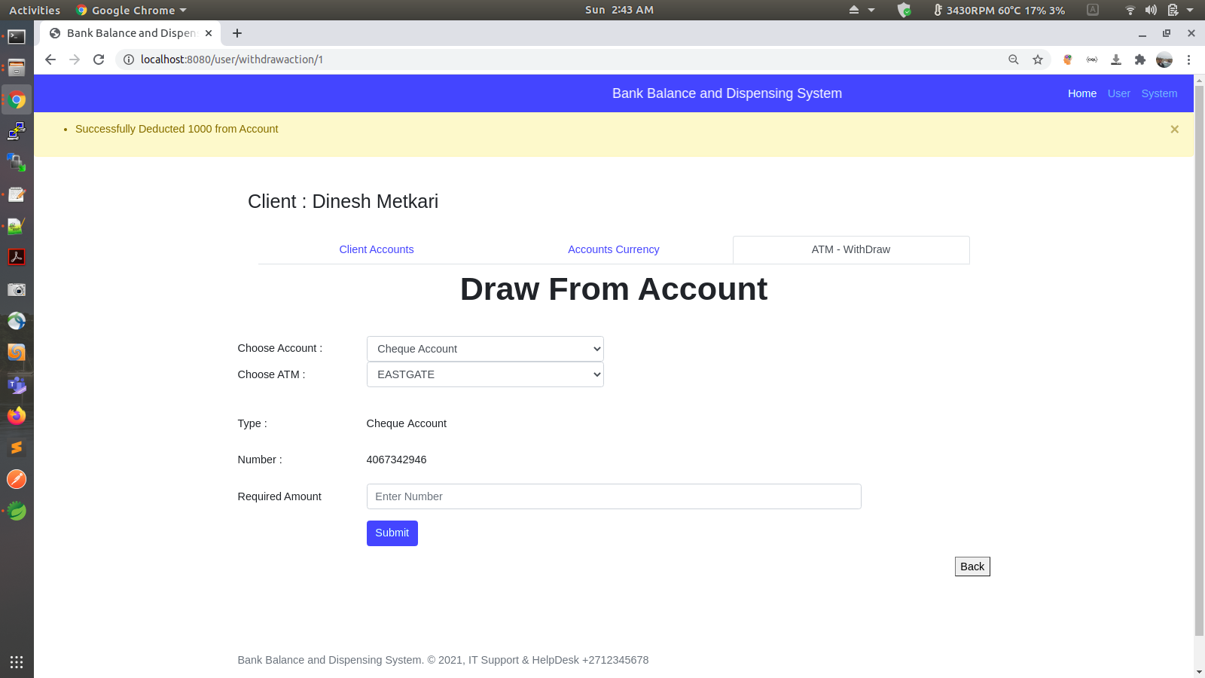

1. Reporting: Highest Accounting

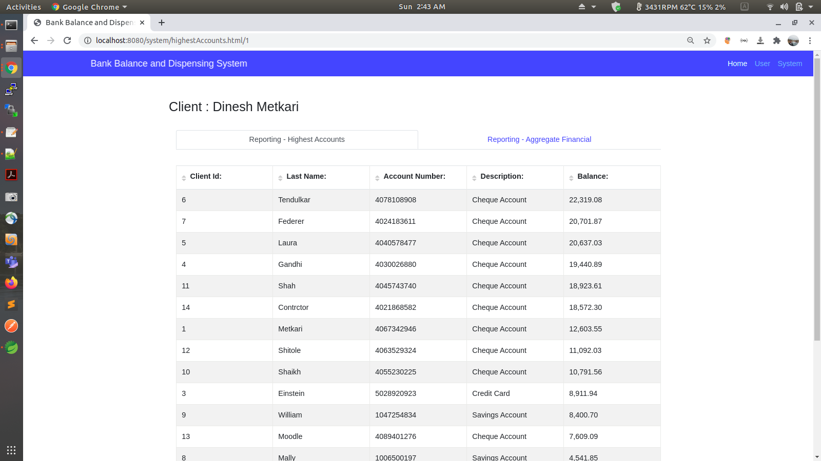

1. Sorting Column: Ascending

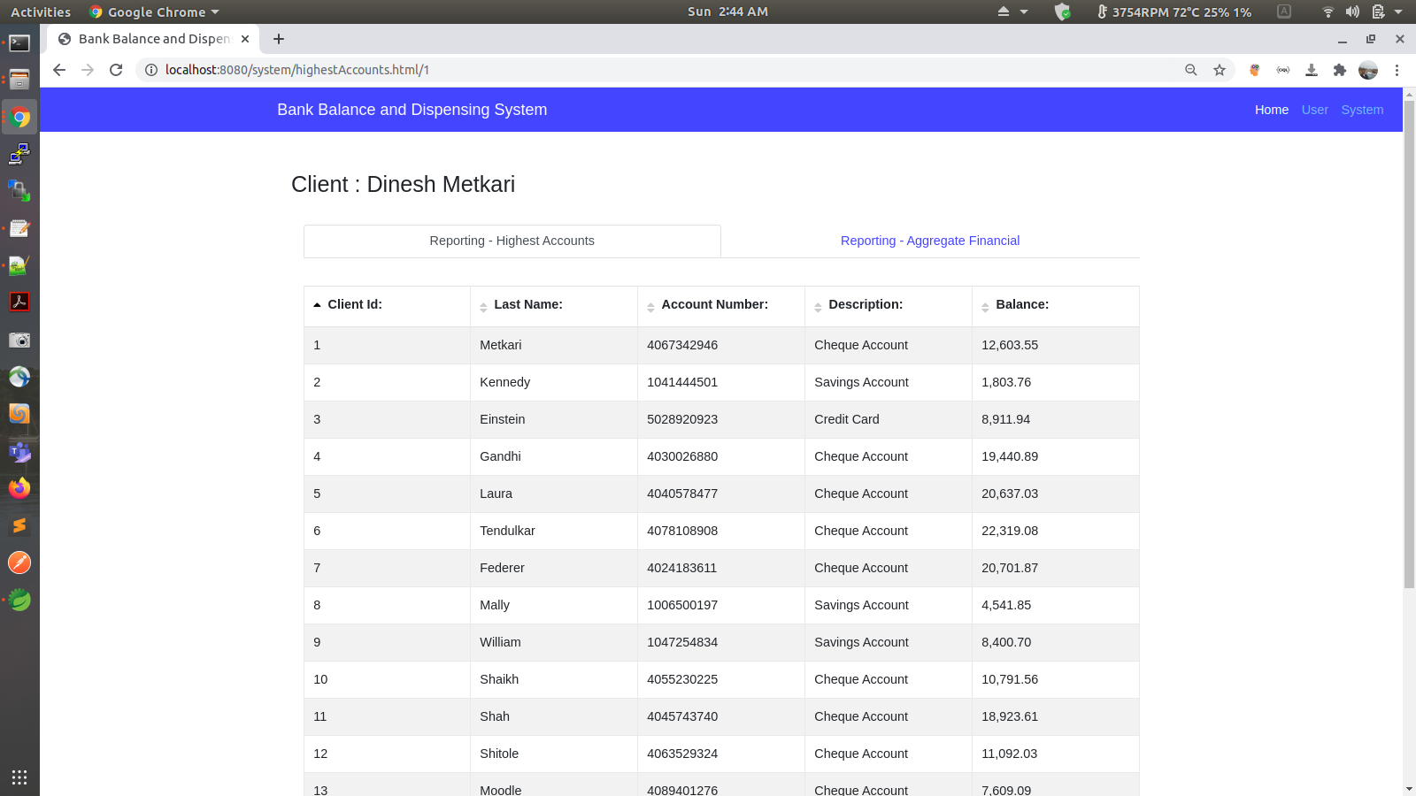

1. Sorting Column: Descending

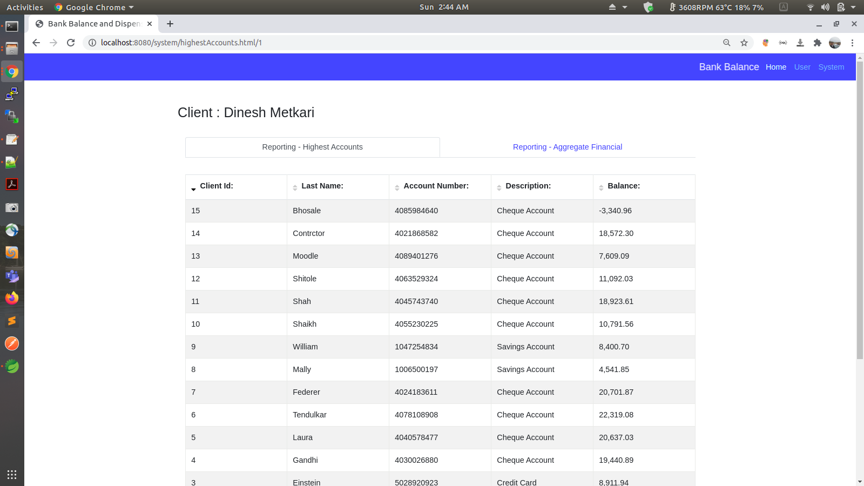

1. Reporting: Aggregate Financial

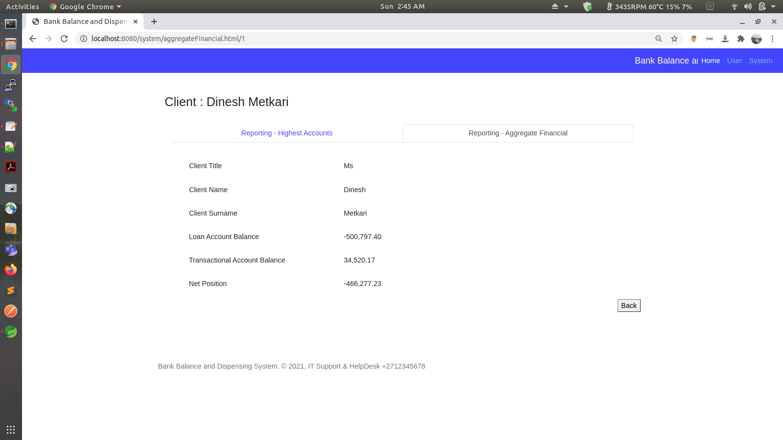

1. Generated Java Documentation

