* 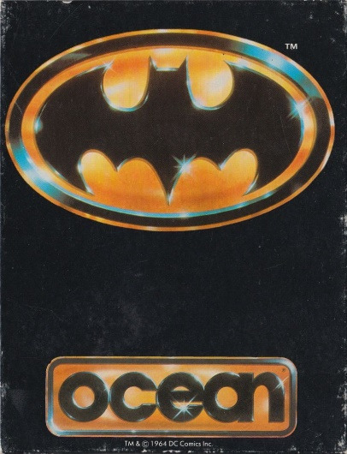**Description**

Based on the 1989-Batman movie. The game consists of five different parts, each resembling well known game types. Part one, the chemical plant: Hunt down Jack Napier who has raided the plant (typical platform action, climb ladders or use "Bat"-rope and shoot at some enemies...). Part two, "Batmobile" (...the car): Joker is chasing you and have to escape to "Bat"-cave. Avoid obstacles like police blocking the road and others. Part three, "Bat"-cave: A puzzle game where you have to find a certain item (belonging to Joker) amongst other items. Part four, "Batjet": Cut the ropes of the balloons which are filled with poisonous gas. Part five, the cathedral: Hunt down Joker. This part plays like the first one. Finally you will confront Joker

* 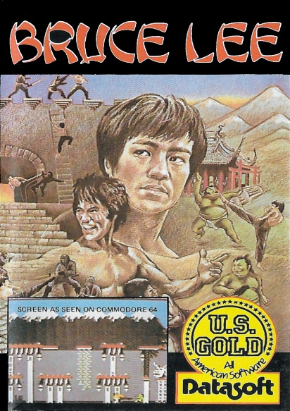**Description**

The late martial arts hero features in this platform game, with the aim of reaching a wizard in an underground lair, defeat of whom can offer him untold wealth.   
In each area you must collect the many strategically-placed lanterns before exiting through the newly-revealed passageway. Some rooms also have escalator-type sections to run along, and the standard (although slightly illogical in this context) ladders. There are 20 areas to be completed.  
On the way, you'll fight two enemies - a ninja and a green sumo warrior named Yamo. You can defeat them by punching, kicking, dropping on their heads or luring them into hazardous terrain, or even by making them accidentally hit each other. Even after they are killed, however, they keep coming back for more after a few seconds. The game also allows a second player to take control of Yamo.  
There are lots of hazards to avoid by either walking round or jumping - walls of electrical charge and exploding bushes for example.

* **Description**

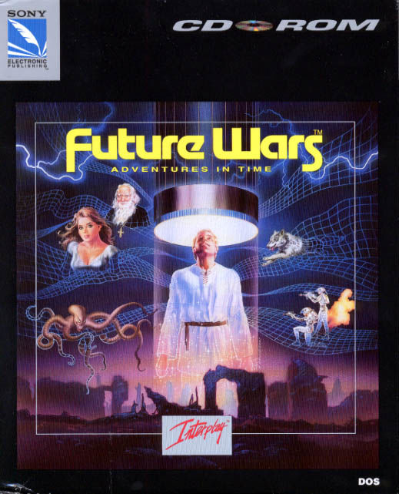In the year 1989, a simple window cleaner is working outside of a skyscraper. Intending to play a prank on his angry boss, the unlikely hero discovers a secret passage leading to a time machine along with mysterious alien documents. Operating the device transports the protagonist to the year 1304, where he is given a seemingly ordinary task of rescuing a lady in danger. However, he soon finds out about a much more serious threat of a global alien invasion. The hero has to travel to the remote future of the 44th century and eventually to the even more remote past of the Cretaceous period to foil their plans. *Future Wars* is a graphic adventure game, and the first to use Delphine's proprietary *Cinematique* point-and-click interface. A right click brings up the verb menu. After choosing one of the six commands, the player points the mouse over the desired target and executes the action with a left click. Small objects are depicted by enlarged drawings once they have been discovered; however, many of them are well-hidden and often require precise positioning on the part of the player character to discover. The game has a linear story advancement, and it is possible to die or become irrevocably stuck by failing to locate a crucial item in one of the previous locations.

* 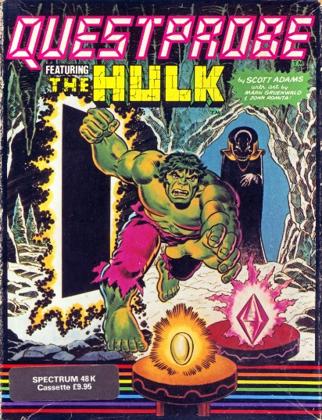**Description**

1st in the Questprobe Marvel Comics series. Play Bruce Banner and the Incredible Hulk through this interactive fiction game with graphics. You awake as Banner, tied by ropes to your chair in a bunker in the desert; once you free yourself, collect all the gems to escape this hellhole.

* **Description**

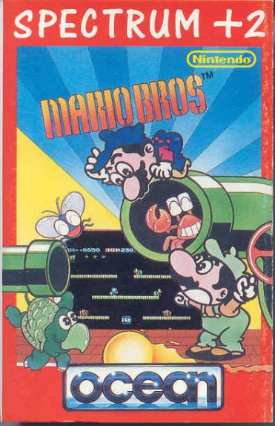Mario and Luigi, the best plumbers in the world, have a real job on their hands. A host of characters have taken over the sewers, and the brothers must clear them out of the pipes.  
  
The platform puzzle which first introduced Luigi to the world has both single and multiplayer action with two differing game types, but with the same objective. Crabs, turtles and fighter flies must be cleared out by jumping underneath the platform they sit on, then kicking them away. Each level is cleared when a set number of coins is collected.  
For the two player mode, the first to collect the set amount of coins wins.

* **Description**

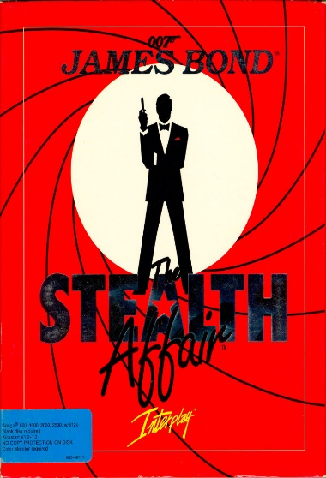*The Stealth Affair* is a graphic adventure game with a point-and-click interface. The player controls the famous secret agent James Bond (John Glames in the European version), whose task is to travel to South America in order to locate and retrieve a newly designed F-19 stealth plane, which was stolen from the Naval Air Station in Miramar, California.   
  
it's been slightly improved and does now allow interaction with the inventory, like examining and combining items. The player can use many typical special agent's gadgets, beginning with a passport forgery kit and ending with explosive cigarettes. Apart from solving puzzles, the player has to make it through some arcade sequences: escape the labyrinth, dive with limited breath, and dodge the evil guy's minions.

**Comodore 64**

The Commodore 64, also known as the C64 or the CBM 64, is an 8-bit home computer introduced in January 1982 by Commodore International (first shown at the Consumer Electronics Show, in Las Vegas, January 7–10, 1982). It has been listed in the Guinness World Records as the highest-selling single computer model of all time, with independent estimates placing the number sold between 10 and 17 million units. Volume production started in early 1982, marketing in August for US$595 (equivalent to $1,509 in 2017). Preceded by the Commodore VIC-20 and Commodore PET, the C64 took its name from its 64 kilobytes (65,536 bytes) of RAM. With support for multicolor sprites and a custom chip for waveform generation, the C64 could create superior visuals and audio compared to systems without such custom hardware.

The C64 dominated the low-end computer market for most of the 1980s. For a substantial period (1983–1986), the C64 had between 30% and 40% share of the US market and two million units sold per year, outselling IBM PC compatibles, Apple computers, and the Atari 8-bit family of computers. Sam Tramiel, a later Atari president and the son of Commodore's founder, said in a 1989 interview, "When I was at Commodore we were building 400,000 C64s a month for a couple of years." In the UK market, the C64 faced competition from the BBC Micro and the ZX Spectrum, but the C64 was still one of the two most popular computers in the UK.

Microprocessor CPU:

* MOS Technology 6510/8500 (the 6510/8500 is a modified 6502 with an integrated 6-bit I/O port)
* Clock speed: 0.985 MHz (PAL) or 1.023 MHz (NTSC)

Video: MOS Technology VIC-II 6567/8562 (NTSC), 6569/8565 (PAL)

* 16 colors
* Text mode: 40×25 characters; 256 user-defined chars (8×8 pixels, or 4×8 in multicolor mode); or extended background color; 64 user-defined chars with 4 background colors, 4-bit color RAM defines foreground color
* Bitmap modes: 320×200 (2 unique colors in each 8×8 pixel block), 160×200 (3 unique colors + 1 common color in each 4×8 block)
* 8 hardware sprites of 24×21 pixels (12×21 in multicolor mode)
* Smooth scrolling, raster interrupts

Sound: MOS Technology 6581/8580 SID

* 3-channel synthesizer with programmable ADSR envelope
* 8 octaves
* 4 waveforms per audio channel: triangle, sawtooth, variable pulse, noise
* Oscillator synchronization, ring modulation
* Programmable filter: high pass, low pass, band pass, notch filter

Input/Output: Two 6526 Complex Interface Adapters

* 16 bit parallel I/O
* 8 bit serial I/O
* 24-hours (AM/PM) Time of Day clock (TOD), with programmable alarm clock
* 16 bit interval timers

RAM:

* 64 KB, of which 38 KB (minus 1 byte) were available for BASIC programs
* 1024 nybbles:262 (512 bytes) color RAM (memory allocated for screen color data storage)
* Expandable to 320 KB with Commodore 1764 256 KB RAM Expansion Unit (REU); although only 64 KB directly accessible; REU mostly intended for GEOS. REUs of 128 KB and 512 KB, originally designed for the C128, were also available, but required the user to buy a stronger power supply from some third party supplier; with the 1764 this was included. Creative Micro Designs also produced a 2 MB REU for the C64 and C128, called the 1750 XL. The technology actually supported up to 16 MB, but 2 MB was the biggest one officially made. Expansions of up to 16 MB were also possible via the CMD SuperCPU.

ROM:

* 20 KB (9 KB Commodore BASIC 2.0; 7 KB KERNAL; 4 KB character generator, providing two 2 KB character sets)