## Death Bringer (a.k.a. Galdregon’s Domain)

Death Bringer a.k.a Galdregon’s Domain is a fun dungeon-crawl epic that makes up for its lackluster plot with good gameplay and a vast gameworld to explore. The premise is as cliché as it gets in this kind of game: the dead evil wizard Azazael has risen again as a powerful Lich, retrieved the five gems of Zator, and hence enslaving mankind. You are a freebooter barbarian who– naturally– was commissioned by the King to retrieve the five gems and return to the King. Zator’s fate rests upon your shoulders as you venture forth into the unknown lands.

The game features a 3D view of the world, which can be explored step by step like in many RPGs of the time, e.g. Bard’s Tale or Dungeon Master.

## Dungeon Master

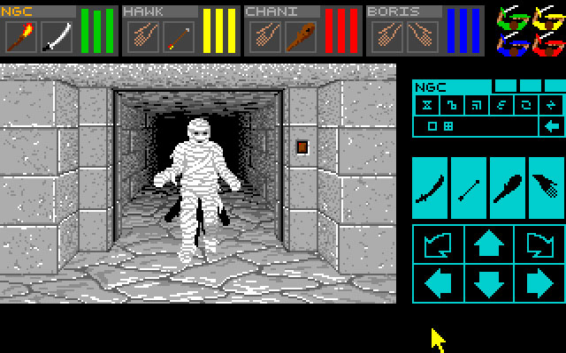

**Introduction**

Dungeon Master isn’t just a game, it’s a religion. Even though the game was made in 1987 for the Atari ST (and a PC port was made two years later) the fanbase is quite big today. This ‘mother of all rpg’s’ was certainly groundbreaking when it appeared, both in gameplay and graphics. The 3D first person perspective was still rather unheard of in those days, as most games were side- or topview. The fact that you’d have a team of 4 characters that you could each specialise and the huge dungeon to explore made it an instant hit. The sheer amount of ports for this game for every operating system and 3d engine you can imagine proves that Dungeon Master isn’t forgotton at all!

**Black Crypt**

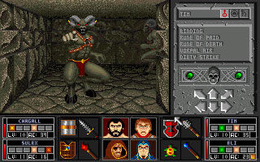

**Introduction**

Black Crypt is a first-person perspective 3D dungeon exploration game similar to the [Dungeon Master](http://www.dungeoncrawlers.org/game/dungeon-master/" \o "Dungeon Master) and [Eye of the Beholder](http://www.dungeoncrawlers.org/game/eye-of-the-beholder/" \o "Eye of the Beholder) series.

Twenty-two years ago a powerful cleric named Estoroth Paingiver was banished and sealed in a crypt. He has been gaining strength since then and is now threatening the country of Astera again. You must take control of a party of four adventurers sent to find and seal Estoroth again by recovering the lost relics that sent him into exile in the past.

Barbarian

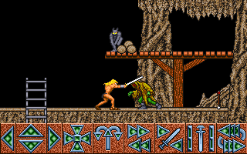

In this game you play the role of a barbarian who must navigate his way through dangerous dungeons. The game is played from a third person side scrolling perspective and also has platform jumping parts to it. The barbarian is controlled by using left and right on the joystick to move and up and down is used to scroll through the various commands at the bottom of the screen. When a command is highlighted pressing fire will perform that action thus saving on extra buttons being needed to play. There are two weapons at your disposal. A sword which you start the game with and later a bow which is handy for long range attacks. There are many traps to avoid and various monsters who have different attack patterns.

Goody

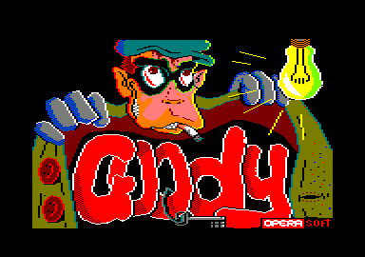

In *Goody* you are a thief with a mission to break into a Spanish bank. In order to accomplish that you need the appropriate tools, such as a torch and pincers. On the way toward the bank you must avoid policemen, gorillas, kung-fu experts, women sweeping the street, paper airplanes, and other hazards. The game is a platformer with light puzzle-solving which requires usage of the correct object in the correct place, similar to [Jet Set Willy](https://www.mobygames.com/search/quick?game=Jet+Set+Willy).

Livingstone II

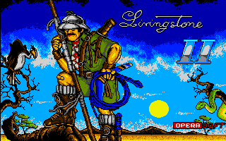

This is the sequel to [Livingstone Supongo](https://www.mobygames.com/game/livingstone-i-presume). It means that Dr. Livingstone will return to our screens to be rescued definitively. In this game you must pass 2 worlds, filled of dangerous savage animals, unfriendly natives, a lot of mortal traps, and, of course, risk and adventure in pure state.  
  
*Livingstone Supongo 2* starts where you finalized the first game, and that as I said before, you must surpass the 2 levels to find the place where Dr. Livingstone is prisoner. In this sequel you must take some important objects to pass to next level.

Speedball 2: Brutal Deluxe

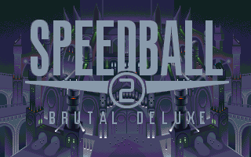

Brutal Deluxe doesn't live up to their name - in fact they're the worst team Speedball has ever seen. As their manager, it is your job to transform their fortunes. As well as the league system, which consists of 2 8-team divisions and challenges you to advance to the top, there are also 2 cup tournaments, one of which is played out over 2 'legs' with the aggregate score deciding who progresses.  
  
You can play the matches as well, which is the real meat of the game. They consist of 2 90-second periods, and the gameplay is futuristic, fast and frantic, with heavy tackling encouraged to retrieve the ball. Power-ups and tokens appear on the pitch, including ones to make your players extra-tough or freeze the opponents.  
  
The sides of the pitch each include a score multiplier, which you can run the ball through to increase the value of your scoring - the opposition can sometimes immediately grab the ball and nullify this. There are also 5 stars which are worth 2 points each if you hit them (more if you have the multiplier activated), but these can also be cancelled out by the opposition hitting the same star, and their points values only become set after the half. Next to the stars there are 'portals' which throw the ball out the opposite side of the pitch, in the direction it was going.  
  
You get money for the results, and by collecting the silver tokens which appear on the pitch at random intervals. Between each match you can spend these either on improving your existing players as far as they can go, or on buying better ones and fitting them into the team. Your original players can only be improved to a certain extent, so remembering where your signed players are and making use of them is important.  
  
A variety of tokens also appear during the match, some of which boost your team's power for a short period of time, and one freezes the opposition.

The Chaos Engine 2

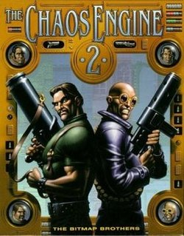

At the end of The Chaos Engine you managed to put a stop to Baron Fortesque's out of control machine, only to free the Baron himself from its clutches. Unfortunately not everything went to plan after that. During the confusion the Baron snuck away back into his own contraption and into another time period. Our two heroes decide the only way to stop him is follow him, but unfortunately luck isn't on their side...  
  
Both players (either two human or one human and one computer controlled) are trapped within the Chaos Engine and can only escape by helping the Baron rebuild the engine. He will reward the character who helps him the most by granting him freedom, thus pitching our two heroes against each other.  
  
Whereas The Chaos Engine was a two-player co-operative game, The Chaos Engine 2 is a two-player competitive game!

Motörhead

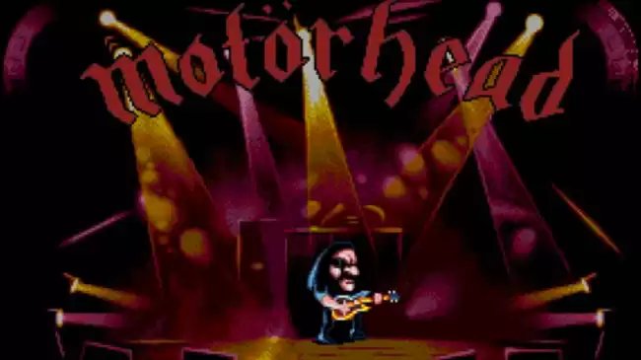

You are [Lemmy](https://www.mobygames.com/developer/sheet/view/developerId,219179/) - the leader of the heavy metal band Motörhead. Your fellow band members have been kidnapped by fans of other music genres. Our bass-guitar-wielding hero goes on a [Double Dragon](https://www.mobygames.com/search/quick?game=Double+Dragon)-esque journey in this side-scrolling beat 'em up. On each level Lemmy heads right, occasionally stopping to fight a group of enemies who pop up in hopes of beating him up.   
  
Throughout 6 levels, each of them representing a different genre, you'll not only beat up the enemies with your trusty instrument, but also use various powers - such as an incinerating belch or a deadly bass guitar solo. You'll need to collect powerups that come out of defeated enemies - some of them will heal you, some will give you the energy necessary to use for your powers. After each level (except for the last one) you play a short minigame.

BloodWych

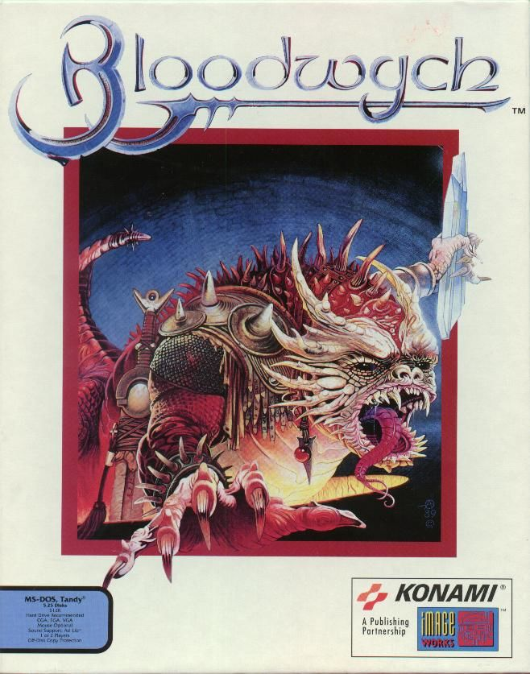

The land of Trazere was once ruled by the powerful and benevolent organization of mages known as *Bloodwych*. Governed by the Grand Dragon, the Bloodwych supervised over the balance in the land, protecting it from evil and driving it to prosperity. However, the second-in-command of Bloodwych, named Zendick, turned against his group, banished his opponents to the astral plane, and began working on a mad plan - summon the ultimate evil, the Lord of Entropy. The player controls the champion of Trazere, whose ultimate goal is to stop Zendick and restore peace in the country.  
  
*Bloodwych* is an RPG in the style of [Dungeon Master](https://www.mobygames.com/game/dungeon-master) and [Eye of the Beholder](https://www.mobygames.com/game/eye-of-the-beholder), being a 3D first-person maze-like game. This game's distinguishing feature is the two-player split screen support, allowing simultaneous playing on one computer.  
  
Each player controls a party of four characters. The four basic classes are warrior, mage, adventurer, and thief; however, each class also has sub-classes, which are represented by four different colors. These colors come into play also when the characters learn and combine spells.