**CSCE 453 Assignment 3**

**Due: June 25, 2020 at 11:30pm on BeachBoard**

In this assignment we build an app that displays vehicle data from restful APIs.

**Project Setup**

1. The vehicle info needs to be displayed as follows (the image size can be different):

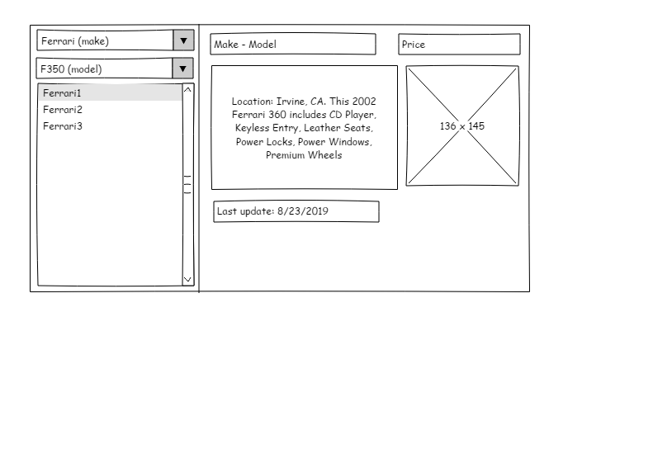

1. The vehicle APIs are
   1. The list of available cars:

<https://thawing-beach-68207.herokuapp.com/carmakes>

* 1. The list of available models:

https://thawing-beach-68207.herokuapp.com/carmodelmakes/<makeid>

e.g <https://thawing-beach-68207.herokuapp.com/carmodelmakes/2>

* 1. The list of available vehicle based on given make and model id can be fetched as below

[https://thawing-beach-68207.herokuapp.com/cars/<make>/<model>/<zipcode](https://thawing-beach-68207.herokuapp.com/cars/%3cmake%3e/%3cmodel%3e/%3czipcode)>

e.g <https://thawing-beach-68207.herokuapp.com/cars/10/20/92603>

* 1. A vehicle detail information based on id

[https://thawing-beach-68207.herokuapp.com/cars/<carid](https://thawing-beach-68207.herokuapp.com/cars/%3ccarid)>

e.g <https://thawing-beach-68207.herokuapp.com/cars/3484>

**Grading Requirements:**

1. (2pts) In an Activity the controls must be
   1. Properly aligned
   2. Work in both tablet and mobile (Just centralizing on the tablet screen would be sufficient for now)
2. (5pts) Your code should work exactly based on this document. If any part of the project is not clear to you it is your responsibility to ask me and clarify it. (Any misunderstanding in demo time is not acceptable)
3. (2pts) Coding style includes:
   1. Proper coding standard.
      1. Proper variable name
      2. Proper control name
      3. Proper Activity and resource name
   2. Comments
      1. One line comment for code and block of code that does certain task
      2. Any costume method, require a comment explaining the functionality of the code (No more than 2-3 lines, this also can be description of the inputs and outputs variables)
4. (6pts) Code presentation: In the presentation day, you will be asked about your code. Also, you should be able to explain methods and codes added by Android Studio as much as we covered in the class (onCreate for example).