The Repository Browser and Grapher
By Blake Dickie
December 2004

Table of Contents

Table of Contents 1
Table of Figures 1
Introduction 2
Discussion 3
Repository Browser Overview 3
Repository Grapher Overview 4
System Components 6
Repository Grapher Design Decisions 7
Extending the Data Layer 9
Extending the Difference View in the Explorer 9
Extending the Graph View Modes 9
Conclusion 11

Table of Figures

Figure 1: Screenshot of Repository Browser 3
Figure 2: Screenshot of Repository Grapher 4
Figure 3: Package Diagram of System 6
Figure 4: Example of Left Bisection and Tangent Limits 7

Introduction

For my Honours Project I have developed two tools for visualizing data in the source code repositories. The first tool provides a method for viewing the structure of the repository in a traditionally file explorer fashion, and allows the user to view the various revisions of a file that exist in the repository. The second tool provides a framework for designing radial tree of the repository with various options on how to render each directory or file.

Both tools were designed to be extended with different ways of accessing the information in the repository and in the case of the tree framework, to be able to add new views to the program.

Discussion

This discussion will first provide an overview of each program and its capabilities. It will then look at the general components of the program and their relationships. Next I’ll example some of the design decisions behind the Repository Grapher. Finally it will discuss how to extend the programs for different purposes.

Repository Browser Overview

The Repository Browser provides a viewpoint similar to that of Windows Explorer with a tree on the left hand side of the screen displaying the files and directories in the repository. You can open a file and get a list of all the revisions of the file and from there view the other revisions for a single MR. You can also view the contents of the files that have contents available.

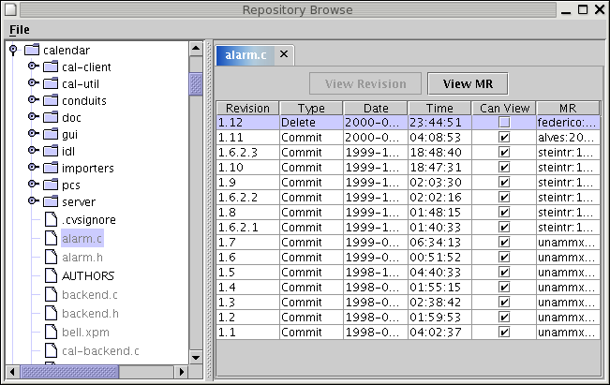
Figure 1: Screenshot of Repository Browser

This program allows for a method of browsing the repository that is similar to methods already learned for working with their OS. It also allows the user for looking at how a single file changed or what happened in a single MR. It isn’t much help for looking at patterns throughout a large portion of the repository.

Repository Grapher Overview

The Repository Grapher provides a framework for implementing radial trees of a repository. It currently has two view available, one showing the number of times a file has been modified over a time period, and the other showing the primary author of a file over a time period. It is able to save the graphs as PNG files and export the tree’s information into a simple XML format.

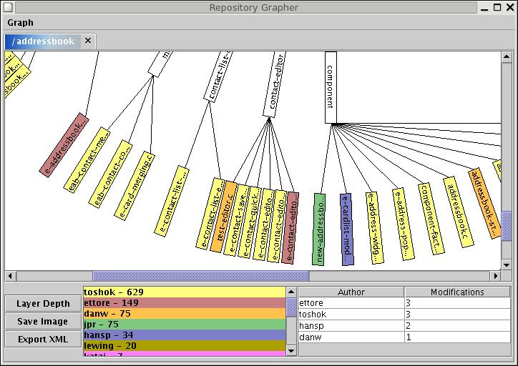
Figure 2: Screenshot of Repository Grapher

The Repository Grapher can be used to see patterns over a large portion of the repository.

The Times Modified View allows for seeing:
- Important files within an area of the repository.
- Seeing which files are edited together before a release or directly after a release (probably bug locations).

The Primary Author View allows for seeing:
- Patterns of ownership within modules.
- Major authors of a module.

Some areas the framework could be extended to show would be:

- Showing the size of modules to see relative value of each.
- Showing the number of dependencies a file has.
- Showing the number of times a given developer edited each file as opposed to the total number of times a file was edited.

System Components

Both programs use the same code base and share a large number of common support classes. In addition since the Repository Browser was developed first a couple of the classes in the Repository Browser’s package are used in the Repository Grapher that weren’t planned on the initial design that should probably be refactored to a common package.

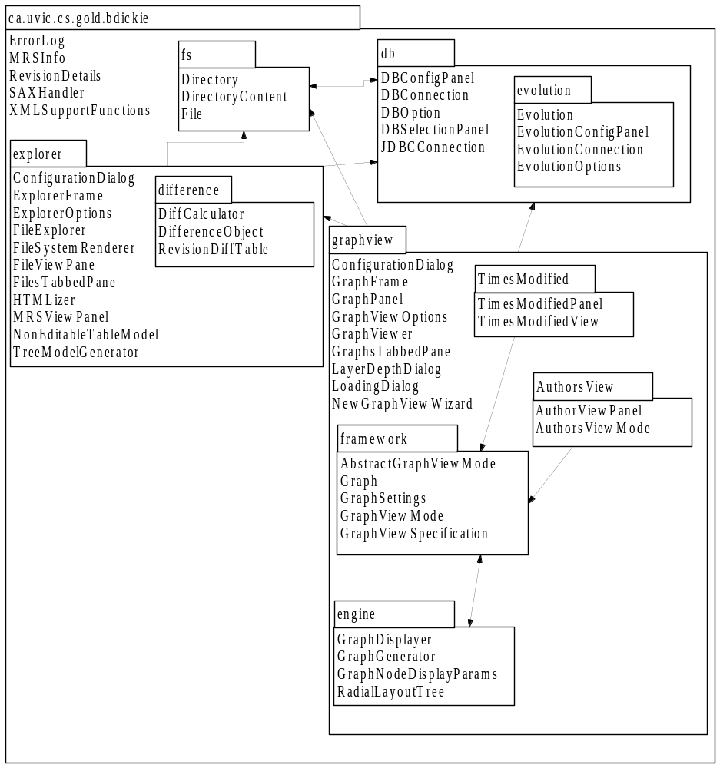
Figure 3: Package Diagram of System

Repository Grapher Design Decisions

The fact that a radial tree layout should be used was decided on early in the specification of the program, but exactly how to obtain it was less then clear. There are a number of Java graph engines available that could have displayed the information (JGraph, OpenJGraph), but they either lacked the ability to finely control how a node was rendered or were too complex for the problem and the performance hit was too great for using them. So I decided to do some research on how to layout radial tree to see if it was possibly to do it myself in a reasonable amount of time.

JGraph’s APIs mentioned the paper which their radial layout tree was based on. "Radial Tree Graph Drawing Algorithm for Representing Large Hierarchies" by Greg Book and Neeta Keshary. I was able to find a copy of it and its concept seemed implementable in a reasonable timeframe. I originally tried converting the C implementation of it that they had in the paper, but proved to have some serious bugs and inefficient code. As such I recoded it from scratch just using the abstract concept presented in the paper.

The concept of the graph layout is that every directory has an angle range in which it can have children with two types of limits: the bisection limits and the tangent limits. The bisection limit specifies that two side-by-side directories will not go more then halfway towards the next directory. The tangent limit is that a directory’s children will not be more then 90 degrees off of the directory’s radial line. The one exception to this rule is the root directory, whose children can occupy the entire 360 degrees around it.

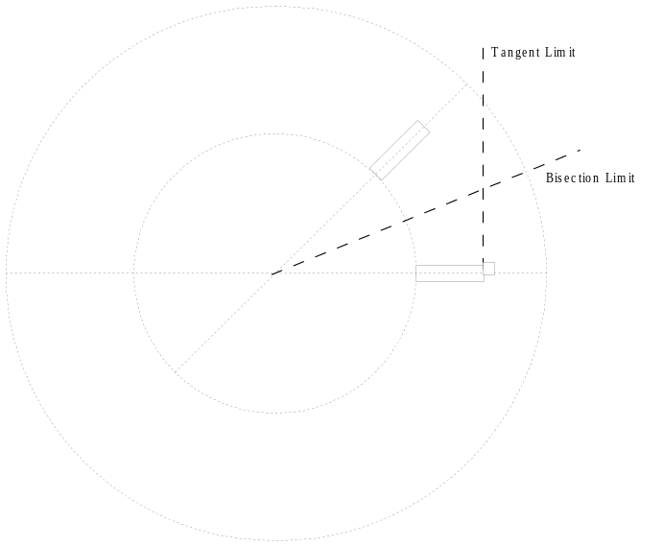
Figure 4: Example of Left Bisection and Tangent Limits

The result of the algorithm is the polar coordinates of the node, which allows for easily changing the size of the layers without recalculating the layout.

During the development of the layout algorithm I started thinking in polar coordinates a lot and it eventually occurred to me rather then the horizontal nodes that most graphs have, it would make better use of the circular layout to draw the nodes at the same angle as their polar coordinates.

When extending the graph layout to support the framework the question arose of what to allow the user to specify about the nodes display. I eventually decided on:
- Node Text
- Text Colour
- Background Colour
- Border Colour
- Border Width
These are about all you can allow the user to control without requiring the user to actually handle graphics code, which the framework was trying to remove the requirement to know.

Finally I found that the view that I was implementing would be improved by having a display area for its own controls and the ability to respond to clicking on a node, so these were added to the framework. I choose not to create more event about mouse interaction with the nodes as first it requires a deeper understanding of Java’s event system then I feel I have and second the method of finding which node is being clicked on is too inefficient to use continually for mouse movement or the like.

When looking at the packages you may notice that the framework and engine packages are fairly tightly coupled. They really together form the framework, but I decided to separate the classes that a developer making a new view mode would need to know about from the other classes. As such you’ll find that any of the view modes will only need to depend on the classes in framework, and not have the other classes to distract them.

Extending the Data Layer

Calls to the database are hidden behind a data layer. Currently the only implemented data layer is that for the schema being used on silver.cs.uvic.ca. It is possibly to implement alternative layer through extending the classes in the db package. The DBOption class describes the general approach to such extension, but the basic logic is done through extending the DBConnection class or the JDBCConnection class.

This data layer seperation also have the unfortunate side-effect the new view modes for the graph layer will either have to add new functions to the DBConnection classes or handle their own connection to the database.

Extending the Difference View in the Explorer

It is possible to implement different ways of finding the differences between two files in the File Explorer. Currently there is an implementation that uses the “diff” output that is saved in the database.

To make a new difference calculator implement the DiffCalculator class. The DifferenceObjects that are returned each resent one portion of the file with the same state (ie. added, removed).

Extending the Graph View Modes

To extend the graph view mode you will probably require two classes, one which extends either the GraphViewMode class or the AbstractGraphViewMode class, and a second Swing panel to show at the bottom of the window. The exact method details are described with the JavaDocs of the GraphViewMode.

The AbstractGraphViewMode is a special version of the GraphViewMode that handles calculating the files in the tree through one of three mode:
- All files
- All files that are modified over time period
- All files that existed at a point during time period
You specify which case you wish to use through passing a constant to its constructor.

The contructor of a view mode should not perform any initialization of data as it may be created before the rest of the settings of the graph are. Instead initialization should occur in the addedToGraph method.

The calls to the GraphViewMode object will come in the following order:
- addedToGraph
  - Called once after the graph settings are initalizated.
- containsFile
  - Called a number of times on various files.
- getViewFor
  - Called a number of times on various files.
- GetControlPane
  - Called once after first set of calls to getViewFor
- MousePressed/getViewFor
  - Called at various times throughout the rest of the life of the object.

Conclusion

These two programs are designed to provide a basis for observing patterns in code development. The Repository Browser is best suited for complimenting other tools when a precise look at a single MR or file is required and is helpful for a new user to a code base to get a general feel for its file structure. The Graph Viewer is able to look at a larger portion of a system and visualize patterns in it. Both systems are designed to have points of extension and hopefully a reasonable code base from which future work can be extended.

