Index

The index screen offers two broad lists of services, those requiring authentication, and those which are public.

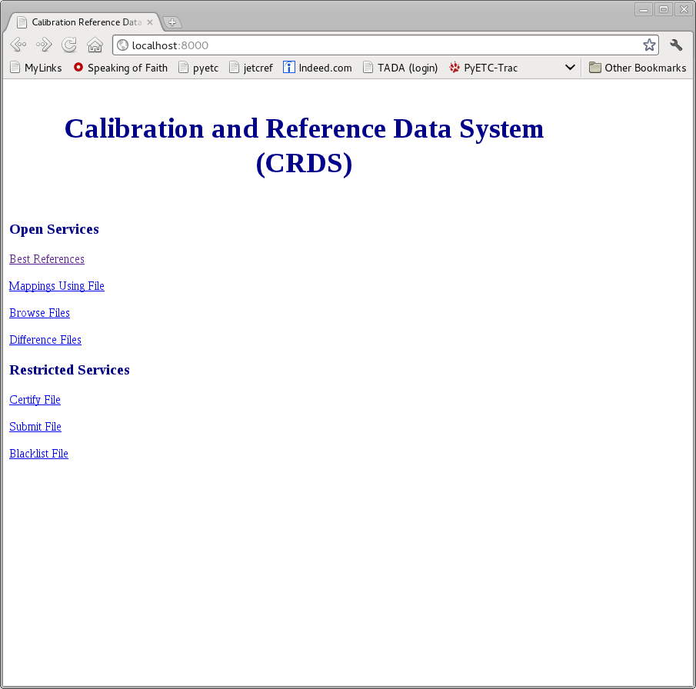

Login
Authenticated services, file submission, certification, and blacklisting are transparently redirected to a login screen. After authenticating a “logout” link becomes visible in the tile bar of all pages. Authentication persists for the duration of the browser session or until logout. Users are presently managed by Django authentication and must be added to the CRDS user base.

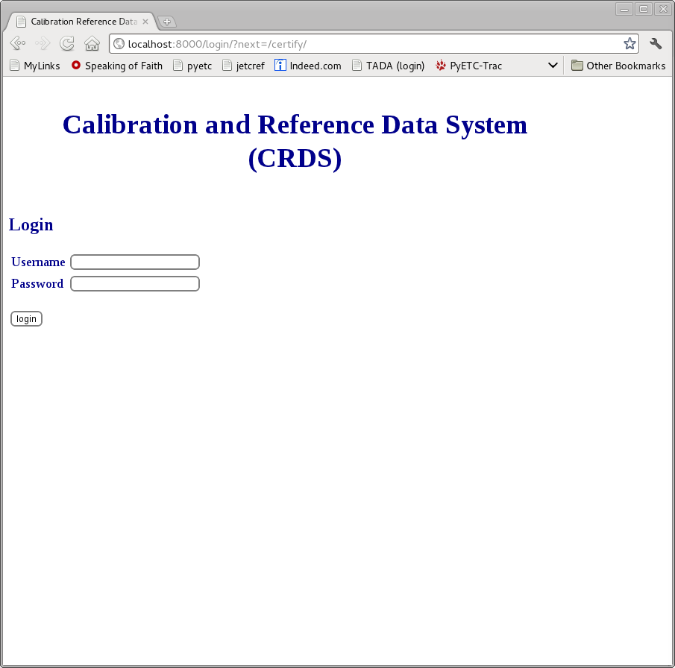

Best References - 1
The best reference service computes best references on the CRDS server based upon interactively entered header values. The first step is to define the context of an instrument. Conceptually the “default” contexts are symlinks to the latest-and-greatest instrument context files. The user has the option of entering a more specific context. Best References only works on known CRDS contexts, not contexts from user development. User contexts should be run locally from the Python shell; presently this is for “official” bestrefs only, not experimental ones.

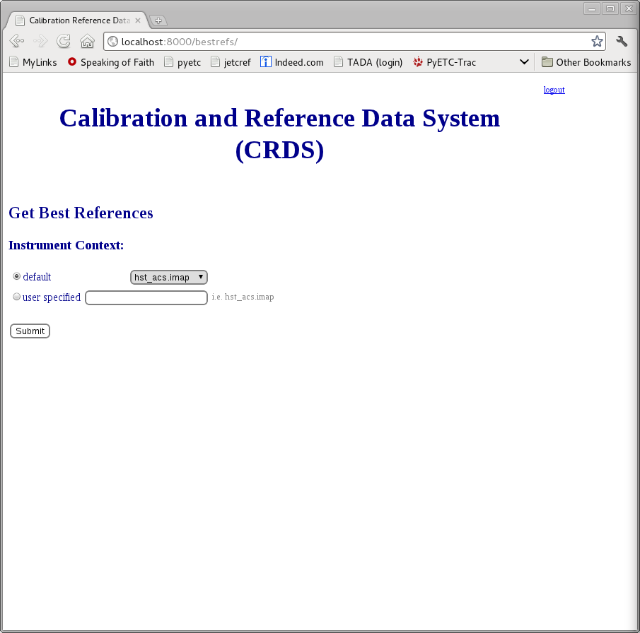

Best References – 2
Based upon the mapping files (rmaps) defined by the instrument context, CRDS presents choice boxes for each of the potentially relevant header parameters. (This is a rough and somewhat imprecise service since existing rmaps tend to group all instrument modes together. Not all parameters are relevant to all modes... and not all choices are relevant to all modes... and not all reference types are relevant to all modes. However, the known choices are all presented so the possible answers can be generated, it's just that discernment is usually required to know what results are irrelevant and should be ignored.)

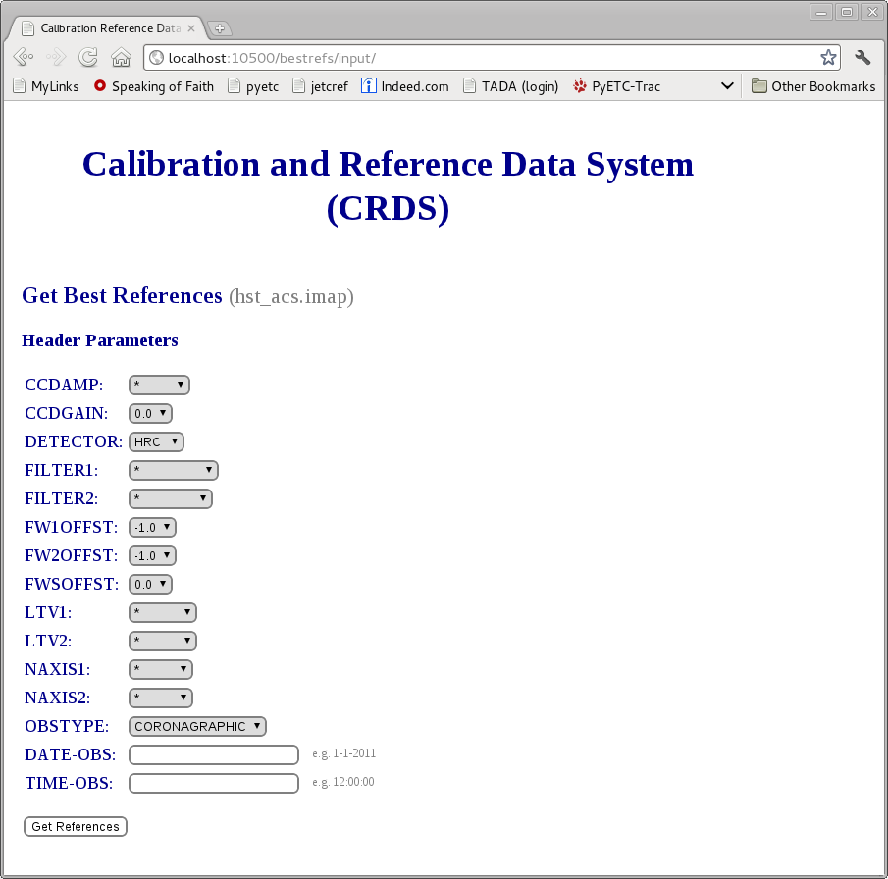

Best References – 3
Best references echoes the set of input choices. CRDS returns the recommended reference files. Since all possible reference kinds are presented, some fail simply because they are inappropriate for the current mode. The first failure, BIASFILE, fails because of a partially implemented BIASFILE rmap which cannot generate the correct answer. The subsequent 3 failures are all assumed irrelevant to the instrument mode. The reference files are given as links which can be used to download the file.
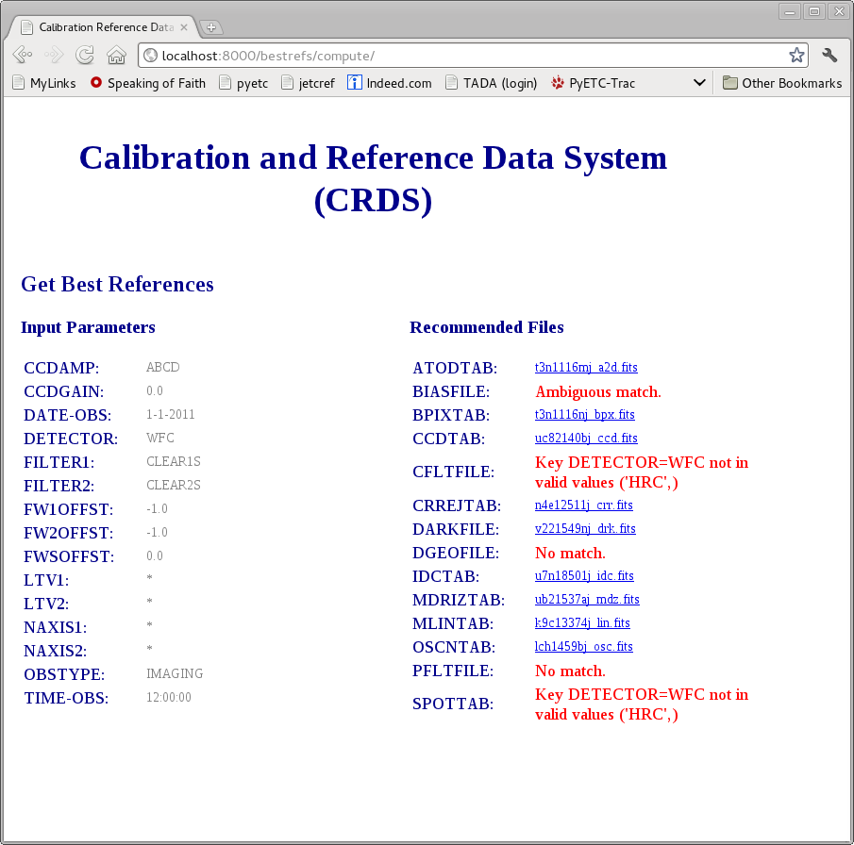

Submit – 1
The submit file page enables a user to deliver a new reference or mapping file to CRDS. Files are uploaded singly and must pass certification before they are entered into the CRDS database and passed on to the archive (not yet implemented). File submission requires authentication and CRDS remembers the CRDS user name and e-mail of the person submitting the file without requiring additional input. Once submitted, a file can be blacklisted but not deleted. CRDS is presently “name agnostic”: it does not automatically manage file versioning; the extent of “version management” is that no filename can be submitted twice.

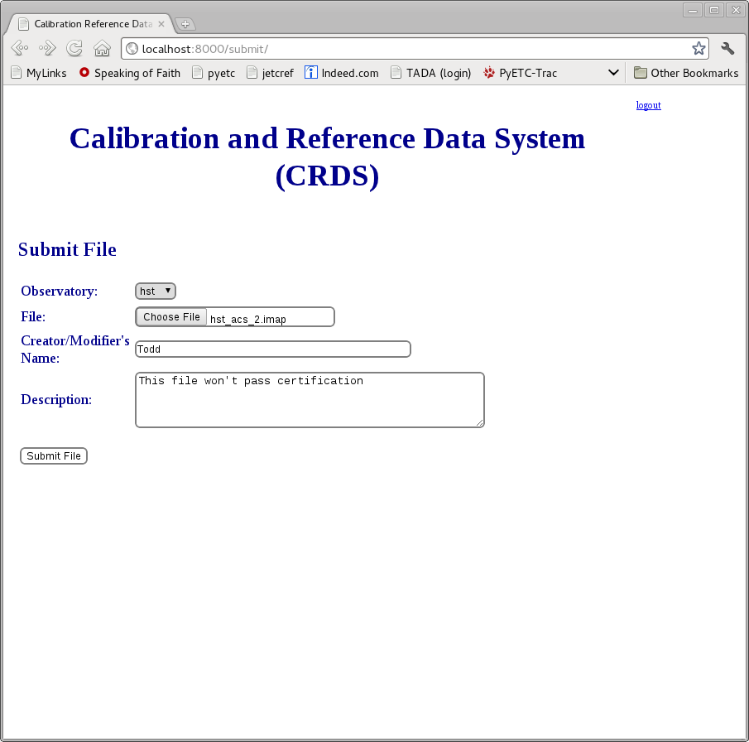

Submit – 2
The file submitted in this instance was corrupted and failed the CRDS rmap sha1sum checksum verification. (Should the file creator seal the file with the sha1sum, or should CRDS seal the file once delivered, assuming that the unverified uplink was successful?)

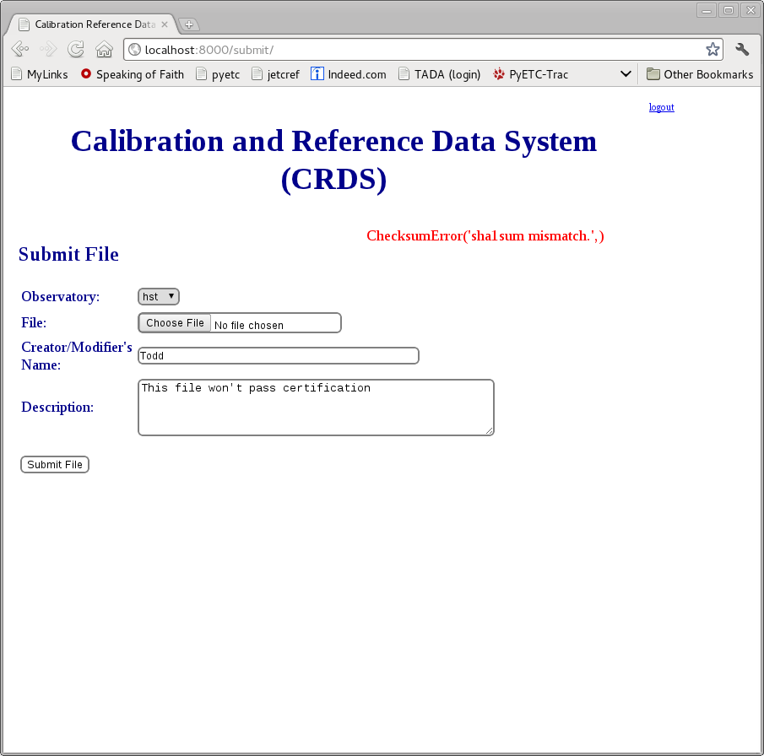
A successful submission is entered into the CRDS database and passed onto the archive. The file is available to CRDS users as soon as it is delivered. (Or should archive checkout be required?) More information is required here to support existing HST practices. Rmaps could potentially be entered into subversion.

Certify – 1
During the submission process it is possible to run the CRDS file certifier without delivering a file. In addition, it is possible to run the certifier on an entire pipeline context to check for missing or unacceptable reference files. Unlike submit, certify can be run on a reference or mapping already known to CRDS. Since deep checks are time consuming, certify is an authenticated service even though it has no impact on the database or file store. Since deep checks are time consuming, examining associated reference files is optional. Note that like most CRDS interactive services, certify operates on either mapping or reference files.
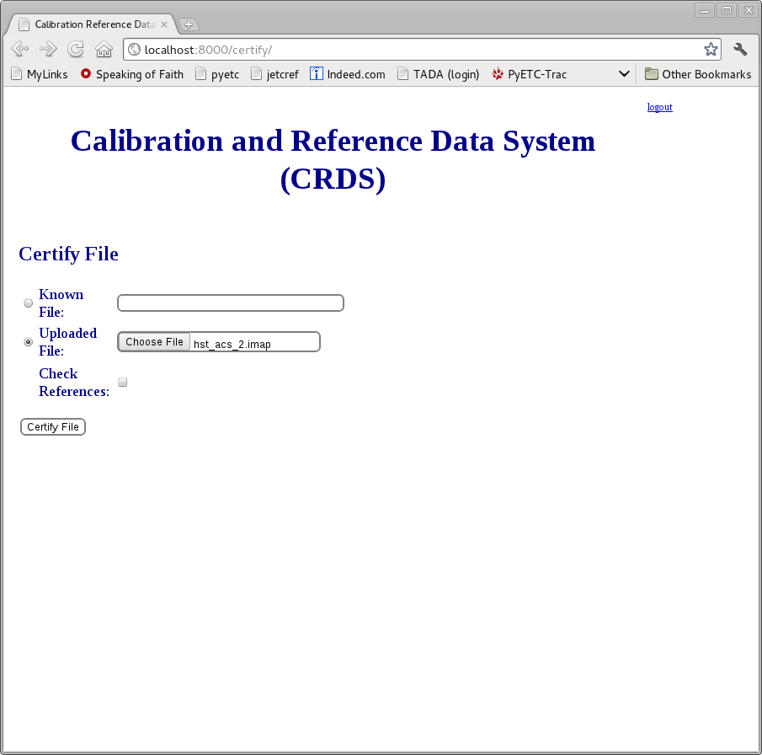

Certify – 2
Certify will report on rmap syntax or checksum errors... or anything which raises an exception during the rmap load process. Certify will also check submitted reference files for required keywords, and their values, presently as defined by HST .tpn files, and general FITS compliance. Further enhancements are under consideration, such as basic checks on file structure and image or table geometry.

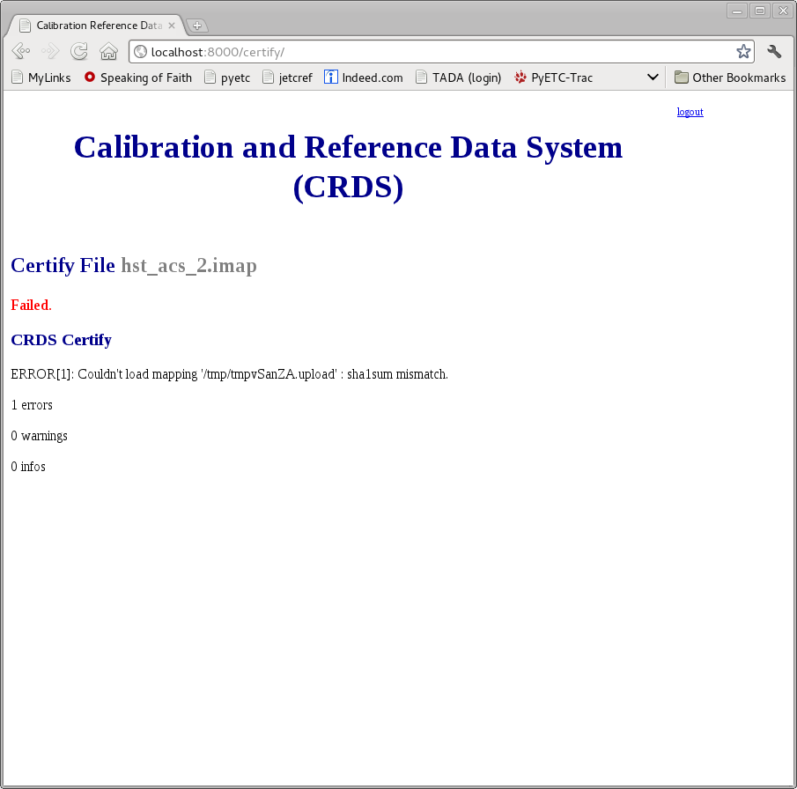

Blacklisting - 1
CRDS has no facility for removing reference or mapping files once they are submitted. Instead, it is possible to mark a file such that it should no longer be used. The file remains in the CRDS database and file store. (The present blacklisting mechanism has no enforcer, it is just an audited database operation. That scheme needs to be worked out.) By it's nature, blacklisting only operates on known files. Blacklisting is authenticated so who did it, when, and why are all recorded. Blacklisting is reversible simply by marking a file “ok”.

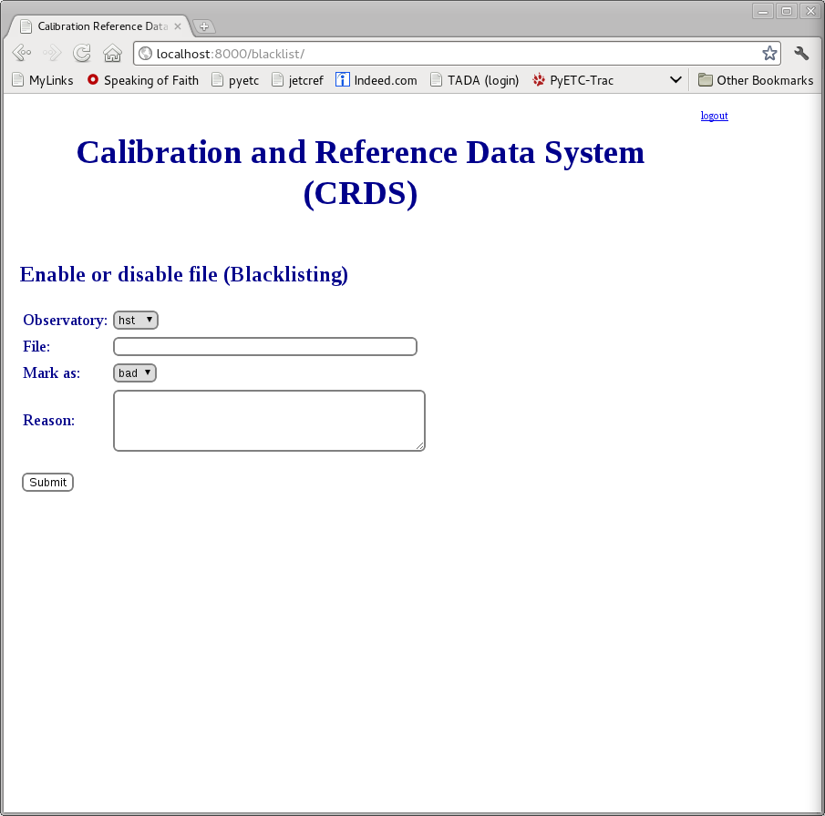

Difference - 1
CRDS offers a facility for difference mappings or FITS files, either files known to CRDS or uploaded by the user.

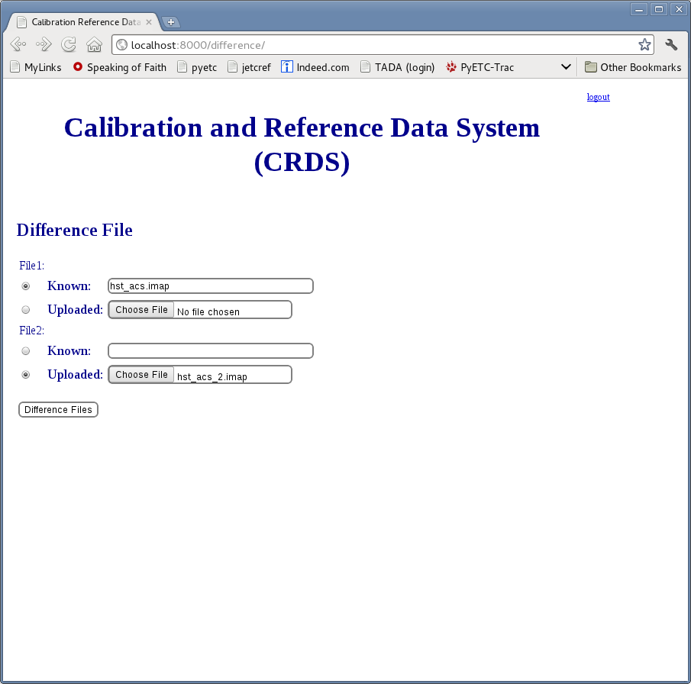

Difference – 2
Below we see the change to hst_acs.imap which caused hst_acs_2.imap to fail the sha1sum check. Given a mapping file, the current difference processing is essentially some version of the UNIX command diff, perhaps eventually massaged and colorized. Given a .fits files, fitsdiff is run and the colorized results are returned. The builtin difference function is useful primarily for conveniently comparing a working file to a related known file. In this case CRDS obtains hst_acs.imap for the user's difference.

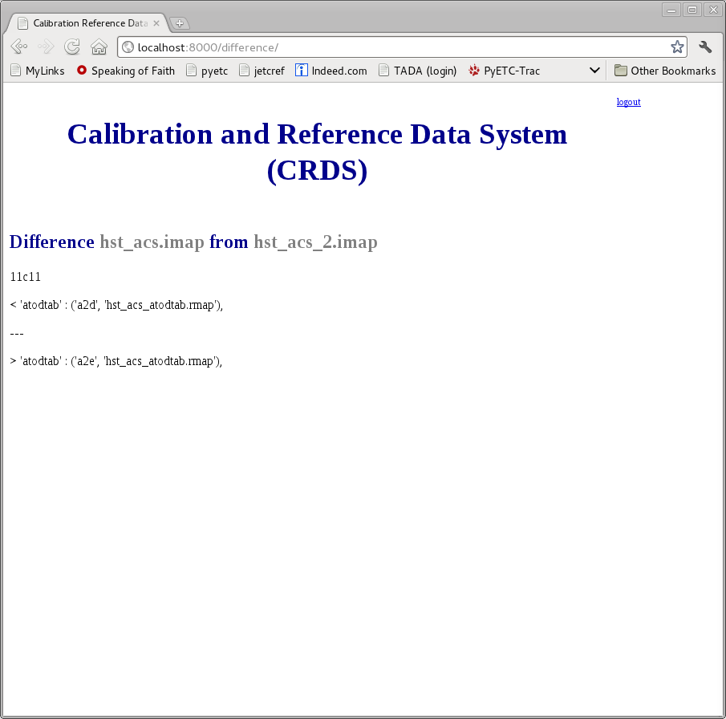

Using - 1
Given a reference or mapping file, CRDS will return a list of all known mappings which refer to it. (Presently it can be a direct or indirect reference.)

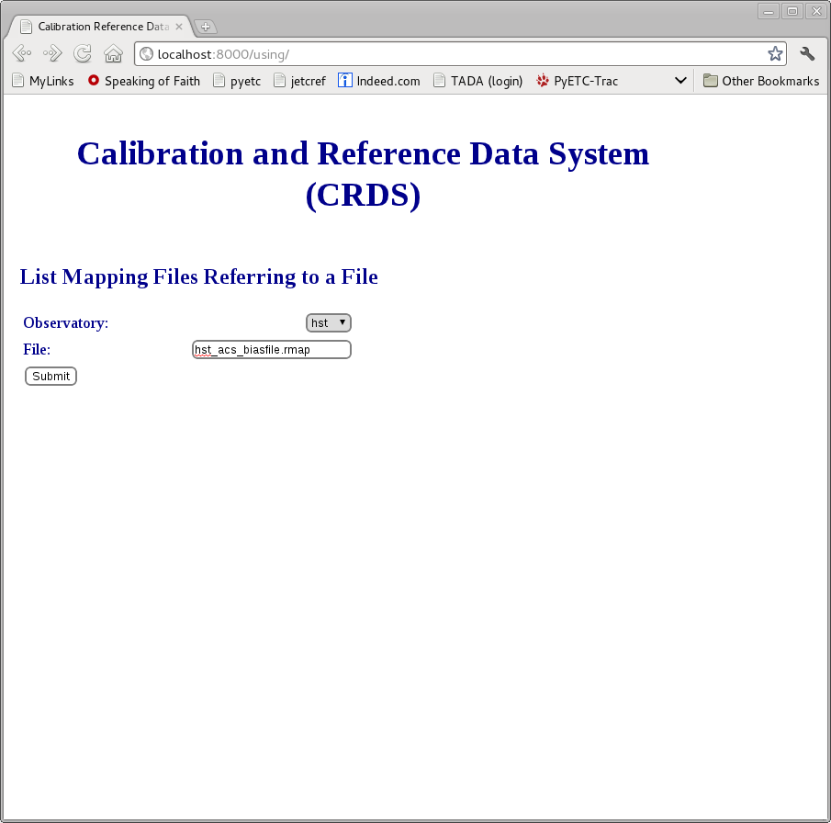

Using – 2

Below we see that the pipeline and instrument contexts of HST ACS both refer, directly or indirectly, to hst_acs_biasfile.rmap. This is potentially useful for cryptic reference file names and situations in which many differently numbered ancestor contexts exist, i.e. v5j1716ei_bia.fits, or hst_00037.pmap.

