CIS 31 Operating Systems Concepts
Homework Problem Set 1
David Gudeman

1.3 What is the main difficulty that a programmer must overcome in writing an operating system for a real-time environment?

The time constraints of the system are paramount. Real-time operating systems are used when rigid time requirements have been placed on the operation of a processor. These are frequently used in embedded applications such as air bags, weapons, manufacturing etc. where time of deployment is critical.

At a more general sense managing time in a multiprogramming real time environment would be addressing the problem of arbitrating resources of the hardware between competing users or processes so that the experience of the user or process is within the time frame of human perception whereby they feel like it is happening in real time as opposed to multi-second delays between the input an output.

To accomplish this mechanisms have to be in place to prioritize which process runs at what time, how memory reads and writes are handled.
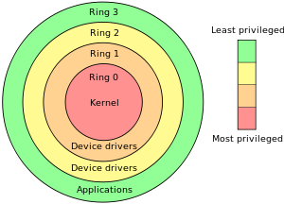

1.8 Some CPUs provide for more than two modes of operation. What are the two possible uses of these multiple modes.

The two modes that virtually all CPU's use: the user mode and the kernel mode. User mode is also known as restricted mode. Kernel mode is also known as supervisor mode, system mode and privleged mode. The supervisor mode has the privileges to use instructions that could harm the system. The user privilege can use instructions on application, libraries and other constructs that cannot harm the system if errors or destructive efforts are made.

x86 architecture has four modes or “rings”. The text book states that most of the time only Ring 0 (most restricted and Ring 3 (least restricted) are used for kernel mode and user mode respectively. The diagram (on the left) from Wikipedia suggests that Ring 1 and 2 are used for device drivers .

In addition to the two fundamental modes of user and kernel, there is another mode called Hypervisor mode. This mode is to deal with virtualization. According to the textbook this has privileges somewhere between the kernel and the user. In x86 parlance it is know as the -1 ring. The Hypervisor mode allows more than one operating system to be used a particular hardware piece. One main purpose of this is to allow companies to make use of legacy systems. I heard it described that a dated OS and a dated application software could be conceptualized as a unit and then run with a hypervisor on a new system.

There are two types of hyper visors.
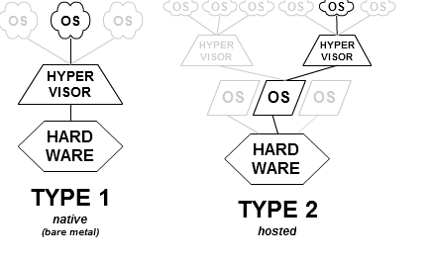

Type 1 actually has the hyervisor loaded onto the machine and the OS is on top of this. Multiple OS's could be on top. Type 2 has an OS loaded onto a machine, then a Hypervisor on the OS and then other OS's on top of the hypervisor. (Diagram from Wikipedia).

1.13 The issue of resource utilization shows up in different forms in different types of operating systems. List what resources must be managed careful in the following settings:

a. Main frame or minicomputer systems
User processes and system process must be allocated so each has a slice of time and so multiple jobs can get done. Multiple people should be able to utilize the hardware and feel like they have entire resources of the hardware and feel safe from interference from other users.

b. Workstations connected to servers
File sharing across networks allow processes to communicate and, in general, different computers to work together. The added complexity of coordinating computer processes and using the network come into play. Security is a major concern as well.

c. Mobile computers
Power utilization becomes a major factor in designing mobile computers (otherwise they can''t be mobile for very long). Operating systems need to manage power consumption as well as the hardware an application packages. Memory capacity and processing speed are, in general, more limited.

1.22 Many SMP (symmetric multiprocessing) systems have different levels of cache; once level is local to each processing core, and another level is shared among all processing cores. What are caching systems designed this way?
In SMP systems all the processors are working on the same problem. This is opposed to a asymmetric multiprocessing unit where there is a boss processor that directs other processors what to work on.
The major trade off is time versus data coherence. In order to allow the instruction fetch and data access in a timely manner it pays to have seperate cache's for each CPU. But the complexity arises when the caches may contain different data, particularly when data is written back to main memory. So by having a second level cache common to all CPUs data coherency is promoted so that each CPU is working from the same data set.

As I understand it the L1 cache, unique to every processor is tuned to have a rapid response time but is smaller so there are more misses. The L2 cache is usually about ten times larger so it is slower to access but there are fewer misses and all the CPUs would be using a coherent dataset at the L2 level.

