Mod1Assignment1

# Danielle Harris

## MIS 502

### Module 1, Assingment 1

library("tidyverse")

## ── Attaching packages ──────────────── tidyverse 1.2.1 ──

## ✔ ggplot2 3.1.0 ✔ purrr 0.2.5  
## ✔ tibble 1.4.2 ✔ dplyr 0.7.7  
## ✔ tidyr 0.8.2 ✔ stringr 1.3.1  
## ✔ readr 1.1.1 ✔ forcats 0.3.0

## ── Conflicts ─────────────────── tidyverse_conflicts() ──  
## ✖ dplyr::filter() masks stats::filter()  
## ✖ dplyr::lag() masks stats::lag()

diamonddata=diamonds

ggplot(data=diamonddata)+  
 geom_point(mapping=aes(x=carat,y=price))

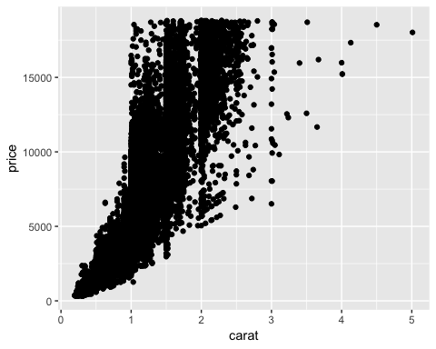

# As carat increases, price tends to increase.

ggplot(data=diamonddata)+  
 geom_point(mapping=aes(x=carat, y=price, color="cut"))

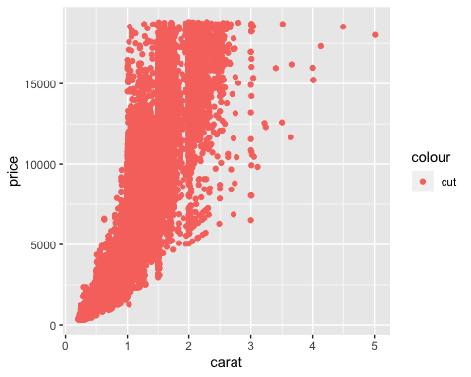

# Price increases as carat increases, but is impacted very little by cut.

ggplot(data=diamonddata)+  
 geom_point(mapping=aes(x=carat,y=price,color="cut"))+  
 facet_wrap(~color, nrow(2))

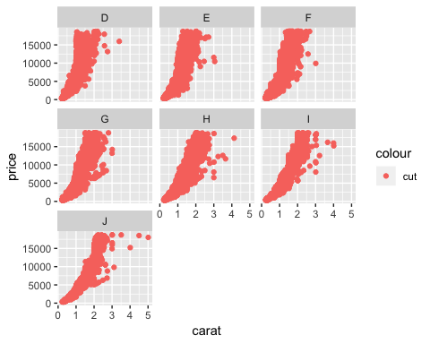

# Price increases as carat and color quality increases, but is impacted very little by cut.

library("readr")

inventory<- read_csv("InventoryData.csv")

## Parsed with column specification:  
## cols(  
## `Item SKU` = col_integer(),  
## Store = col_integer(),  
## Supplier = col_character(),  
## `Cost per Unit ($)` = col_double(),  
## `On Hand` = col_integer(),  
## `Annual Demand` = col_integer()  
## )

inventoryA<- filter(inventory, Supplier== "A")

# After using the filter for only Supplier A, there are 3,695 rows.

inventoryA = mutate(inventoryA, OnHandRatio = `On Hand` / `Annual Demand`)

# The above chunk of code created a new data frame and added a new variable called “OnHand Ratio”

avg_cost<- group_by(inventory, SKUAvgCost = `Cost per Unit ($)` / `Item SKU`)

avg_cost2<- select(avg_cost, SKUAvgCost, `Item SKU`)

# Given my previous experience with RStudio, spreading and subsetting data was difficult for me because we spent the least amount of time on the topic. I also find that I occasionally get stuck when I simply am missing a technicality in the code. nThis assingment was a good way to refresh my memory on the navigation of RStudio.