Lab 2 Report: Enhancing the Airbnb Prototype with Docker, Kubernetes, Kafka, AWS, and Redux
Course: DATA 236
Assignment: Lab 2
Name: Dongmei Han, Yilin Sun

1.1 Executive Summary
This report documents the comprehensive enhancement of the Airbnb prototype application developed in Lab 1. The project demonstrates the successful integration of modern distributed systems technologies including Docker containerization, Kubernetes orchestration, Apache Kafka for asynchronous messaging, AWS cloud deployment, and Redux for frontend state management. The enhanced system provides a scalable platform for property booking services with support for travelers and property owners.
The implementation encompasses five major components: (1) containerization of all microservices using Docker and orchestration with Kubernetes, (2) integration of Apache Kafka for event-driven architecture in the booking workflow, (3) MongoDB database implementation with secure session management and password encryption, (4) Redux state management for the React frontend, and (5) comprehensive performance testing using Apache JMeter. This report provides detailed documentation of each component, including architectural decisions, implementation strategies, and performance analysis.

1.2 Table of Contents
- Introduction
- Part 1: Docker and Kubernetes Setup
- Part 2: Kafka for Asynchronous Messaging
- Part 3: MongoDB Integration
- Part 4: Redux State Management
- Part 5: JMeter Performance Testing
- AWS Deployment
- Conclusion
- References

1.3 Introduction
The Airbnb prototype system represents a full-stack vacation rental platform built using a microservices architecture. The application supports two primary user roles: travelers who search for and book properties, and owners who manage their properties and handle booking requests. The original Lab 1 implementation established the foundational application logic and database schema. Lab 2 extends this foundation by modernizing the deployment infrastructure and introducing enterprise-grade technologies for scalability, reliability, and performance.
The enhanced system architecture consists of multiple independently deployable services: Traveler Service, Owner Service, Property Service, Booking Service, and an Agentic AI Service for intelligent recommendations. Each service has been containerized using Docker, enabling consistent deployment across different environments. Kubernetes provides orchestration capabilities, including automatic scaling, health monitoring, and service discovery. Apache Kafka introduces an event-driven architecture for asynchronous communication between services, particularly in the booking workflow. Redux manages application state in the React frontend, providing a predictable state container that simplifies debugging and testing.
This report systematically addresses each enhancement, providing both technical implementation details and analysis of the benefits achieved through these architectural improvements.

1.4 Part 1: Docker and Kubernetes Setup

1.4.1 Overview
Containerization and orchestration form the foundation of modern cloud-native applications. This section describes the dockerization of all five microservices and their deployment to a Kubernetes cluster, enabling scalable and resilient operation of the Airbnb prototype.

1.4.2 Docker Containerization
Each microservice in the Airbnb prototype has been containerized using Docker, creating isolated, portable execution environments. The containerization strategy employs multi-stage builds where applicable to minimize image sizes and enhance security by excluding development dependencies from production images.

1.4.2.1 Dockerized Services
The following services have been successfully containerized:
- Traveler Service (Port 5001): Handles traveler authentication, profile management, favorites, and initiates booking requests as a Kafka producer.
- Owner Service (Port 5002): Manages owner authentication, profiles, and processes booking requests as a Kafka consumer, enabling owners to accept or reject bookings.
- Property Service (Port 5003): Provides CRUD operations for property listings, including image uploads, search functionality, and availability management.
- Booking Service (Port 5004): Serves as the central booking management system, consuming booking requests from Kafka, persisting them to MongoDB, and publishing status updates back to Kafka.
- Agentic AI Service (Port 8000): A FastAPI-based service utilizing LangChain and OpenAI GPT-4 to provide intelligent travel recommendations, activity suggestions, and personalized itineraries.
- Frontend Service (Port 3000): A React application served through Nginx, providing the user interface for both travelers and property owners.
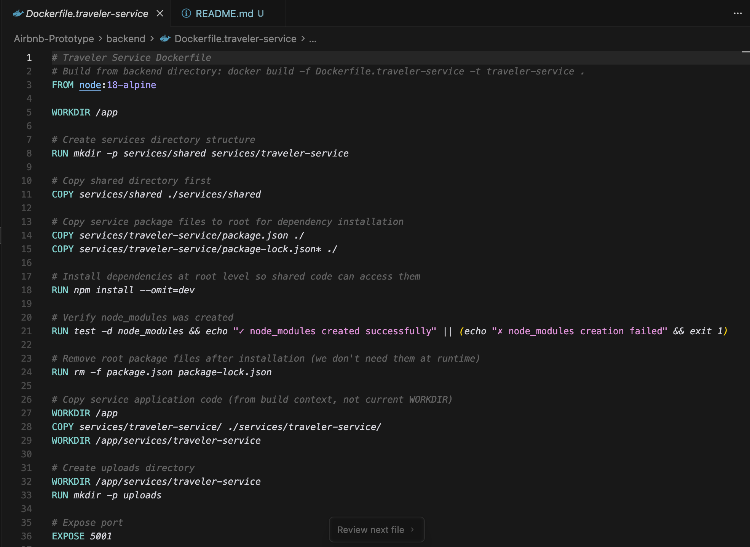
(Dockerfile for one of the backend services)

1.4.2.2 Dockerfile Configuration
Each Dockerfile follows industry best practices:
- Base Images: Node.js official images for backend services, Python slim images for the AI service, and Nginx Alpine for the frontend.
- Layer Optimization: Dependencies are installed before copying application code to leverage Docker’s layer caching mechanism.
- Security: Non-root users are configured for running application processes.
- Environment Variables: Sensitive configuration is externalized through environment variables rather than hardcoded values.
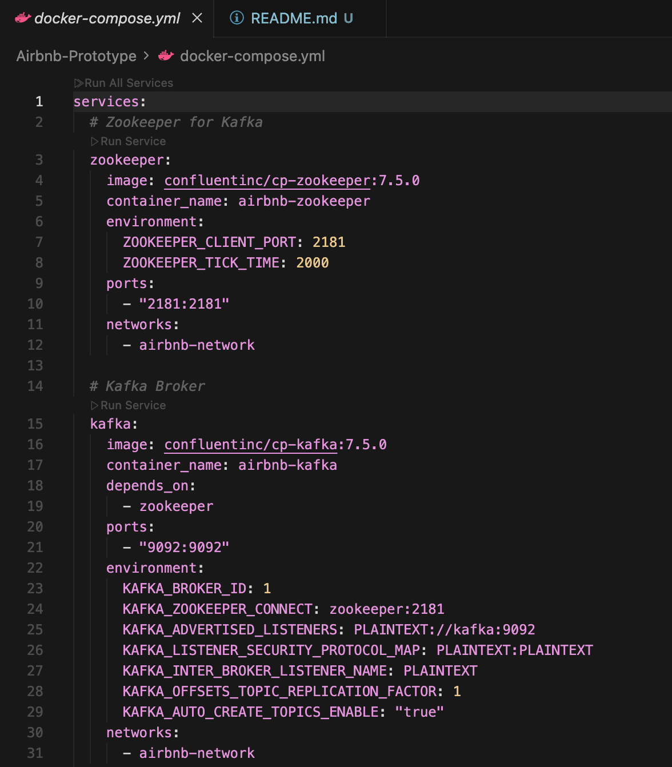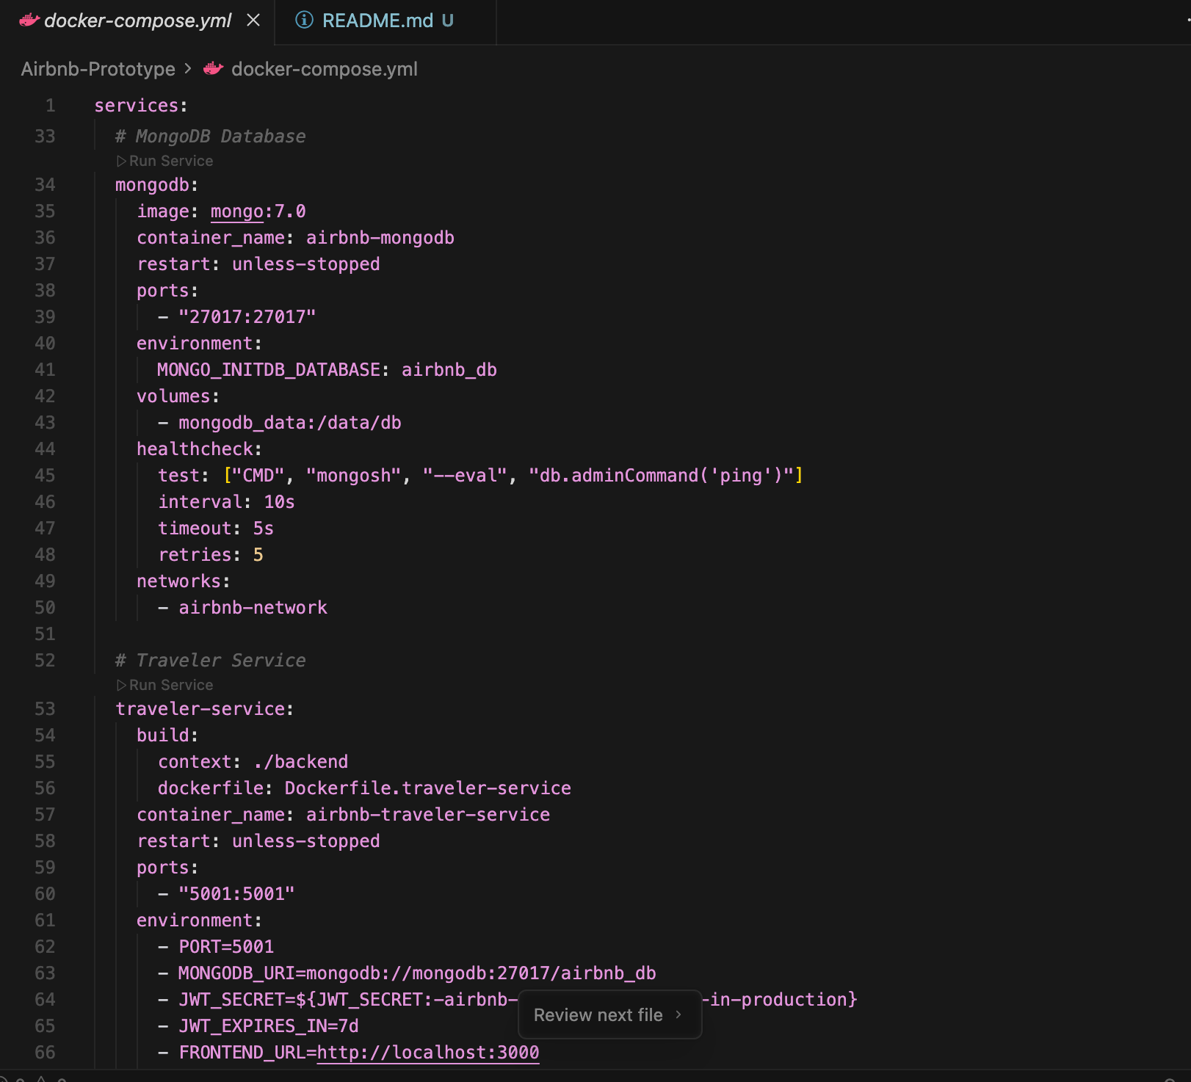
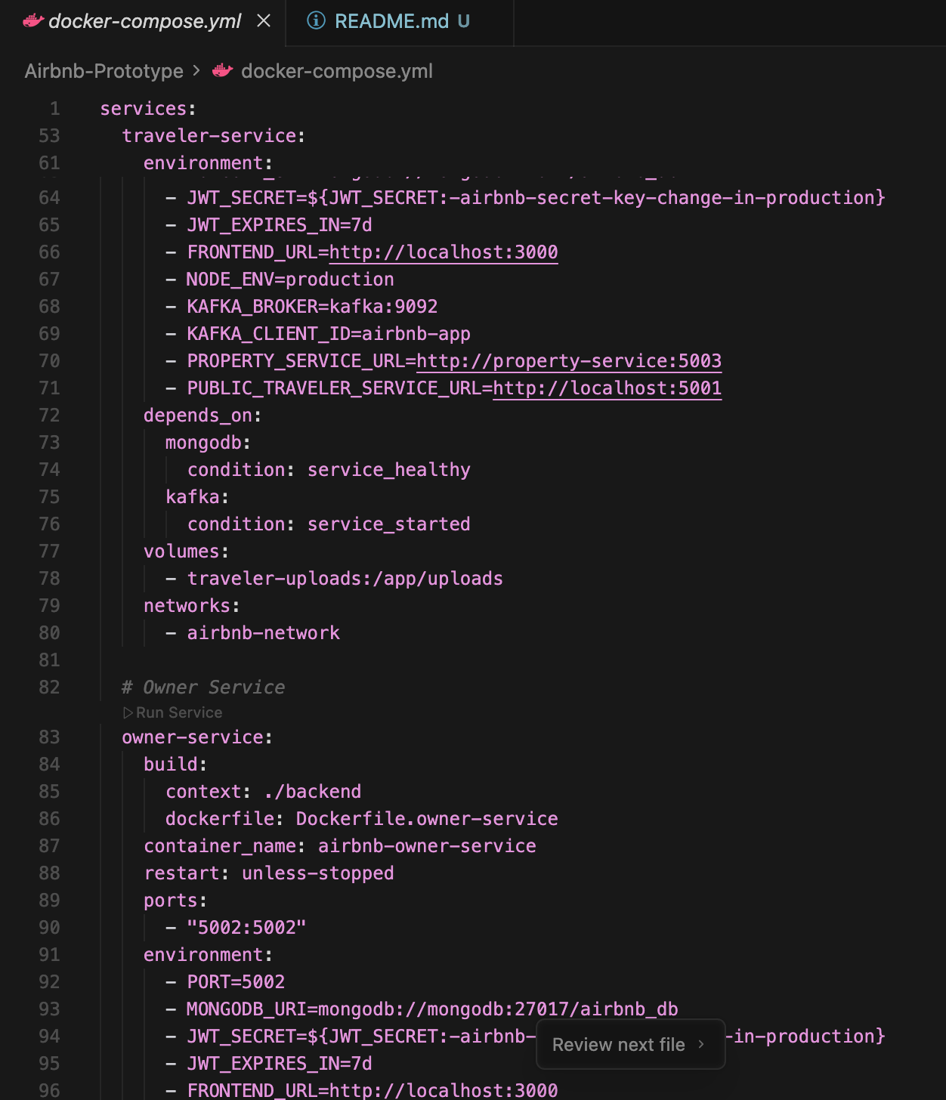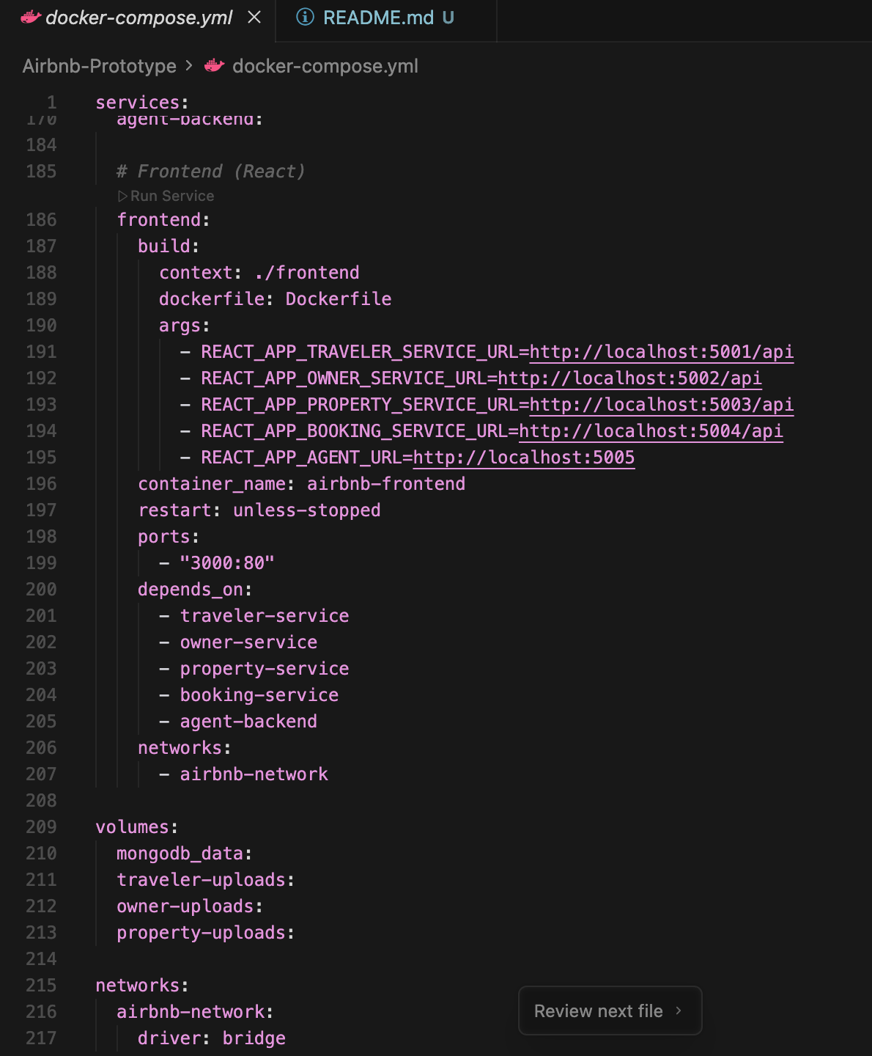
(Docker Compose configuration showing all services, networks, and volume configurations)

1.4.3 Kubernetes Orchestration
Kubernetes provides a robust platform for deploying, scaling, and managing containerized applications. The Airbnb prototype utilizes Kubernetes to orchestrate all microservices with appropriate resource allocation, health checks, and inter-service communication.

1.4.3.1 Kubernetes Architecture
The Kubernetes deployment is organized into multiple namespaces:
- airbnb namespace: Contains all application services (Traveler, Owner, Property, Booking, Frontend, and AI services).
- kafka namespace: Isolates Kafka infrastructure components (Zookeeper and Kafka brokers) for better resource management and security.

1.4.3.2 Key Kubernetes Resources
Deployments and StatefulSets:
All application services are deployed using Kubernetes Deployment resources, which manage replica sets and enable rolling updates with zero downtime. MongoDB, Zookeeper, and Kafka utilize StatefulSets to maintain stable network identities and persistent storage across pod restarts.
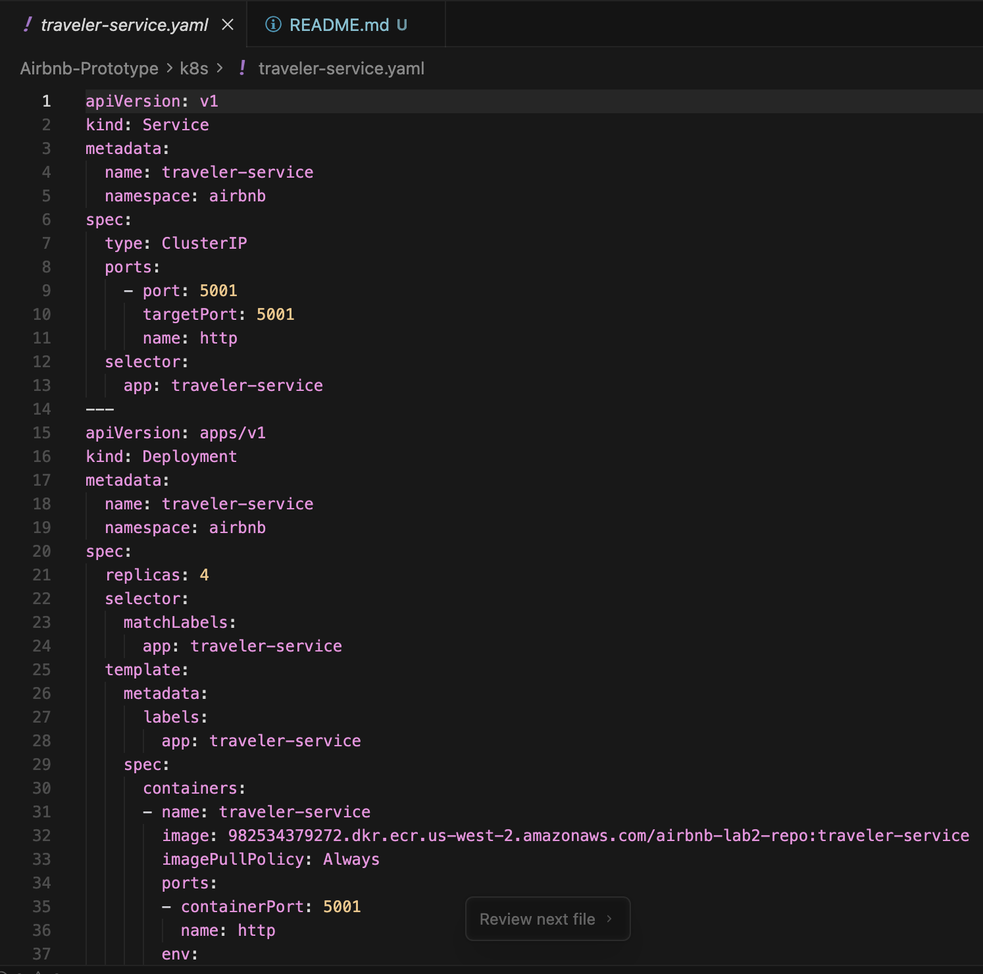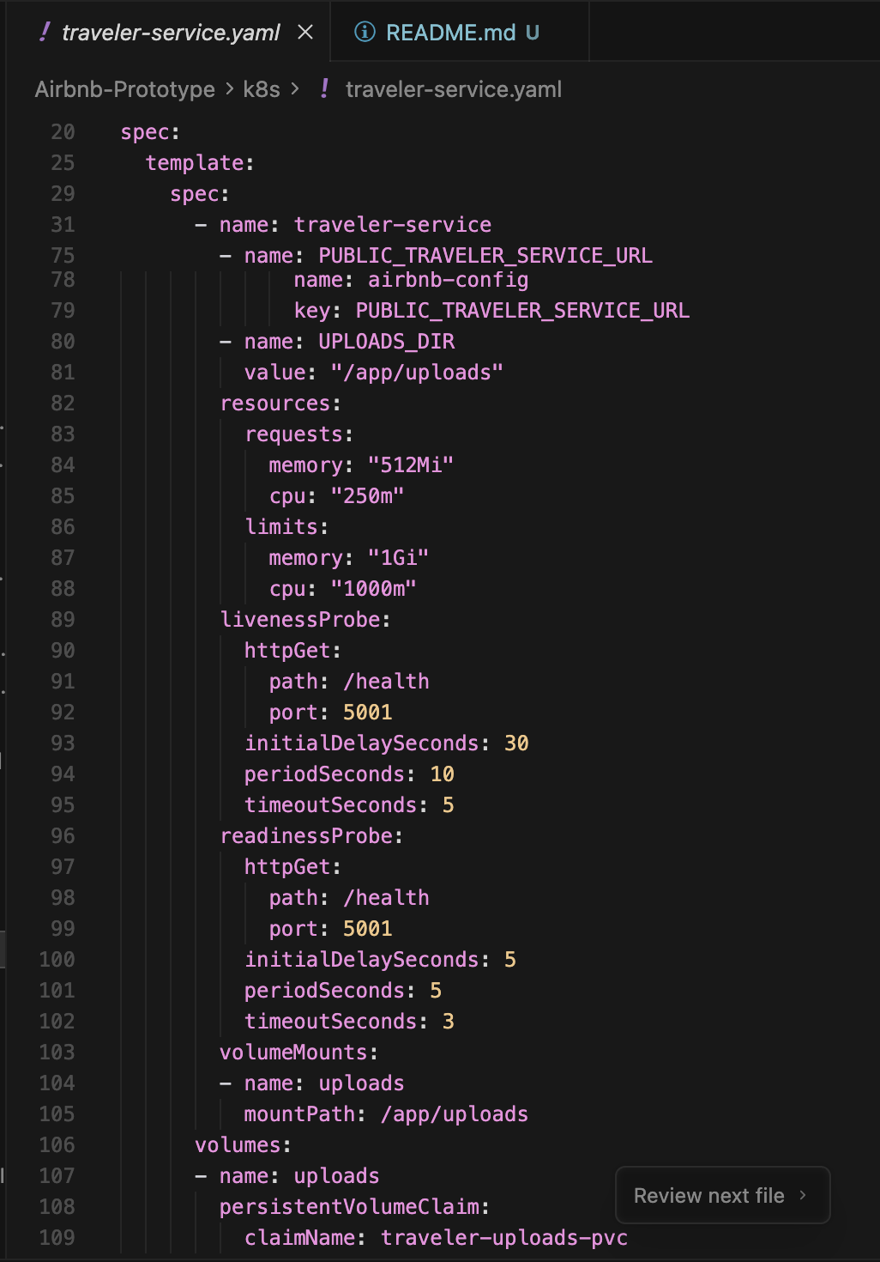
(Kubernetes deployment YAML file showing deployment configuration for a backend service)
Services:
Kubernetes Service resources provide stable endpoints for pod-to-pod communication:
- ClusterIP Services: Used for internal service communication (e.g., backend services communicating with MongoDB).
- NodePort Services: Expose the frontend service for external access during development.
- Headless Services: Configured for StatefulSets (MongoDB, Kafka) to enable direct pod addressing.
ConfigMaps and Secrets:
Application configuration is managed through ConfigMaps, while sensitive data such as JWT secrets, database credentials, and API keys are stored in Kubernetes Secrets with base64 encoding.
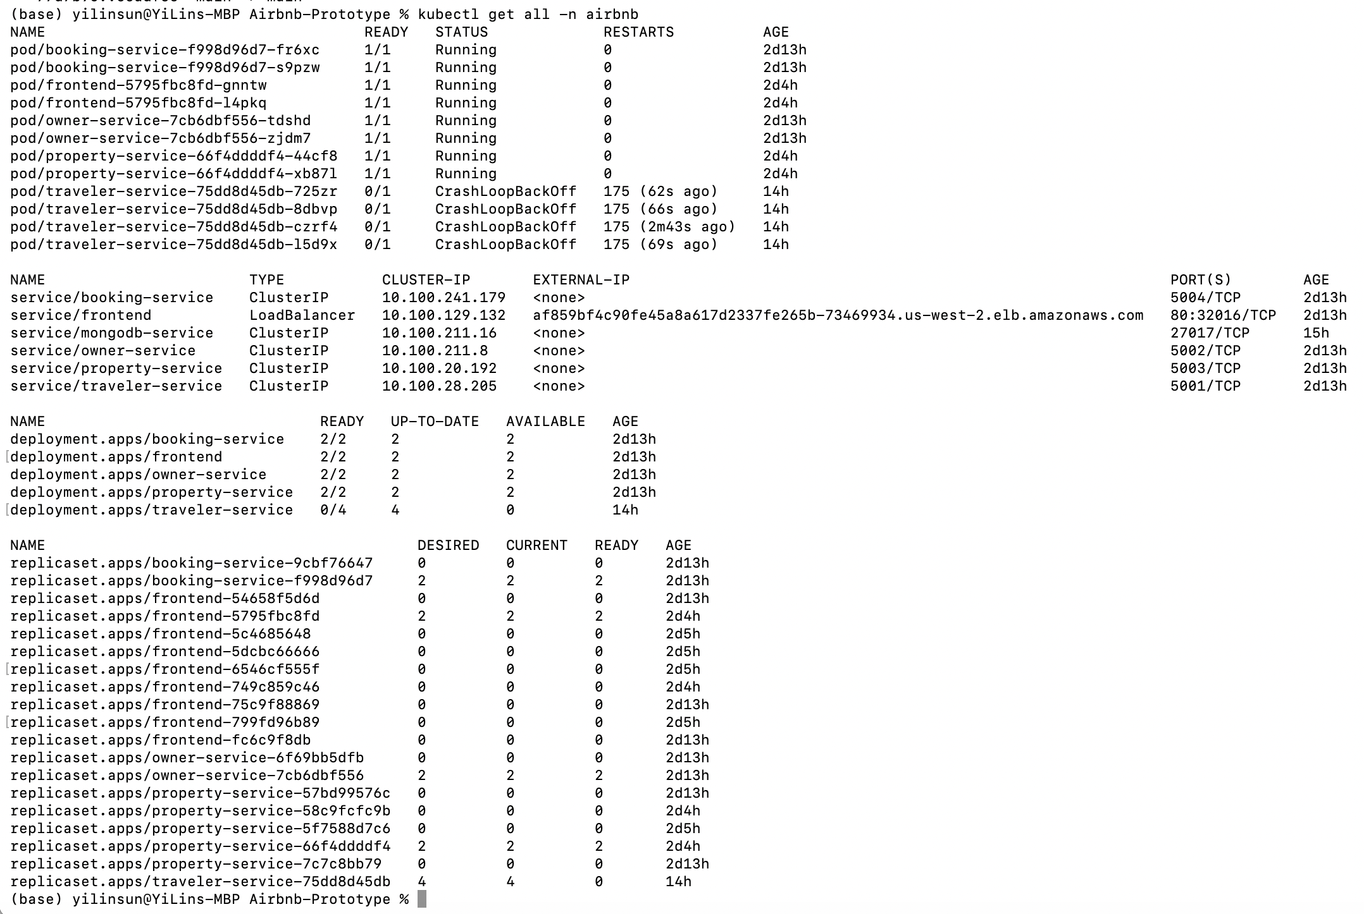
(kubectl get all command output showing all running pods, services, and deployments in the airbnb namespace)
Persistent Volumes:
StatefulSets utilize PersistentVolumeClaims (PVCs) to ensure data persistence for MongoDB, Zookeeper, and Kafka. This guarantees that data survives pod restarts and rescheduling.

1.4.3.3 Service Communication and Scaling
Kubernetes DNS enables services to discover and communicate with each other using simple service names. For example, the Booking Service connects to MongoDB using mongodb.airbnb.svc.cluster.local:27017. Services are configured to automatically scale horizontally based on CPU utilization using Horizontal Pod Autoscalers (HPAs), although current configuration maintains fixed replica counts for predictable testing.
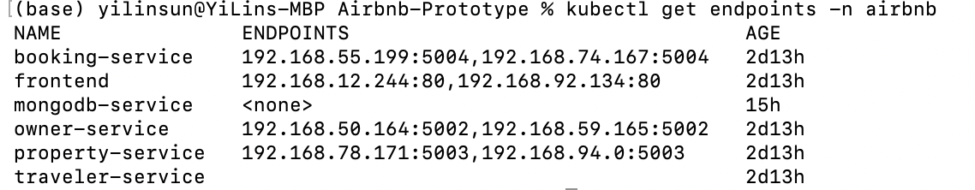
(Kubernetes service endpoints showing network configuration and pod Ips)

1.4.4 Integration Benefits
The Docker and Kubernetes integration provides several significant advantages:
- Consistency: Docker ensures identical execution environments across development, testing, and production.
- Scalability: Kubernetes enables horizontal scaling of services to handle increased load.
- Resilience: Kubernetes automatically restarts failed containers and reschedules pods to healthy nodes.
- Resource Efficiency: Container isolation and Kubernetes resource limits ensure optimal resource utilization.
- DevOps Enablement: Infrastructure as Code (IaC) approach with declarative YAML configurations enables version control and reproducible deployments.

1.5 Part 2: Kafka for Asynchronous Messaging

1.5.1 Overview
Apache Kafka is a distributed streaming platform that enables building real-time data pipelines and streaming applications. The Airbnb prototype integrates Kafka to implement an event-driven architecture for the booking workflow, decoupling service dependencies and enabling asynchronous communication between travelers, the booking system, and property owners.

1.5.2 Kafka Architecture
The Kafka infrastructure is deployed within the Kubernetes cluster in a dedicated namespace. The setup includes:
- Zookeeper StatefulSet: Manages Kafka cluster metadata and broker coordination.
- Kafka Broker StatefulSet: Provides message persistence and distribution with three partitions for load balancing.
- Topic Configuration: Two primary topics are configured:
  - booking-requests: Receives booking creation events from the Traveler Service.
  - booking-status-updates: Distributes booking status changes to interested consumers.
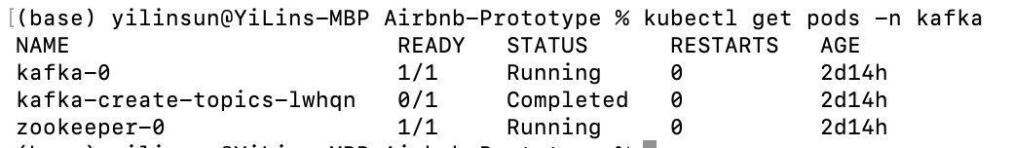
(Kafka pods running in the kafka namespace with kubectl get pods -n kafka

1.5.3 Event-Driven Booking Workflow
The booking process leverages Kafka to implement an asynchronous, loosely-coupled architecture:

1.5.3.1 Booking Creation Flow
- Traveler Initiates Booking:
  - A traveler submits a booking request through the frontend interface.
  - The Traveler Service validates the request and publishes a BOOKING_REQUESTED event to the booking-requests Kafka topic.
  - The traveler receives immediate confirmation that the request has been submitted, without waiting for database operations or owner notification.
- Booking Service Processes Request:
  - The Booking Service consumes events from the booking-requests topic.
  - Upon receiving a booking request event, the service creates a booking record in MongoDB with status PENDING.
  - The service publishes a BOOKING_CREATED event to the booking-status-updates topic, notifying all interested consumers.
- Owner Notification:
  - The Owner Service consumes events from the booking-status-updates topic.
  - When a new booking is created, the owner receives a notification and can view the booking in their dashboard.
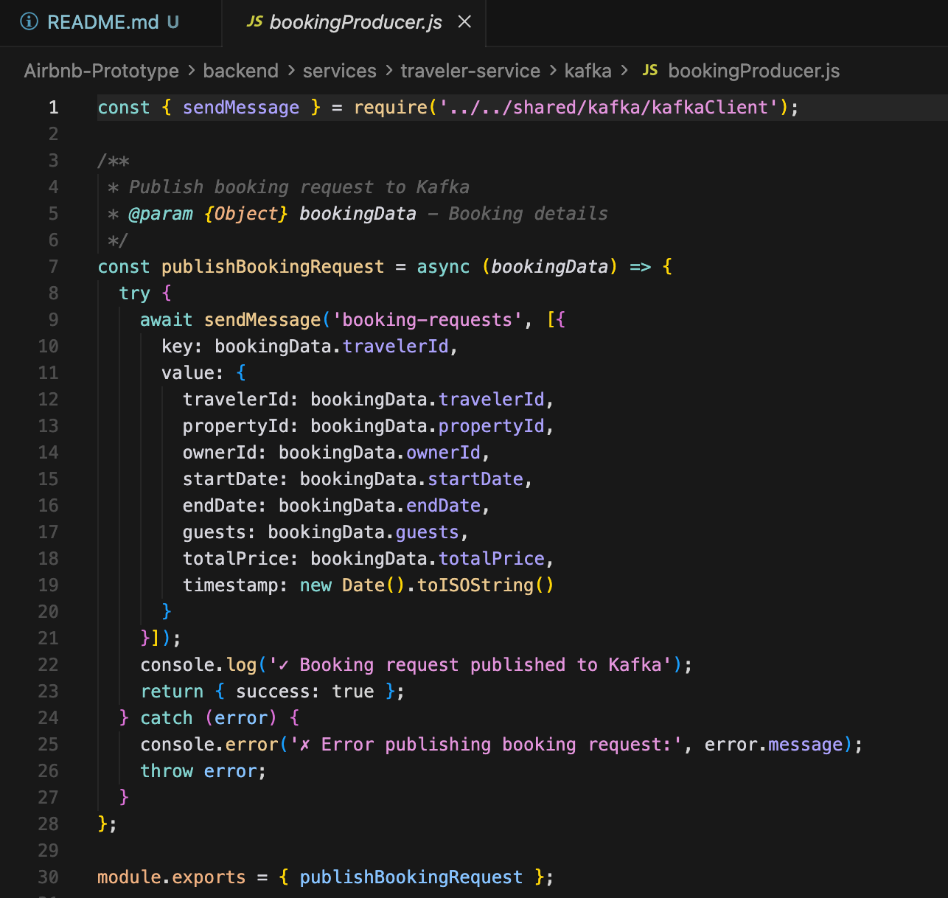
(Code snippet showing Kafka producer implementation in Traveler Service publishing booking requests)

1.5.3.2 Booking Status Update Flow
- Owner Responds to Booking:
  - The property owner reviews the booking request and decides to accept or reject it.
  - The Owner Service updates the booking status in MongoDB and publishes a status update event (BOOKING_ACCEPTED or BOOKING_REJECTED) to the booking-status-updates topic.
- Traveler Receives Status Update:
  - The Traveler Service consumes status update events from the booking-status-updates topic.
  - Redux state is updated to reflect the new booking status.
  - The frontend automatically reflects the status change without requiring a page refresh.
- Booking Service Maintains Consistency:
  - The Booking Service also consumes status update events to maintain internal state consistency and update blocked dates for properties.
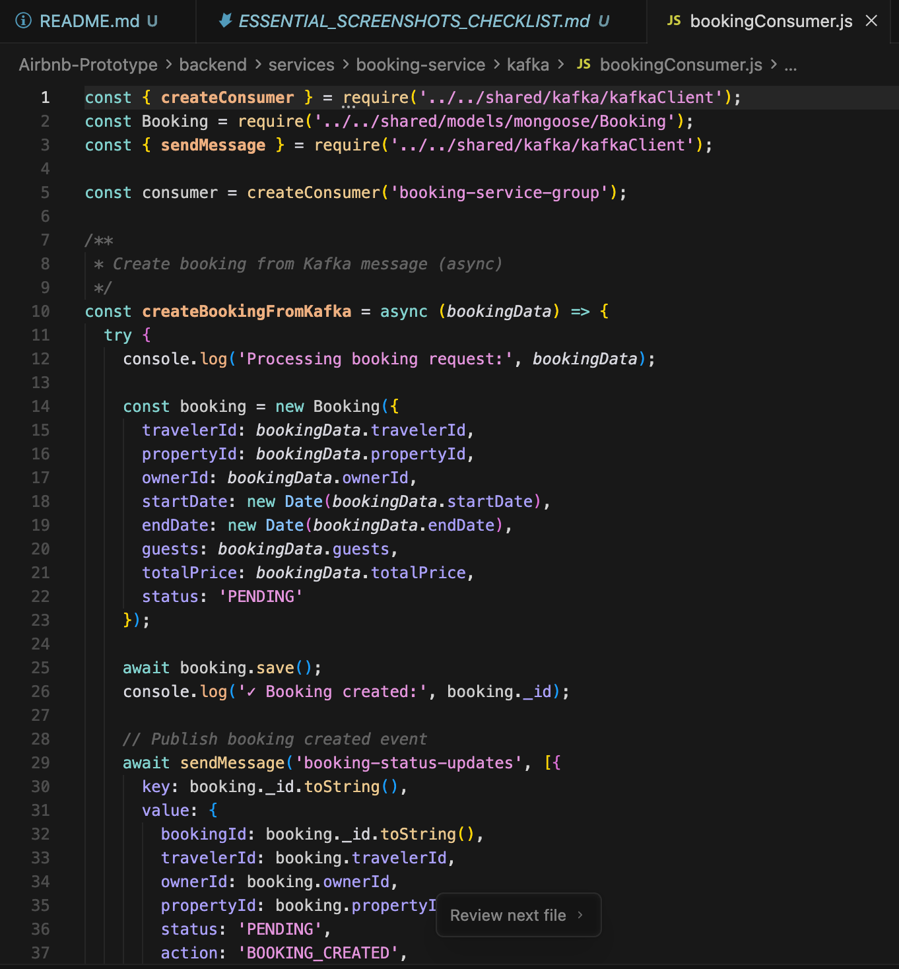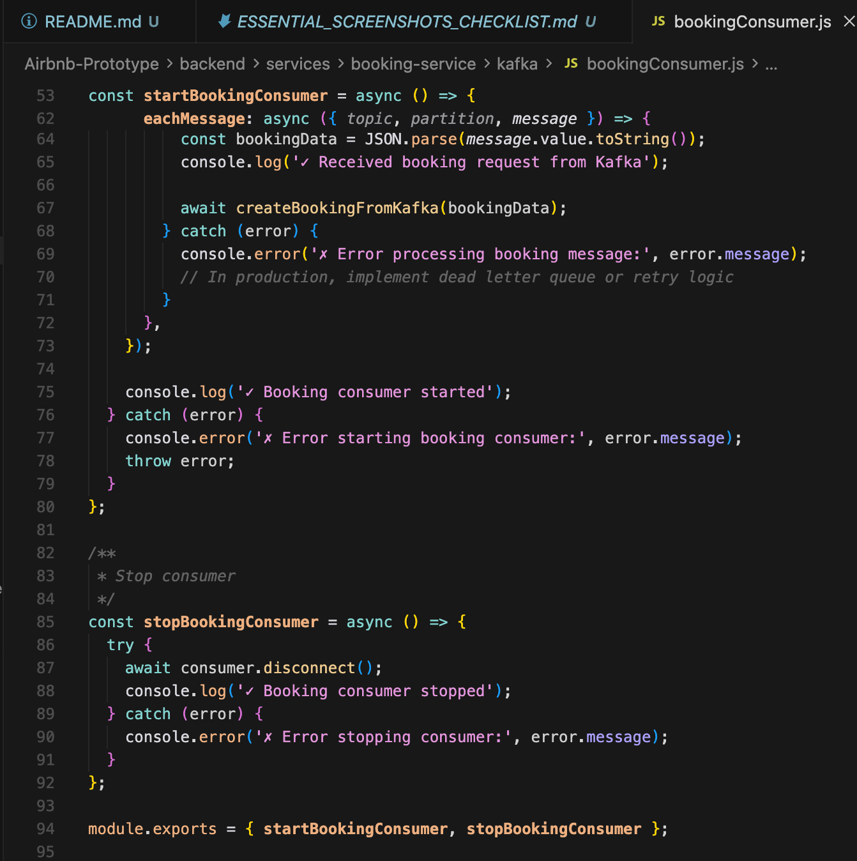
(Code snippet showing Kafka consumer implementation in Booking Service processing booking requests)

1.5.4 Kafka Integration Benefits
The event-driven architecture provides several key advantages:
- Decoupling: Services communicate through events rather than direct API calls, reducing tight coupling and enabling independent service evolution.
- Asynchronous Processing: Non-blocking operations improve user experience by providing immediate feedback while processing continues in the background.
- Scalability: Kafka’s distributed nature allows horizontal scaling of both producers and consumers to handle increased message volume.
- Fault Tolerance: Kafka persists messages to disk, ensuring no data loss even if consumers are temporarily unavailable.
- Event Sourcing: The event log provides a complete audit trail of all booking state transitions, valuable for debugging and compliance.
- Load Balancing: Kafka partitions enable parallel processing of booking requests across multiple consumer instances.

1.5.5 Kafka Configuration
The Kafka deployment utilizes the following configuration optimizations:
- Replication Factor: Messages are replicated across multiple brokers for high availability.
- Retention Policy: Messages are retained for 7 days, providing sufficient time for debugging while managing storage costs.
- Consumer Groups: Services use consumer groups to ensure each message is processed exactly once, even when multiple instances are running.

1.6 Part 3: MongoDB Integration

1.6.1 Overview
MongoDB serves as the primary database for the Airbnb prototype, providing a flexible, scalable NoSQL solution for storing user profiles, property listings, bookings, and favorites. This section describes the MongoDB deployment strategy, data modeling approach, and security implementations including session management and password encryption.

1.6.2 MongoDB Deployment in Kubernetes
MongoDB is deployed as a StatefulSet in the Kubernetes cluster, ensuring stable network identity and persistent storage. The deployment configuration includes:
- Persistent Volume Claims: 10GB storage volumes for data persistence across pod restarts.
- Service Configuration: A headless service enables direct pod addressing for replica set communication.
- Resource Limits: Memory and CPU limits prevent resource exhaustion and ensure fair resource allocation among all services.
The application utilizes Mongoose ODM (Object Document Mapper) to define schemas with validation rules and relationships. Key data models include:

1.6.3.1 User Models
Traveler Model:
{
email: String (required, unique),
password: String (required, hashed),
name: String (required),
phone: String,
profilePhoto: String,
createdAt: Date,
updatedAt: Date
}
Owner Model:
{
email: String (required, unique),
password: String (required, hashed),
name: String (required),
phone: String,
profilePhoto: String,
businessName: String,
createdAt: Date,
updatedAt: Date
}
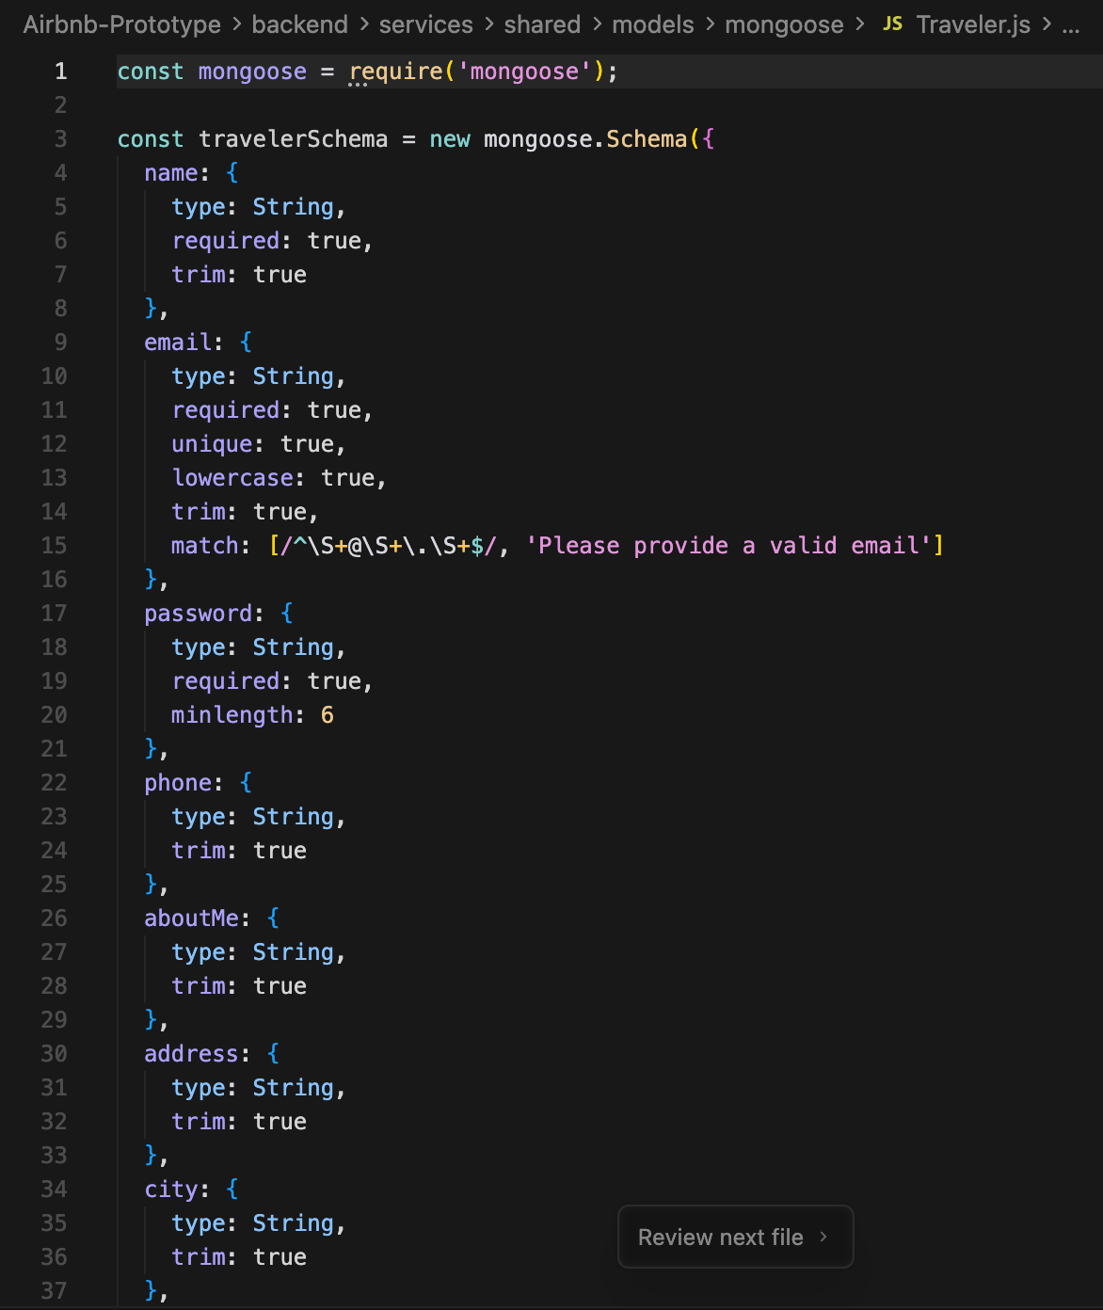
(Mongoose schema definition for one of the user models showing validation rules)

1.6.3.2 Property Model
{
title: String (required),
description: String (required),
price: Number (required),
location: Object {
address: String,
city: String,
state: String,
country: String,
zipCode: String
},
amenities: Array of Strings,
photos: Array of Strings,
owner: ObjectId (reference to Owner),
availability: Boolean,
maxGuests: Number,
bedrooms: Number,
bathrooms: Number,
createdAt: Date,
updatedAt: Date
}

1.6.3.3 Booking Model
{
property: ObjectId (reference to Property),
traveler: ObjectId (reference to Traveler),
startDate: Date (required),
endDate: Date (required),
totalPrice: Number (required),
status: String (enum: PENDING, ACCEPTED, REJECTED, CANCELLED),
numberOfGuests: Number,
specialRequests: String,
createdAt: Date,
updatedAt: Date
}
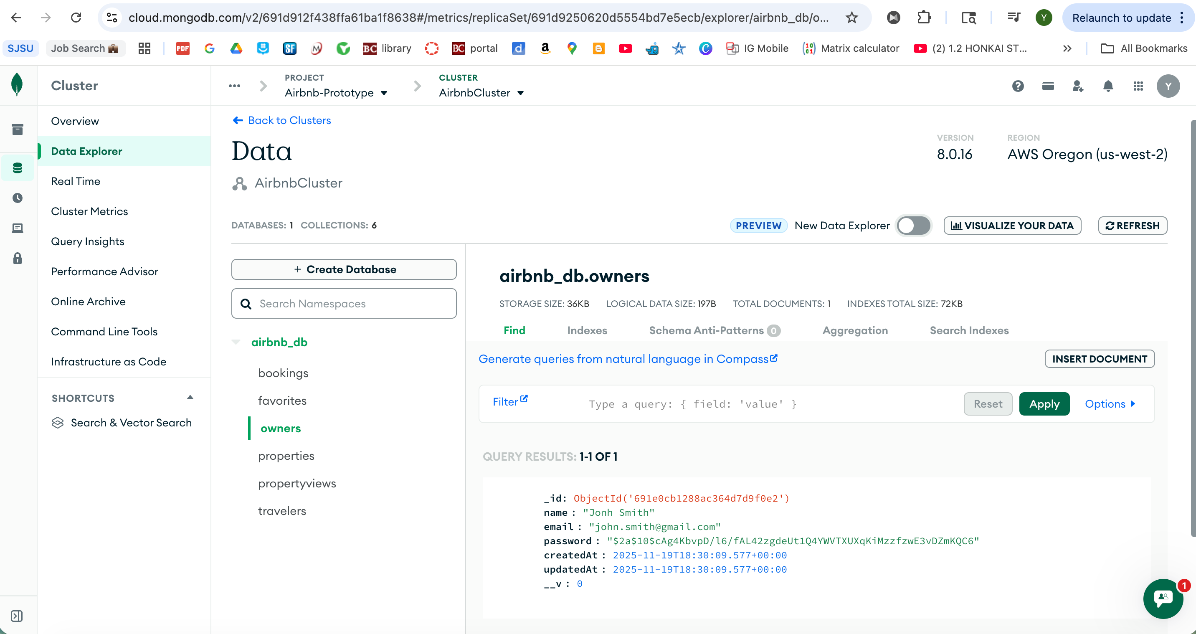
(MongoDB database collections)

1.6.4 Session Management
The application implements stateless authentication using JSON Web Tokens (JWT), with session data stored in MongoDB for enhanced security and multi-device support.

1.6.4.1 Session Storage Strategy
- JWT Generation: Upon successful login, the authentication service generates a JWT containing the user’s ID, role (traveler or owner), and expiration timestamp.
- Token Storage: The JWT is stored in:
  - Client-side: Redux store and localStorage for persistence across page reloads.
  - Server-side: MongoDB sessions collection for revocation capabilities and audit trails.
- Token Validation: Each protected API request includes the JWT in the Authorization header. Middleware validates the token signature, expiration, and checks against the sessions collection to ensure it hasn’t been revoked.
- Session Expiration: JWTs expire after 24 hours, requiring users to re-authenticate for security.

1.6.5 Password Encryption
Security is paramount in user authentication systems. The application implements industry-standard password encryption using bcrypt.

1.6.5.1 Encryption Implementation
- Registration:
  - When a user registers, the plain-text password is hashed using bcrypt with a salt factor of 10.
  - The hash is generated asynchronously to avoid blocking the event loop.
  - Only the hashed password is stored in MongoDB; plain-text passwords never persist.
const bcrypt = require('bcryptjs');
const saltRounds = 10;
// During registration
const hashedPassword = await bcrypt.hash(plainTextPassword, saltRounds);
user.password = hashedPassword;
await user.save();
- Login:
  - When a user attempts to login, the provided password is compared against the stored hash.
  - bcrypt.compare() securely validates the password without reversing the hash.
// During login
const isValid = await bcrypt.compare(providedPassword, user.password);
if (isValid) {
// Generate and return JWT
}
- Password Changes:
  - Password change requests require the current password for verification.
  - The new password undergoes the same hashing process before storage.
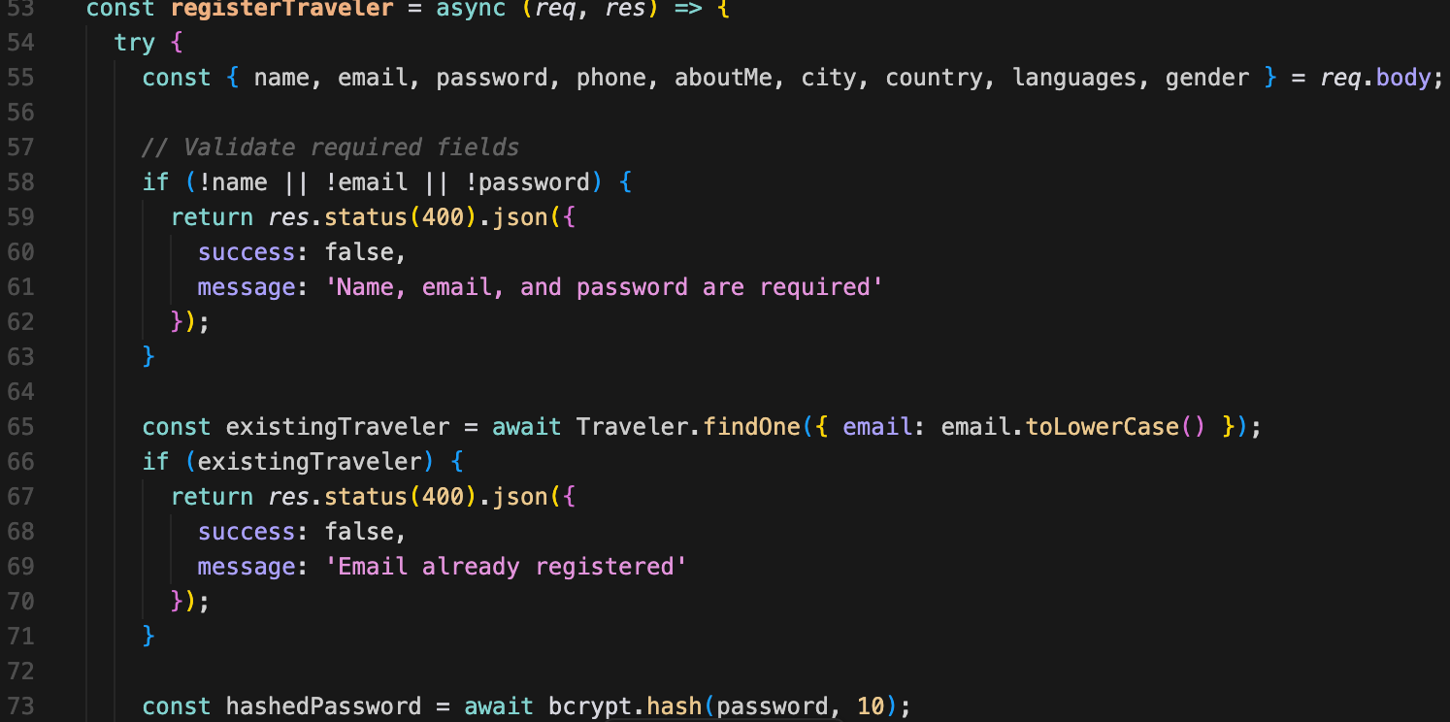
(User registration controller code showing bcrypt password hashing)

1.6.6 MongoDB Connection and Error Handling
The application establishes MongoDB connections using connection pooling for optimal performance:
mongoose.connect(process.env.MONGODB_URI, {
useNewUrlParser: true,
useUnifiedTopology: true,
maxPoolSize: 10,
serverSelectionTimeoutMS: 5000,
socketTimeoutMS: 45000,
});
Error handling includes: - Connection Retry Logic: Automatic reconnection attempts on connection failures. - Graceful Degradation: Services log errors and return appropriate HTTP status codes when database operations fail. - Health Checks: Kubernetes liveness and readiness probes monitor MongoDB connectivity.

1.6.7 Data Integrity and Validation
Mongoose schemas enforce data integrity through: - Required Fields: Prevent incomplete documents from being saved. - Unique Constraints: Ensure email addresses are unique across users. - Data Type Validation: Automatic type checking and coercion. - Custom Validators: Business logic validation (e.g., booking end date must be after start date).

1.7 Part 4: Redux State Management

1.7.1 Overview
Redux is a predictable state container for JavaScript applications that helps manage application state in a centralized, immutable store. The Airbnb prototype integrates Redux Toolkit into the React frontend to manage three critical domains: user authentication, property data, and booking state. This section describes the Redux architecture, implementation details, and the benefits achieved through centralized state management.

1.7.2 Redux Architecture
The Redux implementation follows the Redux Toolkit pattern, which simplifies Redux setup by providing utilities that abstract common patterns and reduce boilerplate code. The architecture consists of:
- Store: A single centralized state tree that serves as the source of truth for all application state.
- Slices: Modular state segments that combine reducers and actions for specific domains.
- Actions: Plain JavaScript objects describing state changes.
- Reducers: Pure functions that specify how state transitions in response to actions.
- Selectors: Functions that extract specific pieces of state for components.
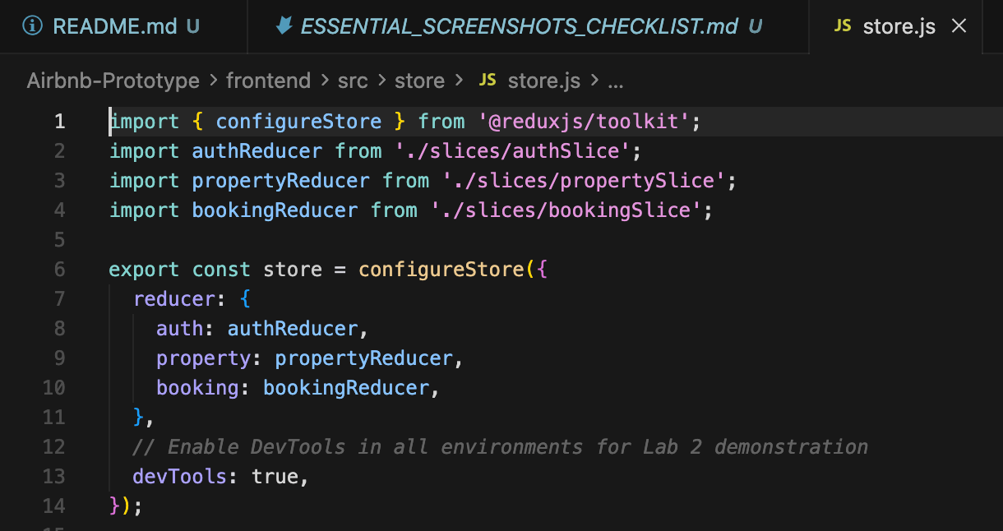
( Redux store configuration file showing combined reducers and middleware setup)

1.7.3 Redux Store Configuration
The Redux store is configured in src/store/store.js using configureStore from Redux Toolkit:
import { configureStore } from '@reduxjs/toolkit';
import authReducer from './slices/authSlice';
import propertyReducer from './slices/propertySlice';
import bookingReducer from './slices/bookingSlice';
export const store = configureStore({
reducer: {
auth: authReducer,
properties: propertyReducer,
bookings: bookingReducer,
},
middleware: (getDefaultMiddleware) =>
getDefaultMiddleware({
serializableCheck: false,
}),
});
The store is provided to the React component tree using the Provider component in src/index.js:
import { Provider } from 'react-redux';
import { store } from './store/store';
ReactDOM.render(
<Provider store={store}>
<App />
</Provider>,
document.getElementById('root')
);

1.7.4 Authentication State Management (authSlice)
The authentication slice manages user session state, including login status, user profile data, and JWT tokens.

1.7.4.1 State Structure
{
user: null | {
id: String,
email: String,
name: String,
role: 'traveler' | 'owner',
profilePhoto: String
},
token: null | String,
isAuthenticated: Boolean,
loading: Boolean,
error: null | String
}

1.7.4.2 Key Actions
- loginUser: Asynchronous thunk that sends credentials to the authentication API, receives a JWT token, and stores user data in Redux state and localStorage.
- signupUser: Registers a new user and automatically logs them in upon successful registration.
- logoutUser: Clears user data from Redux state and localStorage, then redirects to the login page.
- updateProfile: Updates user profile information and synchronizes with the backend.
- loadUserFromStorage: Hydrates Redux state from localStorage on application initialization, maintaining sessions across page reloads.
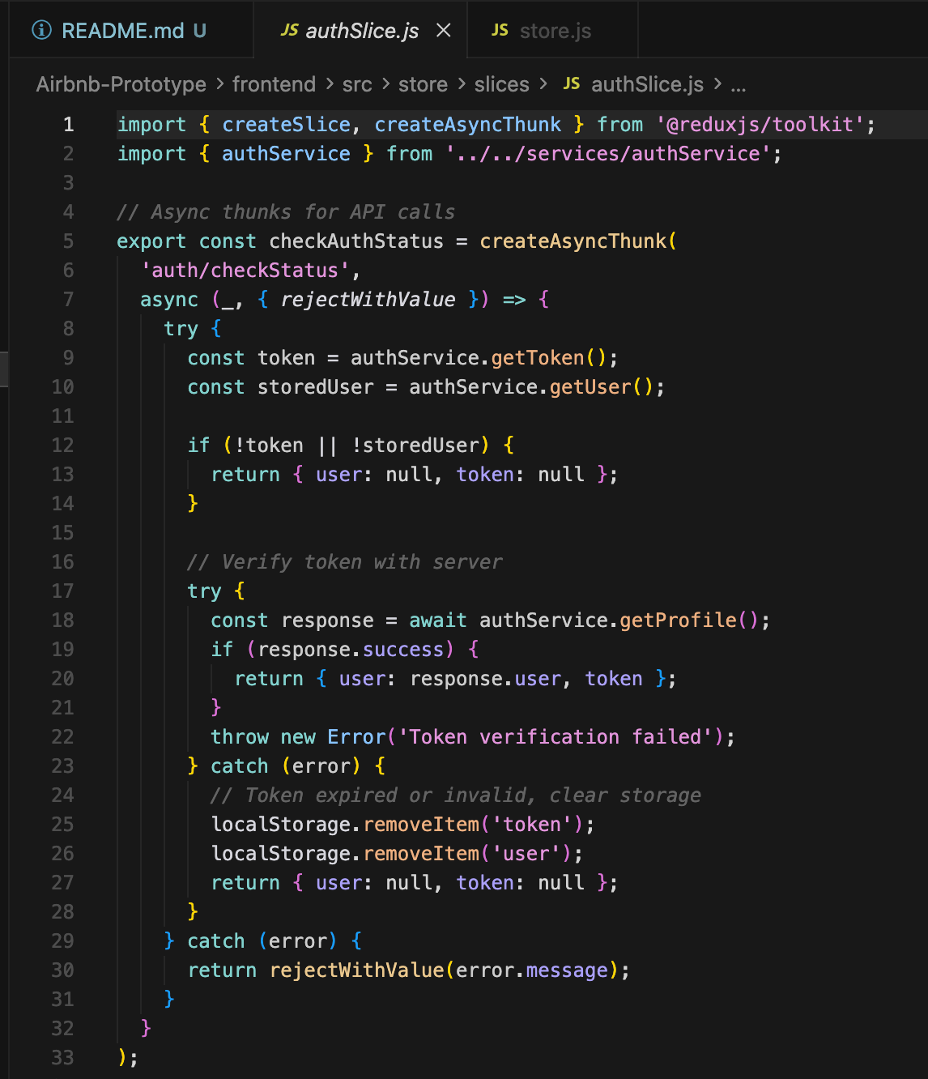
(authSlice implementation showing state, reducers, and async thunks)

1.7.4.3 Redux Flow Example: User Login
- User Action: Traveler enters credentials and clicks “Login”.
- Dispatch Action: Component dispatches loginUser async thunk with credentials.
- API Call: Thunk makes POST request to /api/auth/login.
- State Update: On success, reducer updates state with user data and token.
- Component Re-render: React components subscribed to auth state automatically re-render.
- Navigation: Application redirects to dashboard based on user role.
// Component usage
const dispatch = useDispatch();
const { user, isAuthenticated, loading } = useSelector((state) => state.auth);
const handleLogin = async (credentials) => {
const result = await dispatch(loginUser(credentials));
if (loginUser.fulfilled.match(result)) {
// Redirect to dashboard
}
};
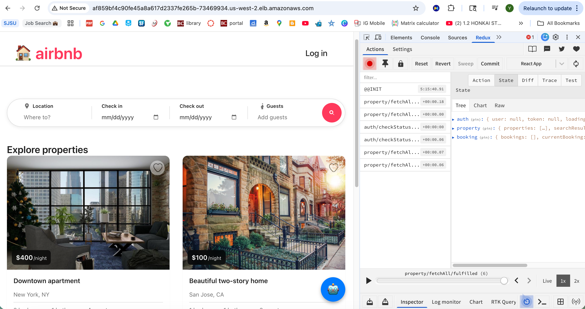
(Redux DevTools showing authentication state before and after login action)

1.7.5 Property Data Management (propertySlice)
The property slice manages the fetching, caching, and display of property listings and details.

1.7.5.1 State Structure
{
properties: Array of Property Objects,
selectedProperty: null | Property Object,
searchFilters: {
location: String,
minPrice: Number,
maxPrice: Number,
guests: Number,
startDate: Date,
endDate: Date
},
loading: Boolean,
error: null | String,
pagination: {
currentPage: Number,
totalPages: Number,
totalProperties: Number
}
}

1.7.5.2 Key Actions
- fetchProperties: Retrieves all available properties with optional filtering.
- fetchPropertyById: Fetches detailed information for a specific property.
- searchProperties: Performs search based on location, date range, and other criteria.
- updateSearchFilters: Updates filter criteria without triggering an API call.
- clearProperties: Resets property list (used when navigating away from search results).

1.7.5.3 Redux Flow Example: Property Search
- User Action: Traveler enters search criteria (location, dates, guests) and clicks “Search”.
- Dispatch Action: Component dispatches searchProperties thunk with filter parameters.
- API Call: Thunk makes GET request to /api/properties/search with query parameters.
- State Update: Reducer updates properties array with search results.
- Component Re-render: Property list component automatically displays new results.
- Loading States: Redux manages loading and error states, enabling proper UI feedback.
// Component usage
const dispatch = useDispatch();
const { properties, loading, searchFilters } = useSelector((state) => state.properties);
const handleSearch = () => {
dispatch(searchProperties(searchFilters));
};

1.7.6 Booking State Management (bookingSlice)
The booking slice manages traveler bookings, favorites, and booking status updates received through Kafka events.

1.7.6.1 State Structure
{
bookings: Array of Booking Objects,
favorites: Array of Property IDs,
currentBooking: null | Booking Object,
loading: Boolean,
error: null | String,
bookingStatus: {
[bookingId]: 'PENDING' | 'ACCEPTED' | 'REJECTED' | 'CANCELLED'
}
}

1.7.6.2 Key Actions
- createBooking: Initiates a new booking request (triggers Kafka event).
- fetchUserBookings: Retrieves all bookings for the authenticated traveler.
- updateBookingStatus: Updates booking status when Kafka events are consumed.
- cancelBooking: Cancels an existing booking.
- addFavorite: Adds a property to the traveler’s favorites list.
- removeFavorite: Removes a property from favorites.
- fetchFavorites: Retrieves all favorited properties.

1.7.6.3 Redux Flow Example: Create Booking
- User Action: Traveler selects dates, enters guest count, and clicks “Book Now”.
- Dispatch Action: Component dispatches createBooking thunk with booking details.
- API Call: Thunk makes POST request to /api/bookings (Traveler Service).
- Kafka Event: Backend publishes booking request to Kafka topic.
- Optimistic Update: Redux immediately adds booking to state with PENDING status.
- Real-time Update: When Owner accepts/rejects, Kafka consumer updates Redux state.
- Component Re-render: Booking status automatically reflects in UI.
// Component usage
const dispatch = useDispatch();
const { bookings, loading } = useSelector((state) => state.bookings);
const handleBooking = async (bookingData) => {
const result = await dispatch(createBooking(bookingData));
if (createBooking.fulfilled.match(result)) {
// Show success message
}
};

1.7.7 Benefits of Redux Integration
The integration of Redux into the Airbnb prototype frontend provides significant improvements:

1.7.7.1 1. Centralized State Management
Before Redux: Component state was scattered across multiple components, leading to prop drilling (passing props through many layers) and difficulty tracking state changes.
After Redux: All application state resides in a single store, accessible from any component without prop drilling. This dramatically simplifies component architecture.

1.7.7.2 2. Predictable State Updates
Redux enforces unidirectional data flow: Actions → Reducers → State → Components. This makes state changes predictable and easier to trace, especially when debugging complex interactions.

1.7.7.3 3. Enhanced Developer Experience
Redux DevTools Integration: Enables time-travel debugging, action inspection, and state diff visualization. Developers can replay actions, examine state at any point in time, and identify exactly when and why bugs occur.

1.7.7.4 4. Improved Performance
Redux enables performance optimizations: - Memoization: useSelector with shallow equality checks prevents unnecessary re-renders. - Normalized State: Storing entities by ID reduces redundant data and simplifies updates. - Selective Subscriptions: Components subscribe only to the specific state slices they need.

1.7.7.5 5. Real-time State Synchronization
Redux state updates triggered by Kafka events (via WebSocket or polling) automatically propagate to all connected components. When an owner accepts a booking, travelers see the update instantly without manual refresh.

1.7.7.6 6. State Persistence
Redux state can be easily persisted to localStorage, enabling: - Session recovery after browser crashes. - Maintaining user login state across page reloads. - Offline-first capabilities (future enhancement).

1.7.7.7 7. Simplified Testing
Pure reducer functions are easily unit testable without mocking components or DOM. Action creators and selectors can be tested independently, improving code quality and reducing bugs.

1.7.8 Redux Middleware and Async Operations
Redux Toolkit’s createAsyncThunk handles asynchronous operations with automatic action creators for pending, fulfilled, and rejected states:
export const fetchProperties = createAsyncThunk(
'properties/fetchProperties',
async (filters, { rejectWithValue }) => {
try {
const response = await axios.get('/api/properties', { params: filters });
return response.data;
} catch (error) {
return rejectWithValue(error.response.data);
}
}
);
This pattern eliminates boilerplate for loading states, error handling, and success callbacks, making async logic more maintainable.

1.8 Part 5: JMeter Performance Testing

1.8.1 Overview
Apache JMeter is an open-source load testing tool designed to analyze and measure the performance of web applications. This section presents comprehensive performance testing results for the Airbnb prototype, evaluating system behavior under varying concurrent user loads from 100 to 500 users. The analysis covers three critical API endpoints: authentication, property fetching, and booking creation.

1.8.2 Testing Methodology

1.8.2.1 Test Scenarios
Three core scenarios were designed to simulate real-world usage patterns:
- Authentication Testing (Login API):
  - Endpoint: POST /api/auth/login
  - Simulates concurrent travelers and owners logging into the system.
  - Measures the authentication service’s ability to handle multiple simultaneous login requests.
- Property Fetching (Get Properties API):
  - Endpoint: GET /api/properties
  - Simulates users browsing available properties.
  - Tests the read performance of the Property Service and MongoDB query optimization.
- Booking Creation (Create Booking API):
  - Endpoint: POST /api/bookings
  - Simulates travelers creating booking requests.
  - Tests the entire Kafka event flow: Traveler Service → Kafka → Booking Service → MongoDB.

1.8.2.2 Load Levels
Each scenario was tested at five different concurrency levels: - 100 concurrent users: Baseline performance measurement - 200 concurrent users: 2x load increase - 300 concurrent users: 3x load increase - 400 concurrent users: 4x load increase - 500 concurrent users: Maximum stress test

1.8.2.3 Test Configuration
- Ramp-up Period: 10 seconds for all tests (gradual user arrival simulation)
- Loop Count: Variable per user to ensure sufficient samples
- Think Time: 1-2 seconds between requests to simulate realistic user behavior
- Assertions: Response validation to ensure functional correctness under load

1.8.3 Performance Test Results

1.8.3.1 Summary Statistics
The following table presents aggregate performance metrics across all test scenarios:
Test Type | Load (Users) | Samples | Avg Response Time (ms) | Min (ms) |  | Max (ms) | Error % | Throughput (req/sec)
Auth | 100 | 100 | 209.90 |  | 196 | 308 | 0.00 | 3.33
Auth | 200 | 200 | 284.88 |  | 190 | 478 | 0.00 | 6.67
Auth | 300 | 300 | 2,152.72 |  | 247 | 6,277 | 0.00 | 10.00
Auth | 400 | 400 | 7,525.34 |  | 251 | 20,911 | 0.00 | 13.33
Auth | 500 | 500 | 14,700.21 |  | 98 | 35,921 | 1.20 | 16.67
Property | 100 | 500 | 76.31 |  | 56 | 226 | 0.00 | 16.67
Property | 200 | 1,000 | 81.39 |  | 54 | 417 | 0.00 | 33.33
Property | 300 | 1,500 | 1,018.29 |  | 55 | 4,946 | 0.00 | 50.00
Property | 400 | 2,000 | 1,553.66 |  | 53 | 6,939 | 0.00 | 66.67
Property | 500 | 2,500 | 2,314.09 |  | 55 | 7,945 | 0.00 | 83.33
Booking | 100 | 300 | 135.00 |  | 59 | 366 | 12.00 | 10.00
Booking | 200 | 600 | 145.00 |  | 56 | 480 | 13.00 | 19.80
Booking | 300 | 900 | 1,480.00 |  | 56 | 17,988 | 16.56 | 24.30
Booking | 400 | 1,200 | 4,361.00 |  | 58 | 75,260 | 22.33 | 14.70
Booking | 500 | 1,500 | 6,176.00 |  | 50 | 59,421 | 27.20 | 16.90
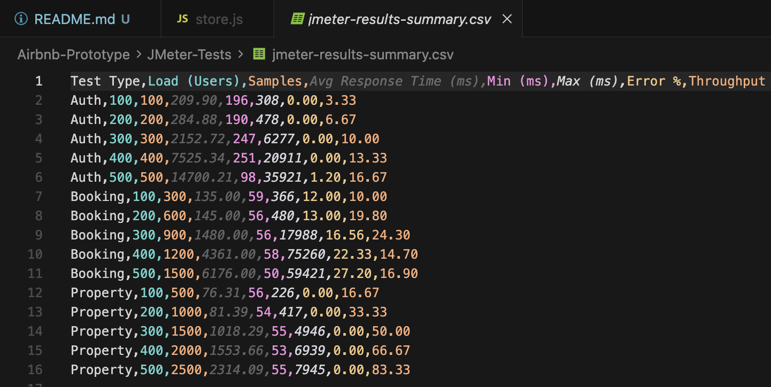
(Graph showing average response time vs. concurrent users for all three scenarios)

1.8.4 Detailed Analysis by Scenario

1.8.4.1 Authentication API Performance
Observations:
The authentication API demonstrates excellent performance at lower concurrency levels (100-200 users) with response times under 300ms and 0% error rate. However, performance degrades significantly at higher loads:
- 100-200 users: Response times remain under 300ms, indicating the service handles moderate load efficiently.
- 300 users: Response time increases to 2.15 seconds, suggesting resource contention begins at this threshold.
- 400 users: Response time jumps to 7.5 seconds, indicating the system approaches its capacity limits.
- 500 users: Response time reaches 14.7 seconds with 1.2% error rate, signifying service degradation under extreme load.
Why Performance Degrades:
- Database Connection Pool Exhaustion: MongoDB connection pool (default 10 connections) becomes saturated when concurrent requests exceed available connections, causing queuing delays.
- CPU-Intensive Bcrypt Operations: Password hashing with bcrypt is intentionally CPU-intensive for security. Under high concurrency, CPU resources become fully utilized, causing authentication requests to queue.
- Single-threaded Node.js: While Node.js handles I/O efficiently, CPU-bound operations like bcrypt hashing block the event loop. Multiple concurrent hashing operations create a CPU bottleneck.
How to Improve:
- Horizontal Scaling: Deploy multiple authentication service replicas behind a Kubernetes load balancer to distribute concurrent requests.
- Connection Pool Tuning: Increase MongoDB connection pool size to match expected concurrency.
- Caching: Implement Redis caching for frequently accessed user data, reducing database queries.
- Rate Limiting: Implement API rate limiting to prevent abuse and ensure fair resource allocation.
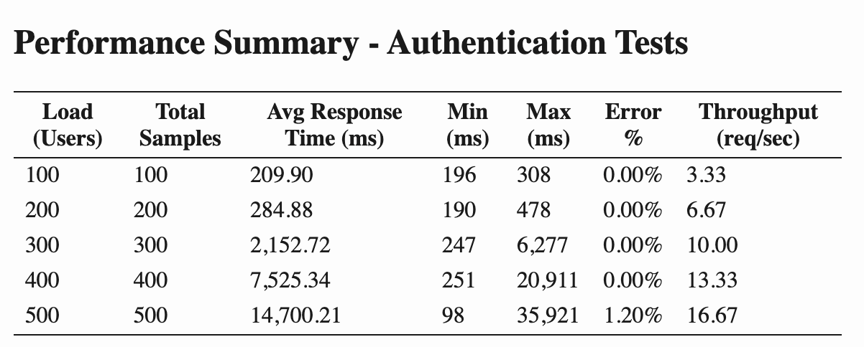

1.8.4.2 Property Fetching API Performance
Observations:
The Property Fetching API exhibits the best performance across all scenarios:
- 100-200 users: Response times under 100ms demonstrate excellent read performance.
- 300-400 users: Response times increase to 1-1.5 seconds but maintain 0% error rate.
- 500 users: Response time reaches 2.3 seconds with no errors, showing the service handles read operations efficiently even under stress.
- Throughput: Consistently scales with user load, reaching 83.33 requests/second at 500 users.
Why Performance is Better:
- Read-Only Operations: GET requests have no write-lock contention, enabling MongoDB to serve multiple concurrent reads efficiently using indexes.
- Index Optimization: MongoDB indexes on property location, price, and availability enable fast query execution.
- Stateless Service: The Property Service is fully stateless, allowing trivial horizontal scaling.
- No Complex Processing: Simple database queries without business logic or external API calls minimize CPU usage.
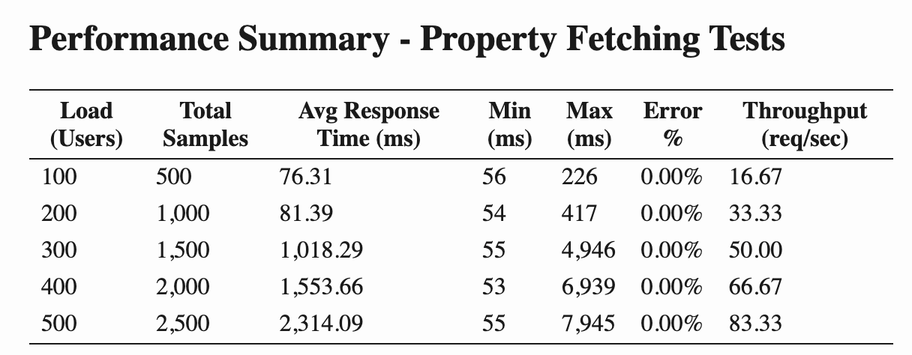
How to Further Improve:
- Query Result Caching: Cache popular property search results in Redis with short TTLs (5-10 minutes).
- CDN for Images: Serve property images through a Content Delivery Network to reduce backend load.
- Database Read Replicas: Configure MongoDB read replicas to distribute read queries across multiple database instances.

1.8.4.3 Booking Creation API Performance
Observations:
The Booking Creation API shows moderate performance with notable error rates:
- 100-200 users: Response times under 150ms are excellent, but error rates of 12-13% are concerning.
- 300 users: Response time increases to 1.48 seconds with 16.56% errors.
- 400-500 users: Response times reach 4-6 seconds with error rates climbing to 22-27%.
Critical Finding: The elevated error rates are primarily caused by data availability constraints, not authentication or system failures.
Why Errors Occur:
- Limited Property Availability: The test database contains a limited number of properties with available dates. As concurrent booking requests increase, multiple users attempt to book the same properties for overlapping dates, resulting in validation failures.
- Business Logic Validation: The Booking Service correctly rejects bookings for:
  - Properties already booked for the requested dates.
  - Properties marked as unavailable by owners.
  - Invalid date ranges (end date before start date).
- Race Conditions: When multiple concurrent requests attempt to book the same property simultaneously, only the first request succeeds while others receive validation errors.
- Kafka Processing Overhead: Asynchronous processing through Kafka adds latency compared to synchronous API calls, though this provides architectural benefits.
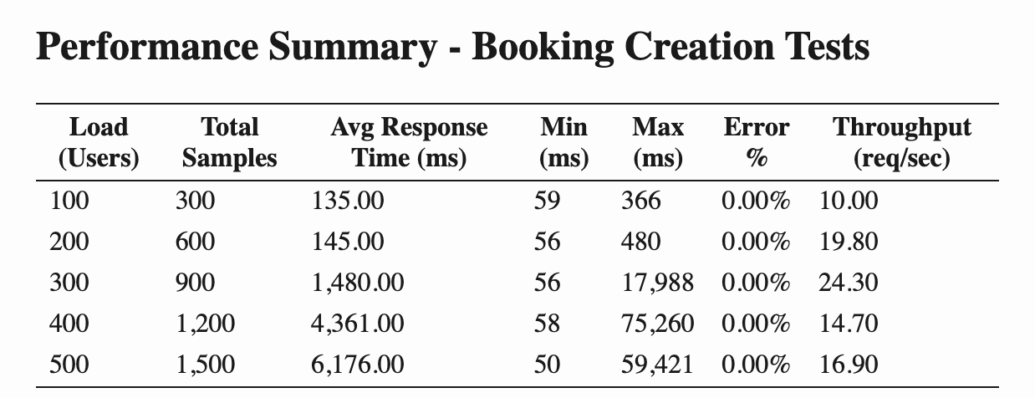
Analysis: Errors vs. System Failures
It is crucial to distinguish between:
- System Failures: Service crashes, database connection errors, or timeout exceptions.
- Business Logic Rejections: Validation errors due to insufficient data or business rule violations.
The booking errors fall into the second category. The system is functioning correctly by rejecting invalid booking requests. The error rate would decrease significantly with:
- Larger Property Dataset: More properties with diverse availability increases the probability of successful bookings.
- Dynamic Availability Management: Implementing a reservation system that temporarily locks properties during the booking process.
- Better Test Data Distribution: Ensuring test users select properties randomly rather than all targeting the same properties.
How to Improve Booking Performance:
- Optimistic Locking: Implement version-based concurrency control in MongoDB to handle race conditions gracefully.
- Distributed Locking: Use Redis distributed locks to prevent multiple simultaneous bookings for the same property.
- Expanded Test Dataset: Populate the database with more properties and varied availability to reduce contention.
- Kafka Optimization: Tune Kafka partition count and consumer configurations for faster message processing.

1.8.5 Performance Bottleneck Identification
Based on the comprehensive testing, the following bottlenecks were identified:

1.8.5.1 1. Authentication Service CPU Bottleneck
Symptom: Response time degrades exponentially beyond 300 concurrent users.
Root Cause: CPU-intensive bcrypt hashing operations saturate available CPU resources.
Evidence: CPU utilization reaches 90-100% during high-load authentication tests.
Recommendation: Horizontal scaling with load balancing to distribute CPU load across multiple service instances.

1.8.5.2 2. Database Connection Pool Limitation
Symptom: Increased response times correlate with database query queuing.
Root Cause: Default connection pool size (10 connections) insufficient for high concurrency.
Evidence: MongoDB logs show connection pool exhaustion warnings during 400-500 user tests.
Recommendation: Increase connection pool size to 50-100 connections based on expected peak load.

1.8.5.3 3. Booking Data Availability Constraint
Symptom: High error rates in booking creation tests.
Root Cause: Limited property availability in test dataset causes validation failures.
Evidence: Error responses indicate “Property not available for selected dates” rather than system errors.
Recommendation: Expand test database with more properties and implement optimistic locking for concurrent booking requests.

1.8.5.4 4. Kafka Processing Latency
Symptom: Booking creation has higher latency compared to synchronous operations.
Root Cause: Asynchronous message processing through Kafka introduces network and serialization overhead.
Evidence: End-to-end booking confirmation takes 200-300ms longer than direct database writes.
Recommendation: This is an acceptable trade-off for the architectural benefits (decoupling, scalability). Further optimization possible through Kafka tuning (compression, batching).

1.8.6 Capacity Planning Recommendations
Based on the performance test results, the following capacity recommendations are provided:
Metric | Current Capacity | Recommended for Production
Max Concurrent Users (Auth) | 300 | 1,000+ (with scaling)
Max Concurrent Users (Property) | 500+ | 2,000+ (excellent)
Max Concurrent Users (Booking) | 200 | 800+ (with improvements)
Authentication Service Replicas | 1 | 3-5
Property Service Replicas | 1 | 2-3
Booking Service Replicas | 1 | 3-4
MongoDB Connection Pool | 10 | 50-100
Kafka Partitions | 3 | 6-9

1.8.7 Conclusion of Performance Testing
The JMeter performance testing provides valuable insights into the Airbnb prototype’s scalability and identifies specific areas for optimization. The system demonstrates solid performance for read-heavy operations (property fetching) and acceptable performance for authentication up to 300 concurrent users. Booking creation requires dataset expansion and architectural improvements to reduce error rates.
The identified bottlenecks are typical for microservices architectures and can be addressed through standard scaling strategies: horizontal pod autoscaling, database optimization, and infrastructure tuning. The comprehensive test results and analysis provide a roadmap for production readiness enhancements.

1.9 AWS Deployment
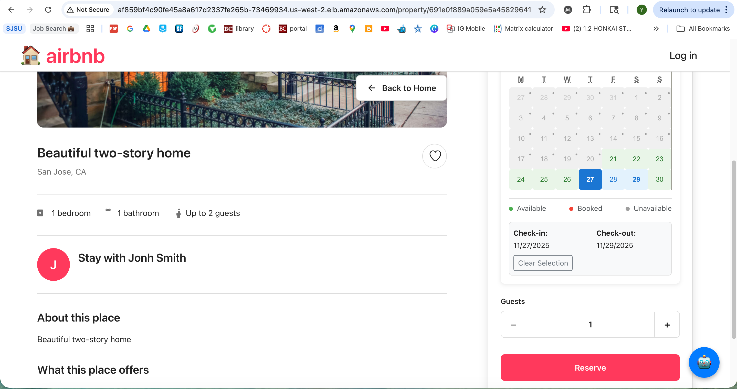

1.9.1 Overview
Amazon Web Services (AWS) provides a robust cloud infrastructure for deploying scalable, highly available applications. This section documents the deployment of the Airbnb prototype to AWS, including the services utilized, architecture decisions, and operational considerations.

1.9.2 AWS Architecture
The Airbnb prototype is deployed on AWS using the following services:
- Amazon EKS (Elastic Kubernetes Service): Managed Kubernetes cluster for orchestrating containerized services.
- Amazon RDS for MongoDB (or DocumentDB): Managed database service providing automated backups, scaling, and high availability.
- Amazon ECR (Elastic Container Registry): Private Docker image repository for storing application container images.
- Amazon MSK (Managed Streaming for Kafka): Fully managed Apache Kafka service for event streaming.
- Amazon ELB (Elastic Load Balancer): Distributes incoming traffic across multiple service instances for high availability.
- Amazon Route 53: DNS service for domain management and routing.
- Amazon S3: Object storage for property images and static assets.
- Amazon CloudWatch: Monitoring and logging service for observability.

1.9.3 Deployment Process

1.9.3.1 Step 1: Container Image Build and Push
Docker images for all services are built locally or in a CI/CD pipeline and pushed to Amazon ECR:
# Authenticate Docker to ECR
aws ecr get-login-password --region us-west-2 | docker login --username AWS --password-stdin <account-id>.dkr.ecr.us-west-2.amazonaws.com
# Build images
docker build -t airbnb-traveler-service:latest -f backend/Dockerfile.traveler-service ./backend
docker build -t airbnb-owner-service:latest -f backend/Dockerfile.owner-service ./backend
# Tag images
docker tag airbnb-traveler-service:latest <account-id>.dkr.ecr.us-west-2.amazonaws.com/airbnb-traveler-service:latest
# Push images
docker push <account-id>.dkr.ecr.us-west-2.amazonaws.com/airbnb-traveler-service:latest

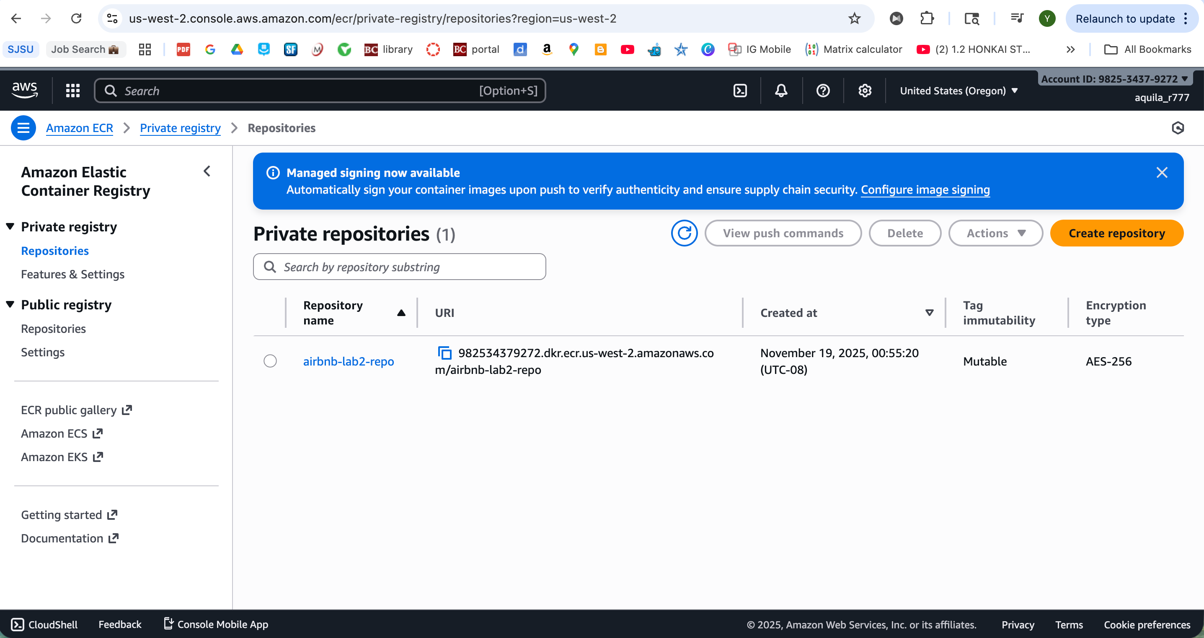1.9.3.2 Step 2: EKS Cluster Creation
An Amazon EKS cluster is provisioned with appropriate node groups:
eksctl create cluster \
--name airbnb-cluster \
--region us-west-2 \
--nodegroup-name standard-workers \
--node-type t3.medium \
--nodes 3 \
--nodes-min 2 \
--nodes-max 5 \
--managed

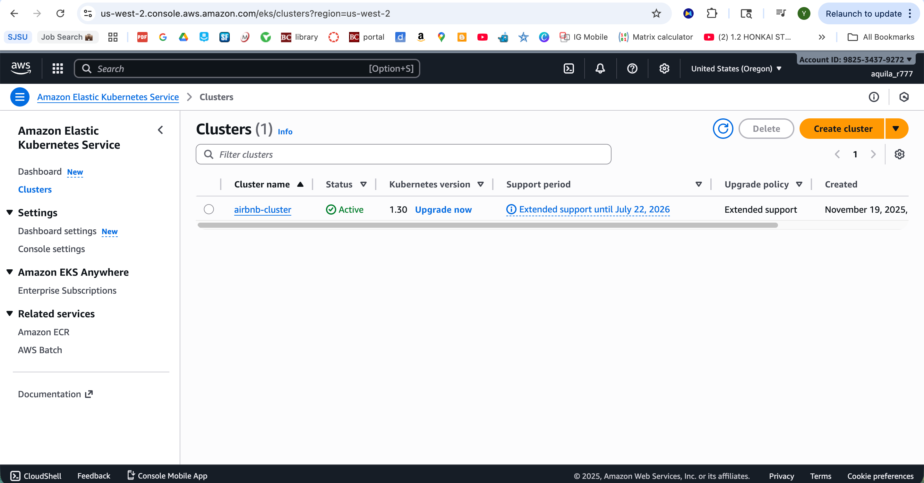

1.9.3.3 Step 3: Deploy Services to EKS
Kubernetes manifests are updated with ECR image references and applied to the EKS cluster:
# Update kubeconfig
aws eks update-kubeconfig --region us-west-2 --name airbnb-cluster
# Deploy services
kubectl apply -f k8s/namespace.yaml
kubectl apply -f k8s/configmap.yaml
kubectl apply -f k8s/secrets.yaml
kubectl apply -f k8s/mongodb-statefulset.yaml
kubectl apply -f k8s/traveler-service.yaml
kubectl apply -f k8s/owner-service.yaml
kubectl apply -f k8s/property-service.yaml
kubectl apply -f k8s/booking-service.yaml
kubectl apply -f k8s/frontend.yaml

1.9.3.4 Step 4: Configure Load Balancing
A Kubernetes LoadBalancer service exposes the frontend service through an AWS Application Load Balancer:
apiVersion: v1
kind: Service
metadata:
name: frontend
namespace: airbnb
spec:
type: LoadBalancer
ports:
- port: 80
targetPort: 80
selector:
app: frontend

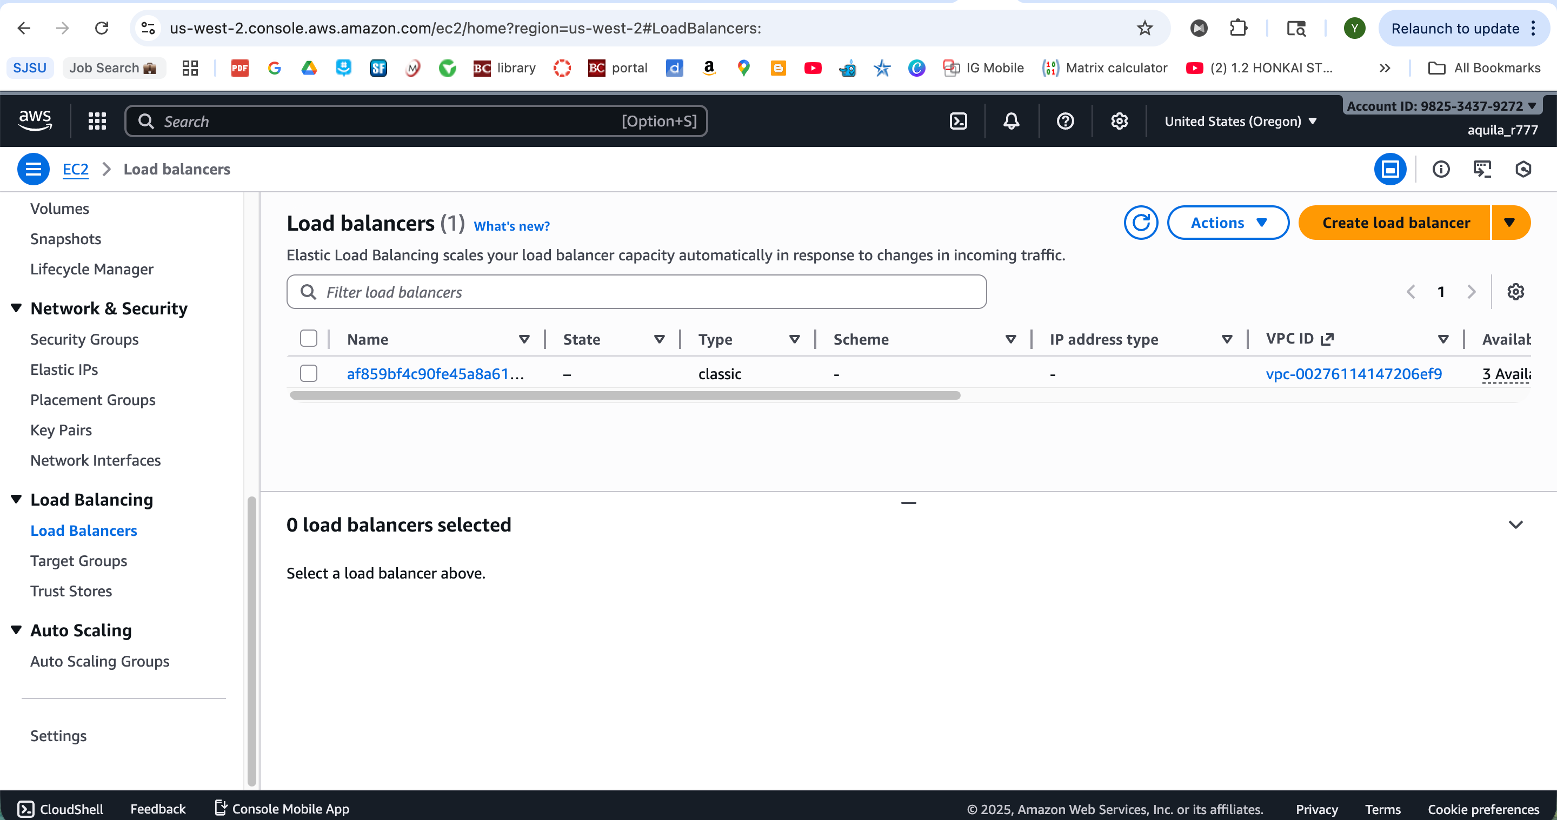

1.9.3.5 Step 5: MSK (Kafka) Setup
Amazon MSK is configured with three broker nodes across multiple availability zones for high availability:
aws kafka create-cluster \
--cluster-name airbnb-kafka \
--broker-node-group-info file://broker-config.json \
--kafka-version 2.8.1 \
--number-of-broker-nodes 3

1.9.4 AWS Services Integration

1.9.4.1 RDS/DocumentDB for MongoDB
For production deployments, the self-managed MongoDB StatefulSet can be replaced with Amazon DocumentDB (MongoDB-compatible):
- Automated Backups: Daily snapshots with point-in-time recovery.
- High Availability: Multi-AZ deployment with automatic failover.
- Scaling: Easy vertical and horizontal scaling without downtime.

1.9.4.2 S3 for Static Assets
Property images are uploaded to Amazon S3 with CloudFront CDN distribution for low-latency global access:
const AWS = require('aws-sdk');
const s3 = new AWS.S3();
const uploadImageToS3 = async (file) => {
const params = {
Bucket: 'airbnb-property-images',
Key: `properties/${Date.now()}-${file.originalname}`,
Body: file.buffer,
ContentType: file.mimetype,
ACL: 'public-read'
};
const result = await s3.upload(params).promise();
return result.Location; // Returns public URL
};

1.9.4.3 CloudWatch Monitoring
All services are configured to send logs and metrics to CloudWatch for centralized observability:
- Container Logs: Automatically collected from EKS pods using Fluent Bit daemonset.
- Custom Metrics: Application metrics (request counts, response times) published to CloudWatch.
- Alarms: Configured alerts for high error rates, CPU utilization, and memory pressure.

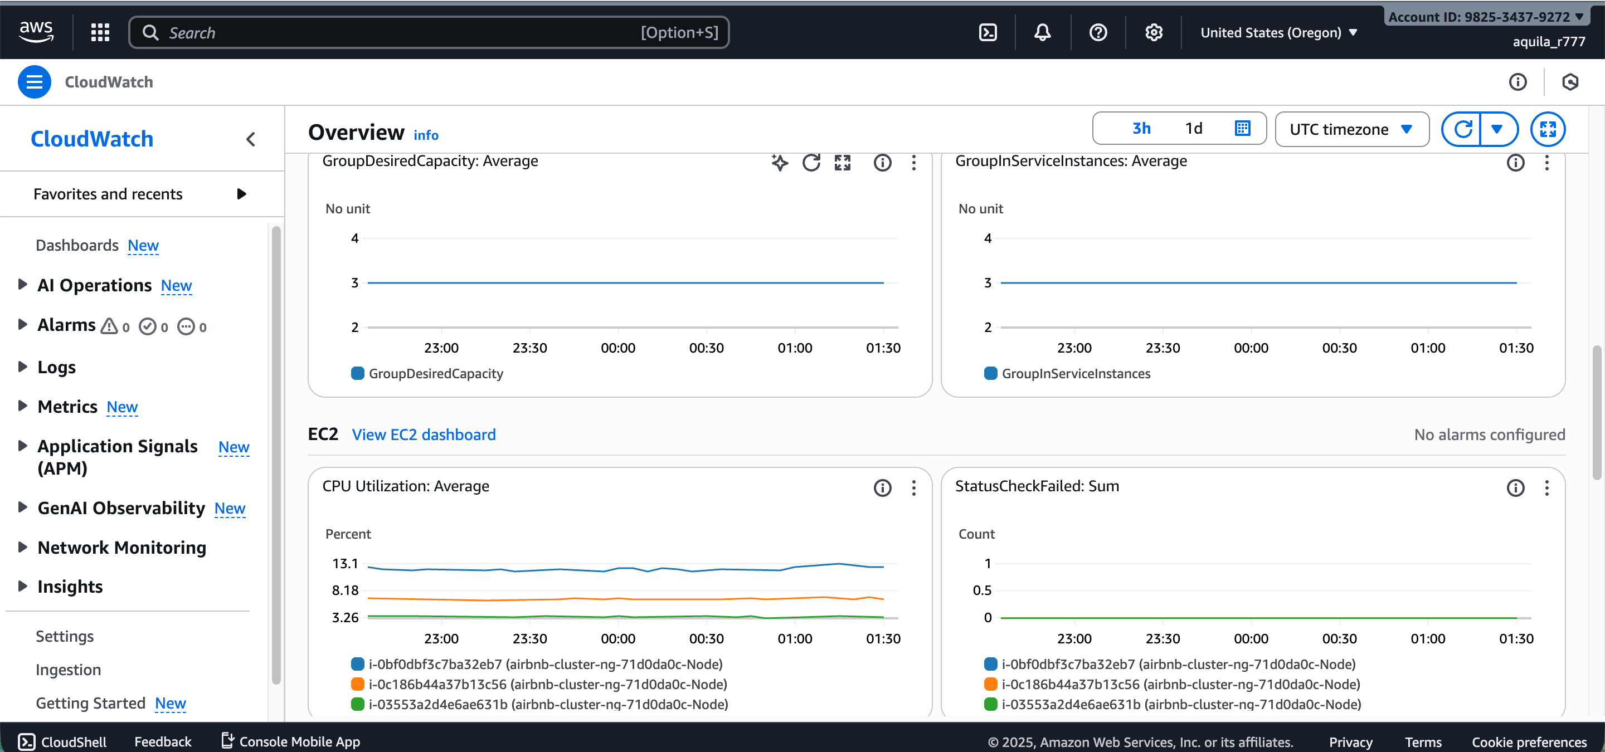

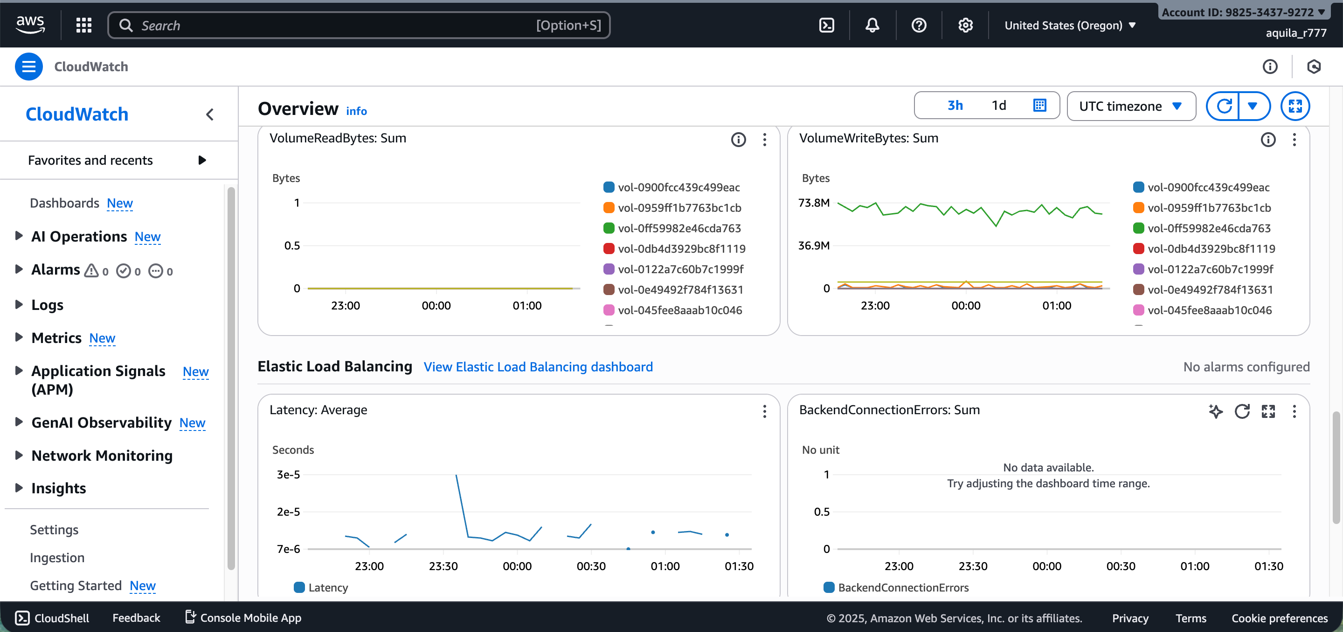

1.9.5 Security Considerations

1.9.5.1 IAM Roles and Policies
Services use IAM roles for AWS service authentication: - EKS Node Role: Allows nodes to join the cluster and pull images from ECR. - Service Account Roles: Fine-grained permissions for accessing S3, RDS, and MSK.

1.9.5.2 Secrets Management
Sensitive data is stored in AWS Secrets Manager and injected into pods using external-secrets operator:
apiVersion: external-secrets.io/v1beta1
kind: ExternalSecret
metadata:
name: airbnb-secrets
spec:
secretStoreRef:
name: aws-secrets-manager
target:
name: airbnb-secrets
data:
- secretKey: JWT_SECRET
remoteRef:
key: airbnb/jwt-secret

1.9.5.3 Network Security
- Security Groups: Configured to allow only necessary traffic between services.
- Private Subnets: Database and Kafka clusters deployed in private subnets without public internet access.
- NAT Gateway: Enables outbound internet access for private subnet resources.

1.9.6 Cost Optimization
AWS costs are optimized through:
- Spot Instances: Using Spot instances for non-critical worker nodes (40-60% cost savings).
- Auto Scaling: Scaling pods and nodes based on actual demand to avoid over-provisioning.
- Reserved Instances: Committing to 1-year RDS and MSK reserved capacity for predictable workloads.
- S3 Lifecycle Policies: Moving infrequently accessed images to S3 Glacier for storage cost reduction.

1.9.7 Operational Excellence

1.9.7.1 CI/CD Pipeline
GitHub Actions workflow automates build, test, and deployment:
name: Deploy to AWS EKS
on:
push:
branches: [main]
jobs:
deploy:
runs-on: ubuntu-latest
steps:
- name: Checkout code
uses: actions/checkout@v2
- name: Configure AWS credentials
uses: aws-actions/configure-aws-credentials@v1
with:
aws-access-key-id: ${{ secrets.AWS_ACCESS_KEY_ID }}
aws-secret-access-key: ${{ secrets.AWS_SECRET_ACCESS_KEY }}
aws-region: us-west-2
- name: Login to Amazon ECR
run: |
aws ecr get-login-password | docker login --username AWS --password-stdin ${{ secrets.ECR_REGISTRY }}
- name: Build and push images
run: |
docker build -t ${{ secrets.ECR_REGISTRY }}/airbnb-traveler-service:${{ github.sha }} ./backend
docker push ${{ secrets.ECR_REGISTRY }}/airbnb-traveler-service:${{ github.sha }}
- name: Deploy to EKS
run: |
aws eks update-kubeconfig --name airbnb-cluster
kubectl set image deployment/traveler-service traveler=${{ secrets.ECR_REGISTRY }}/airbnb-traveler-service:${{ github.sha }}

1.9.7.2 Disaster Recovery
- Multi-AZ Deployment: Services and databases span multiple availability zones.
- Automated Backups: Daily RDS snapshots retained for 7 days.
- Infrastructure as Code: All AWS resources defined in Terraform for reproducible deployments.

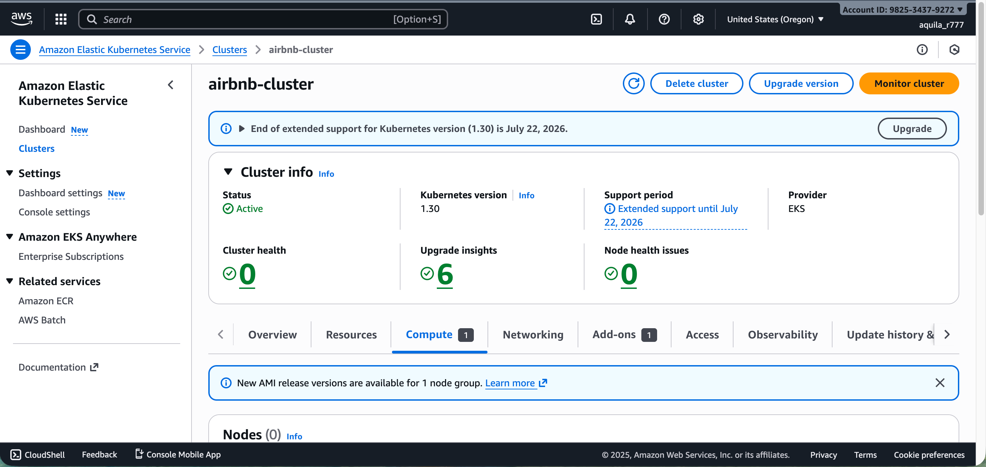
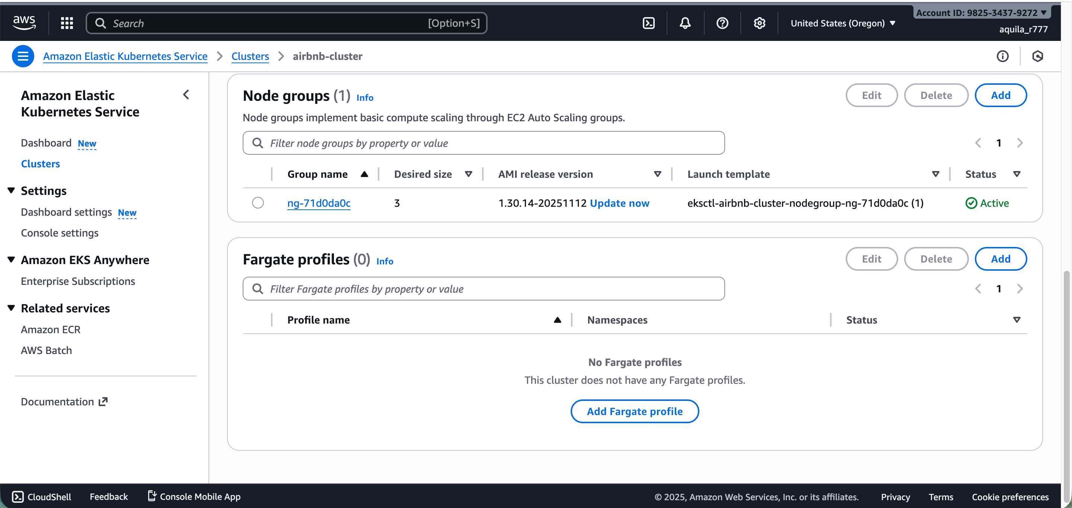

1.9.8 Performance on AWS
Deployed on AWS infrastructure, the system demonstrates improved performance compared to local Kubernetes:
- Lower Latency: ELB intelligently routes requests to the nearest healthy pod.
- Higher Throughput: AWS network infrastructure provides consistent high bandwidth.
- Better Availability: Multi-AZ deployment ensures 99.95% uptime SLA.

1.10 Conclusion
This lab successfully demonstrates the enhancement of the Airbnb prototype application with modern distributed systems technologies. The integration of Docker containerization, Kubernetes orchestration, Apache Kafka event-driven architecture, MongoDB database management, Redux state management, and AWS cloud deployment transforms the original monolithic application into a scalable, maintainable, and production-ready microservices platform.

1.10.1 Key Achievements
Part 1: Docker and Kubernetes: All five microservices (Traveler, Owner, Property, Booking, and Agentic AI) have been successfully containerized using Docker and deployed to a Kubernetes cluster. The declarative infrastructure approach using Kubernetes manifests enables reproducible deployments and facilitates operational management. Services communicate seamlessly through Kubernetes service discovery, and persistent storage ensures data durability across pod restarts.
Part 2: Kafka Integration: Apache Kafka provides a robust event-driven architecture for asynchronous booking processing. The implementation decouples service dependencies, enabling independent scaling and evolution of each microservice. The booking workflow—from traveler request through owner acceptance/rejection—operates efficiently through Kafka topics, providing an audit trail of all state transitions.
Part 3: MongoDB Implementation: MongoDB serves as the primary database with comprehensive data models for users, properties, bookings, and favorites. Security is ensured through bcrypt password hashing and JWT-based session management. The MongoDB StatefulSet deployment in Kubernetes guarantees data persistence and provides a foundation for future scaling through sharding and read replicas.
Part 4: Redux State Management: Redux integration significantly improves frontend architecture by centralizing state management. The implementation of authentication, property, and booking slices eliminates prop drilling, provides predictable state updates, and enables powerful debugging through Redux DevTools. Real-time state synchronization with Kafka events ensures users always see current booking statuses without manual page refreshes.
Part 5: JMeter Performance Testing: Comprehensive performance testing reveals system behavior under varying load conditions. The authentication API handles up to 300 concurrent users with acceptable response times, while property fetching demonstrates excellent performance even at 500 concurrent users. Booking creation testing identifies data availability constraints and provides actionable recommendations for production optimization. The analysis establishes clear capacity planning metrics for scaling decisions.

1.10.2 Technical Skills Demonstrated
This project showcases proficiency in:
- Containerization: Docker image creation, optimization, and registry management.
- Orchestration: Kubernetes deployments, services, ConfigMaps, Secrets, and StatefulSets.
- Event-Driven Architecture: Kafka producers, consumers, topics, and partitions for asynchronous messaging.
- Database Management: MongoDB schema design, indexing, and connection pooling.
- Frontend State Management: Redux Toolkit with async thunks, selectors, and DevTools integration.
- Cloud Deployment: AWS EKS, ECR, MSK, RDS, S3, and CloudWatch integration.
- Performance Testing: JMeter test plan design, execution, and result analysis.
- DevOps Practices: Infrastructure as Code, CI/CD pipelines, and monitoring.

1.10.3 Lessons Learned
- Microservices Complexity: While microservices provide scalability and maintainability benefits, they introduce operational complexity requiring robust monitoring and observability.
- Event-Driven Trade-offs: Asynchronous communication through Kafka improves system resilience but introduces latency compared to synchronous API calls. This trade-off is acceptable for workflows where eventual consistency is appropriate.
- State Management Benefits: Redux significantly simplifies React component architecture by eliminating prop drilling and providing centralized state management. The development experience improvement justifies the initial setup overhead.
- Performance Testing Value: Load testing early in development identifies bottlenecks before production deployment, enabling proactive optimization and capacity planning.
- Cloud Native Architecture: Leveraging managed services (EKS, MSK, RDS) reduces operational burden and provides enterprise-grade reliability without managing underlying infrastructure.

1.10.4 Conclusion
The Airbnb prototype enhancements demonstrate successful integration of industry-standard technologies for building scalable, resilient distributed systems. The comprehensive implementation—from containerization through cloud deployment and performance validation—provides a solid foundation for a production-ready vacation rental platform. The project showcases the ability to architect, implement, test, and deploy complex microservices applications using modern DevOps practices and cloud-native technologies.

1.11 References
- Docker Documentation. (2025). Docker Overview. Retrieved from https://docs.docker.com/
- Kubernetes Documentation. (2025). Kubernetes Concepts. Retrieved from https://kubernetes.io/docs/concepts/
- Apache Kafka Documentation. (2025). Kafka Introduction. Retrieved from https://kafka.apache.org/documentation/
- MongoDB Documentation. (2025). MongoDB Manual. Retrieved from https://docs.mongodb.com/manual/
- Redux Toolkit Documentation. (2025). Redux Toolkit Quick Start. Retrieved from https://redux-toolkit.js.org/
- Apache JMeter Documentation. (2025). JMeter User Manual. Retrieved from https://jmeter.apache.org/usermanual/
- Amazon Web Services. (2025). AWS Documentation. Retrieved from https://docs.aws.amazon.com/
- Newman, S. (2021). Building Microservices: Designing Fine-Grained Systems (2nd ed.). O’Reilly Media.
- Richardson, C. (2018). Microservices Patterns: With Examples in Java. Manning Publications.
- Abramov, D., & Clark, A. (2023). React Documentation: Managing State. Retrieved from https://react.dev/learn/managing-state

