Dirk Holzman

525.742.8VL System-on-a-Chip FPGA Design Laboratory

February 22, 2023

Lab 3A: DDS Modeling and Verification

**Plots**

To generate the DDS Model, I first instantiated a DDS compiler in Vivado with the following parameters:

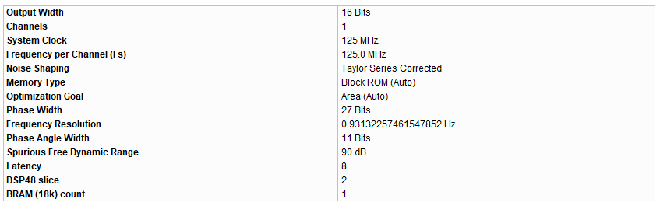

*Figure 1: DDS Compiler IP Summary*

Then, I simulated the DDS compiler with a phase increment meant to generate a 50 kHz signal, calculated as F_output = fs * (phase_inc / 2^N) 🡪 phase_inc = (F_output * 2^N) / fs where F_output = 50 kHz, N = 27, and fs = 125 MHz, resulting in phase_inc = 53,687.

In Matlab, I created a model that matched the summary above, which generated an identical signal to what was simulated in Vivado.



*Figure 2: Comparison of simulated data and Matlab modelled data.*



*Figure 3:**Difference between simulated and modeled data is exactly 0 across all 8192 samples, demonstrating equivalency of model and simulation.*

**Questions**

1. *What changes about the result when you operate the DDS in ‘Unit Circle Mode’ vs the alternative?*
   1. When set into “Full Range,” the DDS will fill the entire M bits of output, while “Unit Circle Mode” will only fill half of the range, creating an output sinusoid with a peak amplitude half that of the amplitude when set to “Full Range.” Unit Circle will fill the bits more properly, ensuring the positive and negative values are equal and a power of 2 by scaling it down by one power.
2. *Compare the resource utilization of the core (DSP slices / BRAM) when you make the same DDS (27 bit phase, 16 bit output) using the Taylor Series Noise Shaping vs. No noise shaping?*
   1. When the DDS is made with Taylor Series Noise Shaping, it uses two DSP48 slices and 1 BRAM (18K). However, without noise shaping the DDS uses 0 DSP48 slices and 15 BRAMs (18K).
3. *What phase increment value did you use to attain 50kHz? What is the computed actual frequency created to the nearest 1/1000th of a Hz?*
   1. As mentioned above, I used a phase_inc of 53,687. Since this value is rounded some, the actual output frequency is 49,999.915 Hz.