ISO 20022

Creditor Payment Activation Request - Maintenance 2019 - 2020

Message Definition Report Part 1

Approved by the Payments SEG on 09 January 2020

This document contains information about the use of the messages definitions for Creditor Payment Activation Request and includes, for example, an overview of the message set and business transactions.

February 2020

Table of Contents

Table of Contents 2

1 Introduction 4

1.1 Terms and Definitions 4

1.2 Abbreviations and Acronyms 4

1.3 Document Scope and Objectives 4

1.4 References 5

2 Scope and Functionality 6

2.1 Background 6

2.2 Scope 6

2.3 Groups of MessageDefinitions and Functionality 6

3 BusinessRoles and Participants 7

3.1 Participants and BusinessRoles Definitions 7

3.2 BusinessRoles and Participants Table 7

4 BusinessProcess Description 9

5 Description of BusinessActivities 11

5.1 Overview - Customer Payment Activation Request 11

5.2 End to End Creditor Payment Activation Request 13

5.3 Refusal of Creditor Payment Activation Request sent by the debtor (buyer) 15

5.4 Creditor (Seller) Portal 16

5.5 Debtor (Buyer) Portal 18

6 BusinessTransactions 19

6.1 Request sent by the Creditor (Sending Party) to the Debtor (Receiving Party), through Agents 19

6.2 Request sent directly by the creditor (sending party) to the debtor (receiving party) through the creditor’s portal 20

6.3 Request uploaded directly by the creditor (sending party) to the debtor (receiving party) through debtor’s portal 21

6.4 Request exchanged directly between creditor (sending party) and debtor (receiving party) 22

7 Business Examples 23

8 Revision Record 24

Preliminary Note

The Message Definition Report (MDR) is made of three parts:

MDR Part 1

This describes the contextual background required to understand the functionality of the proposed message set. Part 1 is produced by the submitting organisation that developed or maintained the message set in line with an MDR Part 1 template provided by the ISO 20022 Registration Authority (RA) on [www.iso20022.org](http://www.iso20022.org).

MDR Part 2

This is the detailed description of each message definition of the message set. Part 2 is produced by the RA using the model developed by the submitting organisation.

MDR Part 3

This is an extract if the ISO 20022 Business Model describing the business concepts used in the message set. Part 3 is an Excel document produced by the RA.

# Introduction

## Terms and Definitions

The following terms are reserved words defined in ISO 20022 Edition 2013 – Part1. When used in this document, the UpperCamelCase notation is followed.

|  |  |
| --- | --- |
| Term | Definition |
| BusinessRole | Functional role played by a business actor in a particular BusinessProcess or BusinessTransaction. |
| Participant | Involvement of a BusinessRole in a BusinessTransaction. |
| BusinessProcess | Definition of the business activities undertaken by BusinessRoles within a BusinessArea whereby each BusinessProcess fulfils one type of business activity and whereby a BusinessProcess may include and extend other BusinessProcesses. |
| BusinessTransaction | Particular solution that meets the communication requirements and the interaction requirements of a particular BusinessProcess and BusinessArea. |
| MessageDefinition | Formal description of the structure of a message instance. |

1. When a MessageDefinition or message identifier is specified, it should include the variant and version number. However, in this document (except in the business examples section, if present), variant and version numbers are not included. In order to know the correct variant and version number for a MessageDefinition, the related Message Definition Report Part 2 document should be consulted.

## Abbreviations and Acronyms

The following is a list of abbreviations and acronyms used in the document.

|  |  |
| --- | --- |
| Abbreviation/Acronyms | Definition |
| CBI | Customer to Business Interaction Consortium |
| CPAR | Creditor Payment Activation Request |
| MCR | Maintenance Change Request |
| MDR | Message Definition Report |
| SEG | Standards Evaluation Group |
| XML | eXtensible Mark-up Language |
|  |  |

## Document Scope and Objectives

This document is the first part of the ISO 20022 Message Definition Report (MDR) that describes the BusinessTransactions and underlying message set. For the sake of completeness, the document may also describe BusinessActivities that are not in the scope of the business processes covered in this document.

This document describes the following:

* the BusinessProcess scope
* the BusinessRoles involved in these BusinessProcesses

The main objectives of this document are as follows:

* to provide information about the messages that support the BusinessProcesses
* to explain the BusinessProcesses and BusinessActivities these messages have addressed
* to give a high level description of BusinessProcesses and the associated BusinessRoles
* to document the BusinessTransactions
* to provide business examples

The MessageDefinitions are specified in Message Definition Report Part 2.

## References

|  |  |  |  |
| --- | --- | --- | --- |
| Document | Version | Date | Author |
| ISO 20022 Business Justification – Creditor Payment Activation Request | 2008 | 2008-07-15 | CBI Consortium |
| ISO 20022 Maintenance Change Request (MCR #147) document (Payments Maintenance 2019/2020) | 2019 | 2019-08-30 | SWIFT, on behalf of CBI Consortium |

# Scope and Functionality

## Background

This Message Definition Report covers a set of two ISO 20022 MessageDefinitions developed by CBI and submitted to the approval of the Payments SEG.

These messages are specifically designed to support the customer-to-bank information flow.

## Scope

This set of Creditor Payment Activation Request messages covers the means to issue, manage and monitor a credit transfer request including payment and remittance information details submitted by the Creditor and by Financial Institutions on behalf of the Creditor.

## Groups of MessageDefinitions and Functionality

* Request message

The CreditorPaymentActivationRequest message is used to request the initiation of a payment (single or file) from the debtor to the intitiating party of the CreditorPaymentActivation request.

* Related message

The CreditorPaymentActivationRequestStatusReport message is used to give positive or negative response to the sender of the request (either single or file).

### Groups

#### Request

CreditorPaymentActivationRequest

This message is used to request the initiation of a payment (single or file) from the debtor to the initiating party of the CreditorPaymentActivation request.

|  |  |
| --- | --- |
| MessageDefinition | Message Identifier |
| CreditorPaymentActivationRequest | pain.013 |

#### Report

CreditorPaymentActivationRequestStatusReport

This message is used to give positive or negative response to the sender of the request (either single or file).

|  |  |
| --- | --- |
| MessageDefinition | Message Identifier |
| CreditorPaymentActivationRequestStatusReport | pain.014 |

### Functionality

See Message Definition Report Part 2 for the message scopes and formats.

# BusinessRoles and Participants

A BusinessRole represents an entity (or a class of entities) of the real world, physical or legal, a person, a group of persons, a corporation. Examples of BusinessRoles: “Financial Institution”, “Automated Clearing House”, “Central Securities Depository”.

A Participant is a functional role performed by a BusinessRole in a particular BusinessProcess or BusinessTransaction. Examples of Participants: the “user” of a system, “debtor”, “creditor”, “investor”.

The relationship between BusinessRoles and Participants is many-to-many. One BusinessRole can be involved as different Participants at different moments in time or at the same time. Different BusinessRoles can be involved as the same Participant.

In the context of CPAR, the high-level BusinessRoles and typical Participants can be represented as follows

## Participants and BusinessRoles Definitions

Participants

|  |  |
| --- | --- |
| Description | Definition |
| Creditor | Party to which an amount of money is due |
| Creditor Sending Party | Initiating party of the Creditor Payment Activation Request on behalf of the Creditor. He may be different from the Creditor itself |
| Creditor Agent | Financial institution servicing an account for the Creditor |
| Ultimate Creditor | Ultimate party to which an amount of money is due |
| Debtor | Party that owes an amount of money to the (ultimate) creditor |
| Debtor receiving party | The debtor himself or a party receiving the Creditor Payment Activation Request on behalf of the debtor |
| Debtor Agent | Financial institution servicing an account for the debtor |
| Ultimate Debtor | Ultimate party that owes an amount of money to the (ultimate) creditor |

BusinessRoles

|  |  |
| --- | --- |
| Description | Definition |
| Party | Entity involved in a payment |
| Financial Institution | Organisation established primarily to provide financial services. |

Others

|  |  |
| --- | --- |
| Description | Definition |
| Debtor’s portal | Website offering services on behalf of the debtor |
| Creditor’s Portal | Website offering services on behalf of the creditor |

## BusinessRoles and Participants Table

|  |  |  |
| --- | --- | --- |
| Participant | BusinessRole  Financial Institution | BusinessRole  Party |
| Creditor |  | x |
| Creditor Sending Party |  | x |
| Creditor Agent | x |  |
| Ultimate Creditor |  | x |
| Debtor |  | x |
| Debtor Agent | x |  |
| Ultimate Debtor |  | x |
| Debtor receiving party |  | x |
| Creditor |  | x |
| Creditor Sending Party |  | x |
| Creditor Agent | x |  |

# BusinessProcess Description

This diagram represents the high level BusinessProcesses.

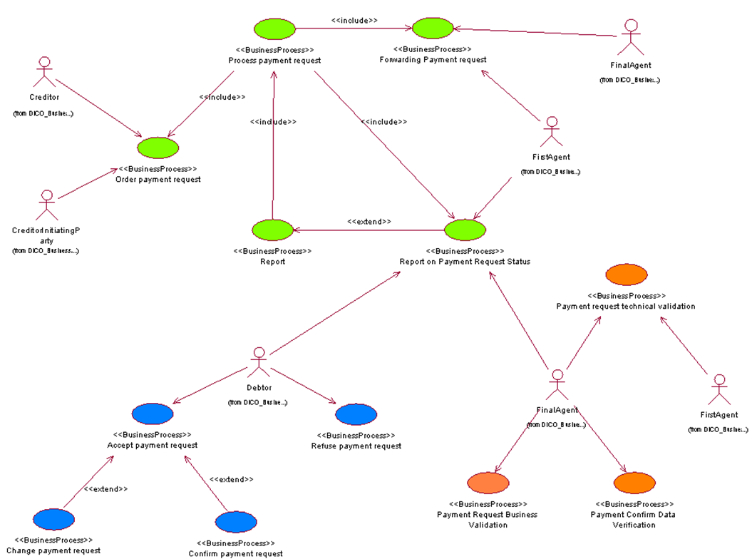

Confirm payment request

|  |  |
| --- | --- |
| Item | Description |
| Definition | The confirmation of a payment request by the debtor (buyer). This is a sub process of the “Accept payment request”. |
| Trigger | A payment request has been sent to a debtor |
| Pre-conditions | The payment request has completed and waits for a confirmation by the debtor |
| Post-conditions | The payment request has been confirmed |
| Role | Debtor |

Refuse payment request

|  |  |
| --- | --- |
| Item | Description |
| Definition | The refusal of a payment request by the debtor (buyer) |
| Trigger | A payment request has been sent to a debtor (buyer) |
| Pre-conditions | The payment request has been completed and waits for a confirmation by the debtor |
| Post-conditions | The payment request has been refused. |
| Role | Debtor |

Payment Request Business Validation

|  |  |
| --- | --- |
| Item | Description |
| Definition | The debtor agent checks if the payment request is within the agreements arranged with its customer |
| Trigger | Trigger: receipt the payment request, technical validation finished and positive |
| Pre-conditions | Pre-conditions: the agent has received the payment request and performed the necessary technical validation |
| Post-conditions | Post-conditions: payment request has been accepted or rejected. If accepted, a request status report is sent. |
| Role | Debtor agent |

Payment Confirm Data Verification

|  |  |
| --- | --- |
| Item | Description |
| Definition | The debtor’s agent checks if the payment request confirmed by the debtor is within the instruction requested by the creditor |
| Trigger | Receipt the payment confirmation |
| Pre-conditions | The agent has received the payment confirmation by the debtor |
| Post-conditions | A positive request status report is sent |
| Role | Debtor agent |

Payment Request Technical Validation

|  |  |
| --- | --- |
| Item | Description |
| Definition | The debtor agent or creditor agent applies the technical validation on the payment request. Technical validation may comprise syntactic validation (conformance of the payment order with its technical definition), semantical validation (message, through to a technical content consistency). |
| Trigger | Receipt of the payment request. Validation procedures need to be executed |
| Pre-conditions | The agent has received the payment request by the previous party |
| Post-conditions | A payment request has been accepted or rejected. If rejected, a negative status message is sent to the next party. Otherwise a positive message is sent to the next party. |
| Role | Debtor agent / Creditor agent |

# Description of BusinessActivities

This section presents the different BusinessActivities within each BusinessProcess. The BusinessActivities of a process are described with activity diagrams.

Legend

|  |  |  |
| --- | --- | --- |
| Symbol | Name | Definition |
|  | Start Point | Shows where the lifecycle of the business process commences. |
|  | End Point | Shows where the lifecycle of the business process may ends. |
|  | Lozenge (or diamond) | Indicates that a choice between several actions can be made. |
|  | Bar | Indicates that several actions are initiated in parallel. |

## Overview - Customer Payment Activation Request

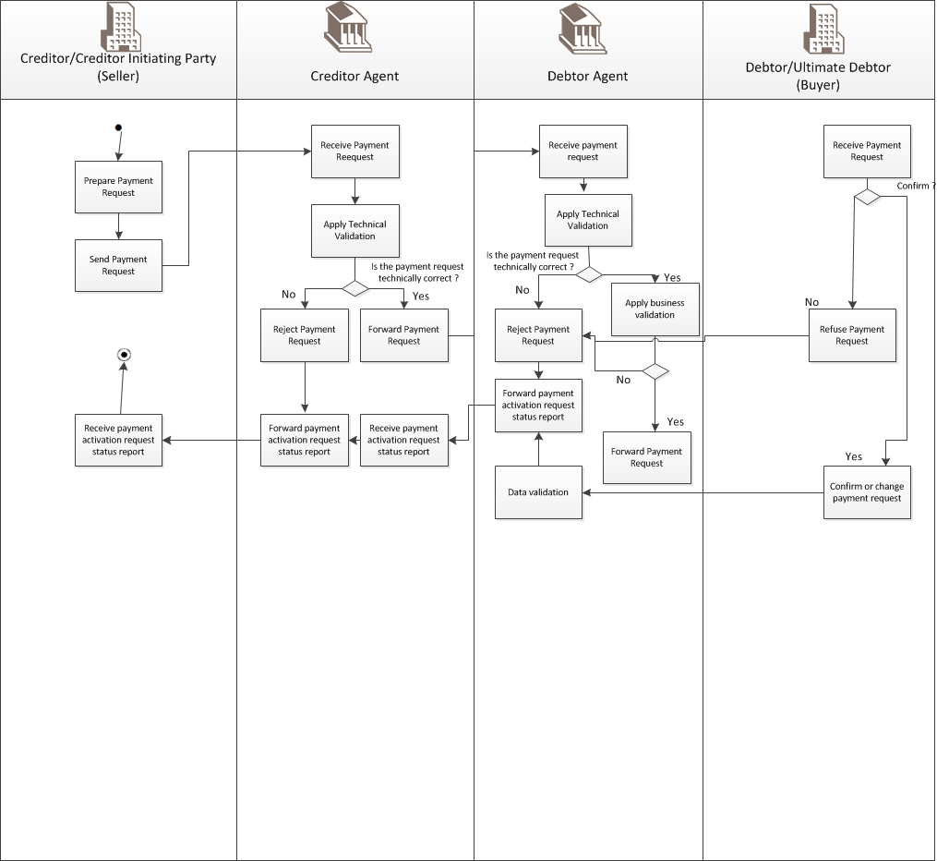

|  |  |  |
| --- | --- | --- |
| Step | Description | Initiator |
| Prepare Payment Request | The Creditor Initiating Party/Creditor prepares the outgoing payment request. | Creditor |
| Send Payment Request | The Creditor Initiating Party Creditor sends out the payment request message to the creditor agent. | Creditor |
| Receive Payment Activation Request Status Report | The Creditor Initiating Party/Creditor receives the payment request status report from the Creditor Agent. | Creditor |
| Receive Payment Request | The Creditor Agent receives the payment request and acknowledges its receipt. | Creditor Agent |
| Apply Technical Validation | The Creditor Agent applies technical validation on the payment request. Technical validation may comprise syntactic validation (conformance of the payment order with its technical validation), semantical validation (message, through to a technical consent consistency). | Creditor Agent |
| Forward Payment Request | If the payment request is technically correct, the Creditor Agent forwards the payment request to the next party | Creditor Agent |
| Reject Payment Request | If the payment request is technically incorrect, the Creditor Agent rejects the payment request and appends a relevant reject reason code explaining the reason of the reject in the Payment Activation Request Status Report. | Creditor Agent |
| Receive Payment Request | The Debtor Agent receives the payment request and acknowledges its receipt. | Debtor Agent |
| Apply Technical Validation | The Debtor Agent applies technical validation on the payment request. Technical validation may comprise syntactic validation (conformance of the payment order with its technical definition), semantical validation (message, through to a technical content consistency) | Debtor Agent |
| Apply Business Validation | The Debtor Agent checks if the payment request is within the agreements arranged with its customer | Debtor Agent |
| Forward Payment Request | If the payment request is technically correct, the Debtor Agent forwards the payment request to the next party | Debtor Agent |
| Reject Payment Request | If the payment request is technically incorrect, the Debtor Agent rejects the payment request and appends a relevant reject reason code explaining the reason of the reject in the Payment Activation Request Status Report. | Debtor Agent |
| Data Verification | The Debtor Agent checks if the payment request confirmed by the Debtor is within the instruction requested by the Creditor. | Debtor Agent |
| Forward Payment Activation Request Status Report | The Creditor Agent forwards the payment request status report to the next party. | Debtor Agent |
| Receive Payment Request | The Debtor receives the payment request and acknowledges its receipt. | Debtor |
| Refuse Payment Request | If the payment request is invalid, the Debtor refuses the payment request and appends a relevant reason to the refusal. | Debtor |
| Confirm or change Payment Request | If the payment request is valid, the Debtor accepts or modifies and accepts the payment request | Debtor |

## End to End Creditor Payment Activation Request

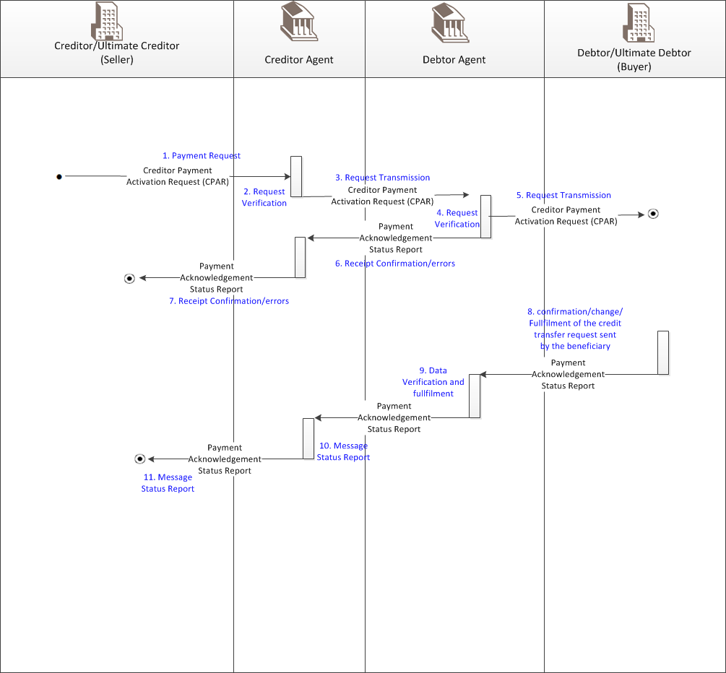

|  |  |  |
| --- | --- | --- |
| Step | Description | Initiator |
|  | The creditor (seller) issues and sends a “Creditor Payment Activation Request” message to his bank, the creditor agent (seller’s bank) (Flow 1). | Creditor |
|  | The creditor agent (seller’s bank) checks the payment request message (e.g. message syntax verification) (Flow 2). | Creditor agent |
|  | According to the results, the creditor agent (seller’s bank)forwards the request to the debtor agent (buyer’s bank) (Flow 3) | Creditor agent |
|  | The debtor agent (buyer’s bank) completes the verification on the payment request message (Flow 4). | Debtor agent |
|  | The debtor agent forwards the message to the debtor (buyer) and sends a message status report to the creditor agent (seller’s bank) (Flows 5 and 6) which can on his turn forward this status report to the creditor (seller) (Flow 7) | Debtor agent |
|  | The debtor (buyer) can confirm or refuse the payment request. The debtor’s agent (buyer’s bank) elaborates and sends a “Payment Activation Request Status Report” message (e.g. payment request confirmed by Debtor (buyer) to the creditor (seller) through the creditor agent (seller’s bank) (Flows 8, 9, 10 and 11) | Debtor |
|  |  |  |

Note:

After receipt of the debtor (buyer) confirmation message, the debtor agent (buyer's bank) can activate the execution.

## Refusal of Creditor Payment Activation Request sent by the debtor (buyer)

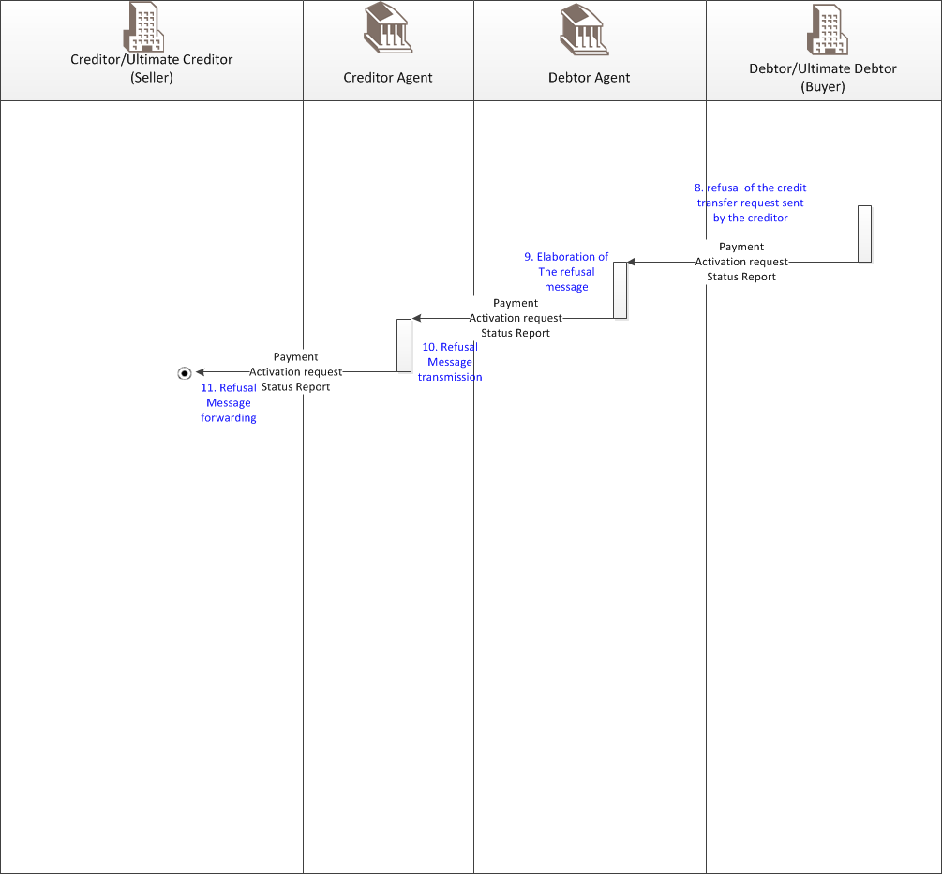

|  |  |  |
| --- | --- | --- |
| Step | Description | Initiator |
|  | The debtor (buyer) refuses the payment request – (Flow 8). | Debtor |
|  | The debtor agent (buyer’s bank) elaborates and sends to the creditor agent (seller’s bank) a “Payment Activation Request Status Report” message specifying the refusal to the request (Flows 9 and 10). | Debtor agent |
|  | The creditor agent (seller’s bank) forwards this message to the creditor (seller) (Flow 11). | Creditor agent |
|  |  |  |

## Creditor (Seller) Portal



|  |  |  |
| --- | --- | --- |
| Step | Description | Initiator |
|  | The “creditor (seller) portal” sends a Creditor Payment Activation Request message to the debtor (buyer) (Flow 1). | Creditor |
|  | The debtor (buyer) can forward the message to his bank, the debtor agent for execution (Flow 2). | Debtor |
|  | When the payment is completed, the creditor agent (Seller’s bank) receives the payment (e.g. from Clearing System) and completes the reconciliation activities. | Creditor agent |
|  |  |  |

Note:

As illustrated in this scenario, the “creditor (seller) portal” can create the Creditor Payment

Activation Request message – including complete payment details – on behalf of the creditor (seller); the debtor (buyer) can then complete the message (e.g. completing debit account information) and forward it to his bank, the debtor agent (buyer’s bank).

As an alternative business scenario, the Creditor Payment Activation Request message can be used on the debtor (buyer) portal, for example as a “Pay me” reminder, to support the debtor (buyer) in the creation of payment messages.

## Debtor (Buyer) Portal



|  |  |  |
| --- | --- | --- |
| Step | Description | Initiator |
|  | The “debtor (buyer) portal” verifies the requests received (Flow 2) and  creates payment messages that are sent to the debtor agent (buyer’s bank) (Flow 3). | Debtor |
|  | When the payment is completed, the creditor agent (seller’s bank) receives the payment request and forwards it to the creditor (Seller) (Flow 4) | Creditor agent |
|  |  |  |

# BusinessTransactions

This section describes the message flows based on the activity diagrams documented above. It shows the typical exchanges of information in the context of a BusinessTransaction.

## Request sent by the Creditor (Sending Party) to the Debtor (Receiving Party), through Agents



The Creditor Payment Activation Request message is sent by the Creditor sending party (only) to the Creditor Agent, which checks the message. According to the results, the Creditor Agent forwards the message to the Debtor Agent that forwards the message to the Debtor receiving party.

On receipt from the debtor agent, the creditor agent may forward a Creditor Payment Activation Request Status Report, with the aim to inform the creditor sending party (creditor) about the status of the Creditor Payment Activation Request.

The Creditor Payment Activation Request Status Report Message can be used in two different ways:

1. to provide information about the formal status (e.g. rejection, acceptance) of a request message. In this case the status message is the result of a technical validation performed by the debtor agent on the request message received (this can be performed in advance by the Creditor Agent or Creditor himself) ;
2. to inform the creditor about the business status of the received payment proposal (e.g.: accepted, accepted with changes, refused). The acceptance could be considered as a "commitment to pay" (this is part of the bilateral agreements between the two Counterparties).

## Request sent directly by the creditor (sending party) to the debtor (receiving party) through the creditor’s portal

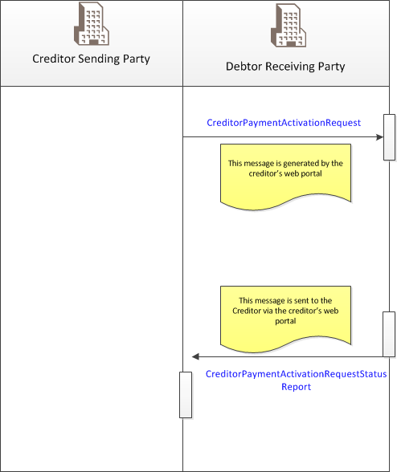

The creditor's portal generates the Creditor Payment Activation Request message on behalf of the creditor – It includes complete remittance information – and forwards it to the debtor (debtor receiving party).

The debtor downloads and checks the message.

The debtor (debtor receiving party):

1. uploads a CreditorPaymentActivationRequestStatusReport to inform the creditor about the status of the CPAR (acceptance/ reject/ acceptance with changes). (optional, depending on service bilateral agreements, e.g. data entry or upload) ;
2. in case of acceptance, it will automatically map the data of the CPAR into the official payment transfer instruction by the date agreed in the CPAR message. It will include the payment details specified by the creditor. The acceptance could be considered as a "commitment to pay" (this is part of the bilateral agreements between the two counterparts).

## Request uploaded directly by the creditor (sending party) to the debtor (receiving party) through debtor’s portal

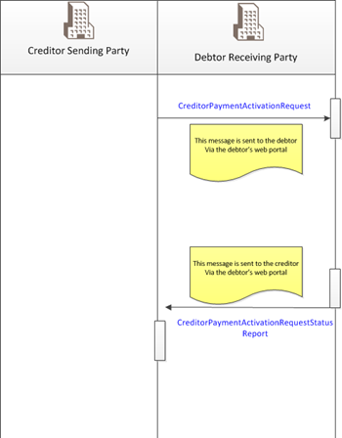

The Creditor Payment Activation Request message is uploaded by the creditor directly into the debtor's portal (e.g. as a structured "Pay me" reminder) to support the debtor in the creation of the payment messages.

The debtor's portal checks the request message received and, in case of positive outcome (both technical and business):

1. forwards a CreditorPaymentActivationRequestStatusReport to inform the creditor (creditor sending party) about the positive status of the CPAR (optional, depending on service bilateral agreements, e.g. download and/or screen shot only) ;
2. Will automatically map data of the CPAR into the official payment transfer instruction to initiate the payment by the date agreed in the CPAR message, including the payment details specified by the creditor. The acceptance could be considered as a "commitment to pay" (this is part of the bilateral agreements between the two counterparts).

## Request exchanged directly between creditor (sending party) and debtor (receiving party)

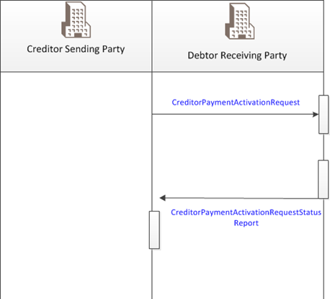

The creditor generates the Creditor Payment Activation Request message - including complete remittance information - and forwards it to the Debtor. The debtor (debtor receiving party) checks the message.

The debtor (receiving party) :

1. sends back a CreditorPaymentActivationRequestStatusReport to inform the creditor about the format and business status of the CPAR (acceptance/ reject/ acceptance with changes) ;
2. in case of (business) acceptance he will automatically map data of the CPAR into the official payment transfer instruction to initiate the payment by the date agreed in the CPAR message, including the payment details specified by the creditor. The acceptance could be considered as a "commitment to pay" (this is part of the bilateral agreements between the two counterparts).

# Business Examples

No samples have been made available

# Revision Record

|  |  |  |  |  |
| --- | --- | --- | --- | --- |
| Revision | Date | Author | Description | Sections affected |
| 1.0 | 01 December 2019 | SWIFT, on behalf of CBI Consortium | Draft version for SEG review | All |
| 2.0 | 01 February 2020 | SWIFT, on behalf of CBI Consortium | Final version |  |
|  |  |  |  |  |
|  |  |  |  |  |
|  |  |  |  |  |

Disclaimer:

Although the Registration Authority has used all reasonable efforts to ensure accuracy of the contents of the iso20022.org website and the information published thereon, the Registration Authority assumes no liability whatsoever for any inadvertent errors or omissions that may appear thereon. Moreover, the information is provided on an "as is" basis. The Registration Authority disclaims all warranties and conditions, either express or implied, including but not limited to implied warranties of merchantability, title, non-infringement and fitness for a particular purpose.

The Registration Authority shall not be liable for any direct, indirect, special or consequential damages arising out of the use of the information published on the iso20022.org website, even if the Registration Authority has been advised of the possibility of such damages.

Intellectual Property Rights:

The ISO 20022 MessageDefinitions described in this document were contributed by the CBI Consortium. The ISO 20022 IPR policy is available at www.ISO20022.org > About ISO 20022 > Intellectual Property Rights.