# **Playwright简介**

Playwright为现代 Web 应用程序提供可靠的端到端测试。

　端到端测试，end-to-end，简称 e2e，也被称作功能测试(Functional Testing)或者浏览器测试或者冒烟测试，是指从使用者的角度出发，对真实系统进行测试，e2e 测试本质上是一种黑盒测试，相当于模拟用户访问应用程序，主要检查界面或功能是否正确，自动化测试不完善的时候通常是由人工来完成这项测试工作。

官网：<https://playwright.dev/>

# **浏览器引擎**

Trident(IE)

IE 1.0 1995

IE 2.0 1995.12

IE 3.0内置到window系统中

WebKit(

-2005年苹果开源了Safari内核Webkit

Safari

Chrome (2008年)

2009(extensions)

2012年，成为最受欢迎的浏览器

JavaScript引擎V8

WebKit2

2010年推出了苹果推出，与Chrome理念冲突，2013年Google从Webkit分支分离出来取名为Blink

Gecko(firefox)

2004年 firefox1.0

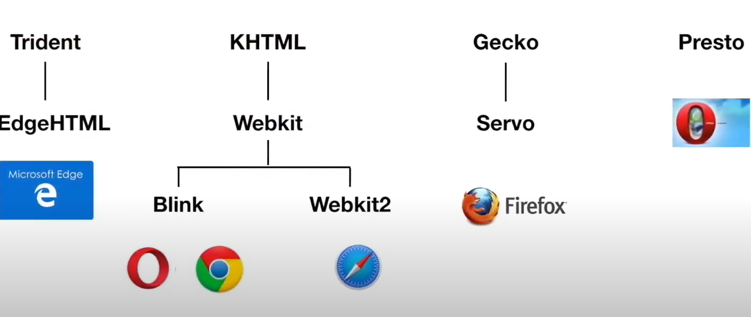

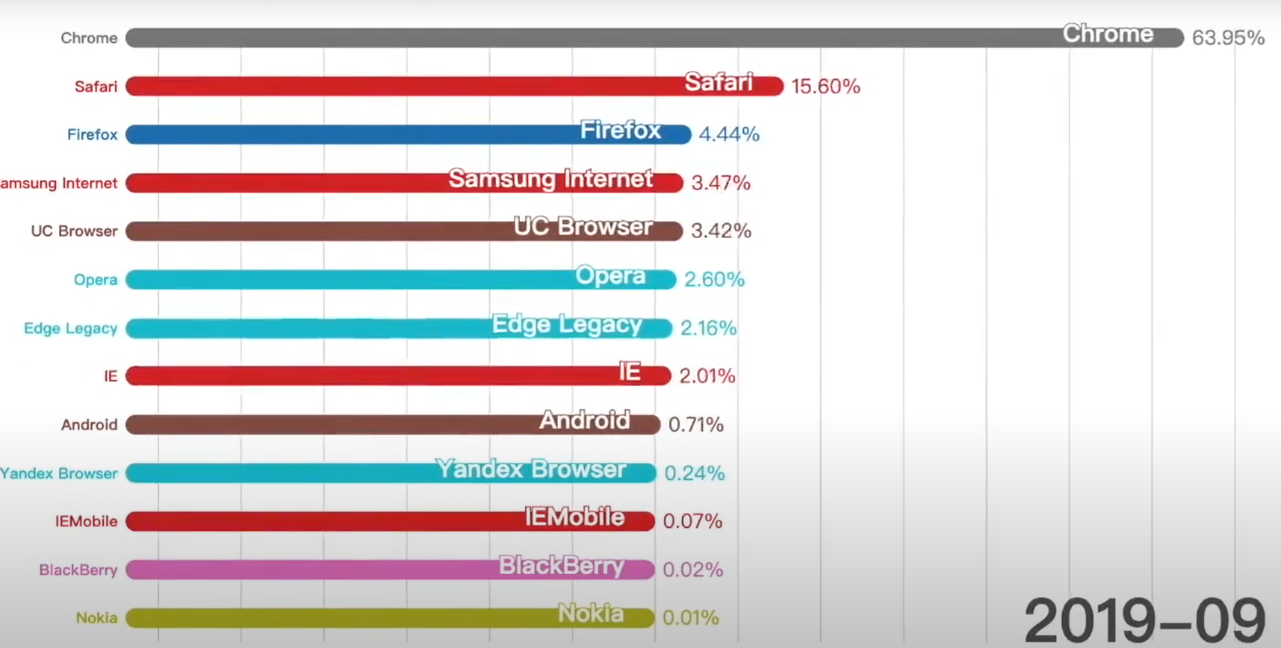

# **Fixture**

**Build-in**

**Page**

**Context**

**Browser**

**BrowserName**

**1：Install**

Install Playwright TestRunner

npm i -D @playwright/test

Install Playwright Browsers

npx playwright install // download new browsers

*PLAYWRIGHT_SKIP_BROWSER_DOWNLOAD*=1 npx playwright install

Run all test cases

npx playwright test

**2: Electron**

*PLAYWRIGHT_SKIP_BROWSER_DOWNLOAD*=1 npm i -D playwright

Supported Electron versions are:

* v12.2.0+
* v13.4.0+
* v14+
* ..

**3: Node**

Support Node version: >=12

4: Angular

**4: Current version**

Playwright: v1.19

Node: v16.14.0

Electron: v4.0

Angular: v4.0

1: install playwright

# Run from your project's root directory

npm init playwright

# Or create a new project

npm init playwright new-project

npm i -D @playwright/test

# install supported browsers

npx playwright install

2: install node

cd /usr/local

wget https://nodejs.org/dist/v12.19.0/node-v12.19.0-linux-x64.tar.xz

xz -d node-v12.19.0-linux-x64.tar.xz

tar -xf node-v12.19.0-linux-x64.tar

ln -s /usr/local/node-12.19.0/bin/node /usr/local/bin/node

ln -s /usr/local/node-12.19.0/bin/npm /usr/local/bin/npm

/usr/bin

3 install i pm2 –g

**Question**

Q1: Indicate whether a cookie is intended to be set in a cross-site context by specifying its SameSite attribute

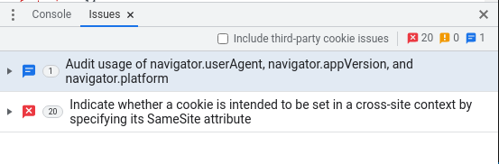

**Command**

npx playwright test --timeout 5000

1. Set test timeout in the config

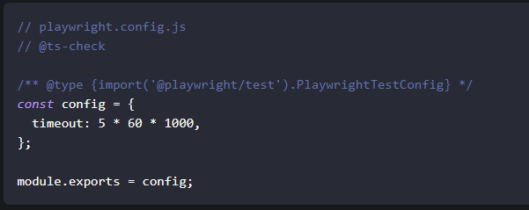

1. Set timeout for a single test

test.setTimeout(120000);

1. Selectors
   1. Text selector

await appWindow.locator('text= English').click();

* 1. CSS selector

await appWindow.locator('.bet-type-box>div:nth-child(1)').click();

1. Generate tests

npx playwright codegen baidu.com

1. xx