TEST 2 - Unit 3 & 4
Name: ________________________________
I. LISTENING

Part 1: A man is talking about his family. Listen and complete the sentences.
→ I have one _____________, a mom and dad, one ____________, one _____________ and two ______________.
→ I do not enjoy going to the _______________ with my _______________.
→ During the holiday, my family will watch ______________ and _____________ dinner.
→ I enjoy spending ____________ with my family because I trust them and we are very close.
→ We like doing many things together, such as _____________, ____________ and going to the mall.

Part 2: People are talking about their jobs. Listen and number the pictures.
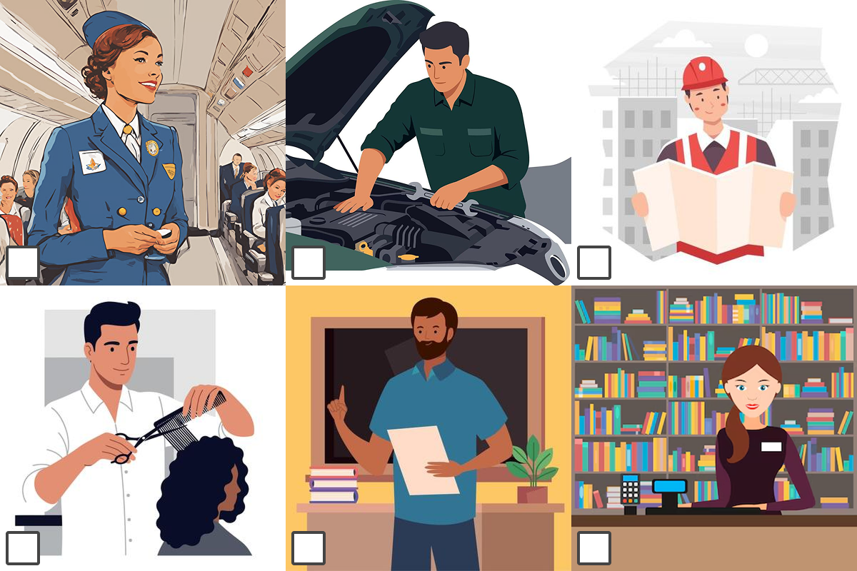

II. GRAMMAR

Part 1: Choose an answer to complete the sentences
1. What ___________ you __________ at the moment in the classroom?
a. do/do b. did/do c. are/doing d.does/do
2. My best friend __________ very good at drawing animals.
a. is b. are c. is being d. was
3. They __________ for the school concert this week.
a. prepared b. prepare c. is preparing d. are preparing
4. Where __________ you __________ during the summer holidays?
a. do/do b. did/do c. had/done d. are/doing
5. I __________ an email to my teacher right now.
a. write b. writes c. am writing d. wrote
6. She __________ doing homework in the evening.
a. like b. likes c. is liking d.liked
7. He __________ a big sandwich and drank some juice.
a. ate b. eat c. eats d. is eating
8. My parents __________ always kind to our neighbors.
a. is b. are c. was d. were
9. We __________ to the zoo last weekend because it was closed.
a. went b. go c. didn't go d. don't go
10. __________ you __________ learning new English words?
a. Do/enjoy b. Did/enjoy c. Did/enjoyed d. Are/enjoying
11.Look! The dog __________ the ball across the yard.
a. chasing b. is chasing c. chased d. chases
12. We usually __________ lunch at school around 12:30.
a. had b. has c. are having d. have
13. They __________ very happy when they saw their new puppy.
a. was b. were c. are d. is
14. I __________ very tired after walking home in the rain yesterday.
a. am b. was c. were d. be
15. She __________ her friends at school last Monday.
a. didn't saw b. doesn't see c. didn't see d. don't see
16. What time __________ your English class usually __________ (start) in the morning?
a. do/start b. does/start c. did/started d. did/start
Part 2: Write the words in their correct column of word position
engineer / apply / job / hire / lawyer / nice / kind-hearted / promote /smart
cousin / computer / salary / future / resign / neighborhood / classmate / family-oriented
Nouns | Adjectives | Verbs
__________________________  __________________________  __________________________  __________________________  __________________________  __________________________ | __________________________  __________________________  __________________________  __________________________  __________________________  __________________________ | __________________________  __________________________  __________________________  __________________________  __________________________  __________________________

III. READING
Part 1: Reading the following passage. Answer the questions.
Talk about Chris’s Family
Hello! My name is Chris, and I am 10 years old. Today, I want to tell you about my family.
I live with my parents and my little sister. My mother’s name is Anna, and she is a teacher at a local school. My father’s name is John, and he works as a doctor in a hospital. My sister Lily is five years old. She goes to kindergarten and loves drawing and playing with her toys.
My grandparents, Peter and Mary, live close to us. They are very kind and often invite us for dinner. I enjoy listening to their stories about when they were young. My aunt Sarah and uncle Mike live in another city. They have two children—my cousins Emma and Tom. Emma is eight years old, and Tom is six. I always have fun when I visit them because we play games and go to the park together.
We also have a dog named Max. Max is very friendly and energetic. He likes running around in the garden and playing with us.
On weekends, my family likes to spend time together. Sometimes we visit my grandparents, and other times we go to my aunt and uncle’s house. I really love my family because we have a lot of fun and support each other.

1. How many people are there in Chris's family? ____________________________________________
2. What does Chris enjoy when he visits his grandparents? ___________________________________
3. What do Chris and his cousins do when he visits them? ____________________________________
4. How does Chris describe about his dog? ________________________________________________
5. Why does Chris really love his family? __________________________________________________
Part 2: Reading the following passage. Decide the statements is TRUE (T) or FALSE (F)
Jobs and Children
Many children think about what job they want to do in the future. Some want to be doctors, teachers, or firefighters. Others want to be artists, chefs, or even YouTubers. There are many different jobs. Every job is important.
Children learn about jobs from people around them. They see what their parents, family, and teachers do. For example, if a child’s mother is a nurse, the child might want to be a nurse too. If a child’s father is a driver, the child might want to drive a bus or taxi one day.
Children also learn about jobs at school. They study different subjects like math, science, English, and art. These subjects help children find out what they like. If a child likes animals, they may want to be a vet. If a child likes helping others, they may want to be a teacher or a doctor.
Children also learn by playing. When they play games like “teacher,” “shop,” or “builder,” they are learning about real jobs. Playing helps them understand how people work and how to work with others.
In the future, there will be some new jobs. People may work with robots, computers, or even in space! That is why it is good to keep learning and trying new things.
It’s okay if children don’t know what job they want yet. They can try many things and learn what they enjoy. One day, they can choose a job that makes them happy and helps other people too.

1. Children can learn about jobs by watching what their family members do. ______
2. If a child likes animals, they should not think about becoming a vet. ______
3. School subjects like math and art can help children discover what they enjoy. ______
4. In the future, all jobs will stay the same and never change. ______
5. Playing job-related games can help children understand the world of work. ______

IV. WRITING
Write at least 50 words about the job you'd love to do in the future

___________________________________________________________________________________
___________________________________________________________________________________
___________________________________________________________________________________
___________________________________________________________________________________
___________________________________________________________________________________
___________________________________________________________________________________
___________________________________________________________________________________
___________________________________________________________________________________
___________________________________________________________________________________
___________________________________________________________________________________
___________________________________________________________________________________
___________________________________________________________________________________
___________________________________________________________________________________
___________________________________________________________________________________
___________________________________________________________________________________
___________________________________________________________________________________
___________________________________________________________________________________
___________________________________________________________________________________
___________________________________________________________________________________
___________________________________________________________________________________

