Learning Journey Assistant
User Documentation
A guide for students on reading the Learning Journey dashboard

Item | Detail
Project | CSE3CAP Capstone Project, La Trobe University (Team ScrumAndCoke)
Team | Dylan Mitchell, Lewis Murray, Md Shakhawat Hossain Rakib, Su Su, Karthik Vijay
Version | 1.0, 13 October 2026
Live dashboard | https://dmitchell295.github.io/learning-journey-assistant/
Source code | https://github.com/dmitchell295/learning-journey-assistant

Status note. This is a student-facing prototype. It shows AI-estimated mastery from Moodle rubric results and is not an official record of grades. See Section 8 for known limitations.

1. About the Learning Journey Assistant
The Learning Journey Assistant (LJA) is a dashboard that helps you see how well you are meeting the learning outcomes in your subjects, rather than only seeing a mark. It reads your marked rubric results and feedback from Moodle, uses an AI model to estimate how well you have mastered each rubric criterion, and then groups the results into strengths and skill gaps.

1.1 What you can do with it
- See a single "average mastery" figure that summarises your understanding across your assessed work.
- Find out how many of your subjects are currently on track.
- See your strongest rubric criteria (strengths) and your weakest (skill gaps), so you know what to revise first.
- Switch between students in the demo data to compare different learner profiles.

1.2 What it does not do
- It does not replace your official grades in Moodle. Mastery percentages are estimates.
- It does not let you edit, submit or resubmit any work.
- It does not yet use real student accounts or log-ins. The data shown is synthetic test data (Section 8).

2. Getting started

2.1 What you need
- A modern web browser such as Chrome, Edge, Firefox or Safari, on a phone, tablet or computer.
- An internet connection. No installation, account or password is required.

2.2 Opening the dashboard
- Open your browser and go to https://dmitchell295.github.io/learning-journey-assistant/.
- Wait for the message "Loading dashboard..." to finish.
- The dashboard appears. The first student with results is shown by default.
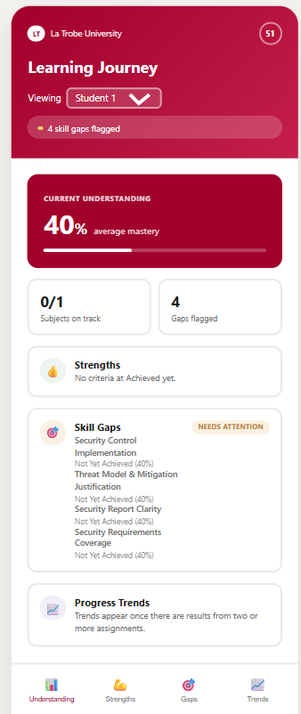
Figure 1. The Learning Journey dashboard on first load.

2.3 The first load can be slow
The data service runs on a free hosting plan that goes to sleep after about 15 minutes without use. If nobody has opened the dashboard recently, the first load can take up to a minute while the service wakes up. Later loads are quick. If it seems stuck, wait one minute and refresh the page once.

3. A tour of the dashboard
The dashboard is laid out like a mobile app, with a header at the top, the results in the middle, and a navigation bar along the bottom. It is designed for a phone but also works in a desktop browser.
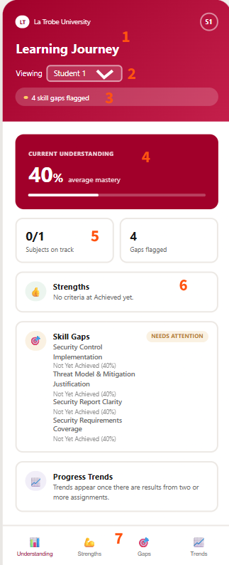
Figure 2. Areas of the dashboard, numbered to match the table below.
# | Area | What it shows
1 | Header | The La Trobe University badge, the page title "Learning Journey", and a circle with the current student, for example S1.
2 | Student picker | A drop-down labelled "Viewing". It lists each student that has results. It only appears when more than one student has results.
3 | Alert banner | A summary line such as "3 skill gaps flagged", or "No skill gaps flagged" when there are none.
4 | Current understanding | A large percentage with a progress bar. This is your average mastery across all assessed rubric criteria. It shows a dash and "no results yet" when there is no data.
5 | Summary tiles | "Subjects on track" (for example 5/8) and "Gaps flagged".
6 | Strengths, Skill Gaps and Progress Trends cards | The detail of what you are doing well, what needs attention, and how results change over time.
7 | Bottom navigation | Four buttons: Understanding, Strengths, Gaps and Trends. They currently only highlight and do not change the page (see Section 8).

3.1 Current understanding
This is the average of the mastery scores (0 to 100) for the student across every rubric criterion that has been assessed. A higher number means stronger demonstrated understanding. If a result has no AI score yet, the dashboard uses a rough value based on its category (Achieved 95, Partially Achieved 60, Not Yet Achieved 25) so that it can still be included.

3.2 Subjects on track
A subject counts as "on track" when the average mastery across its assessed criteria is 50% or higher. The tile shows how many subjects meet this out of all subjects that have results, for example 6/8.

3.3 Strengths
The Strengths card lists criteria rated Achieved, starting with the highest score. Each row shows the criterion name, its rating and its percentage, for example "Achieved (92%)". At most four rows are shown, and a line such as "+3 more" tells you how many are hidden. If none are Achieved yet it reads "No criteria at Achieved yet."

3.4 Skill gaps
The Skill Gaps card lists criteria rated Partially Achieved or Not Yet Achieved, starting with the weakest. It uses the same row layout and four-row limit. A green "On track" tag appears next to Strengths and a "Needs attention" tag appears next to Skill Gaps when the cards contain results.
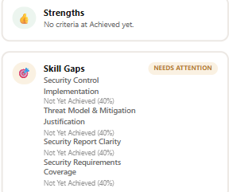
Figure 3. The Strengths and Skill Gaps cards with example rows.

3.5 Progress trends
A trend needs results from at least two different assignments. With only one assignment the card says "Trends appear once there are results from two or more assignments." With two or more it shows the average mastery across them, for example "Average mastery across 4 assignments: 68%."

4. Common tasks

4.1 Check how I am going overall
- Open the dashboard.
- Read the large Current understanding percentage and the Subjects on track tile.
- Read the alert banner under the title for a quick count of skill gaps.

4.2 Decide what to revise first
- Scroll to the Skill Gaps card.
- Start with the first row. Rows are ordered weakest first, so the top item has the lowest mastery.
- If the card shows "+N more", the hidden items are higher than the ones shown, so work down the visible list first.
- Open the criterion in Moodle to re-read your marker feedback for that item.

4.3 Switch to a different student
- Find the "Viewing" drop-down under the page title.
- Choose another student, for example "Student 2".
- All figures and cards update. The circle at the top right changes to match, for example S2.
Figure 4. The Viewing drop-down. Click it to pick another student.

4.4 Refresh the data
The dashboard loads fresh data every time the page is opened or refreshed. Use your browser refresh button (or pull down on a phone) to reload. Data only changes when new results are loaded into the system by the team.

5. Understanding your results

5.1 Mastery levels
Each rubric criterion is given one of three levels. These match the Moodle outcome scale used in the project.
Level | Counts as | Meaning
Achieved | Strength | You have shown the expected level of understanding for this criterion.
Partially Achieved | Skill gap | You show some understanding but there are gaps to close.
Not Yet Achieved | Skill gap | The expected understanding has not been shown yet. Focus here first.

5.2 Where the numbers come from
- Your marker grades each assignment in Moodle using a rubric and writes feedback.
- The system reads the rubric levels and feedback through the Moodle web service.
- An AI model estimates a mastery score from 0 to 100 and a level for each criterion.
- The dashboard groups the results into strengths and gaps and calculates the averages.
Important: The mastery score is an AI estimate meant to guide your study. It is not a mark, it does not change your Moodle grade, and it can be wrong. If something looks wrong, trust your marker's feedback in Moodle and ask your teaching team.

6. Troubleshooting
What you see | Likely cause | What to do
"Loading dashboard..." for a long time | The data service is waking up after being idle. | Wait up to one minute, then refresh once.
"Couldn't load dashboard: Failed to fetch" | The service is still starting, or your connection dropped. | Check your internet, wait a minute and refresh. If it persists, tell the team.
"Couldn't load dashboard: Failed to fetch assessments: 500" | A problem on the server or the database. | Wait a few minutes and refresh. Report it to the team with the time you saw it.
Current understanding shows a dash and "no results yet" | No assessment results are loaded for this student. | Choose another student, or ask the team whether results have been loaded.
No "Viewing" drop-down | Only one student has results. | Nothing is wrong. The picker appears when there are two or more students.
Tapping Understanding, Strengths, Gaps or Trends does not change the page | These buttons currently only highlight. | Scroll down. All sections are already on the one page.
Page looks narrow on a computer | The layout is a phone-style frame. | This is by design. Zoom in your browser if you need it larger.
Blank or broken page | An old copy is cached in the browser. | Hard refresh (Ctrl+Shift+R, or Cmd+Shift+R on Mac).

7. Frequently asked questions
Q. Do I need to log in?
No. The prototype has no log-in and shows synthetic demonstration students.
Q. Is my real Moodle data shown?
No. The data comes from a test Moodle site set up by the team with generated students, subjects and rubric results.
Q. Why is my average different from my Moodle grade?
The dashboard measures mastery of rubric criteria using an AI estimate. A Moodle grade is the marker's mark. The two are separate and are not expected to match.
Q. Why does a criterion appear under Skill Gaps even though I passed?
Passing the assignment overall can hide a weaker criterion. The dashboard looks at each criterion separately.
Q. Why are only four items shown?
Each card shows up to four rows to keep the screen readable. A "+N more" line tells you how many are hidden.
Q. Why does the Trends card not show a chart?
A trend needs results from at least two assignments, and the current version shows a summary line rather than a graph.
Q. Does it work on my phone?
Yes. It is built mobile first and works in any modern browser.
Q. Who do I contact about a problem?
Contact the project team through the repository issue tracker at the link on the cover page, or your unit teaching team.

8. Known limitations
This is a prototype built for a capstone project. Please be aware of the following.
- Synthetic data. Students, subjects and results are generated test data, not real learners.
- No log-in. The dashboard does not know who you are. Any visitor can pick any listed student.
- Navigation buttons. The bottom buttons only highlight. All sections are on a single scrolling page.
- Trends. Shown as a text summary, not a chart, and only when two or more assignments exist.
- AI estimates. Mastery scores can be inaccurate and have not been validated against official outcomes.
- Slow first load. The free hosting plan sleeps when idle, so the first visit after a quiet period can take up to a minute.
- Temporary database. The free hosted database expires after 30 days unless renewed, after which results would need to be reloaded.
- Data refresh. Results are loaded by the team. The dashboard does not update live when Moodle changes.
- Rubric to outcome mapping. The link between each rubric criterion and a learning outcome is a team decision and is still a simplification.

9. Glossary
Term | Meaning
Mastery | How well the evidence in your assessed work shows you understand a criterion, from 0 to 100.
Rubric criterion | One row of a marking rubric, such as "Normalisation" or "Query design".
Learning outcome | A statement of what you should be able to do by the end of a subject.
Strength | A criterion rated Achieved.
Skill gap | A criterion rated Partially Achieved or Not Yet Achieved.
On track | A subject whose average mastery is 50% or higher.
Moodle | The learning management system where assignments are marked.

