Problem Description
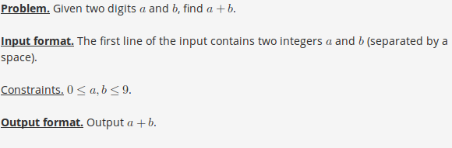

Sample 1
Input:
3 2
Output:
5

Sample 2
Input:
7 9
Output:
16

