Problem Description

Problem
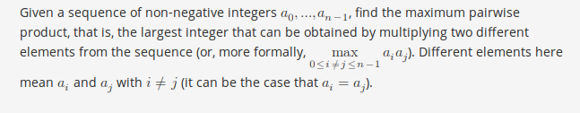

Input format

Constraints
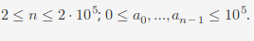

Output format
Output a single number — the maximum pairwise product.

Sample 1
Input:
3
1 2 3
Output:
6
Explanation:

Sample 2
Input:
10
7 5 14 2 8 8 10 1 2 3
Output:
140
Explanation:

Sample 3
Input:
5
4 6 2 6 1
Output:
36

