**Temporary peace (Anathema)**

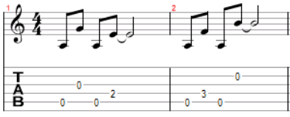Capo: 3

↑ ↓ ↑ ↓ ↑ ↓ ↑ ↓ ↑ ↓ ↑ ↓ ↑ ↓ ↑ ↓

Intro: *Asus2 Asus2addb6*

*Asus2 Asus2addb6 Asus2 Asus2addb6*

Deep inside the silence staring out upon the sea

The waves are washing over half forgotten memory

Deep within the moment laughter floats upon the breeze

Rising and falling dying down within me

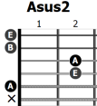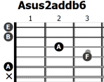And I swear I never knew, I never knew how it could be

And all this time all I had inside was what I couldn't see

I swear I never knew, I never knew how it could be

All the waves are washing over all that hurts inside of me

*Fmaj7sus2 Am7 Em Fmaj7*

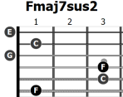*Am7 Cmaj7 Em Fmaj7*

*C Am7 Em Fmaj7*

*Am7 Cmaj7 Em Fmaj7*

*C Am7 Em Fmaj7*

*Am7 Cmaj7 Em (Fmaj7)*

Beyond this beautiful horizon lies a dream for you and I

This tranquil scene is still unbroken by the rumors in the sky

But there's a storm closing in voices crying on the wind

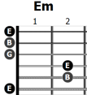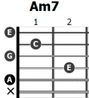The serenade is growing colder breaks my soul that tries to sing

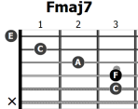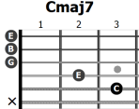And there's so many many thoughts when I try to go to sleep

But with you I start to feel a sort of temporary peace

There's a drift in and out

Drift in and out,

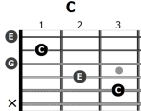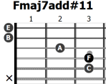Drift

*Fmaj7 Fmaj7add#11 (4x)*

*Asus2 Asus2addb6 (2x)*

*Fmaj7 Fmaj7add#11 (2x)*

*Asus2*