**Without module parameter:**

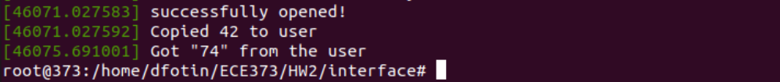

**With module parameter:**

