In the old days of web development, when there were no flexbox and grid properties for

creating layouts, the float property was widely used.

1. **What is float used for?**

The float property is commonly used when we want a block of text to flow around an image or

want an element to stand next to another element. Some web developers even use it to create layouts,

but properties like XSS flexbox xan do this more efficiently.

With the float property defined, an element can be pushed to the left or right, thus allowing the next

element on the webpage (or the next element in the flow) to float around it. Float is useful in these situations because no other CSS property can achieve the same result.

To work with float, we first need a container. In other words, the element we want to float needs

to be contained within a parent element. Neither the element we want to float or its parent element can have their position set to absolute because elements with this setting are removed from the flow of the webpage.

The values we can use with the float property are as follows:

* left: The element will float to the left side of its parent.

* right: The element will float to the right side of its parent.

* inherit: The element will inherit the float value from its parent.

1. **Normal flow**

Example:

<div class=”main-container”>

<img src=<https://cdn.pixabay.com/photo/2017/08/05/11/16/logo-2582747_1280.png> alt="CSS Logo"

<p>The float CSS property places an element on the left or right side of its container</p>

</div>

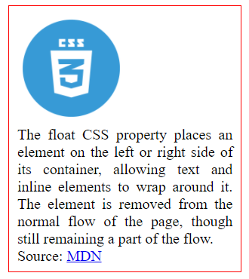

Notice that without float applied, the text is below the image. This occurs because the two elements are in the webpage’s normal flow and are positioned in a column by default.

1. **Float: left and right**

When we want a block of text to wrap around an image, we can achieve this result using the float property. If we want our text to be on the right side of our image, we have to change the flow of the **img** element.

We can achieve this with the following CSS code:

img {

float: left;

}

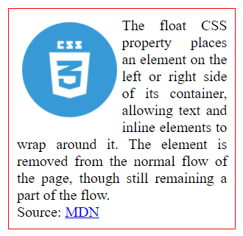

Same with right

img {

float: right;

}

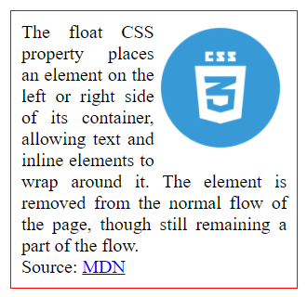

1. **Other float affects**

img, p {

float: left;

}

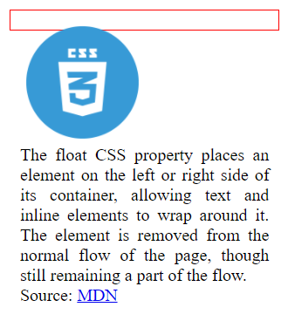

As you can see, the container has collapsed. This occurred because if a container only has floating elements inside, its height will have a value of 0px , and it won't expand.