The properties float and clear often used together.

We use the clear property together with float because they complement each other. When we apply float to an element, all the elements that are inside the same container will float too.

That’s why we use clear: to “clear” the float and make the page flow back to its default state starting from the element on which we used clear.

Clear parameters:

* none: The element will float normally according to the float of the previous element
* left: The element won’t float if one of the previous elements contains the value float: left
* right: The element won’t float if one of the previous elements contains the value float: right
* both: The element won’t float if the previous element contains one of the floating values, left or right.

**2. Normal floating**

<div class="main-container">  
  <div class="header">Header</div>  
  <div class="right-bar">Right Bar</div>  
  <div class="content">Content</div>  
  <div class="footer">Footer</div>  
</div>

.main-container {  
  border: 2px solid black;  
  height: 200px;  
  width: 400px;  
}  
  
.header, .footer {    
  border-color: blueviolet;  
  height: 50px;  
  line-height: 50px;    
  width: 100%;  
}  
  
.content {  
  float: left;  
  height: 80px;  
  line-height: 80px;  
  width: 60%;  
}  
  
.right-bar {  
  float: right;  
  height: 50px;  
  line-height: 50px;  
  width: 20%;  
}

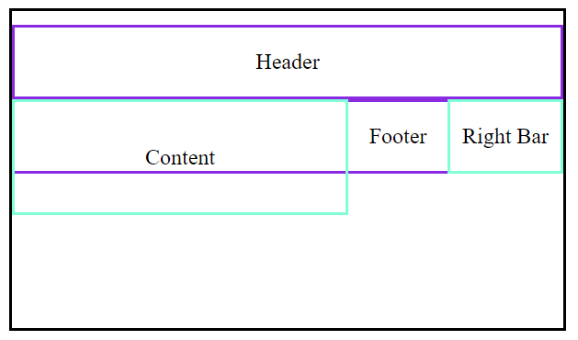

**3. Using clear**

.footer {  
  clear: both;  
}

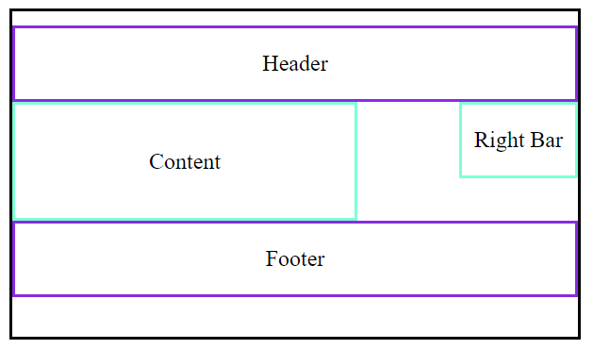

.footer is no longer in the middle. Now any element we create after the footer element will no longer float because the float has been cleared.

.footer {  
  clear: right;  
}

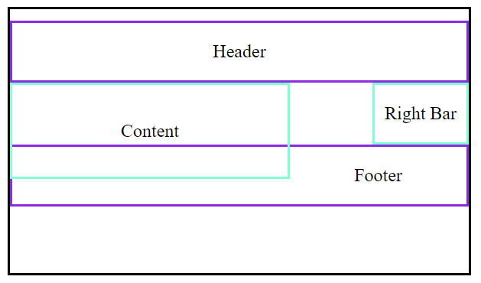

Strange, right? This happened because our right var is smaller than the content element, and since both elements float and we cleared only the right float, the footer will be positioned below the right bar

.footer {  
  clear: left;  
}



We get the same result as clear: both, since content is larger than the right bar element. With the float: left value, footer will be positioned after it.