Overview
Em is the application for emulating any kind of connectivity protocols over UDP/TCP layer (or implementing your own through raw sockets). Useful for prototyping, for example, drivers or creating testing software.
Key features:
- cross-platform PyQt-based application (Win, -nix, tested on Win 10 and Xubuntu);
- creation of the custom user-implemented logical/network level packets;
- support of TCP-server, TCP-client, and UDP protocols (raw-socket mode planned) and on-the-fly switching between them;
- automatic receipting;
- support of the custom user-implemented control sum algorithms;
- programming emulator’s behavior: creating conditions (e.g. receiving one or few messages, passing specified amount of time since application start) and assigning actions to them (responding with one or few messages, switching to different behavior mode with different set of actions applied to conditions, etc).
Unfinished:
- logger functionality: turning off parsing, changing fonts and colors, search, separate log for key messages;
- raw-socket mode support – never been tested;
- grouping fields (some fields can be grouped together and repeated one or more times in one message; feature for older systems) – used to work, but after some major changes was never brought up to speed;
- setting up maximum message length and splitting up messages of greater length at sending (feature for older systems and often has to be implemented for UDP-based protocols);
- localization and translation not completed.
Code notes:
- no QtDesigner and .pro files used; all graphics programmed manually for better compatibility;
- camel case notation was used instead of Pythonic snake notation (to keep code in line with “camel cased” Qt library. Probably a mistake in hindsight);
- inconsistent decisions – this is my first Python application, so some code decisions may seem too C-like. In some places it was fixed, and Python-style decisions were applied, in some it wasn’t.
Known issues and bugs:
- when there are no clients connected but there is an attempt to send a message, no resending is attempted;
- bug when creating new message types (see below for details).
Credits:
- UI icons by Flaticon: https://www.flaticon.com/uicons
I really don’t want to get sued. Great icons. Seemingly free. Didn’t read the fine print.

Quick user guide

Selecting profiles
If you’re starting program for the first time, most likely you’ll see profile management window:
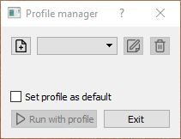

This applications allows user to work with different profiles. So before start you have to either choose previously created profile in upper combo-box or create new one (plus icon).You can also edit or remove previously selected profile. If you select profile, check “Set profile as default” check-box and click “Run with profile”, then on your next run you won’t see this window.

Note for how it works: list of profiles is taken from “profiles” folder, that is created in app’s folder. Essentially, each profile is a set of files in a folder, and folder’s title is profile’s title.
Note for how it works: default profile’s title is stored in “settings.ini” file, that is created in app’s folder.

Creating and editing profiles
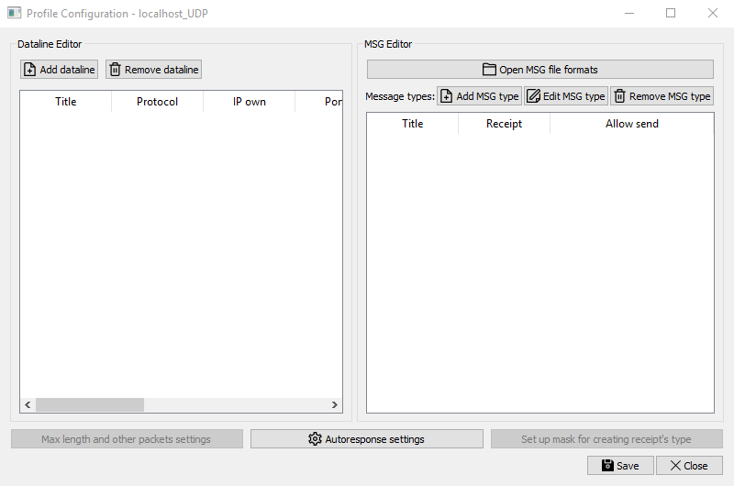
Once you click on “Create” or “Edit” icons you get profile editor window:
Left part of the window is dataline editor with network settings. Click “Add dataline”, and then edit network parameters in the table.
Right part of the window is the message types editor: it allows to either select previously created file with message types or create/edit new types one by one. Once you finish creating message type it will be shown in the message types list. Splitter between two parts allows you to regulate how much of each editor you want to see (up until hiding either one).

Creating and editing message types
Once you click on the “Add MSG type” button (or the “Edit MSG type” button, after selecting message type to edit) you get the message type editor window, which allows you to see structure of the message type being created/edited:
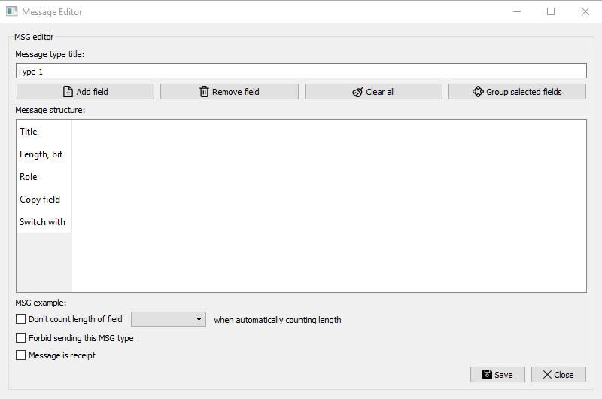
Any field parameter can be edited through this table by clicking and entering new values. It also allows you to specify some type-specific parameters (through check-boxes):
- exclude some fields from length count
- forbid sending of message type (why would you need messages that you don’t want to send, you may ask? So that you could parse them!)
- mark any of the message types as the receipt type (if you have message type, that is marked as receipt, then to the every message that you receive, program will respond with a message of this type)
Also, length measurement units can be switched to bytes and back to bits by clicking on the horizontal header at the left at the row labeled “Length, bit/byte”.
Creating fields
Once you click on “Add field” button you get field editor window:
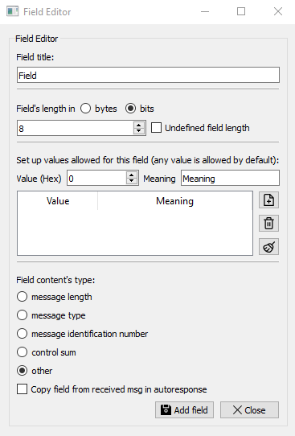

This window allows you set up parameters for a singular field:
- field’s title (has to be unique in this message type)
- field’s length (can be undefined; separator may be requested)
- field’s values (in hex; with meaning (description) attributed to each value)
- field’s role (it is important for the program to know what field’s contents are in order to automate some things – such as filling field with role “control sum” with an actual control sum upon sending or identifying a message type by the field with role “message type”. Which, by the way, exactly one field in one message type should have, and this field should have only one possible value; otherwise message type identification won’t be possible).
- specify, whether content’s of the field should be copied or nullified in a receipt or any other response (assuming that the response message has that field)

After clicking “Add field” you’ll see that new field appeared in the message type editor:
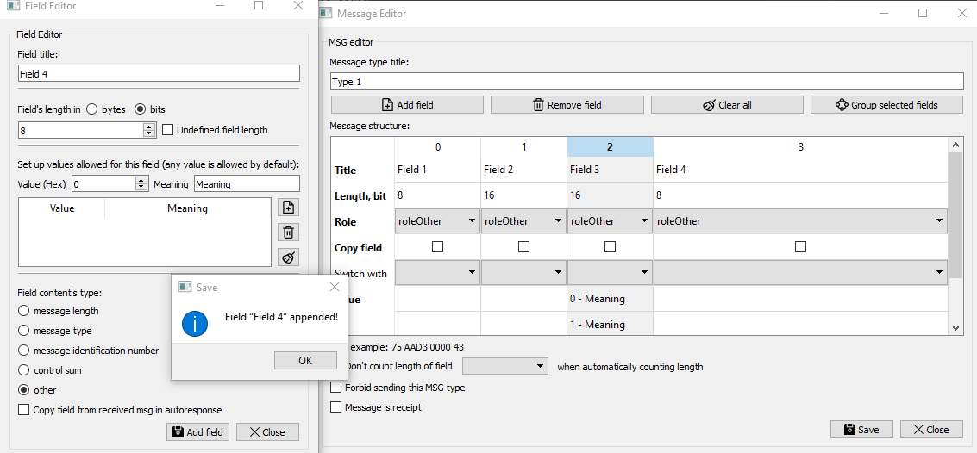
The field editor won’t close, but field’s role will switch to “other” and the values list will be cleared, so that you can continue adding fields. Once you’ve had enough, just click on “Close” button. Then you can inspect and edit message structure in the message type editor: choose roles, change length, edit values, change fields positions by drag’n’dropping them.
While creating your message type you should keep in mind following rules:
- All field titles should be unique.
- There should be exactly one field with the role «type», and that field should have exactly one value (otherwise differentiating message types would be impossible). Also, hex value for the field with role type cannot coincide with hex values for the field with role type of the other message types. So, all field type values should be unique.
- Overall message length for the message type in bits should be a multiple of 8 — so as to fit in bytes.
- If you have bit-fields that are shorter (or longer) then byte, you cannot insert field of undefined length in such a sequence. So, overall message length (in bits) of fields preceding the field with undefined length should be a multiple of 8.
- If you have, for some reason, more then one field with undefined length, you’ll be prompted to enter separator symbol(s), so as to know where it all (fields of undefined length) end.
!BUG: As mentioned above, you always need one field with role message type and that field should have one value. If you forget to do that, you won’t be able to just change field’s role through combo-box, you’ll have to remove the field that was supposed to contain type, and add it again through the field editor and drag it to its rightful place. Sorry. This has to be fixed.
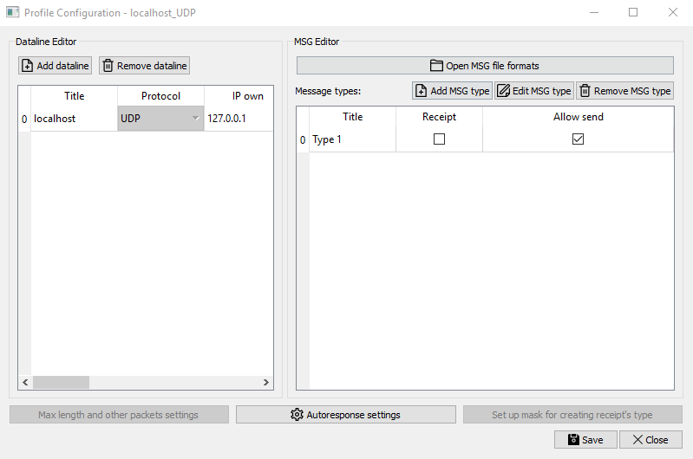
To save the new message type, surely, click “Save”. New type will be added to the message types list:

Configuring emulator’s behavior

Once you click on the “Autoresponse settings” icon you get the Autoresponse Editor window that allows you to change emulator’s behavior:
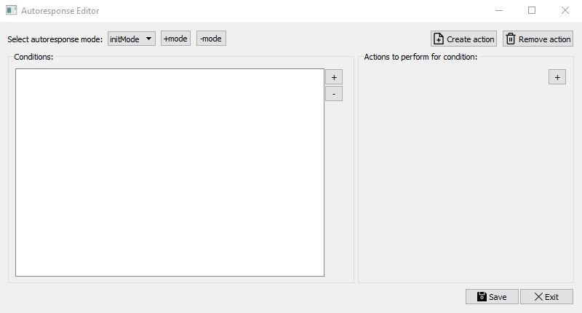
Although it is called “Autoresponse”, it’s not actually limited to responding, and allows to program emulator’s behavior. The way it’s set up is as follows: there are modes in every profile (just one initially, which is called “initMode”). A mode is just a list of user-specified conditions with a list of user-specified actions assigned to every condition. For example:

initMode:
Condition 1:
Action 1
Condition 2:
… (no actions)
…
Condition N:
Action 1
Action 2
Action 3
workMode:
Condition 1:
… (no actions)
Condition 2:
Action 5
…
Condition N:
Action 4
Action 3

Having different modes allows to change emulator’s behavior at runtime by switching between them.
Now let’s look at how these modes are set up.

Creating conditions
On the left side of the Autoresponse Editor window there is a list of user-created conditions.
In order to create a condition, click on the “+” button to the right of the conditions list. You will see the Condition Editor window:
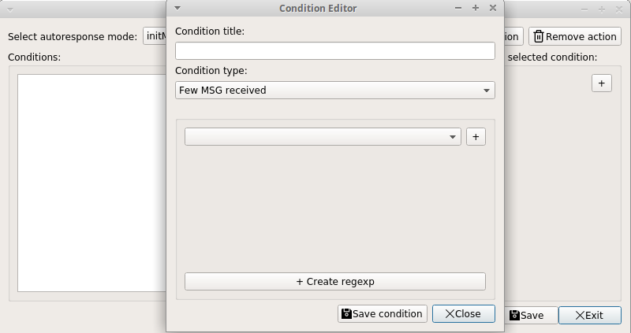
The data needed to be specified by user depends on the condition type. Right now there are six condition types:
- Time passed after start, ms (used when something needs to happen upon start or some time after).
- MSG received (used when something needs to happen upon receiving some message. Obviously, message needs to be specified by the user through creating named regular expression for it, more later).
- Few MSG received (used when something needs to happen only when all previously specified messages were received).
- Time passed after receiving MSG, ms (feels pretty self-explanatory).
- Time passed after sending MSG, ms (“ms” refers to the millisecond, a unit of time).
- Composite condition from previously created conditions (used when something needs to happen in very convoluted circumstances. Probably unnecessarily complicates things).
Here’s example of making a condition of the “Few MSG received” type.
After selecting the “Few MSG received” message type, you will see a group box. Combo-box inside it allows you to select a regular expression for message that is supposed to trigger some action. If you’ve created no regular expression previous to this, there’s nothing to select. It seems like a good time to click the “+ Create regexp” button at the bottom.
Once you click the “+ Create regexp” button you get the Named Regexp Editor window:
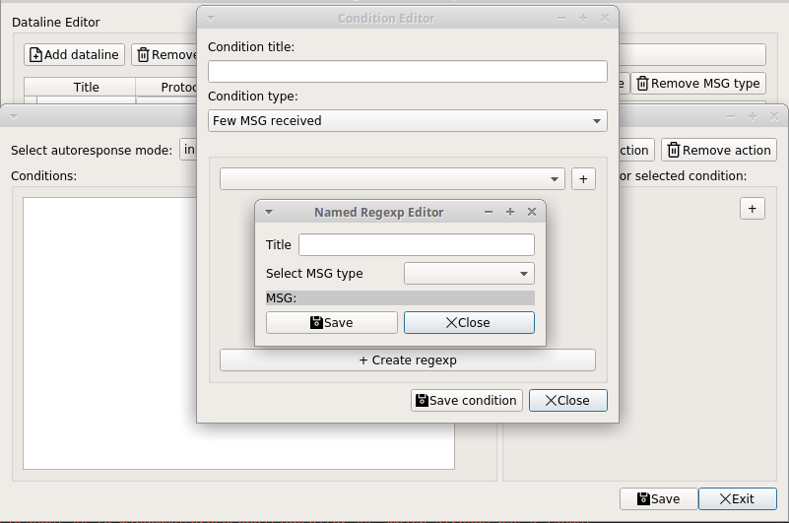
After selecting MSG type (we’ve created them at the “Creating and editing message types” stage), you’ll be able to specify the exact message you want to receive:
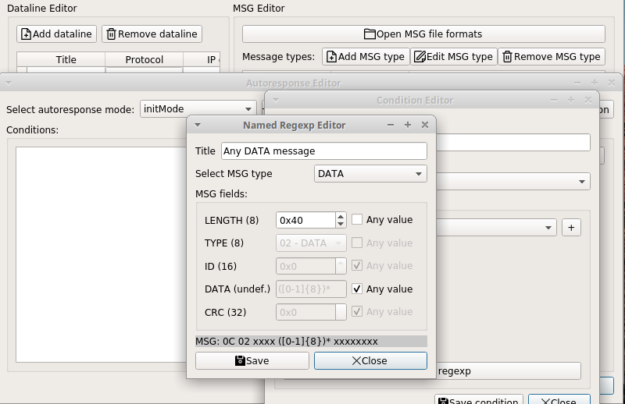
First column consists of labels with field titles and lengths. Second consists of widgets, that allow you to enter a specific value that you expect this field to be. If you don’t care about particular field’s value, you can look at the 3rd column, which consists of check-boxes, that, when checked, mark a field as any value — any field value will be allowed.
At the bottom you can see the resulting MSG label. Note that fields of undefined length are by default marked as any value, which translates into “([0-1{8}])*” — part of a future regular expression. You can un-check “Any value” combo-box and enter your own value for the field of undefined length, as long as the number of symbols entered is even (and, therefore, fits into byte).
Also note that fields with roles: type, id and crc can’t be marked as any value. Fields with role type are used to identify message types, fields with role id are used to support receipting, and fields with role crc are filled by script “calcCrc.py” in the profile’s directory. Although automatic filling of fields with roles id and crc can be turned off at runtime in emulator’s settings.

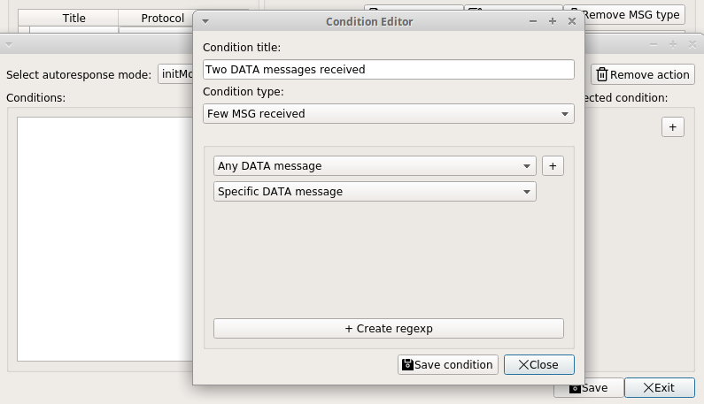
Once you’ve created a regular expression for a message, you can hit the “Save” button and return to the previous window. Now you’ll be able to select freshly created message in the combo-box:

You might ask: “But when a condition type is called “Few MSG received”, doesn’t it mean that we have to be able to expect more than one message?”. And it does mean that. Click on “+” button to add another combo-box and select another regular expression for a message.
You only have one? Well, you know how to make them now.
All the other condition types exploit the same principles: create something, name it, and then choose it in the combo-box list.

Creating actions
What to we have now is a single condition called “Two DATA messages received”. If we click on it, nothing changes. But! Now we can click “+” button in the right half of the window and what we“ll see is a combo-box with two options: no action (empty line) and something called “Respond with received msg” (which, once triggered, does exactly that). Right now selecting it would be problematic, since condition doesn’t really receive one message. It probably will answer with the last received message (and I pray it won’t just crash), but any kind of uncertainty is not good. Right now no checks are imposed on assigning actions to conditions, but anything crazy probably just won’t work (and I pray it won’t just crash). Further testing needed.
So, that’s just one type of an action. And it simply is not enough. So let’s create some other action by clicking the “Create action” button in the right half of the Autoresponse Editor window.

This is the window I’m talking about:
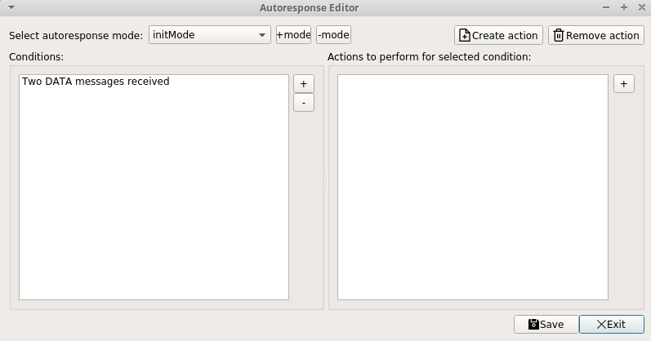
Remember?
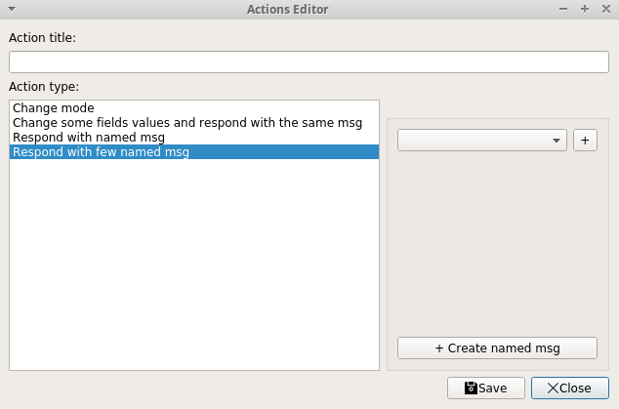
There is a “Create action” button in the top right corner. Once you click on it, you get the Action Editor window:

Right now there are four types of actions:

- Change mode (when you need emulator to change behavior at runtime by switching to a different mode. All modes share the same set of conditions, but actions assigned to them are usually different, otherwise it’s pointless)
- Change some fields values and respond with the same message (when you need to send received message in response, but with a few changes. You’ll have to provide the exact field title and a new hex value that will be assigned to that field)
- Send named msg (when you know the exact message you want to send. I know, screen above reads “Respond with”, but I realized it’s misleading, since messages can be sent not only as a response, and changed it)
- Send few named msg (when you know the exact messages you want to send)
Let’s select “Send few named msg”. Logic behind is exactly the same as when we were making a condition of type “Few MSG received”: create named messages in editor, save them, select them in combo-boxes; add combo-boxes by clicking “+” button so that you can send more messages.
The Named Messages editor is slightly different, lets call upon it by clicking the “+ Create named msg” button:
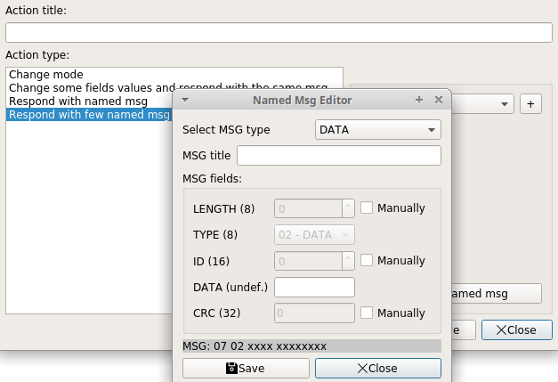
It’s essentially the same, but instead of “Any value” you have “Manually” check-box, so that you can enter specific values to fields that would otherwise be automatically filled.

Let’s finish creating this action:
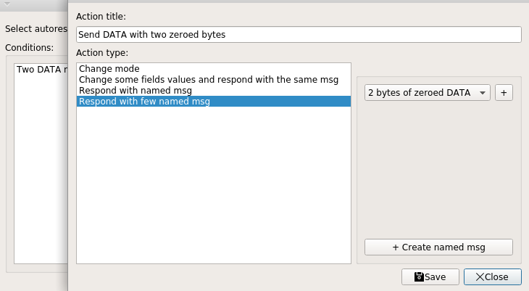
And, once we’ve saved, we can assign this new action to the selected condition:
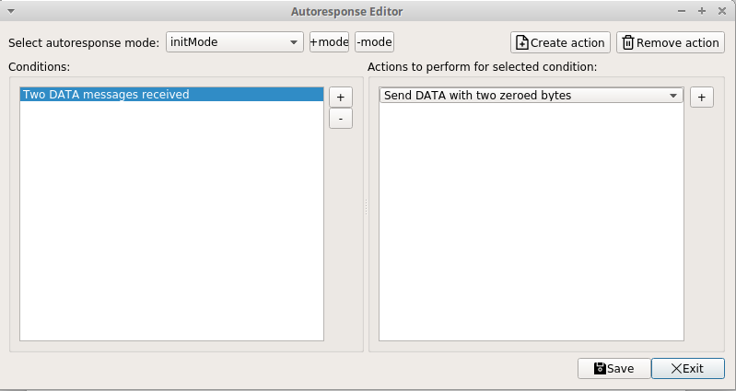
That’s pretty much how programming emulator’s behavior goes.

Main windows overview
Once you finish creating your profile (don’t forget to save), you can get back to this window:

Click on the combo-box and select the profile you’ve only just created. After that the “Run with profile” button becomes available for clicking. You can also check the “Set profile as default” combo-box, so the next time you happen to start this program it won’t show you the Profile Manager window above, but will just start with the selected profile every time.

Note for how it works: clicking on the “Run” button with checked combo-box creates “settings.ini” file in the emulator’s directory with a single key: current_profile = {profile title that you’ve selected as default}. If you feel like it, you can remove a profile title from the key, or remove the whole “settings.ini” file, causing the Profile Manager window to show up again on the next run.

The Work window is going to look somewhat like this:

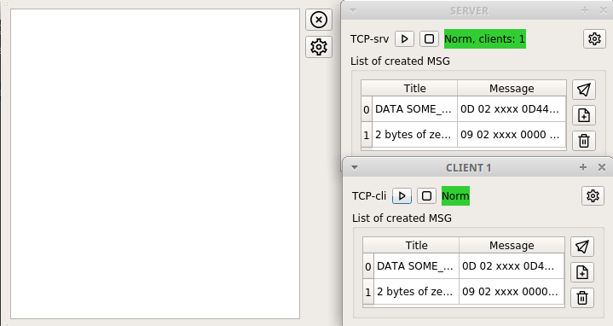

On the left you see the logger window. Cross in a circle in its top right corner is a proper way to exit the application. Button below it is settings button. Right now clicking on it allows you to switch to another profile or reset to no default profile. Logger window can be resized only by the grips at its corners and moved by clicking on any “none-button” part of the window and dragging.
On the right you see two dataline windows, one per each dataline entered at the profile creation stage. Top widget line shows (left to right): user protocol type (TCP-server, TCP-client, UDP or raw-UDP), restart button for restarting dataline’s network thread (probably after changing network settings), stop button to stop dataline’s network thread, state label to show dataline’s current stage (“Norm”, or “STOP”, or some kind of error) and way on the right – settings button to show dataline’s settings. Window can be dragged.
Below all that rests group-box that contains the list of the named messages for profile (we created them at the “Creating actions” stage). Three buttons are placed to the right of that group-box (top to bottom): send message button (one or few messages from the list of named messages should be selected for sending), create new named message button (just like before at the “Creating actions” stage) and remove selected named message.

Dataline settings window
Once you click on settings icon, you get th Dataline Settings window:
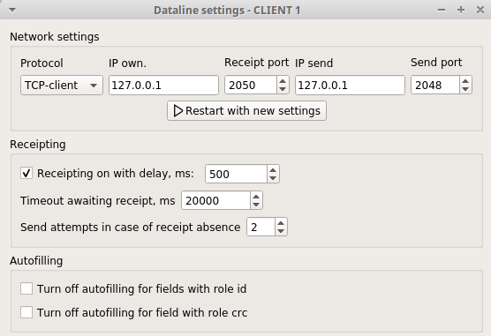

This window allows user to:
- change network settings (IP, ports, protocol) and restart network thread;
- turn off/turn on receipting (as in sending receipts for every received message);
- set a duration for the delay before receipt is sent (“0” is fine too);
- change timeout for a receipt, after witch message is considered lost;
- change the amount of the resend attempts on lost messages;
- turn off/turn on the autofilling identification numbers and control sums in messages.
After closing the window, settings are saved and will stay the same on next run (apart from the “receipting on” and autofilling parameters – those, by default, are always on. Meaning that on the next run receipts will be sent and id’s and crc’s will be filled correctly, until turned off)

That’s pretty much it, I hope it helps.

