HORIZON SERVICES LLC
PRINTDECK
A local-first touchscreen controller prototype for monitoring and cautiously controlling Bambu Lab printers.
INDEPENDENT BAMBU LAB CONTROLLER DEVELOPMENT PROJECT
Prepared by Dima / Horizon Services LLC
Firmware reviewed: v0.7.1 deployed prototype build / July 2026
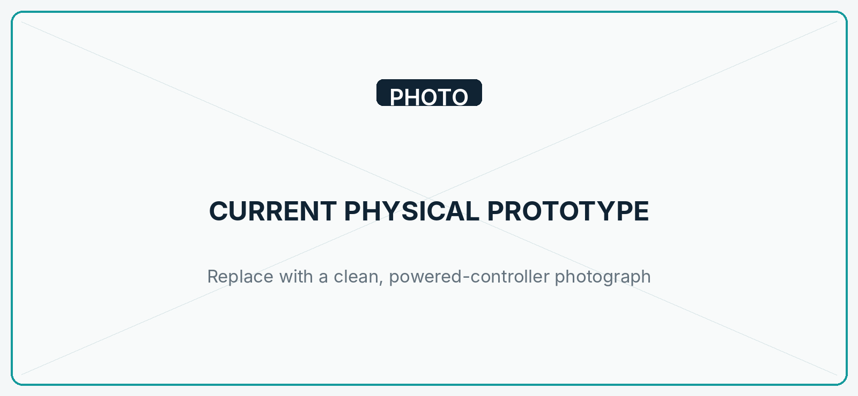
Current physical prototype.
Bambu Lab is not currently affiliated with or responsible for this independent project.

1 | PROJECT OVERVIEW

PrintDeck is a dedicated touchscreen device being developed to put useful printer information and carefully gated controls on a small, always-available local display. The current prototype targets a Bambu Lab P1S and is intended to reduce the need to reach for a phone or computer for routine at-a-glance monitoring and selected printer actions.
The project is local-first: the working P1S integration communicates over the local network. The design leaves clear boundaries for an optional novahorizon.net backend/dashboard and a Jetson Orin Nano vision system, but neither is part of the current working printer path.
2 | CURRENT DEVELOPMENT STATUS

STATUS | CURRENT EVIDENCE-BASED POSITION
Completed and verified | Firmware build; 4.3-inch display; landscape LVGL UI; aligned touch; ESP32-C6 Wi-Fi; local P1S authentication; live print reporting; chamber-light control; P1 camera liveview; physically enabled LAN OTA.
Functional, refining | P1S telemetry, on-screen setup, reconnect behavior, SD mounting, camera lifecycle, and UI messaging. Signed v0.7.1 is deployed with stable short health samples; full regression remains pending.
In active development | Safe validation of pause/resume/cancel, credential-storage hardening, local file indexing and print initiation, and broader regression tests.
Planned | AMS/filament workflows, multi-printer profiles, optional novahorizon.net backend/dashboard connectivity, Jetson vision verification, and broader diagnostics.
Needs more printers | X- and H-series authentication, telemetry, cameras, AMS generations, command behavior, firmware differences, errors, and UI adaptation.

Current touchscreen interface.

3 | KEY PLANNED CAPABILITIES

CAPABILITY | STATUS | CURRENT BOUNDARY
Status / monitoring | Working on P1S, refining | Connection and job state, progress, layers, remaining time, temperatures, fan level, and chamber-light state.
Job management | Implemented; validation pending | Pause/resume/cancel paths exist; cancel confirms. Chamber light is runtime verified.
Files / print start | UI scaffold only | Non-destructive SD mount is implemented; media confirmation, indexing, transfer, queueing, and print initiation remain pending.
Motion / thermal / fan | Intentionally disabled | Visible design scaffolding is rejected by the transport until safely validated.
Camera / AI vision | P1 camera working; AI planned | On-demand encrypted P1 liveview is implemented; no vision model or Jetson integration exists.
AMS / filament | Planned | No AMS parser or control workflow is present.
Multi-printer / remote | Planned | One P1S profile today; optional novahorizon.net backend/dashboard is a roadmap item.
Diagnostics | Partial | Heap, stack, reset, uptime, coredump, OTA, auth, and connection state are reported; long-duration and full error/HMS work remains.

4 | HARDWARE AND SOFTWARE ARCHITECTURE

Guition JC4880P443: ESP32-P4NRW32, 32 MB PSRAM, 16 MB flash, ESP32-C6 Wi-Fi, 4.3-inch ST7701S MIPI-DSI display, GT911 touch, and SDMMC. Firmware: ESP-IDF 6.0.2 / FreeRTOS / LVGL 9.5. Working printer transport: authenticated local TLS/MQTT with CA and printer-identity checks.
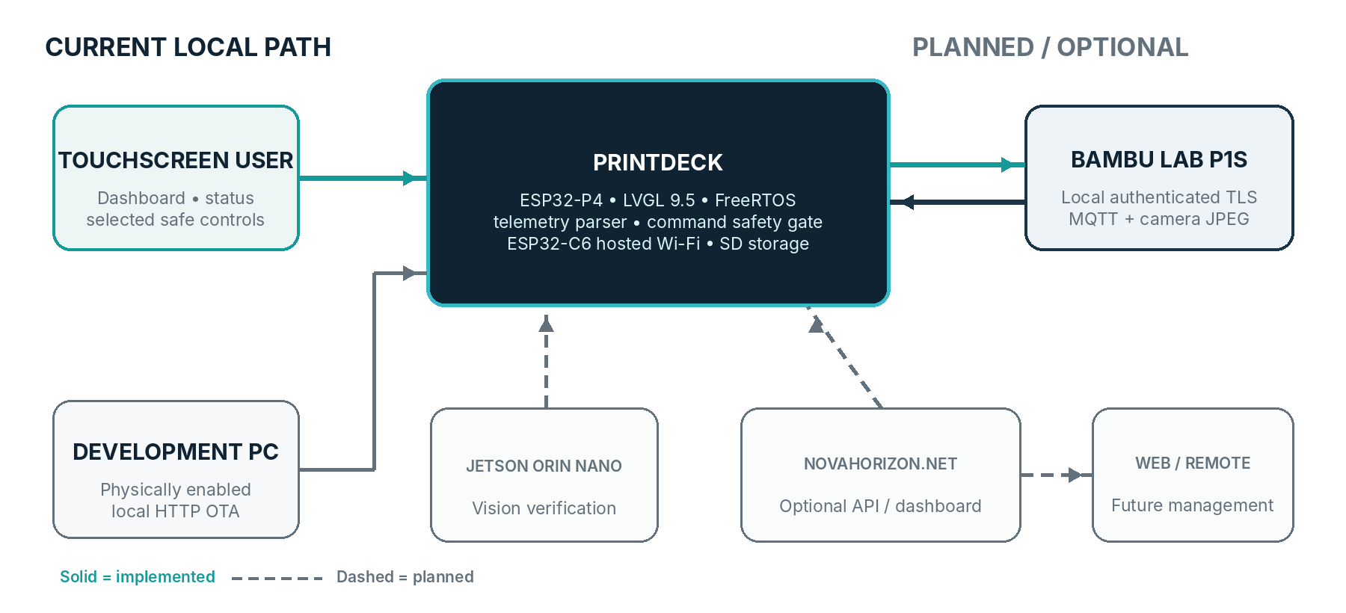
Solid lines are implemented; dashed lines are planned. No credentials or private identifiers are shown.
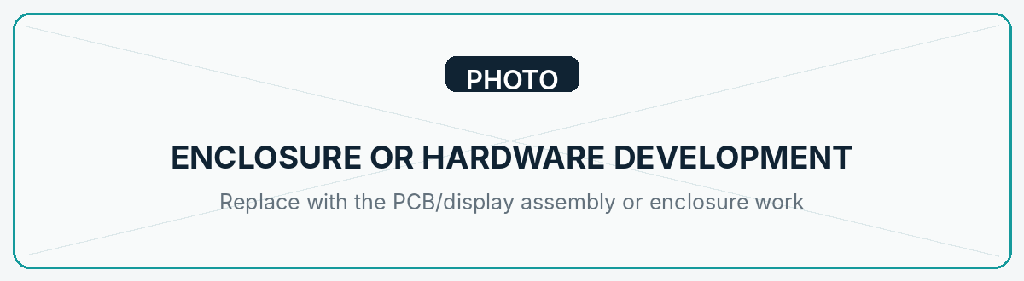
Enclosure or hardware development.

5 | WHY ADDITIONAL PRINTERS ARE NEEDED

One P1S can validate only one printer family and one set of firmware, telemetry, camera, accessory, and command behaviors. It cannot establish whether the same fields, responses, reconnect behavior, error states, or interface assumptions hold across Bambu Lab’s X and H families.
RECOMMENDED LOAN UNIT | TESTING VALUE
X1 Carbon + AMS | Adds X-series authentication/firmware coverage and a higher-resolution chamber camera plus Micro Lidar behavior—useful for separating model capabilities from P1S assumptions.
H2D + AMS 2 Pro | Adds the broadest H-series protocol challenge: dual-nozzle state, newer camera/sensor roles, active chamber functions, and newer filament-system behavior.
With the existing P1S, these units would provide broad P/X/H family coverage—not certification of every Bambu Lab model or SKU. A-series and per-model certification would remain separate work.
Official references: P1S specification / X1 Carbon technical specification / H2D technical data sheet
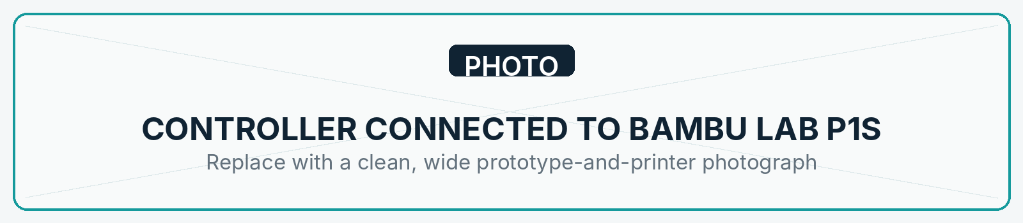
Controller connected to Bambu Lab P1S.
6 | PROPOSED PRINTER-LOAN ARRANGEMENT

I am requesting one or two printers on a temporary development loan for compatibility development, validation, demonstrations, and preparation of accurate project media. The equipment would be kept in a clean, controlled development environment and used for normal printing, protocol observation, regression testing, and documented demonstrations. The planned LAN-integration work does not require permanent printer modification; I would follow applicable operating and maintenance guidance and document relevant configuration changes.
I am willing to comply with reasonable loan terms, provide periodic progress reports, and share compatibility findings and relevant technical feedback. The printers can be returned at the end of an agreed loan period unless a different arrangement is mutually agreed. This request does not presume approval, endorsement, sponsorship, or partnership.

7 | TESTING AND VALIDATION PLAN

Complete = observed on the current prototype / Partial = implemented or observed with remaining tests / HW = requested printer required
TEST AREA | P1S | X1C + AMS | H2D + AMS 2 PRO
Discovery / connection | Partial: manual profile; no discovery | HW | HW
Authentication / TLS / MQTT | Complete for current profile | HW | HW
Job / temperature telemetry | Partial: live; regression ongoing | HW | HW + dual-nozzle
Commands / safety gates | Light complete; job controls pending | HW | HW
File handling / print launch | Pending implementation | Pending | Pending
Camera behavior | Partial: local P1 liveview works | HW | HW + camera roles
AMS / filament state | Pending implementation | HW | HW / AMS 2 Pro
Errors / reconnection | Partial code paths; fault tests pending | HW | HW
Firmware / long-duration | Pending matrix | HW | HW
UI adaptation / regression | P1S-focused UI working | HW | HW
Safety-sensitive commands will be exercised only with an appropriate setup, confirmation behavior, and a recoverable test job.

Development and testing setup.
8 | DEMONSTRATION AND PROMOTIONAL PLAN

After a reliable demonstration stage, I plan to prepare a dedicated project website, development updates, prototype demonstrations, product walkthroughs, compatibility demonstrations, and educational technical content. Outreach would include multiple 3D-printing and technology YouTube creators, social media content, and carefully targeted Meta advertising.
These are planned activities—not existing creator partnerships or guaranteed coverage. Bambu Lab would be acknowledged as a project supporter only if Bambu Lab agrees and approves the form of that acknowledgment.

9 | POTENTIAL VALUE TO BAMBU LAB

A successful independent controller could create additional community-driven use cases while generating practical compatibility feedback across printer families. Potential—not guaranteed—value includes:
- More technical and demonstration content featuring the Bambu Lab ecosystem.
- Engagement from advanced users, makers, and integration-oriented customers.
- Earlier identification and documentation of cross-model compatibility issues.
- Demonstrations of responsible local integration and command gating.
10 | DEVELOPMENT ROADMAP

PHASE | SCOPE / EXIT CONDITION
Current — P1S prototype | Hardware-regression test deployed v0.7.1 telemetry, reconnect, camera lifecycle, SD refresh, health data, and guarded actions.
Next technical milestone | Validate supported job commands; harden credentials; implement real local file browse/print start.
Multi-printer compatibility | Add model capability profiles; characterize X1 Carbon and H2D telemetry, cameras, AMS, commands, and UI.
Reliability / hardening | Reconnect, malformed/error-state, firmware-regression, long-duration, and safe-command testing.
Creator demonstration | Presentable enclosure, repeatable demos, accurate photography/video, compatibility summary.
Public launch preparation | Website, walkthroughs, support documentation, disclosures, and outreach materials.
No completion dates are asserted; progress depends on hardware access and compatibility findings.
11 | CONTACT AND NEXT STEP

I would welcome a discussion about whether Bambu Lab would consider a temporary development loan of an X1 Carbon and/or H2D, ideally with their corresponding AMS systems.
DIMA | Email: [INSERT EMAIL] / Phone: [INSERT PHONE]
PROJECT | Website: [INSERT PROJECT WEBSITE]
LINKS | Repository: [INSERT REPOSITORY, IF SHARED] / Social: [INSERT SOCIAL LINKS]
PrintDeck is an independent development project of Horizon Services LLC. Bambu Lab is not currently affiliated with or responsible for it.

