Summary:

While analyzing airline performance, we noticed that same origin airports tend to be present in a list of highest delay percentages. Initial analysis looked at Southwest, American, and United Airlines (which make up 50% of all US flights) and delay percentages as a function of origin airport.

Southwest Airlines

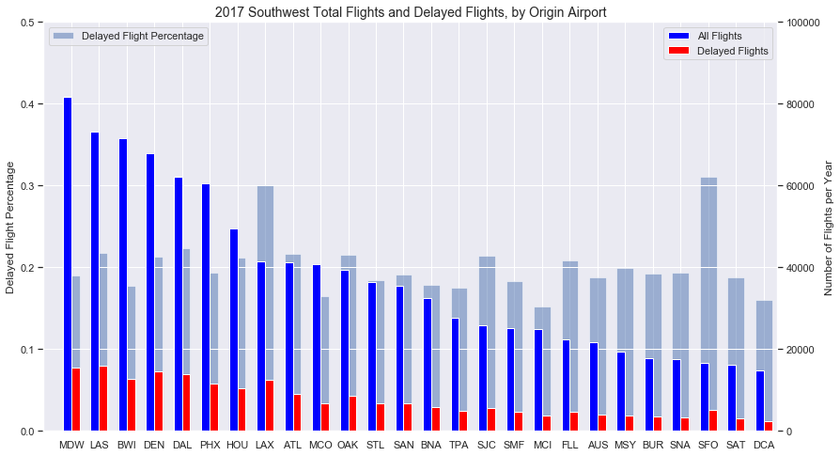

SFO 0.311330

LAX 0.300265

EWR 0.271363

DAL 0.223535

LAS 0.218197

ATL 0.216150

OAK 0.215234

SJC 0.214712

DEN 0.213428

HOU 0.212105

American Airlines

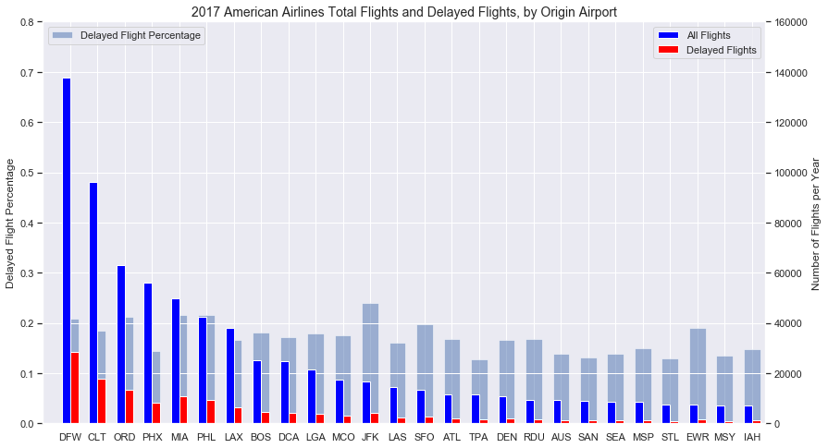

JFK 0.239166

MIA 0.215648

PHL 0.215173

ORD 0.212090

DFW 0.207660

IAD 0.203976

SFO 0.197801

EWR 0.189142

CLT 0.184354

BOS 0.180293

United Airlines

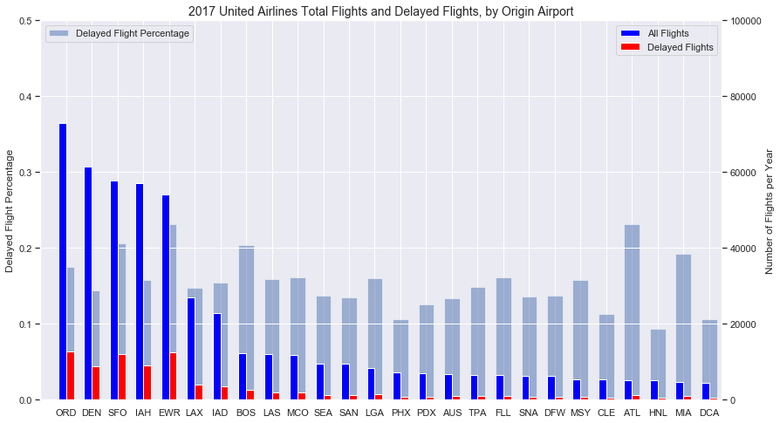

PBI 0.263673

EWR 0.231172

ATL 0.230904

BNA 0.219697

SFO 0.206219

BOS 0.204175

EUG 0.198057

SJU 0.197797

MIA 0.192012

ORD 0.174702

Looking at the breakdown of delays and flight volume by airlines:

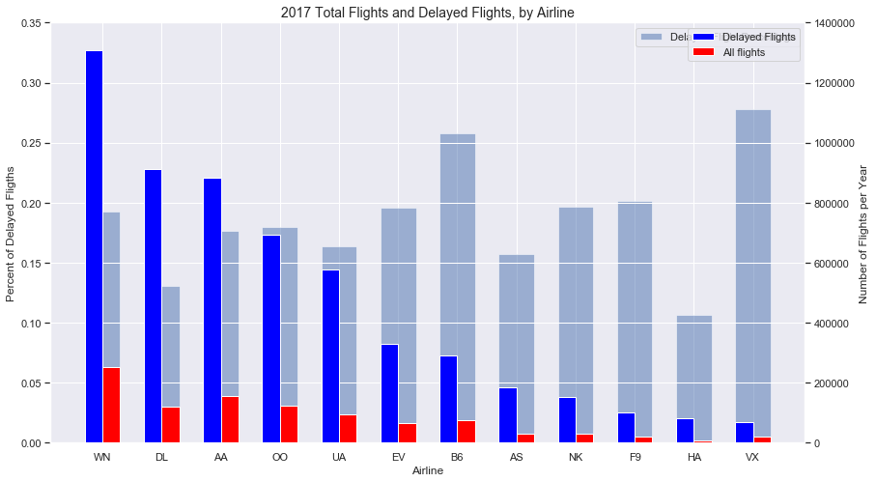

VX 0.277877

B6 0.257856

F9 0.201811

NK 0.196220

EV 0.195932

WN 0.192491

OO 0.179436

AA 0.176565

UA 0.163890

AS 0.157340

DL 0.130984

HA 0.106147

Analyzing flight volume / delay volume percentages can give us a better picture of how the delays are weighted.

We then looked top airports by flight volume to determine the delay rate of each airport:

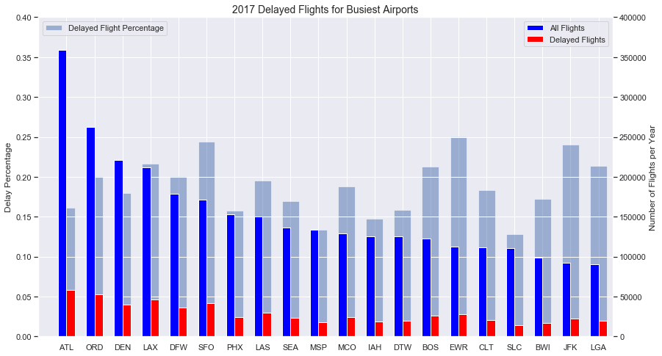

EWR 0.250590

SFO 0.244134

JFK 0.240389

LAX 0.216559

LGA 0.213504

BOS 0.212972

DFW 0.201238

ORD 0.200680

LAS 0.195448

MCO 0.187614

The above analysis can be used to determine the probability and length of delay given the origin airport and airline information.

Further breaking down the reasons for delay by category:

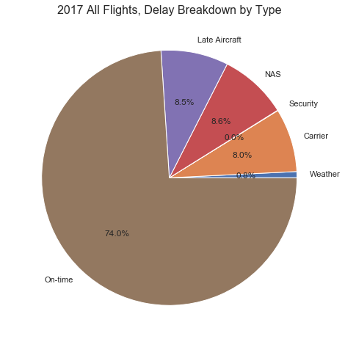

NAS - We can continue to look at patterns for heavy traffic or trends in increasing air traffic patterns areas and look for constancies. Additionally, extreme events are not considered here, normal weather patterns that cause air traffic slowdowns are. Looking at weather patterns may be beneficial. FAA has a database breaking down the NAS delays by cause. (FAA OPSNET)

Carrier - carrier performance can be further analyzed by location and see if there are patterns

Late Aircraft - This can be handled with arrival delay information. This field highly depends on the other delay causes.

Weather - only extreme weather events are considered here. These events are rare and would result in region-wide cancellations, as such, these can be ignored as outliers.

Breaking down the FAA data (NAS delays section from above):

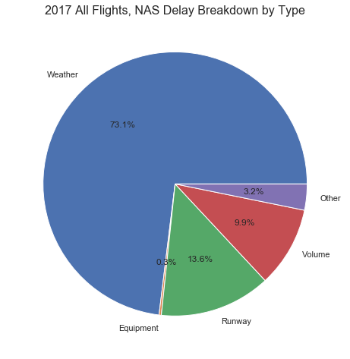

Correlations: