In our previous studies we have demonstrated that the random path selection shows a lot of advantage over the weighted round robin scheduler when it comes down to routing the packets.

Here we confirm that the random path selection shows better performance over WRR scheduler in terms of reordering distance and entropy when the paths are not similar, that is when paths have diverse delays. When paths are similar WRR is more advantageous.

Similar paths:



Paths are different (in the first setting we have paths that are simulated with exponential distribution and in the second case the delays are drawn from Pareto distribution):





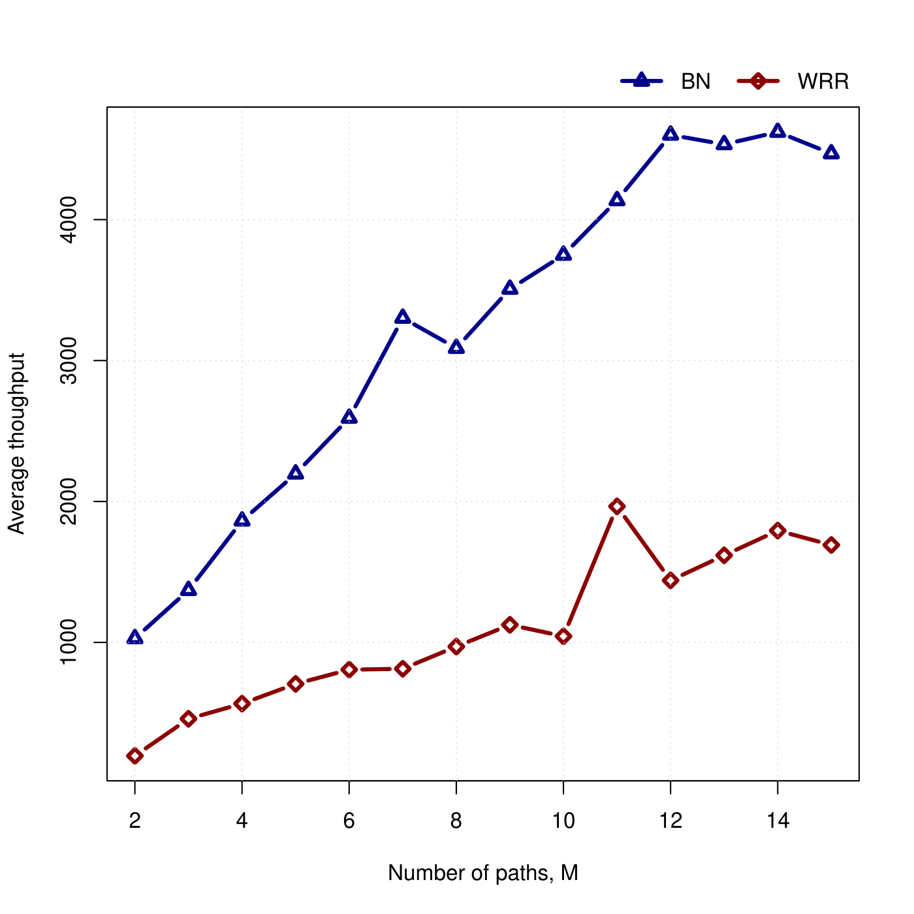

What important is that the throughput also increases with the Bernoulli scheduling scheme: