When the number of features is too large, and some features do not introduce much information the dimension of the dataset may be reduced using Principal Component Analysis approach.

Consider we are given a vector of observations, whereas each contains N features. In the PCA the first step is to subtract the mean from each feature as follows:

$$Y=X-\overline{X}$$

Now, all the datapoints are centered around zero, that is the mean of the features is zero. Consider the following case:

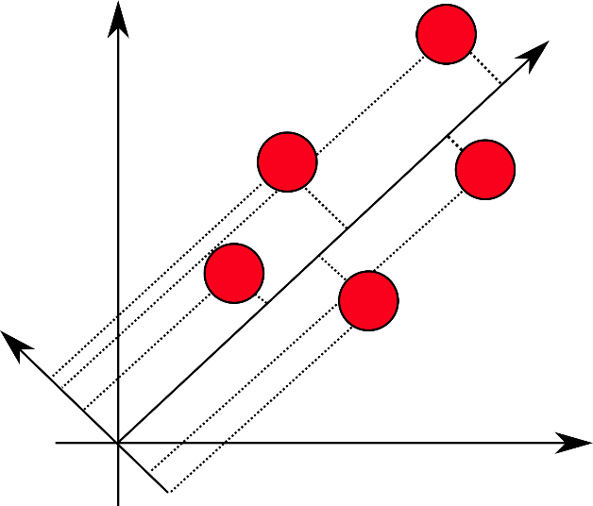

For simplicity, assume that we have 2-dimensional data. And consider that we have projected the datapoints on some vector **u**. The idea behind the PCA is to choose such vector **u** that maximizes the variance of the projections. Thus, we can write this fact mathematically as follows:

$$Var = \frac{1}{N}\sum{({ux}_{i}-u\overline{X}}){(ux_{i}-u\overline{X})}^{T}=u[\frac{1}{N}\sum{(y_{i}}){(y_{i})}^{T}]u^{T}=uCu^{T}$$

Observe that the term under the sum is just a covariance matrix of Y (it can be easily shown that it is indeed so by expanding the multiplication of matrix).

Since the task is to maximize the variance and given that the magnitude of vector **u** should be bounded (otherwise the optimization will lead to infinitely large vector **u**) we say that $uu^{T}=1$

We can construct the Lagrangian and formulate the primal optimization problem (given the constraint $uu^{T}=1)$:

$$L=uCu^{T}-α(uu^{T}-1)$$

Taking the derivative of this expression with respect to vector **u** (matrix and vector derivatives are described here <https://en.wikipedia.org/wiki/Matrix_calculus>) and equating it to zero we get:

$$Cu^{T}=αu^{T}$$

But this is exactly the expression for the eigenvalues and eigenvectors. That is to maximize the variance we need to select the maximum value for the eigenvalue and select **u** to be corresponding eigenvector.

At the end, we can construct the matrix in which rows are eigenvectors (ranked according to eigenvalues in the descending order), select top k rows and multiply the original vector X by the sought matrix of eigenvectors. This will be our reduced matrix with lower dimensionality without losing much information:

$$\hat{X}=XU^{T}$$