**Задача A**

select airport_code, coordinates from airports_data  
where city = '{"en": "Moscow", "ru": "Москва"}' or city = '{"en": "Kazan", "ru": "Казань"}'  
order by airport_code desc;

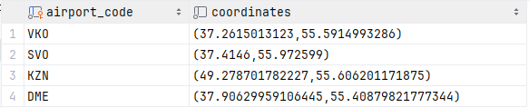

**Задача B**

SELECT *concat_ws*(', ', airport_code, airport_name->'ru', city->'ru', coordinates, timezone) AS full_information  
FROM airports_data  
order by full_information asc;

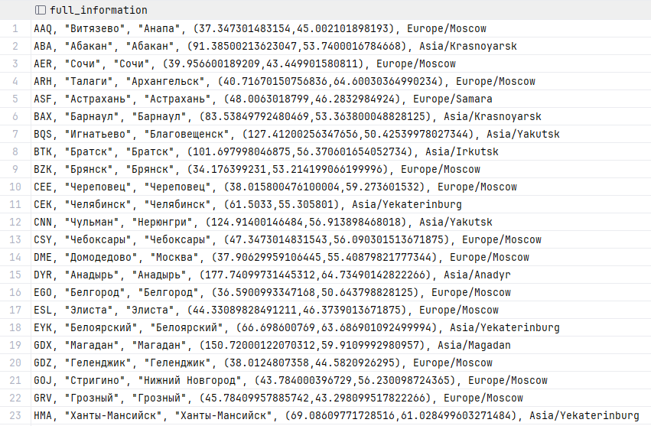

**Задача C**

select departure_airport, *count*(*\**) as count  
from flights  
where departure_airport in ('KZN', 'DME', 'OVB', 'IKT', 'LED', 'SVO')  
group by departure_airport  
order by count desc  
;

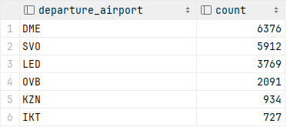

**Задача D**

select departure_airport, *count*(*\**) as count  
from flights  
where departure_airport not in ('KZN', 'DME', 'OVB', 'IKT', 'LED', 'SVO')  
group by departure_airport  
order by count asc  
;

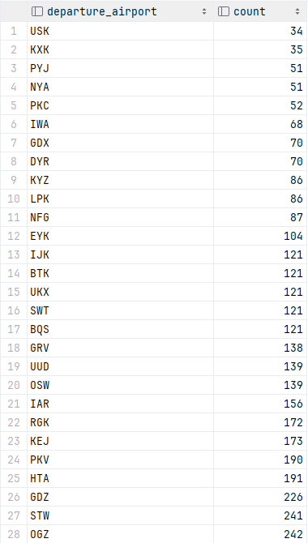

**Задача E**

select flight_id, scheduled_departure, count  
from flights  
join (select flight_id as fid, *count*(*\**) as count  
from boarding_passes  
group by flight_id  
) on flights.flight_id = fid  
  
where count between 27 and 90  
order by flight_id desc  
;

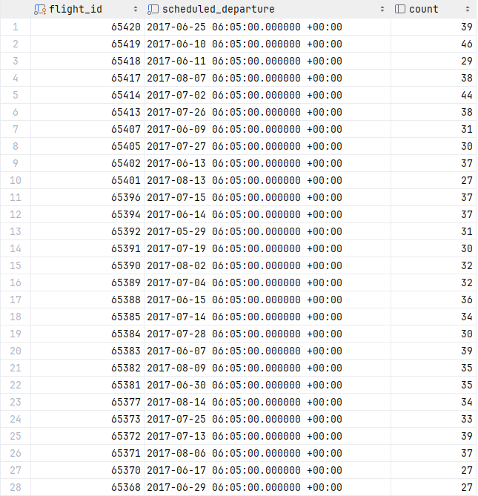

**Задача F**

select distinct passenger_name, departure_airport, arrival_airport  
from boarding_passes  
  
join flights on boarding_passes.flight_id = flights.flight_id  
join tickets on tickets.ticket_no = boarding_passes.ticket_no  
  
;

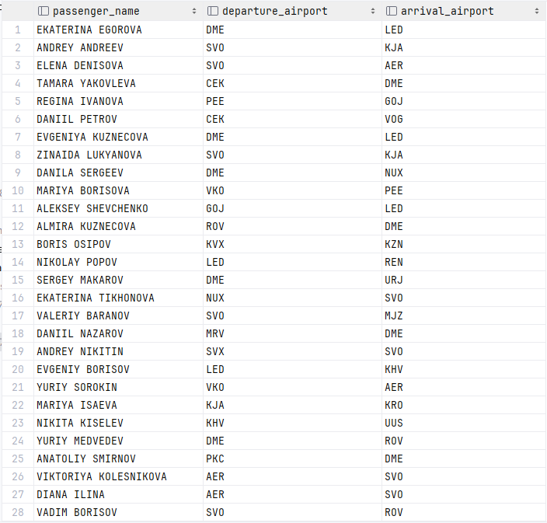

**Задача G**

select distinct passenger_name as data, 'Пассажир' as data_type  
from boarding_passes  
  
join flights on boarding_passes.flight_id = flights.flight_id  
join tickets on tickets.ticket_no = boarding_passes.ticket_no  
  
  
UNION  
  
select airport_name->>'ru' as data, 'Аэропорт' as data_type  
from airports_data  
  
order by data_type desc, data asc  
;

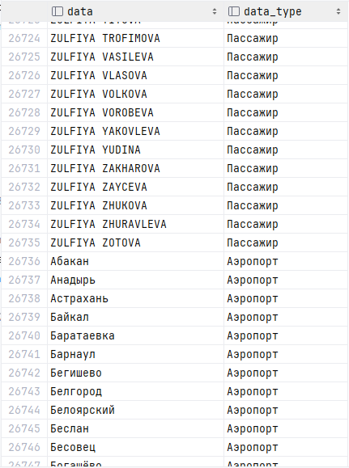**Задача H**

select *count*(*\**)  
from flights  
left outer join boarding_passes  
 on flights.flight_id = boarding_passes.flight_id  
  
where boarding_passes.ticket_no is null  
group by ticket_no  
;



**Задача J**

select flights.flight_no as flight_no, *min*(bookings.total_amount) as min_price, *max*(bookings.total_amount) as max_price  
from flights  
join boarding_passes on flights.flight_id = boarding_passes.flight_id  
join tickets on tickets.ticket_no = boarding_passes.ticket_no  
join bookings on tickets.book_ref = bookings.book_ref  
group by flights.flight_no  
order by flights.flight_no asc  
;

