1 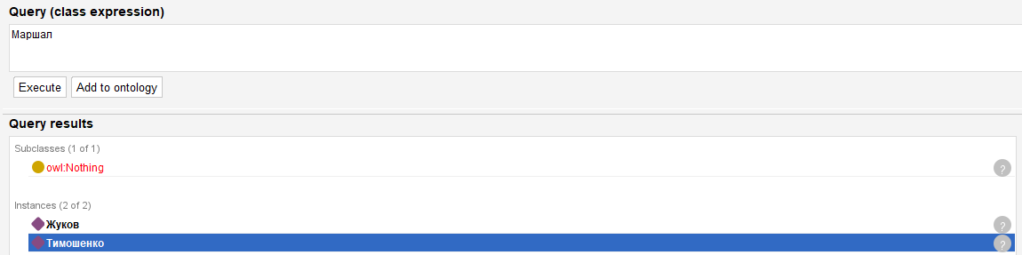
2
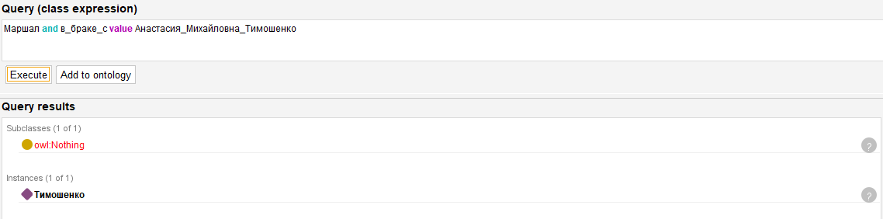
3
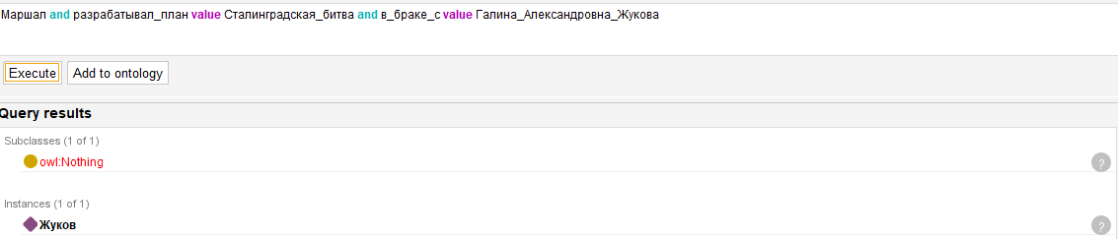
4
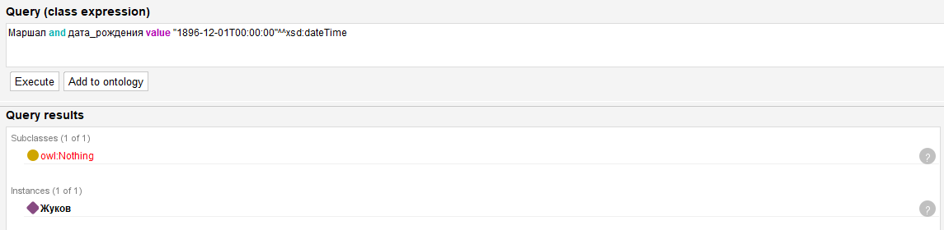

5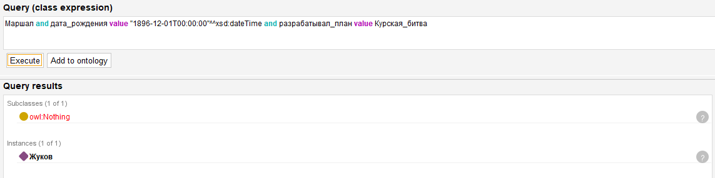

Запросы SPARQL
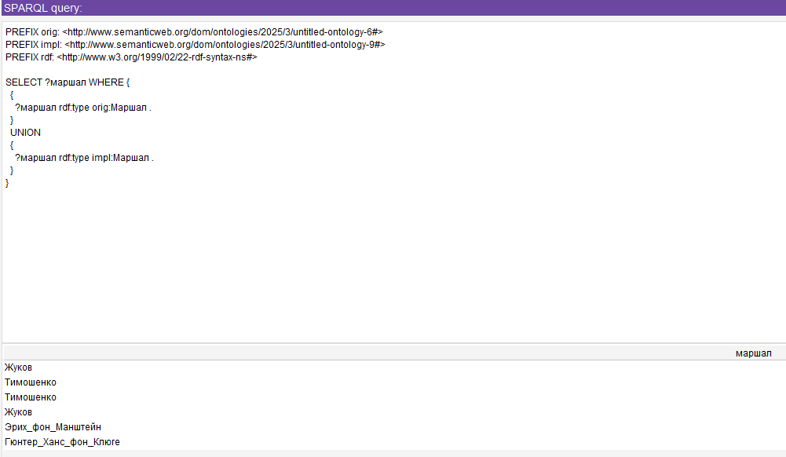

PREFIX rdf: <http://www.w3.org/1999/02/22-rdf-syntax-ns#>
PREFIX owl: <http://www.w3.org/2002/07/owl#>
PREFIX rdfs: <http://www.w3.org/2000/01/rdf-schema#>
PREFIX xsd: <http://www.w3.org/2001/XMLSchema#>

PREFIX orig: <http://www.semanticweb.org/dom/ontologies/2025/3/untitled-ontology-6#>

PREFIX impl: <http://www.semanticweb.org/dom/ontologies/2025/3/untitled-ontology-9#>

SELECT DISTINCT ?predicate1 ?predicate2 ?propertyOrig ?predicateImpl
WHERE
{
{
?predicate1 owl:equivalentProperty ?predicate2 .
?instance2 owl:sameAs ?instance1 .

?instance1 a impl:Маршал ;
?predicate2 ?object1 .

?instance2 a orig:Маршал ;
?predicate1 ?object2 .

?propertyOrig a owl:DatatypeProperty.

?instance1 ?propertyOrig ?object.
?instance2 ?predicateImpl ?object3
FILTER(?predicate1 != rdf:type && ?predicate2 != rdf:type && ?propertyOrig != rdf:type && ?predicateImpl != rdf:type && ?predicateImpl != owl:sameAs && (?predicateImpl != ?predicate2 && ?predicateImpl != ?predicate1))
}
}

TEST

SELECT DISTINCT ?instance1 ?predSovm ?dataProperty1 ?dataProperty2 ?predOrig1 ?predOrig2 ?predOrig3
WHERE
{
?instance1 a impl:Маршал.
OPTIONAL {?instance2 owl:sameAs ?instance1 .}
OPTIONAL
{
?predSovm owl:equivalentProperty ?predicate2 .
?instance2 owl:sameAs ?instance1 .

?instance1 ?predicate2 ?object1 .
?instance2 ?predSovm ?object2 .
}

OPTIONAL
{
SELECT ?dataProperty1 ?dataProperty2
WHERE
{
?dataProperty1 a owl:DatatypeProperty.
?instance1 ?dataProperty1 ?data1

OPTIONAL
{
?dataProperty2 a owl:DatatypeProperty.
?instance1 ?dataProperty2 ?data2.
FILTER(?dataProperty2 != ?dataProperty1)
}
FILTER(STR(?dataProperty2) > STR(?dataProperty1)).
}
}
OPTIONAL
{
?predOrig1 a owl:ObjectProperty.
?instance1 ?predOrig1 ?o1.
FILTER(?predOrig1 != rdf:type)
FILTER(STR(?predOrig1) < STR(?predSovm))
}
}

