Methods
Last Version of Methods: 25.09.2026
Last Version of Prompts: 25.09.2026
For the standardized annotation of the radiology reports within a patient trajectory of existing radiology reports of different modalities, the customized platform RadTag was built to set a time axis with the radiology reports put chronologically, starting from the earliest radiology report available until the latest one extracted from the database available by the time the annotation was being done.
To ensure reproducibility, we established a methodology with clear rules and a schema for each part of the trajectory. The aim was to ensure a change-centered scheme for annotating how radiological findings evolve across a patient’s sequential imaging studies across different modalities, with no preference for either modality. Rather than paraphrasing every key finding at the corresponding time points, the established annotation scheme aims to assess what changed between examination T1 and examination T2, providing details only when changes are necessary to understand the overall trajectory. It draws on different strands of annotations: sentence-level progression annotation with temporal comparison between the two examinations; event-based finding annotation that focuses on and represents findings with corresponding attributes, if necessary, to understand the overall development; and disease- or organ-specific trajectory categories summarized in the overall summary of the given trajectory.
The key attributes of the annotation were based on approaches from other studies that also used LLMs to assess radiology reports (1). The wording for the labels of different attributes and corresponding changes in findings is based on the guidelines provided by LI-RADS® (2-4).
To objectively systematize the annotation process, we established 3 annotation levels, corresponding to 3 fields used in RadTag: an Interval Note, a Finding-Specific Note, and a Global Note.
The Interval Note captures the essential changes between two examinations. It assigns the comparability label - whether the findings are comparable, only partially comparable, not comparable at all, or not assessable – and the overall interval label, describing the general character of the change: no significant change, regression, progression, mixed change, indeterminate, or not assessable. Additionally, standardized change flags can be added and a short free-text sentence outlining the essential change in plain language. Because there may be significant time gaps between comparable findings, the surveillance gap flag can also be noted here to support a more differentiated approach to assessing comparability. If there is a significant time gap between findings, a note on the length of the gap should be included.
This annotation includes 4 attributes with key information regarding the change:
- Vergleichbarkeit (Comparability)
German Term (entered in RadTag) | English Explanation
Vergleichbar | Comparable – the prior and current study are sufficiently comparable.
Eingeschränkt vergleichbar | Limited comparability – comparison is possible yet limited by modality, protocol, contrast agent, time interval or the overall findings.
Nicht vergleichbar | Not comparable – a reliable assessment of change is not possible. Alternatively, no prior study exists.
Nicht beurteilbar | Not assessable – the relevant region or finding cannot be evaluated.
This attribute refers to the technical and/or protocol-related comparability.
- Hauptverlaufslabel (Overall interval label)
German Term (entered in RadTag) | English Explanation
Keine wesentliche Intervallveränderung | No significant interval change – none of the relevant finding considerably changed.
Rückläufig | Regression – a relevant decrease in size, count, extent, density, or solid component.
Progredient | Progression – a relevant increase, a new relevant lesion, or spread of an existing finding.
Gemischte Veränderung | Mixed change – simultaneous regressive and progressive relevant finding in independent finding complexes.
Indeterminiert | Indeterminate – a change is described or suspected but cannot be reliably classified.
Nicht beurteilbar | Not assessable – the interval cannot be assessed due to technical or content-related limitations.

- Veränderungslabel (Change Labels)
At least one change label is assigned. In case no relevant changes have been identified, the label “Keine Befundsänderung” is used.
German Term (entered in RadTag) | English Explanation
Neuer Befund | New finding
Größenzunahme | Increased size
Größenabnahme | Decreased size
Zunahme der Anzahl | Increase count
Abnahme der Anzahl | Decreased count
Dichtezunahme | Increased density
Dichteabnahme | Decreased density
Zunahme des soliden Anteils | Increased solid component
Abnahme des soliden Anteils | Decreased solid component
Zunahme der Ausdehnung | Increased extent
Abnahme der Ausdehnung | Decreased extent
Morphologische Veränderung | Morphologic change
Nicht mehr nachweisbar | No longer detectable — requires an explicit absence evidence given in the report text.
Neue Komplikation | New complication
Keine Befundsänderung | No relevant change
Mögliche Nachsorgelücke | Surveillance gap – set when the interval between the examinations exceeds the follow-up interval normally expected for the entity/clinical question (more than 12 months for oncologic surveillance, unless specified otherwise), and no interim reports exists in the database.

- Wesentliche Veränderung (essential change)
This attribute captures the most important change(s) within one connected paragraph consisting of 1-3 sentences; even with several sub-aspects and complexes, it remains one paragraph – sub-aspects are linked linguistically and not listed. Where relevant, the lab values available supporting the change can be named, yet only as supplementary evidence.
The default phrasing when nothing relevant has changed would be “Keine wesentliche Intervallveränderung” (“No significant interval change”).
When the change label “Mögliche Nachsorgelücke” is included, the context should be given by naming the length of the gap before the substantive findings follow.
Sample Annotation

Vergleichbarkeit: Vergleichbar
Hauptverlaufslabel: Gemischte Veränderung
Veränderungslabel: Mögliche Nachsorgelücke, Neuer Befund
Wesentliche Veränderung: Lücke von ca. 2 Jahren 11 Monaten ohne dokumentierte Zwischenbefunde. Deutliches Ansprechen der linksseitigen HCC-Manifestationen nach Radioembolisation, demgegenüber Progredienz rechts mit neuen Läsionen Segment V/VI bei unverändert großem Herd Segment VIII (LI-RADS 5).

The Finding-Specific Note captures the clinically relevant findings individually by capturing the status at the current timepoint (whether it is newly detected, persistent, no longer detectable, or not accessible), its direction of change (unchanged, increasing, decreasing, mixed, or indeterminate), which specific features changed (count, siye, density, solid component, extent, morphology, etc.) and a short evidence snippet quoting or content wise closely paraphrasing the measurement change of the corresponding radiological finding.
The annotation includes the following attributes:
- Entität (entity)
The name of the finding described, e.g. “HCC-Herd”.
- Lokalisation (location)
The anatomical location of the finding, e.g. “Lebersegment VIII”.
- Befundstatus (finding status)
German Term (entered in RadTag) | English Explanation
Neu aufgetreten | Newly detected – not described or detectable in the prior study, newly occurred and described in the current study
Persistierend | Persistent – already present before and still detectable now.
Nicht mehr nachweisbar | No longer detectable – not detectable in the current study. Explicit statement of absence is required.
Nicht beurteilbar | Not assessable – status cannot be reliably assessed. That includes findings that are not mentioned.

- Verlaufsrichtung (direction of change)
German Term (entered in RadTag) | English Explanation
Unverändert | Unchanged
Zunehmend | Increasing
Rückläufig | Decreasing
Gemischt | Mixed – different components of the same finding change in opposite directions
Unklar | Indeterminate

- Verändertes Merkmal (changed feature)
German Term (entered in RadTag) | English Explanation
Größe | Size
Anzahl | Count
Dichte | Density
Solider Anteil | Solid component
Ausdehnung | Extent
Morphologie | Morphology
Verteilung/Lokalisation | Distribution
Kontrastmittelaufnahme | Enhancement
Begleitbefund | Associated finding
Kein spezifisches Merkmal | None specified

- Delta/Beleg (delta/evidence)
Numeric values are given as directly as possible and embedded in a full sentence, e.g., “Der Herd hat im Vergleich zur Voruntersuchung an Größe zugenommen, von 8 mm auf 11 mm.” Here, no measurements or interpretation beyond what report provides shall be placed, just the paraphrasing of the corresponding content from the report.
If several studies are done on the same day but with different modalities (CT and MRI, for example), they are treated as one finding entry, not several. The evidence text should present both values side by side, without ranking one modality over the other. That does not apply if the studies were done on different days, or if multiple studies were done on the same day with a clear change in the corresponding finding(s).
If findings from different modalities on the same day conflict, the overall finding is annotated as indeterminate, with the conflict outlined in the context field.
Interventional-radiology reports (brachytherapy, SIRT, TACE, RFA, etc.) are annotated like any other finding with all the same attributes. There is no separate event type for such cases – interventional reports are treated as any other radiological finding within the trajectory.
Sample Annotation in German

Entität: HCC-Herd Lebersegment VIII
Lokalisation: rechter Leberlappen, Segment VIII
Befundstatus: Persistierend
Verlaufsrichtung: Unverändert
Verändertes Merkmal: Kein spezifisches Merkmal
Delta/Beleg: Im MRT größenkonstant bei 4,8 cm gegenüber der Voruntersuchung; CT vom gleichen Tag bestätigt konkordant 4,7 cm.

The Global Note essentially summarizes the overall trajectory of the relevant findings without simply paraphrasing the finding-level details. This annotation carries one overall status – stable, improved, progressive, mixed, complete regression, indeterminate, not assessable, or not comparable with an additional contextual sentence and the corresponding explanation. Because different key findings may be marked as progressive and improved simultaneously, assign the mixed label based on the specific aggregation logic.
- Gesamtstatus (overall status)
German Term (entered in RadTag) | English Explanation
Stabil | Stable – no relevant change among the relevant finding.
Gebessert | Improved – predominantly regressive or no longer detectable.
Progredient | Progressive – at least one relevant finding is new or increasing with no opposing relevant change within the same complex.
Gemischte Veränderung | Mixed – at least two independent finding complexes with opposing status.
Vollständige Rückbildung | Complete regression – all previously relevant findings are no longer detectable or explicitly fully regressed.
Indeterminiert | Indeterminate – no reliable overall classification possible.
Nicht beurteilbar | Not assessable – an overall assessment is not possible.
Nicht vergleichbar | Not comparable – no reliable basis for comparison.

Before assigning the overall status, the relevant findings should be grouped into finding complexes which capture the findings that lie in the same organ/anatomical unit and are subject to the same treatment or clinical decision (e.g. “right hepatic lobe after right-sided radioembolization” vs. “left hepatic lobe pending left-sided radioembolization”). Some trajectories have one complex; others have several, and this difference is to be addressed correctly.
- If there is no comparability across the findings within the trajectory, then “Nicht vergleichbar”/“Nicht beurteilbar”.
- Within one given complex, the single worst finding determines the overall status of the finding complex. If a new increasing finding is next to a regressive finding in the same complex, the status is “Progredient”, not “Gemischte Veränderung”.
- “Gemischte Veränderung” is assigned only when at least two finding complexes exist and have opposing status.
- If everything remains unchanged with no new findings, then the status “Stabil” is assigned.
- If a finding cannot be reliably classified, then the status “Indeterminiert” is assigned.
- “Vollständige Rückbildung” is assigned only when all previously relevant findings are no longer detectable or are fully regressed.

- Kontext (context)
When overall status is “Gemischte Veränderung”, the Kontext field should outline the overall summary for each finding complex, sorted and folded into one connected paragraph with no bulleted list.
Sample Annotation in German

Gesamtstatus: Gemischte Veränderung
Kontext: [Leber links: Gebessert] [Leber rechts: Progredient]
Deutliches Therapieansprechen links nach Radioembolisation (Regression bis Verschwinden der Läsionen), demgegenüber Progredienz rechts mit neuen Läsionen Segment V/VI bei konstant großem Herd Segment VIII.

To ensure a more efficient annotation process, the preliminary annotation will be done initially with LLMs and then adjusted and fine-tuned by the human annotator. This approach has been proven viable in the related literature, significantly reducing overall annotation time by up to 58% with no considerable loss of quality (5). Using a human-in-the-loop approach in annotation tasks can minimize differences across annotators. However, it may also increase anchoring bias if annotators are less willing to double-check preliminary LLM-produced annotations (6).
For the preliminary annotations, specfic prompts for the corresponding fields have been composed with additional assistance of Claude Opus 5. These prompts outline the rules with labels as explained above. There is an additional fallback instruction included for cases in which the current report of a pair does not exist or not available. In this case, LMM is instructed to generate a prediction on the most plausible development from prior report. It was implemented for future testing of predictive annotation and was not used or tested yet. Prompts can be found in the separate document in the same repository.
The following screenshot illustrates an example with synthetic data of how RadTag with the annotations fields described above looks like:
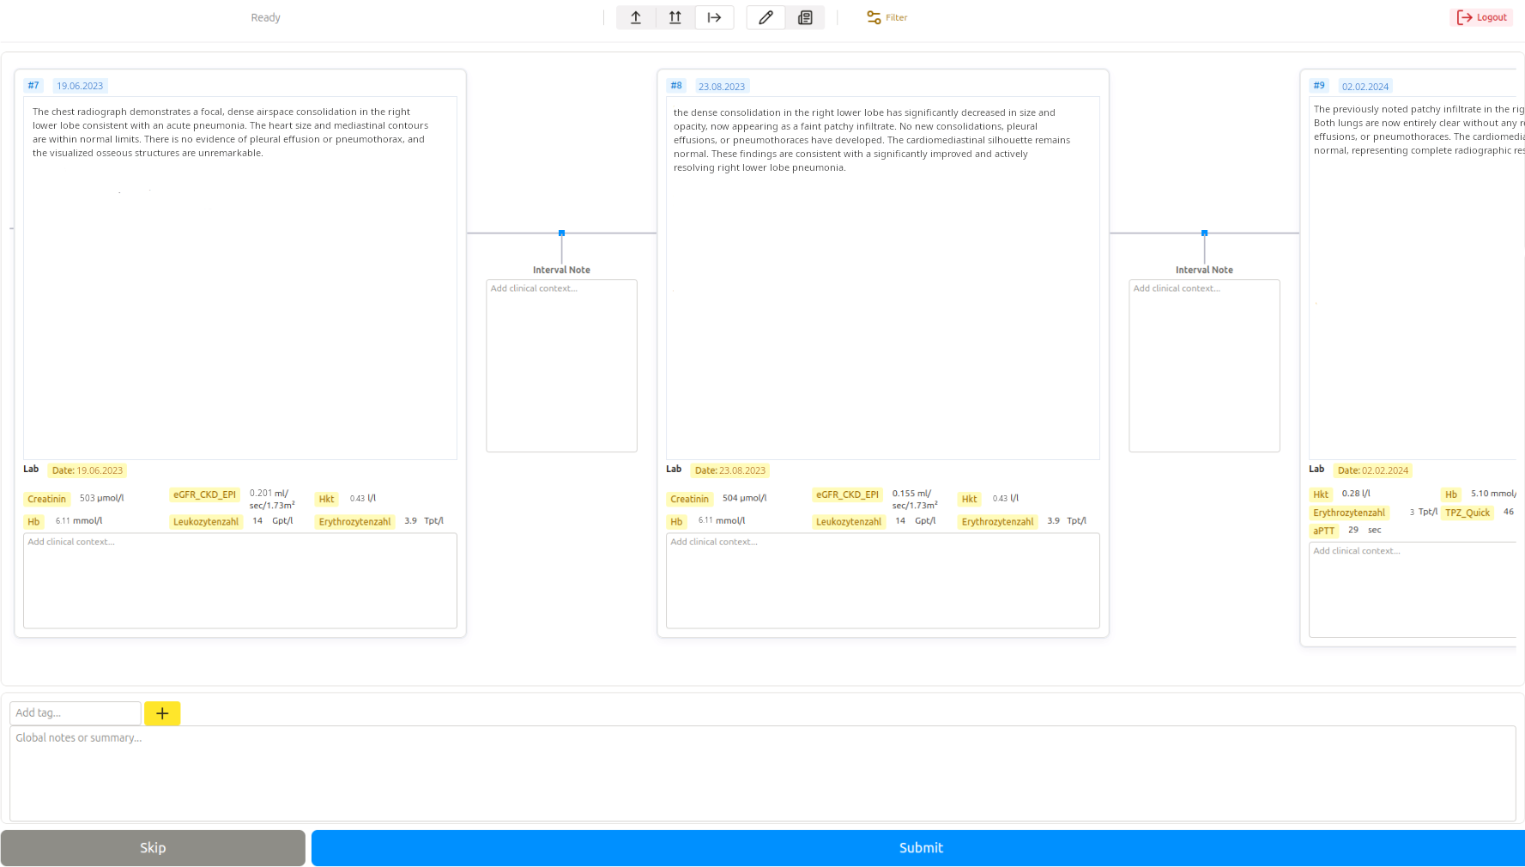

Reference
1. Wang X, Figueredo G, Li R, Chen X. Standardizing Longitudinal Radiology Report Evaluation via Large Language Model Annotation. arXiv preprint arXiv:260116753. 2026.
2. American College of Radiology Committee on L-R. CT/MRI Liver Imaging Reporting and Data System (LI-RADS) v2018. 2018.
3. Chernyak V, Fowler KJ, Kamaya A, Kielar AZ, Elsayes KM, Bashir MR, et al. Liver imaging reporting and data system (LI-RADS) version 2018: imaging of hepatocellular carcinoma in at-risk patients. Radiology. 2018;289(3):816-30.
4. Marks RM, Masch WR, Chernyak V. LI-RADS: past, present, and future, from the AJR special series on radiology reporting and data systems. American Journal of Roentgenology. 2021;216(2):295-304.
5. Goel A, Gueta A, Gilon O, Liu C, Erell S, Nguyen LH, et al., editors. Llms accelerate annotation for medical information extraction. machine learning for health (ML4H); 2023: PMLR.
6. Ningtyas AM, Herwanto GB, Sari Y, Putri RA, Kovacevic F, El-Ebshihy A, et al., editors. AnnoHID: LLM-Assisted Annotation Framework for Low-Resource Medical Texts. Proceedings of the 64th Annual Meeting of the Association for Computational Linguistics (Volume 3: System Demonstrations); 2026.

