Week04 – SQL - QUESTIONS

1. List all items:

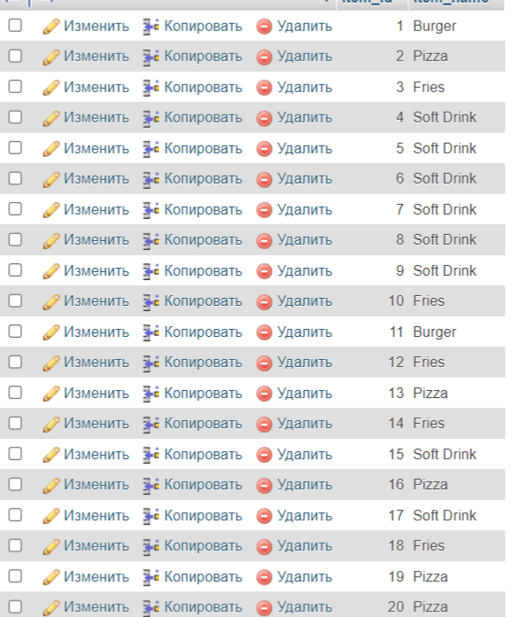

1. Find total price for each product (item)

total_price237.43

1. Sellect all customers who make order 03.12.2023

SELECT customers.customer_surname, customers.customer_firstname, customers.customer_address, customers.customer_email FROM customers JOIN orders ON customers.customer_id = orders.customer_id -- Join on the customer_id WHERE orders.order_date = '2023-12-03';



1. Find 5 most costing items: 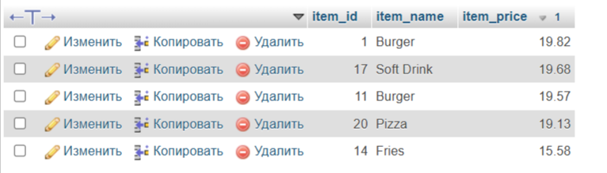

SELECT item_id, item_name, item_price

FROM items

ORDER BY item_price

DESC LIMIT 5;