Valuing 3- and 4-Asset Spread/Rainbow Options: A Comparative Study
Prepared by: Dmitry Goryunov
Date: 18 March 2026

Executive Summary
We benchmark three fast approximations—(i) Presentation (Kirk/Margrabe + pairwise ranking), (ii) LZD conditional quadrature (pairwise, 1-D), and (iii) Presentation with improved ranking—against a Monte-Carlo (MC) reference under lognormal dynamics. The Presentation model is extremely fast and usable for 3 assets when vols are similar and correlations are moderate to high. The LZD pair engine improves pair accuracy (notably for K>0 or uneven vols) but inherits the same ranking-factorization limitations when extended to 3/4 assets. The MC benchmark remains the gold standard but is the slowest.

Methodology
Under risk-neutral GBM assumptions, forwards (netbacks) F follow correlated lognormal distributions. Payoff: max_{k>=2}(S_k - S_1 - K, 0). We price pair spreads with either Kirk/Margrabe (Presentation) or Li–Zhou–Deng (LZD) conditional quadrature. For 3/4-asset cases, we decompose into pair terms vs base and scale by outranking probabilities; this is exact only when ranking events factorize—an assumption that becomes fragile as dimensionality and correlation increase.

Models

1) Presentation (Kirk/Margrabe + Pairwise Ranking)
Price each alternative vs base using Kirk (Margrabe when K=0). For 3 assets: V ≈ V(2,1) + V(3,1)×P(S3>S2). For 4 assets: add V(4,1)×P(S4>S2)×P(S4>S3).
Pros:
• Fastest; closed-form pairs; easy to audit
• Reasonable for 3 assets when vols similar & correlations moderate-high
Cons:
• Ranking factorization is structurally wrong for >2 assets
• Bias grows when legs are close and correlated
• 4-asset extension is fragile

2) LZD Conditional Quadrature (Pairwise, 1-D)
One-dimensional Gauss–Hermite integration by conditioning on S1; inner term is a Black call on the conditional S2. Extended to 3/4 assets by same ranking scaffold.
Pros:
• More accurate pair pricing than Kirk when K>0 or vols are uneven
• Very fast; accuracy tunable via nodes
Cons:
• Extension still uses approximate ranking
• Not a true multivariate method

3) Monte-Carlo (Benchmark)
Correlated GBM simulation with antithetic variates; payoff evaluated pathwise.
Pros:
• Most accurate and flexible; handles any correlation/vol structure and number of legs
Cons:
• Slowest; statistical noise; needs many paths for tight confidence intervals

Results
Figure 1 compares values for the 3-asset case (Presentation, LZD-ext, MC).
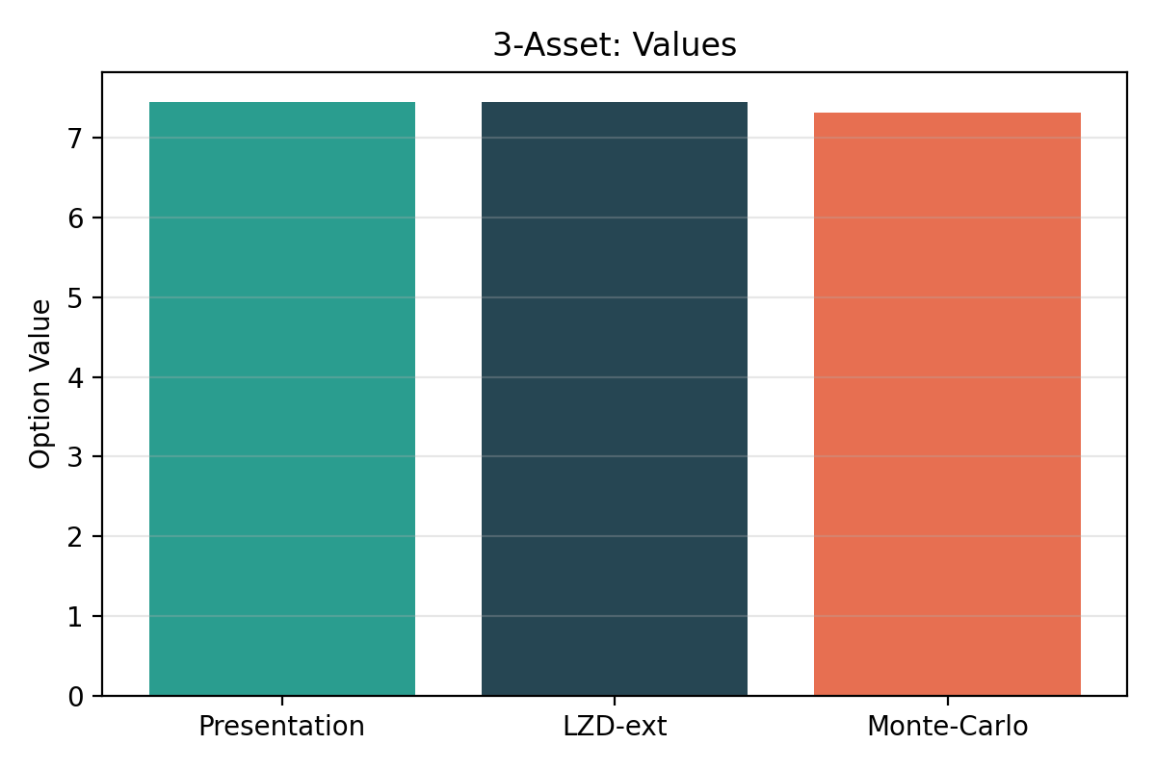
Figure 2 compares runtimes for the 3-asset case.
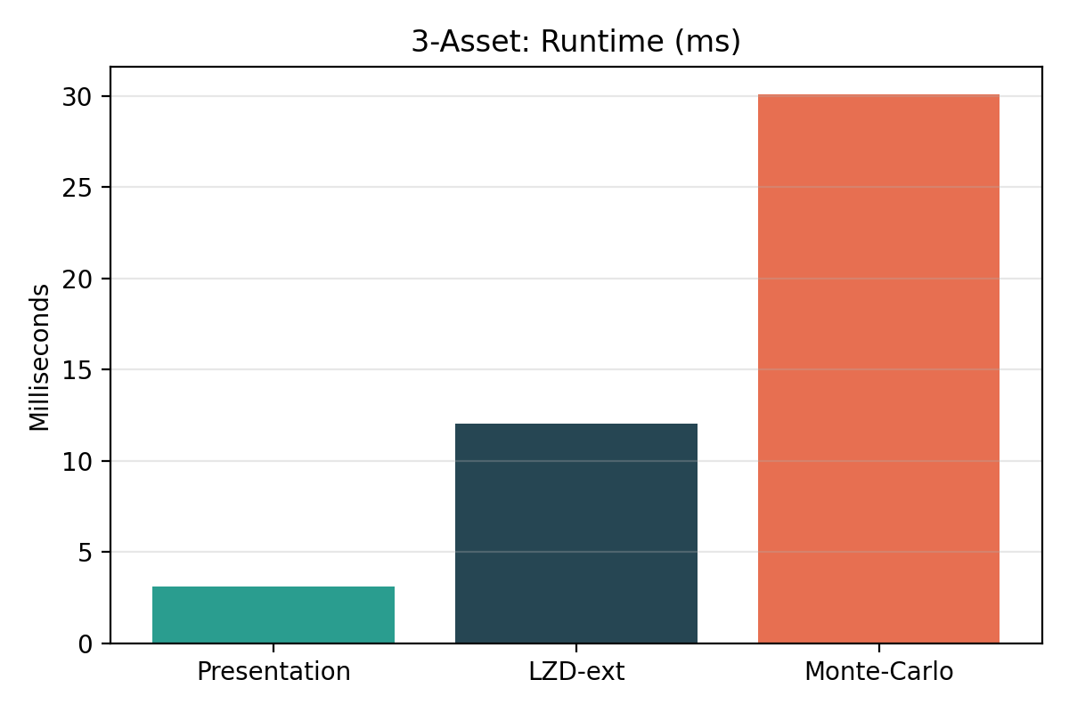
Figure 3 compares values for the 4-asset case.
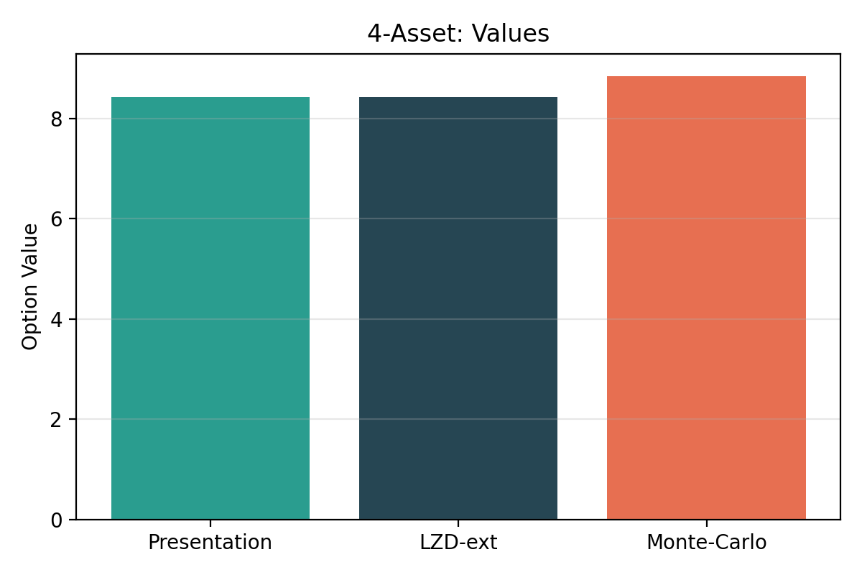
Figure 4 compares runtimes for the 4-asset case.
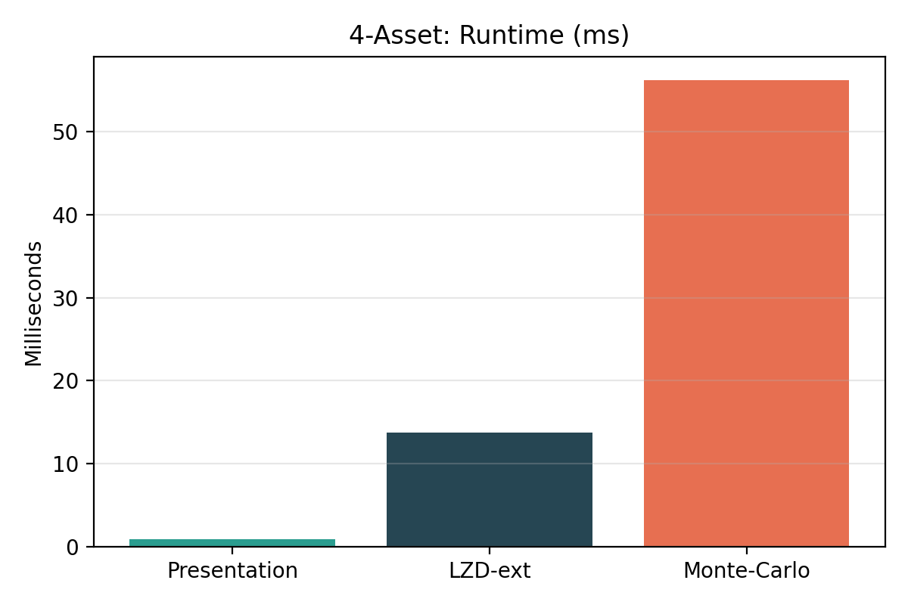
Figure 5 shows absolute error vs MC across a uniform correlation grid for the 4-asset case. Both approximations degrade as correlation changes, with LZD-ext generally closer to MC than the Presentation model when vols are uneven.
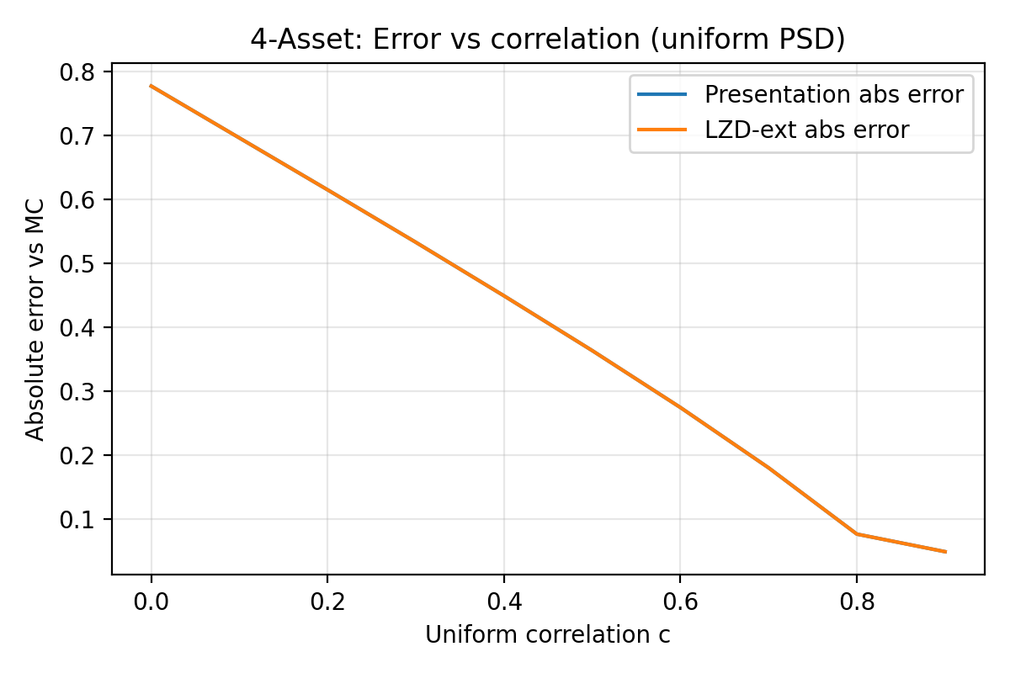

Practical Guidance
• Use Presentation for rapid screening in 3-asset setups with similar vols and moderate/high correlation; validate against MC on a small scenario set.
• Prefer LZD pair pricing over Kirk when K>0 or vols diverge.
• For 4+ assets, avoid factorized ranking unless you can tolerate bias; fall back to MC or an MVN-aware ranking module.
• Operational LNG decisions require embedding diversion value within a broader model (storage, send-out, shipping) rather than pricing in isolation.

Limitations and Future Work
The ranking-factorization assumption is the main source of bias beyond two assets. Replacing the 4th-leg factor with a joint MVN outranking probability reduces, but does not eliminate, this bias. A future step is to implement full multivariate-normal orthant probabilities for ranking events and/or Curran-style conditioning to reduce dimensionality while preserving multivariate dependence.

