Introduction

Hello guys, let me start with brief introduction, for those of you who don’t know me my name is Dmitry. I’m a student of Belarusian State Technological University, currently I’m finishing my 3-d year. Now I’d like to present you a project, I’ve been working on for 3 months.

This project is the issue tracking or management system to manage development process. You are all aware of such issue tracking system as Jira, Redmine or Trello. So, I decided to use Trello as basis for my project and to create similar solution.

Architecture

Now I’d like to tell you about solution architecture, this is web application, based on onion architecture. I followed MVC architecture pattern. Technologies I used in this application:

* ASP.NET and MVC Framework;
* JQuery and JS;
* IoC;
* AJAX;
* Entity Framework;
* Bootstrap;
* Identity;

Now I’m going to show you solution. Data provider stands for communication and connection to database. IoC is one class project, it describes unity container configuration. Logic project contains business logic. Model is project for view models. Web contains MVC controllers, user views, JS libraries.

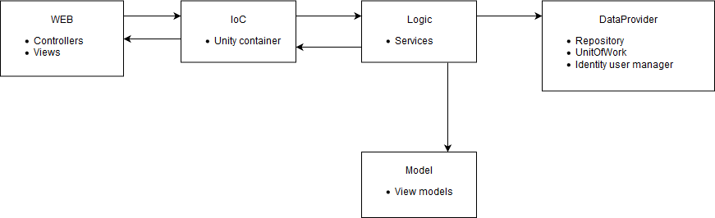

When request comes from web then, through IoC it goes to logic then it sends the request to database through DataProvider and populates view model with data. After that user can see response on the view.

Application

Let’s check end user scenarios.

First, we get to user projects page. From here we can observe all projects and create a new one. To create a new project push “Create Project” button and fill modal. After project is created, we can open the project and create new board. To manage tasks in board we can create columns. Columns can reflect task status for example: finished\in progress, etc. User can create tasks on the board. To do this user can push plus button inside column. Each task has fixed number of attributes like type, priority, severity, assignee. Also, user can attach some files like jpg, png, docs, rtf, zip. If user wont fill required fields error message will be displayed on UI while application calls server and response come from server side with validation. Tell about unsupported file formats. To change task status user can drags and drops task to another columns. While doing this UI makes AJAX request the page is not reloaded but user can see these changes. User a view the task and update it: delete, assign it to user, change type etc. Also, user can search for tasks and filter them. Board has its own settings, here user can change column position and delete it. Same for project. User can change his settings.