Manual for KINGROUP v2.08+

Chapter 2
dmitry.konovalov@jcu.edu.au

Introduction 1
Population Allele Frequencies 1
Pairwise Relatedness 1
Large data sets. 1
References 2

Introduction
This chapter describes how to perform analysis reported in the following studies: (Konovalov 2006; Konovalov et al. 2005a; Konovalov & Heg 2008a; Konovalov & Heg 2008b; Konovalov et al. 2005b)

Population Allele Frequencies
The population allele frequencies could be inferred from the sample as per (Konovalov & Heg 2008a) via Menu | Alleles | Generate … and then by selecting “Konovalov&Heg(2008)” option.

Pairwise Relatedness
The pairwise relatedness estimators could be accessed via Menu | Relatedness | Pairwise.
- The “KINSHIP” option calculates relatedness estimates as per the KINSHIP program
- The “Konovalov&Heg(2008)” option calculates relatedness estimates as per (Konovalov & Heg 2008a)
- The “Maximum Likelihood” option calculates relatedness estimates as per (Konovalov & Heg 2008b)

Large data sets.
The displayed number of pair-wise relatedness values is limited to the maximum of 1000. If the complete set of the pair-wise values is needed, select the “save to file” check box in the “Sort” pane, see the following screenshot.

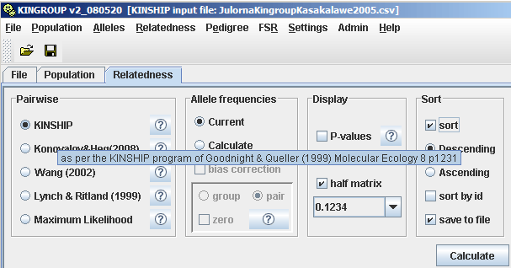

References

Konovalov DA (2006) Accuracy of four heuristics for the full sibship reconstruction problem in the presence of genotype errors. Series on Advances in Bioinformatics and Computational Biology, 3, 7-16.
Konovalov DA, Bajema N, Litow B (2005a) Modified SIMPSON O(n³) algorithm for the full sibship reconstruction problem. Bioinformatics, 21, 3912-3917.
Konovalov DA, Heg D (2008a) Estimation of Population Allele Frequencies From Small Samples Containing Multiple Generations Series on Advances in Bioinformatics and Computational Biology 6, 321-331.
Konovalov DA, Heg D (2008b) A maximum-likelihood relatedness estimator allowing for negative relatedness values Molecular Ecology Resources, 8, 256-263.
Konovalov DA, Litow B, Bajema N (2005b) Partition-distance via the assignment problem. Bioinformatics, 21, 2463-2468.

