Manual for KINGROUP v2.08+

Chapter 1
dmitry.konovalov@jcu.edu.au

Introduction 1
Pairwise Likelihood Calculations 2
Perform Significance Test 2
Example 4
Matrix of p-values 4
Complex Hypothesis 6
Example 6
Kin Group Reconstruction 9
Method 9
Structure of the KinGroup search algorithms 10
Descending Ratio 10
Exhaustive Descent 10
Reconstruction Options 10
Examples 10
Two Full-Siblings 11
Three Full-Siblings 14
Full Siblings Kin Group Reconstruction 17
Full and Half-Siblings 19
Kin Groups 21
Haplodiploids 23
Population Generation 25
Sample Input Files 26
Directory: kingroup_fs 27
Kinship Complex 28
KINSHIP File Format 30
Index 36
References 36

Introduction
Please note that starting from the 2nd version, the KINGROUP program is aiming to replicate the Mac based KINSHIP (Goodnight & Queller 1999) in its entirety. If you discover functionality of KINSHIP that is missing in KINGROUP, please let me know.

Some parts of this manual are based on, and/or extensively adopted from, the KINSHIP manual (Goodnight). Such sections are highlighted and referenced to the original manual of Keith Goodnight. Heavy reuse of the KINSHIP manual should help those users who have had some experience with the KINSHIP program already. For those users who wish to learn more about KINSHIP, the original KINSHIP manual is available from the KINGROUP website (for those without a Mac) and the KINSHIP website together with KINSHIP program.

Pairwise Likelihood Calculations

See (Goodnight & Queller 1999) and (Konovalov et al. 2005) [a pdf is available from www.kingroup.org].

Perform Significance Test

The following highlighted text is adopted from the Kinship Manual (Goodnight):
When the simulation checkbox is clicked (Figure 1), Kinship/KinGroup will run a simulation series to find what values of the likelihood ratio correspond to certain significance levels.
The likelihood ratio does not match the significance level in an intuitive way, nor is it easy to calculate a significance level analytically. Kinship/KinGroup determines significance empirically, by generating a series of pairs at random (using the allele frequencies and RmRp settings) and determining what values of the likelihood ratio result.

A user may choose how many simulated pairs Kinship/KinGroup will generate in order to find the significance levels (3,000 pairs in Figure 1). The program will begin by generating a series of pairs that match the null hypothesis (see more detailed description below). High values of the likelihood ratio for these pairs will constitute false positives or Type I errors. Kinship/KinGroup will find the ratios needed to exclude such errors at significance levels of p= .05, .01 and .001 (i.e. the ratio that represents the p=.05 significance level will be that which excludes 95% of the simulated pairs, etc.).
Once it has found these ratios, Kinship/KinGroup will generate a second series of pairs that match the primary hypothesis. Low values of these ratios represent false negatives or Type II errors. For each significance level, Kinship will find the rate of Type II errors which results.

The default value for the number of pairs to simulate is 1000. This value represents a compromise between speed of calculation and precision of results. If your data allows you to obtain results significant at the p= .001 level, you will probably want to increase this number to improve the precision of the appropriate ratio.
The ratio reported for each level will be that which excludes exactly the appropriate number of pairs; normally, you will want to accept ratio values higher than that (not equal to it) and report your significance values as p< __ .

The significance testing that these controls provide is limited. Kinship/KinGroup cannot calculate significance levels if either hypothesis is complex, because the range of RmRp values requires additional assumptions about the distribution of values in the simulated pairs. Without precise information about the actual composition of the data set, the significance value will not be accurate. Therefore Kinship/KinGroup will not attempt such calculations.

Another limitation is that the simulated pairs are always both diploid (again, because the other alternative would require additional assumptions about the number of haploids vs. diploids in the data set)

If the flag option is checked (Figure 1), KinGroup will output “ns” for not significant, “*” for p< .05, “**” for p< .01 and “***” for p< .001. An output file with these flags replacing the ratio values can be used as an easy-to-read “index” complementing a file of the actual numerical values.

Confidence levels for the pairwise likelihood values are estimated empirically through simulations for a given hypothesis 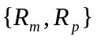. Following Goodnight & Queller (1999), a simulated pair is generated as follows:
- alleles of are randomly set based on the allele frequencies 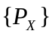;
- maternal allele 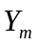 is then set to 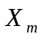 with probability of 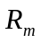;
- with probability 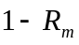, the allele is randomly set based on the population allele frequencies;
- steps 2 and 3 are repeated for paternal alleles.

Given the probability of rejection of the null hypothesis when it is true (the type I error rate 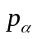), KinGroup can find a significance value, 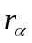, from the simulations as follows:
- A number of simulated pairs, specified by the user, are generated according to the null hypothesis : 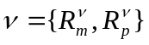;
- KinGroup then calculates the ratio of the pairwise likelihood for the primary hypothesis over the null hypotheses for each pair;
- Based on the resulting distribution of ratios 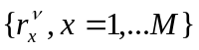, KinGroup finds the significance value corresponding to the -value. For example, for 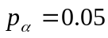, is approximated by one of 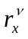 that is greater or equal then 95% of all 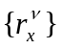.
Three preset choices for are 0.05, 0.01, and 0.001.
The type II error rate is calculated by repeating the above process, but generating pairs according to the primary hypothesis 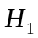: 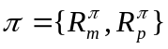. The type II error rate (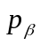), the probability of not rejecting the null hypothesis when it is false, is calculated as the percentage of ratio values 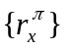 that are smaller then the significance value .

Example

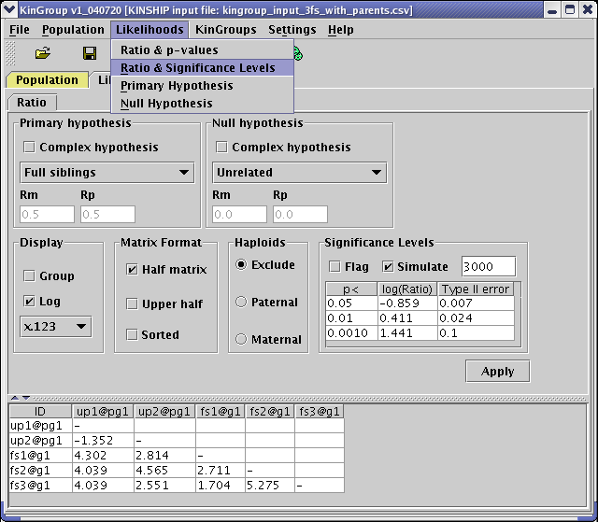
Figure 1 Significance test for examples/kinship_complex/kingroup_input_3fs_with_parents.csv

Matrix of p-values

More detailed information could be generated by selecting Menu | Likelihoods | Ratio & p-values (Figure 2). In the case of significance levels (see previous subsection) the ratios may be flagged using 4 markers (“ns”, “*”, “**” and “***”) in relation to the levels generated for each of the p-values (0.05, 0.01, and 0.001). This option allows flagging each of the pairwise ratios with the corresponding p-values.

In order to find a p-value for a given ratio, the requested number of pairs is randomly generated based on the null hypothesis. All resulting ratios are then sorted and the p-value is calculated as the percentage of all simulated ratios that are greater or equal to the given ratio value.

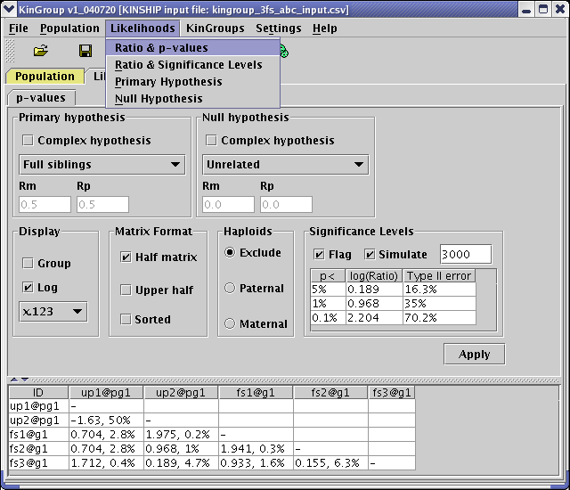
Figure 2 Matrix of p-values for examples/kinship_fs/kingroup_3fs_abc_input.csv loaded with the first 4 (four) loci.

Complex Hypothesis
“…Complex hypotheses: A complex hypothesis is one in which the user specifies a range of r values instead of a single set. When a complex hypothesis is entered, Kinship/KinGroup will find the likelihoods for all r values within the range (the user can set how finely it divides the search space) and use the highest one that it finds in calculating the final ratio. A complex hypothesis represents a hypothesis that a given pair is related in any one of several possibilities. Its most common use will be in the null hypothesis, for example to test whether pairs are full siblings as opposed to half-siblings, cousins, or unrelated. (A simple null hypothesis could only test for full-siblings vs. a single one of the possibilities at a time.)
Caution should be used in choosing the complex hypothesis option. Kinship/KinGroup does not confine its tests to particular significant values of rp or rm but checks the full range of possibilities. If your range is too broad, then the meaning of the results is less clear. In addition, Kinship/KinGroup is unable to perform significance tests when either hypothesis is complex…”- adopted from the Kinship Manual (Goodnight).

Both primary and null hypotheses may be set as complex. In the example below, see Figure 3, only one interval is requested resulting in two values of Rm: 0 and 1. If one of the descent identity values stays the same in the “To:”-option, KinGroup scans the one that varies the number of times equal to the intervals plus one. If, however, both are different, a two dimensional grid of all possible combinations of Rm and Rp is calculated.

Example
Load “Kinship Complex” sample input file, see “Sample Input File” section on how to load this file. Figure 3 and Figure 4 show the resulting ratios for a complex and simple null hypothesis correspondingly.

The true relationship is known between “up” - unrelated parents and “fs” - full siblings since the sample file was randomly generated to conform to the Mendellian inheritance rules. Simple null hypothesis of “unrelated” individuals is not sufficient to distinguish between parents and their siblings, see Figure 4. The only ratio that is significantly lower than the rest is the one between the two unrelated parents, “up1” and “up2”, which relationship corresponds exactly to the “unrelated” null hypothesis.

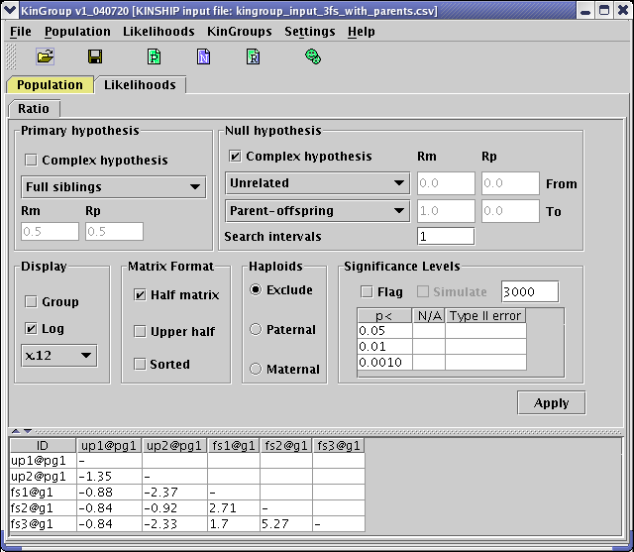
Figure 3 Ratios of primary to null likelihoods using a complex hypothesis for examples/kinship_complex/kingroup_input_3fs_with_parents.csv.

Once the “parent-offspring” relationship is included in the null hypothesis resulting parent-to-siblings pairwise likelihood ratios drop significantly, see Figure 3. These are the values between “up1, up2” and “fs1, fs2, fs3” in Figure 3.

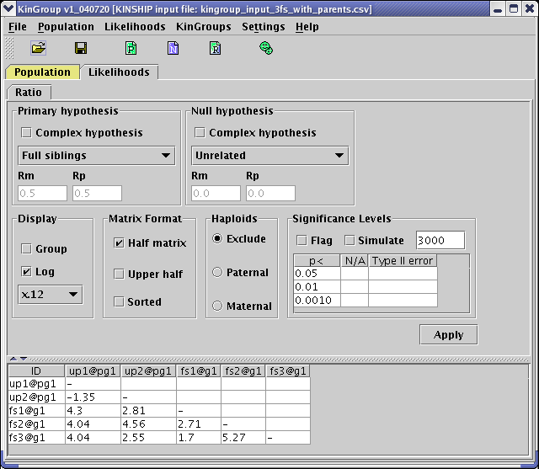
Figure 4 Null hypothesis is a simple hypothesis for examples/kinship_complex/kingroup_input_3fs_with_parents.csv.

Kin Group Reconstruction

Pairwise likelihoods provide with valuable information about a population especially when combined with the simulation to determine confidence levels. However quite often the given set of individuals must be partitioned into subgroups based on some relationship hypothesis, for example when all full siblings must be extracted for further analysis. Various approaches exist to perform such partitioning, for example (Beyer & May 2003) and references therein.

KinGroup uses a partitioning approach in which individuals are added to partitions one at a time and all possible new partitions are created. The overall likelihood of each partition is then calculated and only the one with highest value is retained for the next iteration (Konovalov et al. 2004). Two kin group reconstruction algorithms have been implemented in this version of KinGroup, namely Descending Ratio and Exhaustive Descent.

Method

Using notation introduced in the Section “Pairwise Likelihood Calculations”, a primary hypothesis is tested against null hypothesis, where superscripts and denote primary and null hypotheses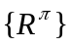 and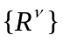. Pairwise likelihoods for a pair of individuals are denoted as

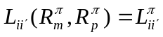, 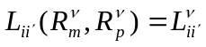. (Eq. )

Overall likelihood of a partition is defined as a product of pairwise likelihoods over all unique pairs in the sample

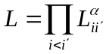, (Eq. )

where when and belong to the same subgroup , and where when and belong to different subgroups. In other words, the primary hypothesis is used within a subgroup and the null hypothesis between subgroups.

Structure of the KinGroup search algorithms

The algorithms are run in cycles starting with all individuals belonging to the pool of unassigned individuals. At each algorithm cycle one individual is assigned into kin groups. The cycles continue while the unassigned pool is not empty.

Each cycle consists of a number of steps:
- Select one individual from the pool of unassigned individuals.
- Build candidate partitions. Each partition is a collection of kin groups were each individual is only assigned to one group.
- Select which partitions to keep for the next cycle.

Descending Ratio

The Descending Ratio search algorithm is described in (Konovalov et al. 2005).

Exhaustive Descent

The Exhaustive Descent search algorithm builds every possible combination of partitions by taking individuals in the order determined by the Descending Ratio search algorithm. However, all resulting combinations are kept for the next step and not just the combination with the best likelihood as in the Descending Ratio. The practical usefulness of such exhaustive search is limited to small data sets (order of tens) as the number of possible combinations rapidly approaches an incomputable level.

However the Exhaustive Descent algorithm is invaluable for testing the Descending Ratio algorithm, as it is impossible to determine if the Descending Ratio achieved the best partition without building all possible combinations.

Reconstruction Options

Examples

File naming abbreviations | Description
FS, HS | Full or half siblings
Input/results | Input or results file. For example, kingroup_2fs_input.csv
ED, DR | Exhaustive Descent or Descending Ratio algorithm results, e.g. kingroup_2fs_results_ed_us.csv
U,Q,S | Unique, sequence, sorted options, e.g. the file kingroup_2fs_results_ed_us.csv was generated with “unique” and “sorted” options switched on.

Two Full-Siblings
Location: www.kingroup.org/examples/kingroup_fs/kingroup_2fs_input.csv. This file contains one parent and its two full-sibling children. The second parent is also present in the file for verification but is commented out for this example.

This example is one of the simplest to consider and it is used to illustrate all KinGroup partitioning options. In this example we will focus on the following question: “Given a population, which individuals are full-siblings?”

Results for an Exhaustive Descent search are shown in Figure 5. For an explanation on loading this file see the “Directory: kingroup_fs” section on page 27 and for help with the complex hypothesis settings see the “Complex Hypothesis” subsection on page 6.

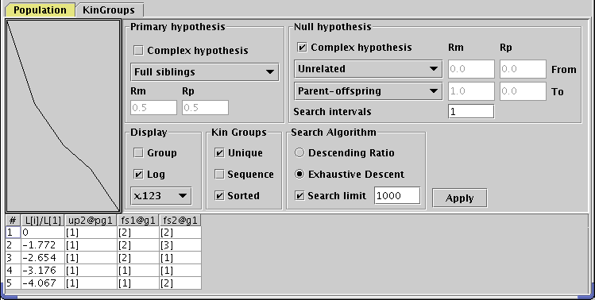
Figure 5 Exhaustive Descent results for examples/kingroup_fs/kingroup_2fs_input.csv

The Results were saved into a file: kingroup_2fs_results_ed_us.csv, with Figure 6 showing an extract from this file. Because the “Sorted” option was selected, the top most partition in Figure 5 and the left most partition in Figure 6 is the partition with the highest overall likelihood. This partition has “up2”- unrelated parent in group [1] and two of its full-sibling children “fs1” and “fs2” in group [2]. The numbering of the kin groups is arbitrary in this version of KinGroup since the emphasis is on partitioning of a population into kin groups. Hence no special meaning is attached to the full-siblings being placed into group two and not into group one.

Please note that if the “by group” option is used and user saves the results, only the selected group will be processed and saved using Exhaustive Descent (ED). The rest of the groups will be processed using Descending Ratio (DR).

To allow for additional comparison between different partitions, the overall likelihoods are also displayed for each partition. These are displayed as a graph and the second column in Figure 5 and as a row in the results file see Figure 6.
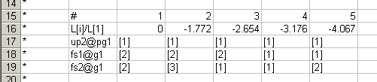
Figure 6 Possible partitions from kingroup_2fs_results_ed_us.csv.

The results file also contains the frequency block that was used plus the new set of kin groups according to the first partition (Figure 7). When the “Sorted” option is selected, the first partition will be the one with the highest overall likelihood. As always, the results file is saved in the KINSHIP format so it could be reloaded into KinGroup with the new kin groups for further analysis.

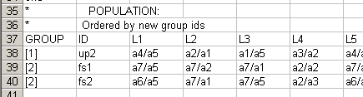
Figure 7 Resulting kin groups from kingroup_2fs_results_ed_us.csv.

The “Unique” option does not contribute in the case of Exhaustive Descent since only unique partitions are built exhaustively until the “Search limit” is hit or your computer runs out of memory. The search limit is set to 1,000 in the example shown in Figure 5.

The “Sequence” option (Figure 8) shows in what order individuals were taken for group assignment. In the case of Exhaustive Descent all possible partitions are made first for the full-siblings “fs1” and “fs2”. By running the algorithm a few times the only difference will be that the first individual may vary between “fs1” and “fs2”. That is because their pair-wise primary to null hypothesis ratio is the highest amongst all thee possible ratios: fs1-fs2, fs1-up2, and fs2-up2. The choice of which individual from the pair is taken first is random. However the next individual is always the remaining from the pair.

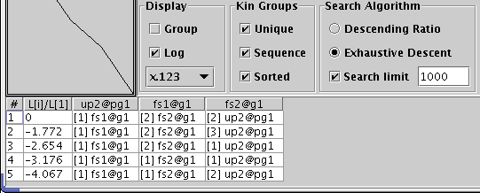
Figure 8 Exhaustive Descent results for kingroup_2fs_input.csv with sequence.

The “Sorted” option is always expected to be switched on. The unsorted choice (Figure 9) will report partitions in the order they are stored internally in KinGroup, which could be quite random.

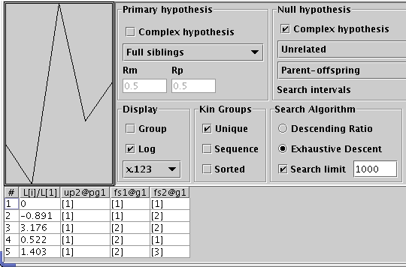
Figure 9 Unsorted Exhaustive Descent results for kingroup_2fs_input.csv.

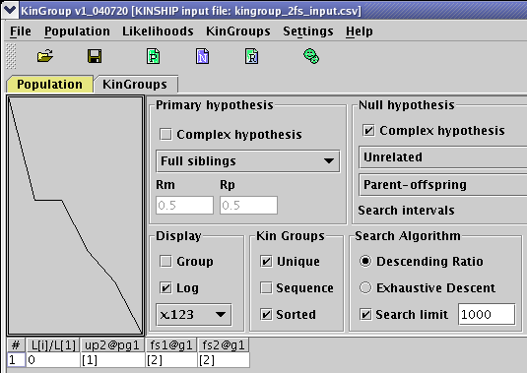
Figure 10 Descending Ratio results for kingroup_2fs_input.csv

The results of Descending Ratio algorithm for the same population are shown in Figure 10. Both algorithms have found the same kin groups correctly. The effect of various options is left to other more complicated examples.

Three Full-Siblings
Location: www.kingroup.org/examples/kingroup_fs/kingroup_3fs_input.csv. This file contains two parents (namely “up1” and “up2” – unrelated parents in the “pg1” – parental group one) and their three “fsX” - full-sibling children. All up this population contains five individuals.

This is a slightly more complicated example compared to the Two Full-Siblings example. Firstly, the Exhaustive Descent is run to obtain the theoretically correct answer within the limits of the overall likelihood approach of the Descending Ratio algorithm. Please note that just five individuals required 52 different partitions, see Figure 11 and Figure 12.

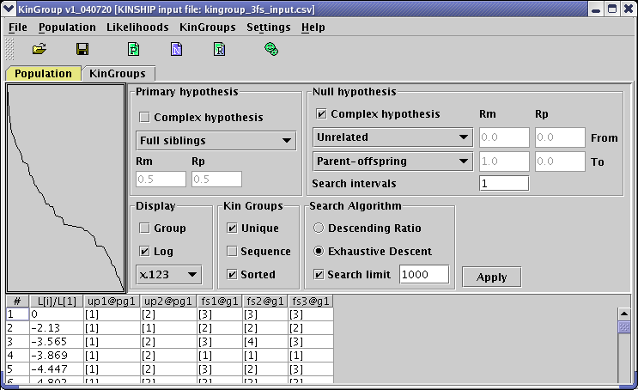
Figure 11 Exhaustive Descent results for kingroup_3fs_input.csv

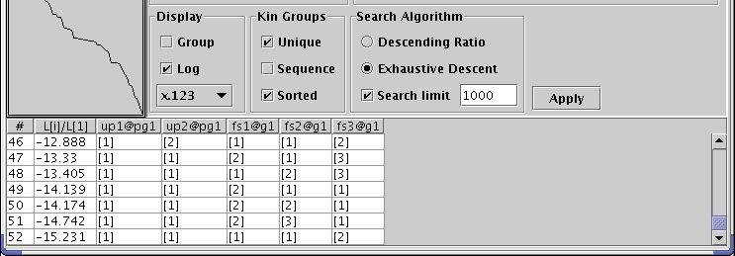
Figure 12 Exhaustive Descent results for kingroup_3fs_input.csv with 52 partitions.

The options that can be used with the Descending Ratio algorithm are illustrated in Figure 13.

The “Unique” option: When the highest pairwise ratio is found amongst unassigned individuals the order in which one or the other pair member is taken is random. That variance may yield a different partition path and result in a number of different partitions. However, such cases mainly occur with populations that do not have sufficient allelic and/or loci information.

The number of attempts is limited to the population size if it is less than ten or ten otherwise. The practical usefulness of a larger number of attempts is questionable so KINGROUP limits it to a maximum of ten. A typical example of when all attempts yield exactly the same kin groups is shown in Figure 13, even though
attempt #1 used the order: “fs1”, “fs3”, “up2”, “fs2”, and “up1”,
while for example
attempt #3 used: “fs3”, “fs1”, “fs2”, “up2”, and “up1”.
By not selecting the “Unique” option (and selecting the “Sequence” option) it is possible to see which individual is added at each cycle. This combination of options as shown in Figure 13 is useful for testing and experimenting with the algorithm.

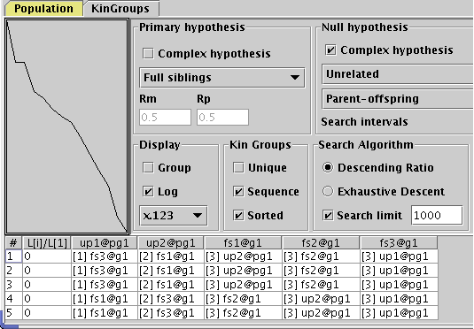
Figure 13 Descending Ratio non-unique results for kingroup_3fs_input.csv

The “Search limit” option has a slightly different meaning for this algorithm. If selected, KinGroup will try to build alternative partitions by moving each individual into a different group. At this stage it is not clear how to calculate confidence levels for the final partition. The search “around” the local area provides some feel if the found solution stands out amongst possible alternatives or is it only marginally better.

Full Siblings Kin Group Reconstruction

Table 1 summarizes kin group reconstruction results for full-siblings. All results files were generated with the Descending Ration algorithm and the files contain correctly reconstructed kin groups. All files can be found at www.kingroup.org/examples/kingroup_fs/.

Input and Results file | Description | Population size | Alleles | Loci
kingroup_2g_3fs_input.csv  kingroup_2g_3fs_results.csv | Two groups of 3 full-siblings plus their parents. Ten loci with 10 alleles in each locus. (E) - denotes equally frequent alleles. | 10 | 10 (E) | 10
kingroup_2g_8fs_input.csv  kingroup_2g_8fs_results.csv | Two groups of 8 full-siblings plus their parents. | 20 | 10 (E) | 10
kingroup_5g_10fs_input.csv  kingroup_5g_10fs_results.csv | Five groups of 10 full-siblings, without parents (Figure 14) Because the parents are absent, the correct kin groups could be reconstructed even using the simplest “unrelated” null hypothesis (Figure 15). | 50 | 10 (E) | 10
kingroup_10g_10fs_input.csv  kingroup_10g_10fs_results.csv | Ten groups of 10 full-siblings plus their parents. | 120 | 20 (E) | 20
kingroup_10g_8fs_input.csv  kingroup_10g_8fs_results.csv | Ten groups of 8 full-siblings plus their parents. (R) - denotes random allelic frequencies. | 100 | 50 (R) | 20
kingroup_10g_18fs_input.csv  kingroup_10g_18fs_results.csv | Ten groups of 18 full-siblings plus their parents. | 200 | 50 (E) | 20
kingroup_20g_48fs_input.csv | Twenty groups of 48 full-siblings plus their parents. | 1,000 | 50 (E) | 20
Table 1 Examples of input and results for full-siblings reconstruction.
As discussed earlier the Descending Ratio may produce a number of partitions, see Figure 14 and Figure 15. This is a good indication that the discriminative power of the used set of alleles and loci is reaching its limit. This is could be verified by reducing the number of loci to 5 (five) when kingroup_5g_10fs_input.csv is imported. With only 5 loci, the Descending Ratio algorithm makes a number of wrong group assignments.

The current limit on the population size is between 200 and 1,000 individuals depending on user’s computer configuration.

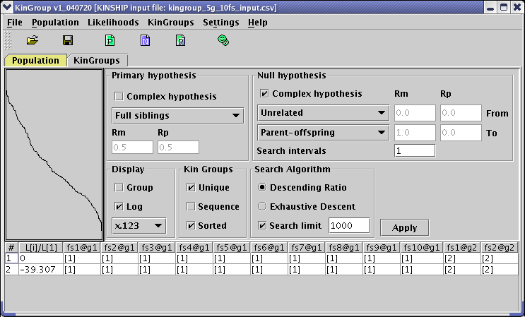
Figure 14 Descending Ratio results for kingroup_5g_10fs_input.csv

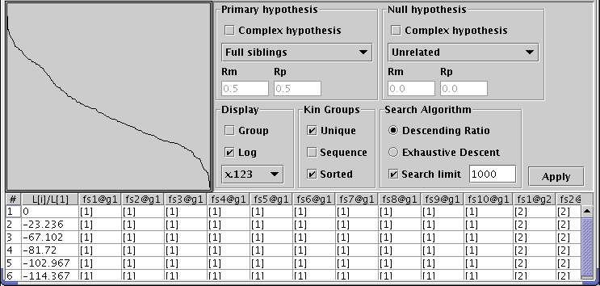
Figure 15 Descending Ratio with simple null hypothesis for kingroup_5g_10fs_input.csv

Full and Half-Siblings

All files for this section can be found at www.kingroup.org/examples/kingroup_hs/.

The first example is a population with two full-siblings and 2 half siblings from each of the common parents, see Figure 16.

Abbreviations | Description
_g1 | Group #1
_pg1 | Parental group #1
_fs# | Full siblings from common parents “cp1” and “cp2”
_cp# | Common parents # 1 and 2.
_c1m# | Mating partners of the common parent “cp1”.
_c1h# | Half-siblings to the “fs” full-siblings. These are the off-springs of common parent “cp1” and the corresponding mate “c1m”. For example, c1h1 is the off-spring of cp1 and c1m1.
Table 2 Abbreviations used in kingroup_2hs_input.csv

Figure 17 and Figure 18 show the results of Descending Ratio with incorrect null hypothesis. The null hypothesis was left the same as in the previous examples dealing only with unrelated and parent-offspring relationships. In this example there are 4 (four) half-siblings (two from each common parent), while the null hypothesis only assumes two possible values: Rm=Rp=0 [unrelated] and Rm=1 Rp=0 [parent -offspring].

The correct null hypothesis for this example should include the half-sibling relationship, which is in terms of Rm and Rp could be expressed as: Rm=0.5, Rp= 0. By setting the number of intervals to 2 (two), see Figure 19, all three relationships are included in the null hypothesis. This version of KinGroup does not distinguish paternal and maternal alleles and therefore Rm and Rp yield the same likelihoods if their values are swapped, e.g. Rm=0.5, Rp=0 is exactly the same as Rm=0, Rp=0.5.

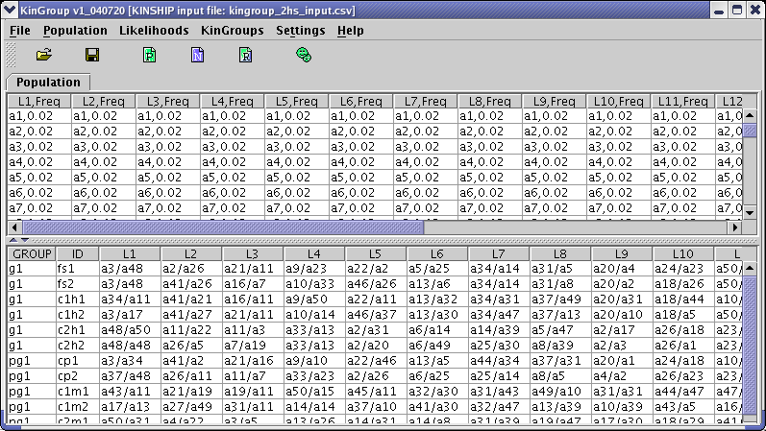
Figure 16 Population loaded from kingroup_2hs_input.csv

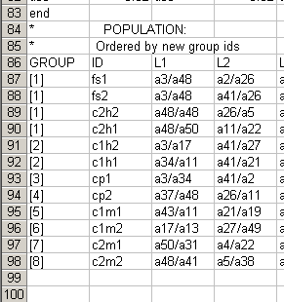
Figure 17 Results for kingroup_2hs_input.csv with incorrect null hypothesis.

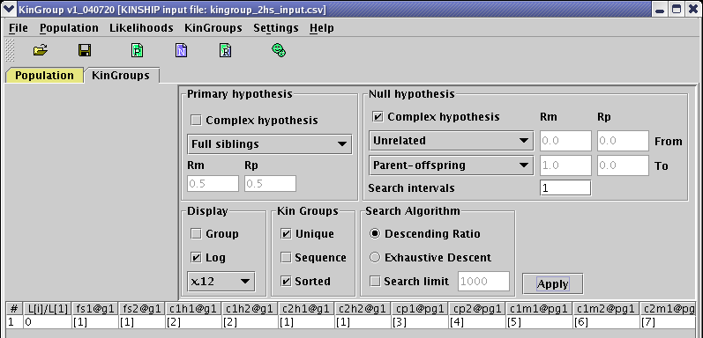
Figure 18 Descending Ratio for kingroup_2hs_input.csv with incorrect null hypothesis.

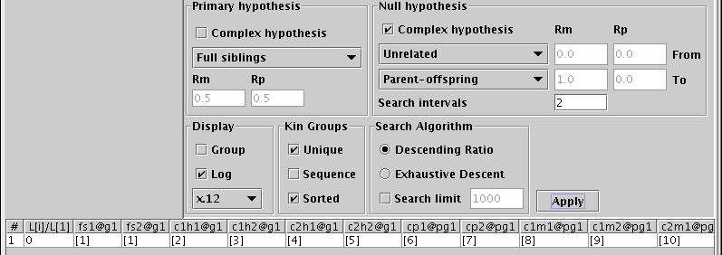
Figure 19 Descending Ratio for kingroup_2hs_input.csv.

Kin Groups

This section illustrates the convenience of using KinGroup for the reconstruction of a wide variety of kin groups using the example of half siblings in Figure 16.

The first question to consider is “Given a population, which individuals are half-siblings?”

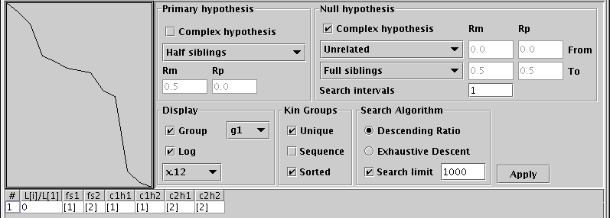
Figure 20 Half-sibling kin groups in group g1 of kingroup_2hs_input.csv

The half-sibling kin groups within the g1-group are shown in Figure 20. This is a simplified example in which we know that the g1-group contains only half-siblings and full-siblings. The null hypothesis was set to cover only “unrelated” and “full-siblings”. Note that the “half-siblings” hypothesis is also a part of the null hypothesis but KinGroup excludes it from the choices given by the null hypothesis. This is very convenient since otherwise it could be impossible to devise a suitable null hypothesis (using the current options) without overlapping with the primary values. In this version, KinGroup only excludes the simple component of the primary hypothesis from the choices generated by a complex null hypothesis.

Mates of cp1 |  |  |  | Mates of cp2
 | _cp1 |  | _cp2
_c1m1 | _c1h1 | _fs1 | _c2h1 | _c2m1
_c1m2 | _c1h2 | _fs2 | _c2h2 | _c2m2
Table 3 Half-siblings kin groups in kingroup_2hs_input.csv

Table 3 illustrates the correct half-siblings kin groups found in Figure 20. In particular, “c1h1”, “c1h2” and “fs1” have the same common parent “cp1” but a different second parent.

The correctly identified half-sibling kin groups are shown in Figure 21 with Figure 22 demonstrating the importance of specifying the null hypothesis. Not including the “full-siblings” relationship in the null hypothesis yields incorrect kin groups (Figure 22).

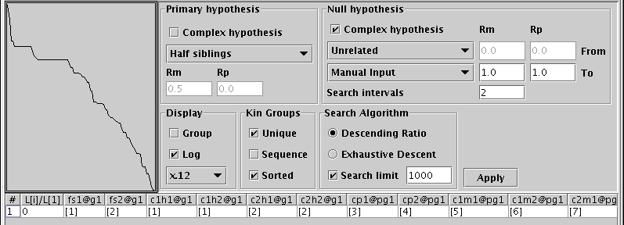
Figure 21 Half-siblings kin groups in kingroup_2hs_input.csv

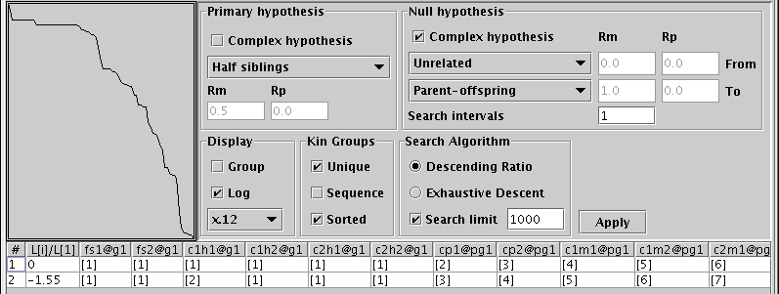
Figure 22 Incorrect null hypothesis for half-siblings kin groups

Haplodiploids

Input file (Henshaw 2004) examples/kingroup_hd/kingroup_input.csv contains 4 unrelated mothers (mom1 to mom4), their mates (dad1 to dad4), 8 daughters from each mother (e.g., daughter1/1 to daughter1/8 are the offspring of mom1 + dad1), 3 males mated to 3 of the daughters of the first mother (mate1 to 3), and 3 sets of 8 daughters from these second matings (e.g., daughter1/1/1 to daughter 1/1/8 are the offspring of daughter1/1 + mate1).

The original input file is used to construct an “easy” data set where there are 4 sets of unrelated daughters and their mothers (file kingroup_input_fs_with_parents.csv). A “harder” data set (with 3 sets of related sister groups and their mothers) is stored in kingroup_input_all_diploids.csv.

In order to partition the “harder” population, null hypothesis was chosen (Figure 23) to cover entire spectrum of relationships by setting the “Search intervals” to 40 (with the corresponding step 0.025). Such choice of null hypotheses includes haplodiploid cousins (Rm=0.375, Rp=0). The Descending Ratio was able to partition the population of 60 individuals into the correct set of kin groups, see kingroup_results_all_diploids.csv.

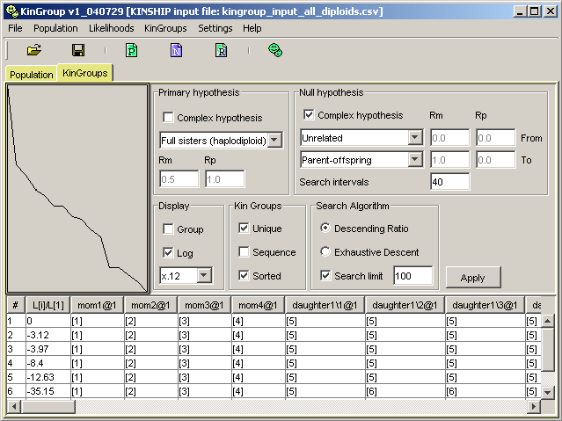
Figure 23 Correct partitioning achieved by the Descending Ratio algorithm on the population from examples/kingroup_hd/kingroup_input_all_diploids.csv

Population Generation

Sample Input Files
All sample input files are located at www.kingroup.org/examples or in the [location on your computer where you installed KinGroup]/kingroup/examples - directory. This version of KinGroup can only read files in the KINSHIP format.

To import a kinship file, select “Menu | Population | Import Kinship File …”, see Figure 24.
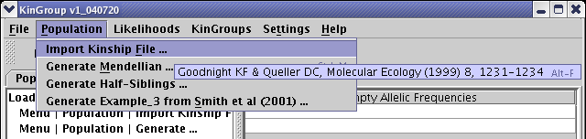
Figure 24 How to import a KINSHIP file.

Directory: kingroup_fs
Location: www.kingroup.org/examples/kingroup_fs/. This directory contains a number of sample populations containing full siblings. Each of the populations were generated using KinGroup via “Menu | Population | Generate Mendellian …”, see the “Population Generation” section on page 25 for more details.

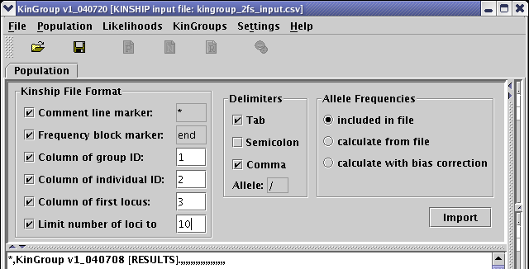
Figure 25 How to load kingroup_2fs_input.csv

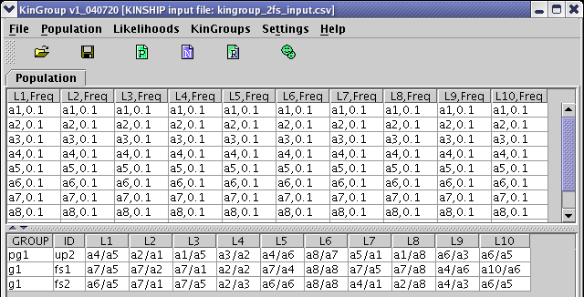
Figure 26 Imported kingroup_2fs_input.csv

Kinship Complex
File location: www.kingroup.org/examples/kinship_complex/input_3fs_with_parents.csv

This input file contains three full siblings (hence the abbreviation _3fs_) plus two unrelated parents. Figure 27 shows the choice of file format options that are required to import this sample file successfully. Figure 28 shows the result of successful import.

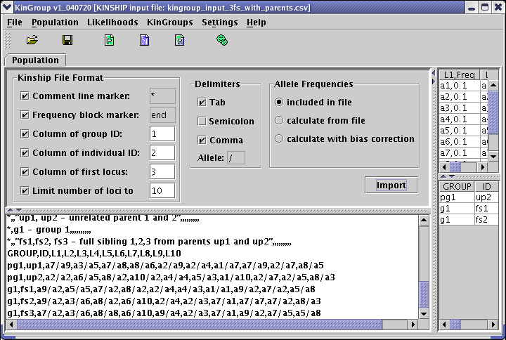
Figure 27 File format options for input_3fs_with_parents.csv

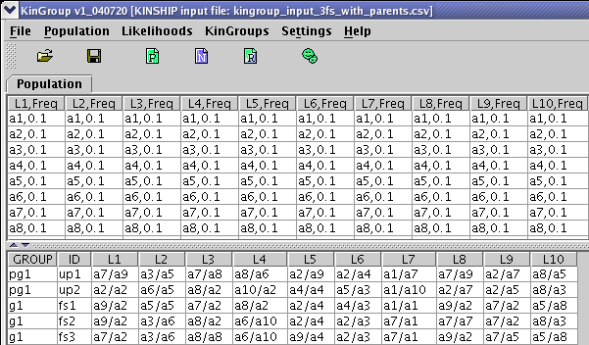
Figure 28 Loaded input_3fs_with_parents.csv

KINSHIP File Format

It is recommended to present your input files in comma-separated values (.csv) format. Such format is recognized by Excel and it is easy to work with.

The rest of this section is based on, and extensively adopted from, the KINSHIP manual (Goodnight):
“… The basic organization of the Kinship files is that (in spreadsheet format) each individual occupies one row and each variable one column. The file can contain comment lines which begin with the character * (asterisk); KinGroup will ignore such lines completely. In addition, missing information can be simply left blank in the TEXT file.

A data file consists of two main sections. Both of them are optional (although at least one of the two must be present or else the file is simply empty):

Allele frequency block: When an allele frequency block is present in the data file (Figure 29), the user may select to use these frequencies exclusively for performing all calculations. When no allele frequency block is present, the user must select how the allele frequencies should be calculated based on the individual data in the file. The first available option in such case is just to calculate the frequencies each allele occurs in a given locus. The second option is to use bias correction, see more on that later. …”- adopted from the Kinship Manual (Goodnight).

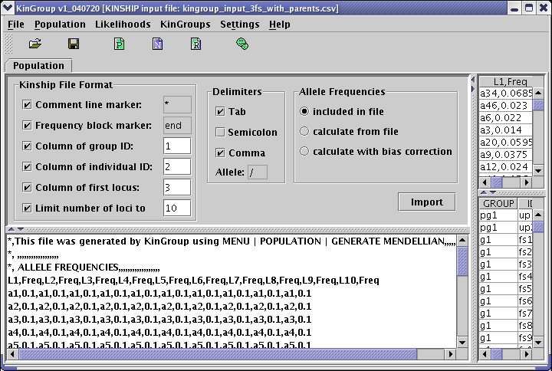
Figure 29 Example of importing a KINSHIP file.
Since the program does not require it, you will want to include a frequency block primarily when you have additional information on allele frequencies beyond that available in the current data set (for example, if the file is only one of several data sets which have been genotyped in the population of interest). You may also want to include a frequency block if you want to include a group ID variable but override the bias-correction to allele frequencies (see “Allele frequencies and group ID” below).
NOTE: When both and allele frequency block and an individual genotype block are present in a file, the allele frequency block must come first.

The data must be arranged with each locus occupying two columns: the first for the names of the alleles and the second for the frequency of that allele. The first locus must occupy columns 1 and 2, the second 3 and 4, and so on, see an example in Figure 30. The loci should read across, right to left, in the same order as they will appear in the individual genotype data.

The first non-comment line of the block must be a list of locus names, in the allele-names column for each locus. Starting with the second line, the information for allele frequencies begins.
The allele frequency block continues for as many lines as there are alleles in the most poly-allelic locus. Because the program has no a priori way of knowing how many alleles it will find, you must tell it when the allele frequency block is ending by including the word “end” on a line by itself at the end of the block.
The number of loci, and the number of alleles at each locus, is limited only by the available memory of the computer.

Individual genotypes block: This version of KinGroup always requires this section. If however all you interested in is simulation based on the allele frequencies, you need to include a couple of individuals so that KinGroup has something to load (see the “Simulations” section below for information about the simulation function).
NOTE: When both an allele frequency block and an individual genotype block are present in the file, the individual genotype block must come second, see example in Figure 30.

The first non-comment line of the individual genotype block must give the variable names of each column.
KinGroup reads the following variables: group ID, individual ID, and genotype. Please note that this version of KinGroup does not have a facility to read Mother’s ID and Father’s ID. Additional variables may be present in the file, although the program will not read them. These variables can occupy any column in any order, with the only restrictions being: 1) That loci occupy a set of consecutive columns, and that they read left to right in the same order as they appear in the allele frequency block (if one is present).
Missing information for any variable can be indicated with the • character (option-8) on the Macintosh keyboard, or may simply be left blank. The • character cannot be used as an actual value for any variable: the program will always treat it as indicating missing information. All other characters both alphabetic and numeric can be used. For alphabetic characters, case is significant (i.e. upper and lower case are treated as different).
Each locus should occupy one column. For diploid genotypes, both allele names are placed in the same column, separated by a delimiter character (which the user can specify).

EXAMPLE:
If the delimiter character is “/” and two alleles are named “100” and “110”, then valid diploid genotype entries could be:
100/110 100/100 110/100 etc.
A haploid genotype could be written in any of the following ways:
100/• 100/ 100 •/100 etc.
Likewise, a missing genotype could be any of the following:
•/• / <blank>

The end of the individual genotype block is marked by the end of the file; no special designator is required for it.
Figure 30 shows a portion of a Kinship data file as displayed in Microsoft Excel. The KinGroup distribution package also contains a variety of sample data files, which you can examine to see the file format.

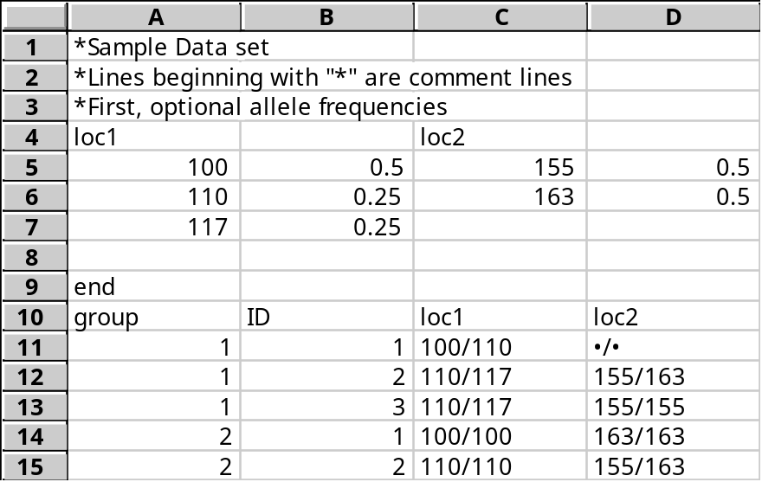
Figure 30 Part of a Kinship set, showing both allele frequency and individual genotype blocks

KINSHIP File Format options in Figure 29 are (from top to bottom):

Comment line marker: This version of Kingroup does not allow changing this marker, which is preset to “*” – asterisk. Any line starting with this marker is ignored during the import of a KINSHIP file. User may use such lines for commenting of the data. Note that this option cannot be unchecked.

Frequency block marker: This version of Kingroup does not allow changing this marker, which is preset to “end”. During the import of a KINSHIP file the program checks for this marker. If encountered, the program tries to proceed assuming that the information above that marker was in fact the allele frequency block. Note that this option cannot be unchecked.

Column of group ID: The primary function of the group ID, if present, is to specify sets of putative relatives for use in applying a bias correction to the allele frequency calculations (see below). When present, this variable also allows you to split the data file into groups and optionally to perform the likelihood comparisons only among pairs in the same group. If there is no group variable, the program will always perform comparisons among all pairs in the file. (This remains an option even when Group ID is present.)

Column of individual ID: When present, this variable allows the program to label the rows and columns of the output matrix with the ID of the individual each row and column represents. Without this variable, the program will label them to some defaults. While this might be acceptable if the only question is (for example) whether all individuals in a group are full siblings of one another, normally you will want to use this variable.

Column of first locus: This is the first in the set of consecutive columns that give the genotypes at each locus. Remember that all loci must occupy a consecutive set of columns and must read from left-to-right in the same order as they appear in the allele frequencies block, if present, although the set may begin with any column. Note that this option cannot be unchecked.

Limit number of loci to: This box indicates how many columns of locus information the program will read. It need not be the same as the full number present in the file: you can instruct the program, for example, to read only the first 3 out of 6 loci listed in the file.

Delimiters options in Figure 29 are (from top to bottom):

Tab, Semicolon, Comma: These are recognizable column delimiters. Please note that KinGroup will replace tab delimiters with commas before showing the content of the opened file, see the pane under the formatting options in Figure 29.

Allele delimiter character: The character in this box is the one the program will use to separate the alleles in individual genotypes. The default is “/”.
Allele Frequencies options in Figure 29 are (from top to bottom):

Included in file: Check this box if your data file contains an allele frequencies block and you wish to use the frequencies. KinGroup also supports the option of ignoring supplied frequencies if one of the calculating options is chosen.

Calculate from file: Regardless of frequency block presence, the program will calculate the frequencies based on how often a particular allele occurs in a locus across entire loaded population.

Calculate with bias-correction: Regardless of frequency block presence, allele frequencies are calculated for a group in such a way that only allele occurrence outside the group contributes to the corresponding frequency.

During the bias-correction procedure, some allelic frequencies could become zero for a particular group. That could happen when corresponding alleles only occur in that group but not in the rest of the population. Such cases are deemed to be extreme and in this version KinGroup does not make any further adjustments to such frequencies leaving them as zeros.

As discussed in (Queller & Goodnight 1989), when performing relatedness calculations using population allele frequencies obtained from the same data set as the individuals being measured, a bias correction must be applied to those frequencies. The same consideration applies to the likelihood calculations performed by KinGroup. Basically, any individuals who by hypothesis are relatives of the individual(s) under consideration will be expected to have allele frequencies closer to those individuals than the true population mean. Their inclusion in the limited sample of a data set thus biases its measure of population frequencies in that direction.
The solution is to exclude from background frequency calculations all individuals who might be relatives of the current individual.

KinGroup uses a “Group ID” variable to identify sets of such individuals. As it performs calculations on a given pair of individuals, the program will use allele frequencies obtained from the data set excluding the group to which the current pair belongs.

Please note that this version of KinGroup only supports bias-corrected allele frequencies for a population with multiple groups and only for pair-wise calculations within groups.

Index

Exhaustive Descent, 12
Search limit, 13; Descending Ratio, 17
Sequence: kin groups, 13
Sorted: kin groups, 13
Unique: Descending Ratio, 16; kin groups, 13

References

