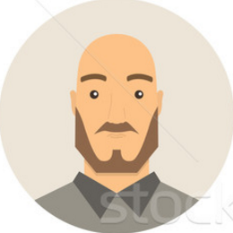**Victor**, 32 – Java developer.

“Look, I have a new cool app on my brand new iphone.”

Victor is not married. He likes to play video games. At home he plays his PS4. When he is out of home, he plays games on his mobile device. He likes to follow the trends, so he bought a VR headset for his mobile and now tries out different VR mobile applications and games. He prefers games with beautiful graphics and nice sound.

VR Experience: Some (mobile).