n

The Teacher
Val Castro earned her B.A. in English and Music from the University of California at Berkeley, and her M.A. in Education from Seattle Pacific University. She taught fourth grade and preschool in Seattle for many years, and opened Secret Garden Preschool in Silverton in 2001. She is happily married and a parent of two grown children. She shares with the children her love of God and her interests in singing, hiking, literature, and exploring nature’s wonders.

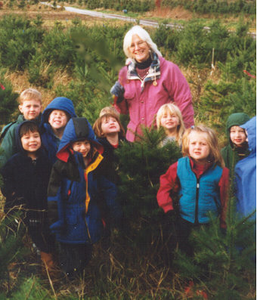
“Let my teaching fall like rain and my words descend like dew, like showers on new grass, like abundant rain on tender plants.”
- Deuteronomy 32:2

The Philosophy
Secret Garden Preschool, for children ages four and five, operates in a home on six pastoral acres in Silverton. The small class size (10 children) and supportive atmosphere help each child develop positive self-esteem, empathy for others, appreciation of differences, respect for the environment, and acceptance of responsibility for one’s own behavior. Children are encouraged to pursue their natural curiosity in the wonders of nature through regular daily exploration of the woods and meadows just outside our door.

Enrollment
Days: Monday - Thursday
Time: 9:00am - 1:00pm
Information: call (503) 874-9862

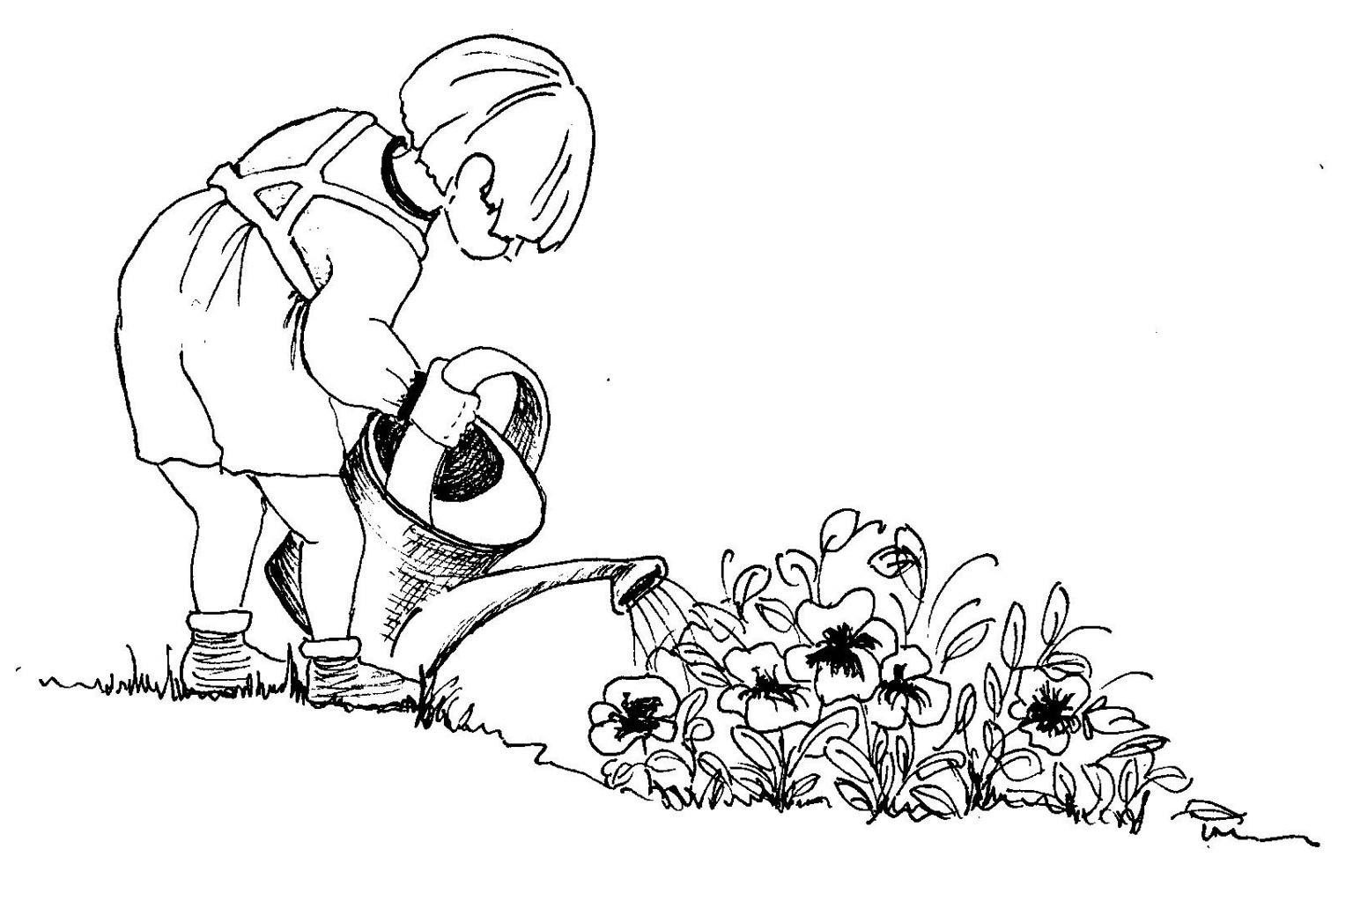

4501 Edison Road NE
Silverton, OR 97381
(503) 874-9862
Secret Garden Preschool

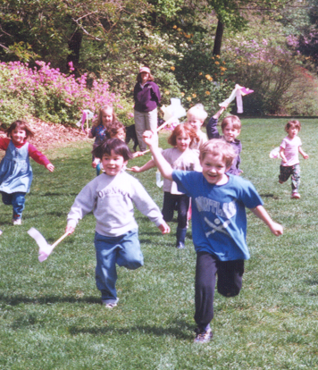

“If a child is to keep alive his inborn sense of wonder…, he needs the companionship of at least one adult who can share it, rediscovering with him the joy, excitement, and mystery of the world we live in.”

- Rachel Carson

SECRET
GARDEN
PRESCHOOL

