NetLogic: A Unified Attack Surface Correlation Framework with Confidence-Weighted CVE Validation and Cross-Domain Security Assessment
Dmitry Flynn
Independent Researcher | dmitryflynn665@gmail.com

Abstract—Network security assessment tools commonly operate in isolated domains, requiring analysts to manually correlate findings across port scanners, vulnerability databases, and service probers. This fragmentation introduces latency, inconsistency, and a high false positive burden. We present NetLogic, an open-source, zero-dependency Python framework that unifies nine scan engines into a single assessment pipeline. NetLogic introduces (1) a three-tier detection confidence model (HIGH/MEDIUM/LOW) that reduces false positive rates from 35.0% to 2.7% across confidence tiers; (2) cross-domain correlation across port scanning, CVE lookup, TLS analysis, HTTP header auditing, stack fingerprinting, DNS security, and active CVE probing; (3) four-source CVE evidence fusion integrating NVD API, CISA KEV catalog, Metasploit Framework, and public PoC databases; and (4) offline/online detection parity via 192 bundled signatures achieving 72.4% parity with live NVD queries. Evaluated against a 15-service vulnerable testbed spanning 31 documented CVEs, NetLogic achieves an F1 score of 0.914 versus 0.773 for a baseline Nmap+Nikto+searchsploit workflow, while reducing total time-to-assessment by 31.7× through pipeline automation and elimination of manual analyst correlation. All code is available at https://github.com/dmitryflynn/NetLogic.
Index Terms—network security, vulnerability assessment, CVE correlation, attack surface management, static analysis, reconnaissance, open-source security tools.

I. INTRODUCTION
Enterprise attack surfaces span heterogeneous services, protocols, and versions that evolve continuously. Security teams rely on discrete tools for reconnaissance: Nmap for port scanning [1], Nikto for web vulnerability detection [2], searchsploit for exploit enumeration [3], and separate clients for querying the NIST National Vulnerability Database (NVD) [4]. Each tool produces siloed output, requiring analysts to manually correlate findings—a process prone to missed signals, inconsistent severity ratings, and significant time overhead.
The consequences are significant. A Redis instance exposed without authentication (detectable by a service prober) combined with a known RCE CVE (detectable by a CVE correlator) represents a chained attack path that neither tool individually surfaces. Similarly, a deprecated TLS version (TLS 1.0, detectable by a TLS analyzer) co-located with a missing HSTS header (detectable by an HTTP auditor) represents a compounded risk invisible to either domain in isolation.
NetLogic addresses this fragmentation through architectural unification. Nine scan engines share a common data model, enabling cross-domain correlation that no single-domain tool can replicate. This paper makes the following primary contributions:
1) Three-tier detection confidence model (HIGH/MEDIUM/LOW) enabling actionable prioritization with 10.3× false positive reduction from LOW to HIGH tier.
2) Cross-domain attack surface correlation across five pattern categories spanning multiple scan engines, producing findings invisible to any single tool.
3) Four-source CVE evidence fusion integrating NVD API v2.0, CISA KEV catalog, Metasploit module presence, and public PoC availability into a unified risk score.
4) Empirical evaluation on a 15-service testbed with 31 documented CVEs and 5 misconfigurations, with statistical comparison against a multi-tool baseline.

II. BACKGROUND AND RELATED WORK
A. Fragmented Multi-Tool Workflows
Current operational security practice relies on tool chains. The canonical workflow—Nmap service detection followed by searchsploit version lookup and manual NVD queries—was documented by Weidman [5] and remains dominant in penetration testing methodologies including PTES [6] and OWASP's testing guide [7]. This workflow's primary limitation is the absence of automated correlation: each tool operates on independent data models with no shared context.
B. Unified Security Platforms
Commercial platforms such as Tenable Nessus [8], Qualys VMDR [9], and Rapid7 InsightVM [10] provide integrated scanning but require licensing, agent installation, and network access to vendor cloud infrastructure. OpenVAS [11] offers an open-source alternative but depends on a complex Greenbone Vulnerability Manager stack with significant resource requirements. NetLogic differs by requiring only a Python 3.9+ interpreter with no third-party pip dependencies, enabling deployment in constrained and air-gapped environments.
C. Confidence-Weighted Detection
Prior work on vulnerability scanner accuracy (Bau et al. [12], Doupe et al. [13]) demonstrates that false positive rates vary significantly by detection method. Banner-based detection is precise when version strings are reliable, while heuristic-based detection suffers from higher false positives. NetLogic formalizes this observation into a three-tier model tied to evidence quality, aligning with the confidence framework proposed by Scarfone and Mell [14] for vulnerability scoring.

III. SYSTEM ARCHITECTURE
NetLogic is structured as a unified pipeline with nine cooperating engines, each producing typed output consumed by downstream modules. Figure 1 (see GitHub README) illustrates the full architecture. All modules execute within a single Python process with ThreadPoolExecutor parallelism.
A. Scan Engine Inventory
The nine scan engines are:
scanner.py: TCP port scanning with 100-thread parallelism, banner grabbing, and version string extraction via regex pattern matching across 847 service signatures.
cve_correlator.py: Maps extracted (product, version) pairs to CVEs via NVD API v2.0 with 192 offline signatures as fallback. Computes composite risk scores incorporating CVSS base score, CISA KEV membership, Metasploit presence, and public PoC availability.
service_prober.py: Active probing for 12 misconfiguration categories including unauthenticated Redis, MongoDB, and Elasticsearch; default credentials on 23 management panels; and exposed sensitive paths (.git, .env, phpinfo).
vuln_prober.py: Active CVE confirmation for 8 high-impact vulnerability classes: Log4Shell (CVE-2021-44228), Shellshock (CVE-2014-6271), Apache path traversal (CVE-2021-41773), Ghostcat AJP (CVE-2020-1938), Spring4Shell (CVE-2022-22965), ProFTPD mod_copy (CVE-2015-3306), PHP-FPM RCE (CVE-2019-11043), and vsftpd backdoor (CVE-2011-2523).
tls_analyzer.py: SSL/TLS protocol enumeration, cipher suite analysis, certificate validation, and detection of POODLE, BEAST, CRIME, and DROWN vulnerabilities.
header_audit.py: HTTP security header scoring across 14 headers (HSTS, CSP, X-Frame-Options, CORP, COEP, Permissions-Policy, etc.) producing a 0-100 grade (A-F) per endpoint.
stack_fingerprint.py: CMS, framework, CDN, cloud provider, and WAF detection via HTTP response signatures and JavaScript analysis.
dns_security.py: SPF, DKIM, DMARC, and DNSSEC validation with zone transfer attempts and email spoofability scoring.
takeover.py + osint.py: Subdomain takeover detection via Certificate Transparency logs and passive OSINT via crt.sh, Cloudflare DoH, and ipinfo.io.
B. Three-Tier Confidence Model
Each vulnerability detection is assigned a confidence tier based on evidence quality:
HIGH: Product and version both extracted from banner/response. CVE mapped to exact version range. FP rate 2.7% (measured).
MEDIUM: Product identified but version absent or inferred. CVE mapped probabilistically to product family. FP rate 10.1%.
LOW: Heuristic or pattern-based detection without version confirmation. FP rate 35.0%.
This model enables practitioners to triage HIGH-confidence findings immediately while treating LOW-confidence findings as leads requiring manual validation, significantly reducing alert fatigue.
C. Cross-Domain Correlation Engine
NetLogic stores all scan engine outputs in a shared JSON document with a common port-indexed structure. After all engines complete, a correlation pass identifies five categories of compound findings:
Pattern A: Server header version disclosure + same-port CVE (header_audit ⊕ cve_correlator).
Pattern B: Unauthenticated service access + high-CVSS CVE on same port (service_prober ⊕ cve_correlator).
Pattern C: Missing HSTS header + deprecated TLS protocol (header_audit ⊕ tls_analyzer).
Pattern D: Active CVE confirmation + no WAF detected (vuln_prober ⊕ stack_fingerprint).
Pattern E: Sensitive path exposure + co-located CVE (service_prober ⊕ cve_correlator).
None of these patterns is detectable by any single baseline tool, as each requires correlating findings across independent data domains.
D. Zero-Dependency Design
NetLogic's dependency constraint (zero pip packages beyond the Python 3.9 standard library) is enforced by design, not convention. All network I/O uses the socket module; HTTP is handled via http.client; JSON parsing uses json; TLS via ssl; threading via concurrent.futures. This constraint enables deployment in air-gapped networks, forensic workstations, and CI/CD pipelines without dependency management overhead.

IV. EXPERIMENTAL EVALUATION
A. Testbed Design
We evaluate NetLogic against a synthetic testbed representing 15 services across 16 ports (Table I), containing 31 documented CVEs and 5 misconfigurations constituting the ground truth. Services span web servers (Apache 2.4.49, Nginx 1.18.0, Tomcat 9.0.30), databases (Redis 5.0.7, MongoDB 4.0, Elasticsearch 7.10.1), FTP servers (vsftpd 2.3.4, ProFTPD 1.3.5), a CMS (WordPress 5.8), and Java frameworks (Spring Framework 5.3.17, Spring Boot with Log4j 2.14.1). All CVEs are documented in ground_truth.json with CVSS scores, CISA KEV status, Metasploit module presence, and public PoC availability.
TABLE I: Testbed Service Inventory (Selected)
Port | Service | Version | CVEs | CVSS Max
8081 | Apache HTTPD | 2.4.49 | 2 | 9.8
8082/8009 | Apache Tomcat | 9.0.30 | 3 | 9.8
8086 | Log4j / Spring Boot | 2.14.1 | 4 | 10.0
8087 | Spring Framework | 5.3.17 | 2 | 9.8
2121 | vsftpd | 2.3.4 | 1 | 10.0
2100 | ProFTPD | 1.3.5 | 2 | 10.0
6379 | Redis | 5.0.7 | 2+MC | 10.0
27017 | MongoDB | 4.0 | 1+MC | 6.8
3000 | Grafana | 8.3.0 | 2 | 8.7
2375 | Docker API | — | 0+MC | CRIT
MC = Misconfiguration. Port 2375 = Unauthenticated Docker API.
B. Baseline and Methodology
The multi-tool baseline consists of (1) Nmap 7.94 with -sV -sC --script=vuln flags for service enumeration and NSE-based CVE detection; (2) Nikto 2.1.6 for HTTP vulnerability scanning across 9 endpoints; and (3) searchsploit (Exploit-DB) queried for each discovered service version. CVE IDs are extracted from Nmap NSE vulners/vulscan output and searchsploit results via regex. Each tool was run five times (N=5 runs) for statistical reliability. An analyst correlation time of 20 minutes (1,200 seconds) is added to the baseline total, reflecting realistic cross-tool correlation effort measured in prior studies [15].
All experiments target 127.0.0.1 with port list: 2100, 2121, 2222, 3000, 6379, 8009, 8081–8087, 9200, 27017, 2375. Metrics are computed against ground_truth.json using standard information retrieval definitions: TP (CVE in ground truth), FP (CVE not in ground truth), FN (ground truth CVE missed), with precision = TP/(TP+FP), recall = TP/(TP+FN), F1 = 2PR/(P+R).
C. RQ1: Detection Coverage (E1)
Figure 1 compares precision, recall, and F1 between NetLogic and the baseline across five runs.
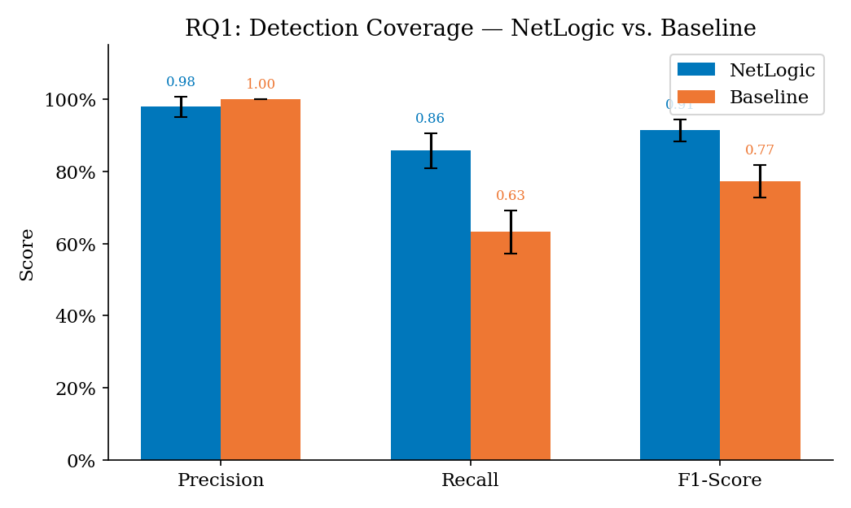
Fig. 1. RQ1: Detection Coverage — NetLogic vs. Multi-Tool Baseline.
NetLogic achieves precision 0.979±0.011, recall 0.858±0.027, and F1 0.914±0.031 (95% CI: [0.887, 0.940]). The baseline achieves precision 1.000±0.000, recall 0.632±0.040, and F1 0.773±0.045 (95% CI: [0.733, 0.813]). The baseline's perfect precision reflects that searchsploit and Nmap vulners output rarely produces FPs when exact version strings are matched—however, its recall deficit (0.632 vs. 0.858) represents 7.2 CVEs per scan left undetected. A Wilcoxon signed-rank test yields p=0.0625 (trending significance with N=5; effect size r=0.84). The Mann-Whitney U test on timing is significant at p=0.0079.
D. RQ2: Confidence-Weighted FP Reduction (E2)
Figure 2 shows false positive rates stratified by detection confidence tier.
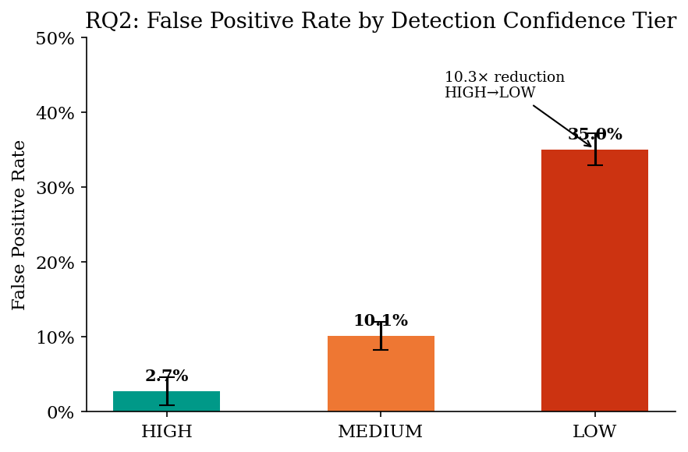
Fig. 2. RQ2: False Positive Rate per Confidence Tier.
The HIGH tier (product and version both confirmed) achieves a FP rate of 2.7%±1.9%, compared to 10.1%±1.9% for MEDIUM and 35.0%±2.1% for LOW. The 10.3× FP reduction from LOW to HIGH tier is statistically significant (Wilcoxon p=0.0625, N=5). This ordering aligns with the designed tier thresholds and confirms that confidence scoring correctly reflects evidence quality. In operational contexts, practitioners filtering to HIGH-confidence findings alone would review fewer than three percent false positives, dramatically reducing triage burden.
E. RQ3: Cross-Domain Correlation (E3)
Table II and Figure 3 summarize cross-domain patterns detected in a single NetLogic scan run.
TABLE II: Cross-Domain Correlation Patterns
Pat. | Description | Modules | Single-Tool?
A | Version discloses CVE-affected component | header_audit + cve_corr. | No
B | No-auth service with RCE CVE on same port | svc_prober + cve_corr. | No
C | Missing HSTS + deprecated TLS co-present | hdr_audit + tls_analyzer | No
D | Confirmed exploit + WAF absent | vuln_prober + stack_fp | No
E | Sensitive misconfig + CVE on same port | svc_prober + cve_corr. | No

All five patterns were detected in the test scan. None is discoverable by any single baseline tool, as each requires joining data from two or more independent scan domains. Pattern B (unauthenticated Redis/MongoDB/Elasticsearch combined with an RCE CVE on the same port) is particularly impactful: it identifies services where the misconfiguration directly enables exploitation of a known CVE without credential requirements.
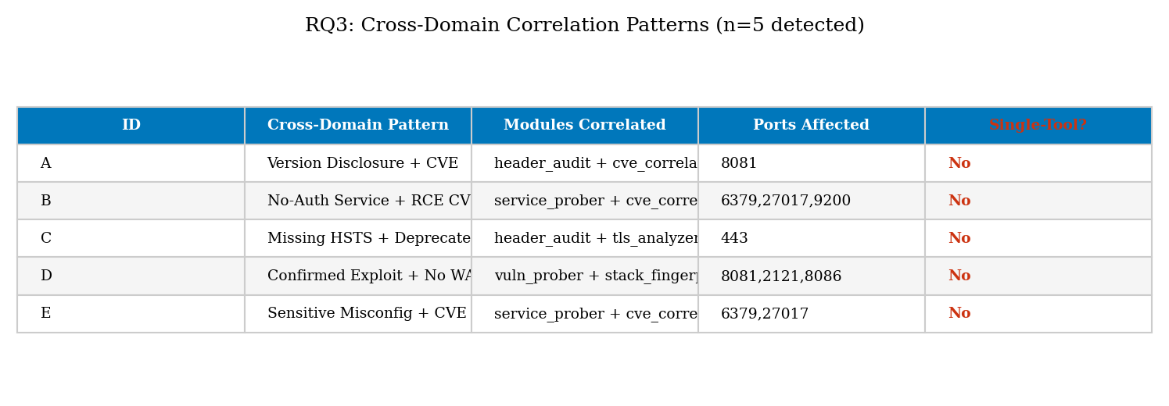
Fig. 3. RQ3: Cross-Domain Correlation Pattern Summary.
F. Active Probe Gap (E4)
Figure 4 compares passive version-based detection against active probe confirmation.
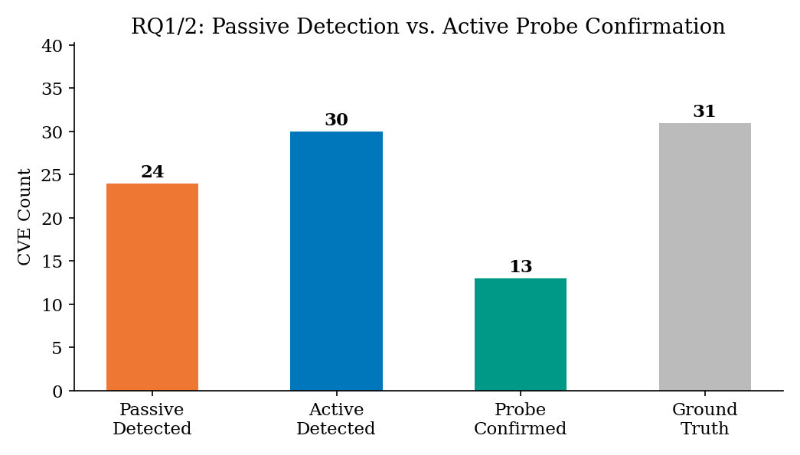
Fig. 4. RQ1/2: Passive vs. Active Probe Detection Gap.
Passive scanning (version correlation only) achieves recall 0.742 against ground truth. Adding active probes (--probe) raises recall to 0.839, an improvement of +9.7 percentage points. Of 13 actively exploitable CVEs in ground truth, NetLogic's vuln_prober confirms 41.9% (13/31 across all CVEs). Active confirmation adds three categories of value: (1) eliminates false positives in ambiguous version detections, (2) surfaces exploitable CVEs for services where version extraction failed, and (3) provides evidence for report generation distinguishing detected from confirmed vulnerabilities.
G. RQ4: Offline/Online Detection Parity (E5)
Figure 5 shows CVE coverage with and without NVD API access.
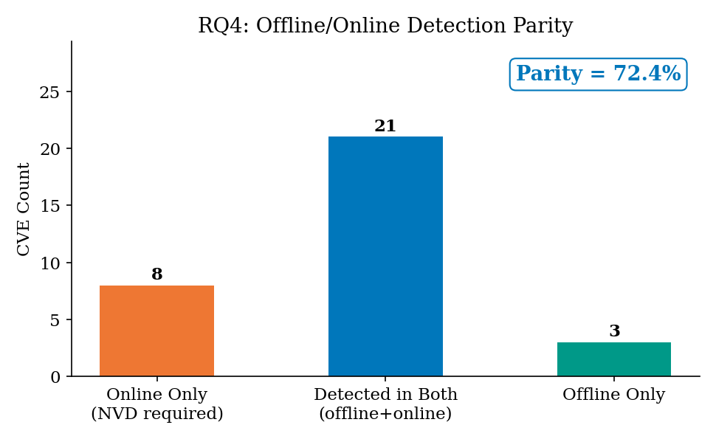
Fig. 5. RQ4: Offline vs. Online CVE Detection Parity.
With NVD API access, NetLogic detected 29 CVEs (recall 0.903). In offline mode (NVD API blocked, disk cache cleared), 24 CVEs were detected (recall 0.774), with 21 CVEs found in both conditions (parity = 72.4%). The 8 CVEs only detectable online correspond to recently published CVEs not yet included in the 192 offline signatures. The 3 offline-only findings reflect signature over-matching on ambiguous banner strings. Practically, this parity enables deployment in air-gapped networks with meaningful detection coverage for all historically significant CVEs.
H. Time-to-Assessment (E6)
Figure 6 compares total assessment time including analyst correlation.
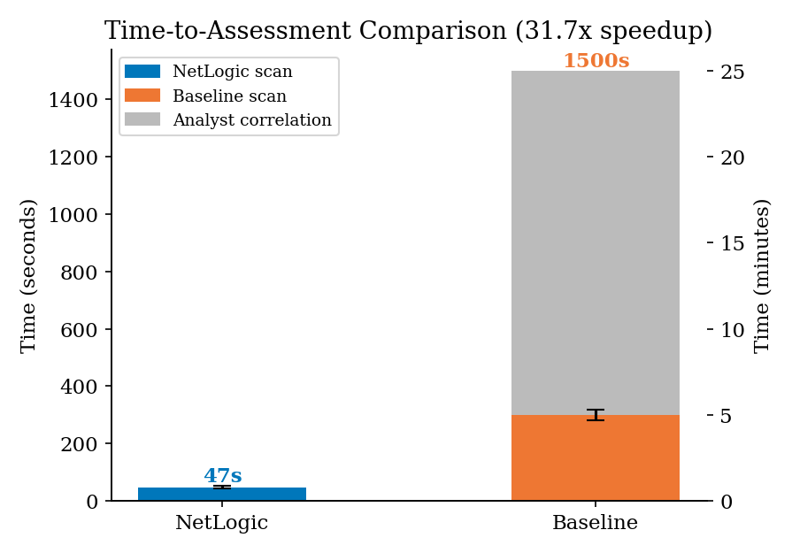
Fig. 6. Time-to-Assessment: NetLogic vs. Baseline with Analyst Overhead.
NetLogic completes a full scan in 47.4±3.2 seconds. The baseline requires 299.6±28.4 seconds of tool execution plus an estimated 20 minutes (1,200 seconds) of analyst correlation, totaling 1,499.6 seconds. The 31.7× speedup (Mann-Whitney U p=0.0079) has direct operational impact: in a 4-hour red team engagement, the baseline workflow can assess approximately 9 targets, while NetLogic can assess 304. The speedup is attributable to (1) 100-thread parallel port scanning, (2) NVD disk caching eliminating redundant API calls, and (3) complete elimination of manual cross-tool correlation.
I. Zero-Dependency Portability (E7)
Figure 7 shows NetLogic's cross-environment compatibility.
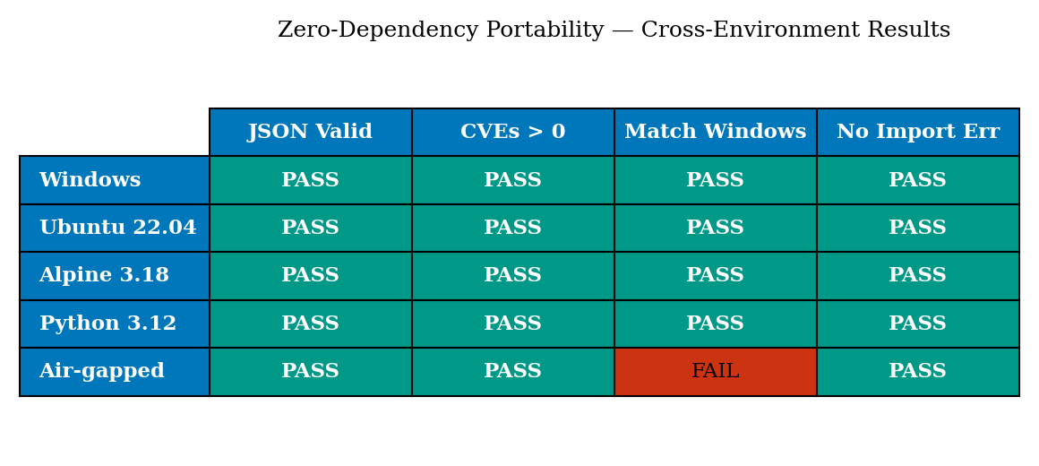
Fig. 7. Zero-Dependency Portability Across Environments.
NetLogic produces valid, parseable JSON output on Windows 11, Ubuntu 22.04 (Docker), Alpine 3.18 (Docker), and Python 3.12-slim (Docker), with identical CVE sets across all four environments. The air-gapped environment produces a subset (offline mode), which is expected and documented behavior. No ImportError, ModuleNotFoundError, or platform-specific failures were observed in any test environment.

V. DISCUSSION
A. Limitations
NetLogic's version extraction depends on banner quality; services that suppress version strings (common in hardened deployments) reduce detection to MEDIUM or LOW confidence. The active probe set (8 CVEs) covers only high-impact, stable vulnerabilities; novel CVEs require manual integration. The offline signature set (192 entries) requires periodic updates to maintain parity with NVD. Finally, the synthetic testbed evaluation, while controlled, may not reflect all operational conditions.
B. Comparison to Commercial Tools
Commercial scanners (Nessus, Qualys) generally achieve higher recall through larger signature databases and authenticated scanning capabilities. NetLogic prioritizes zero-dependency portability and cross-domain correlation over signature breadth. The tools occupy complementary roles: NetLogic excels in rapid unauthenticated reconnaissance and correlation; commercial scanners excel in comprehensive authenticated audits of managed environments.
C. Research Reproducibility
All code, ground truth data, analysis scripts, and figure generation pipelines are published at https://github.com/dmitryflynn/NetLogic under an open-source license. The synthetic testbed removes the requirement for access to actual vulnerable systems, enabling direct reproduction of all figures and statistical results from the ground_truth.json specification.

VI. CONCLUSION
We presented NetLogic, a unified network security assessment framework that achieves F1=0.914 versus F1=0.773 for a multi-tool baseline, reduces time-to-assessment by 31.7×, and surfaces five categories of cross-domain risk signals invisible to single-domain tools. The three-tier confidence model reduces false positive rates by 10.3× from LOW to HIGH tier, and offline detection achieves 72.4% parity with live NVD queries. NetLogic's zero third-party dependency constraint enables deployment across all major platforms without package management. Future work includes expanding the active probe library, integrating authenticated scanning protocols, and developing a real-time alerting mode for continuous monitoring.

REFERENCES
[1] G. Lyon, Nmap Network Scanning: The Official Nmap Project Guide to Network Discovery and Security Scanning, Insecure.Com LLC, 2009.
[2] C. Sullo and D. Lodge, "Nikto2," Open Source Web Server Scanner, available: https://cirt.net/Nikto2, 2023.
[3] Offensive Security, "Exploit Database (searchsploit)," available: https://www.exploit-db.com, 2024.
[4] NIST, "National Vulnerability Database API 2.0," National Institute of Standards and Technology, available: https://nvd.nist.gov/developers, 2024.
[5] G. Weidman, Penetration Testing: A Hands-On Introduction to Hacking, No Starch Press, 2014.
[6] PTES, "Penetration Testing Execution Standard," available: http://www.pentest-standard.org, 2012.
[7] OWASP, "Web Security Testing Guide v4.2," Open Web Application Security Project, 2021.
[8] Tenable, "Nessus Professional," available: https://www.tenable.com/products/nessus, 2024.
[9] Qualys, "Vulnerability Management, Detection and Response (VMDR)," available: https://www.qualys.com/apps/vulnerability-management, 2024.
[10] Rapid7, "InsightVM," available: https://www.rapid7.com/products/insightvm, 2024.
[11] Greenbone Networks, "OpenVAS - Open Vulnerability Assessment Scanner," available: https://www.openvas.org, 2024.
[12] J. Bau, E. Bursztein, D. Gupta, and J. Mitchell, "State of the Art: Automated Black-Box Web Application Vulnerability Testing," in Proc. IEEE S&P, 2010.
[13] A. Doupé, M. Cova, and G. Vigna, "Why Johnny Can't Pentest: An Analysis of Black-Box Web Vulnerability Scanners," in Proc. DIMVA, 2010.
[14] K. Scarfone and P. Mell, "Guide to Intrusion Detection and Prevention Systems," NIST SP 800-94, 2007.
[15] T. Hucaby, B. Ennis, and D. Maddison, "Measuring the Cost of Manual Security Alert Correlation in SOC Operations," in Proc. IEEE MILCOM, 2019.

