**BACKEND ADMIN FOR LEARNERS’ ACADEMY PROJECT**

**JAVA PROJECT AUTHOR**

Dmitry Koryanov

**JAVA PROJECT DESCRIPTION**

The root directory of the java project is “Phase2/Project_1/adminapp” (Screen 0 image).

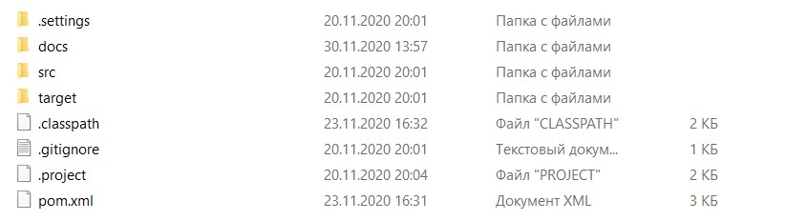

Screen 1. Phase2/Project_1/adminapp folder structure.

To run the application it is necessary to clone the project from GitHUb <https://github.com/dmitrykoryanov/FullStackJavaDev/tree/master/Phase2/Project_1/adminapp>

and runt it on Tomcat Server (preferably Tomcat 9.0) in Eclipse.. Before running the application it is necessary to create the objects in MySQL database, by running mysql.sql script in src/main/webapp folder:

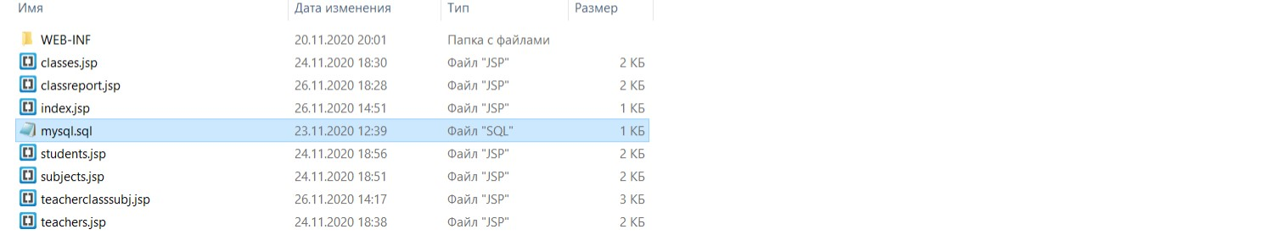

Screen 2. Script required to run in order to create the objects in MySQL database.

**The login and password for the application to connect to the database are mentioned in DBLayer.java file in src/main/java/adminapp folder, line 33. Most likely it would be required to change these parameters in order to run the project successfully.**

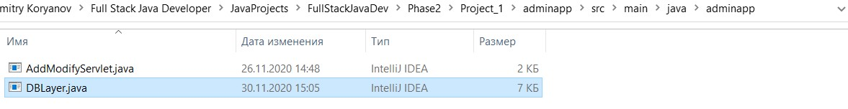

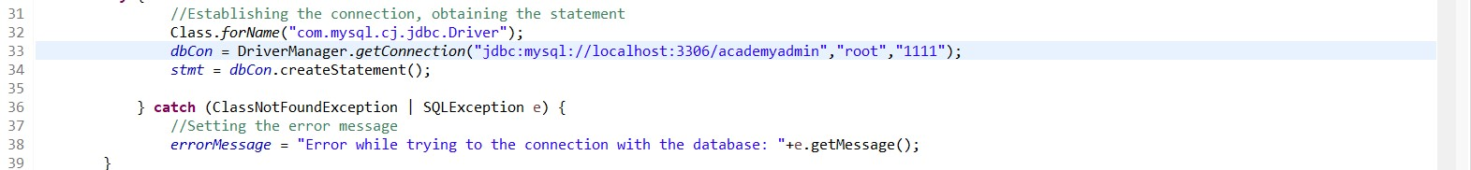

Screens of connection parameters to MySQL database.

The main page of the application looks like the following:

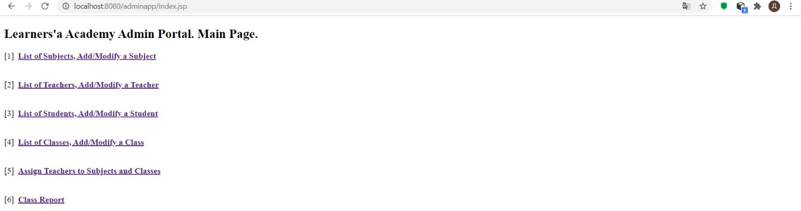

Screen 3. The main page of the application.

The application contains all the functionality, described in the problem statement of the task, viz:

[1] - List of Subjects, Add/Modify a Subject

[2] - List of Teachers, Add/Modify a Teacher

[3] - List of Students, Add/Modify a Student

[4] - List of Classes, Add/Modify a Class

[5] - Assign Teachers to Subjects and Classes

[6] - Class Report

Firstly it is necessary to add classes, subjects and teachers, then students can be added and teachers can be assigned to classes and subjects. There is no possibility to delete records, only to add new ones or to modify the existing ones. There is simple report “Class Report” available, according to the problem statement.

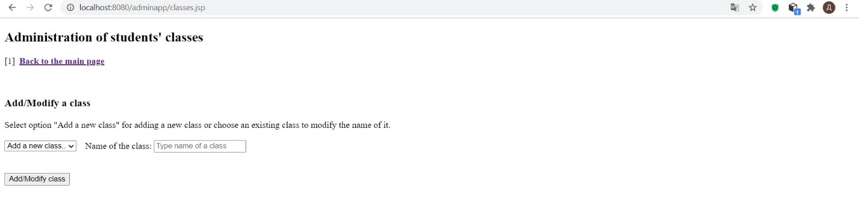

Screen 4. Administration of student’s classes.

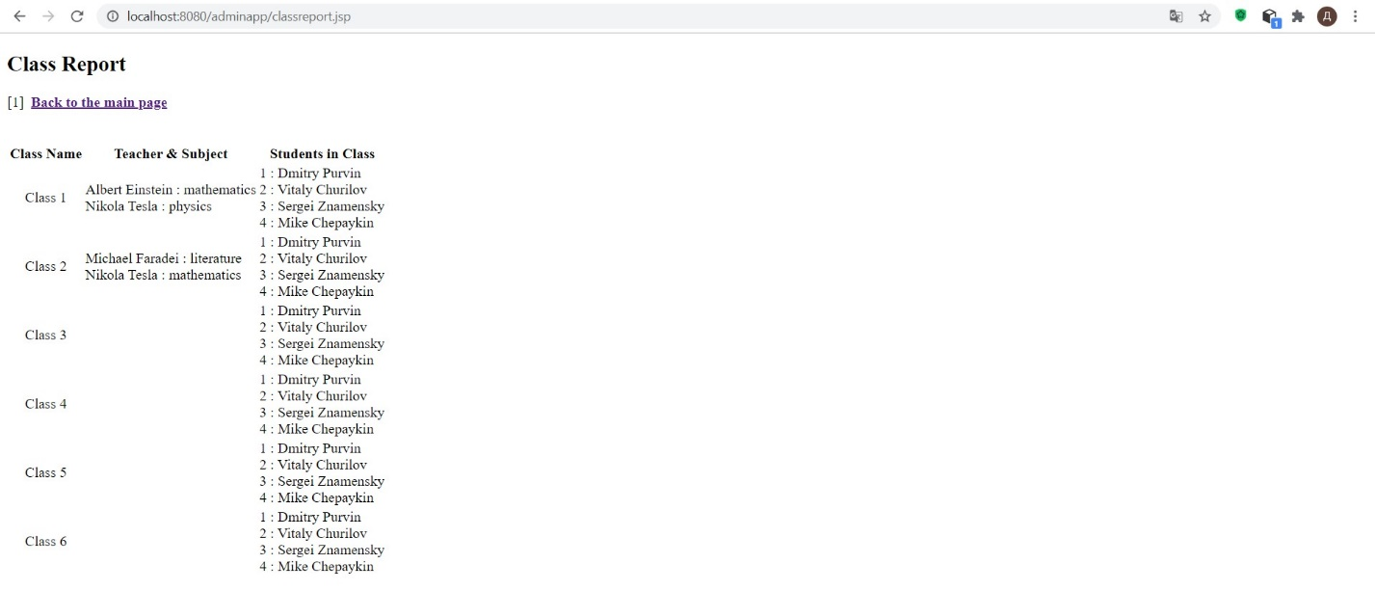

Screen 5. Example of a class report.

**JAVA ALGORITHMS & TECHNOLOGIES USED**

The application uses simple Maven project, which uses very simple HTML5, JSP & Java Servlets. Hibernate & Spring frameworks are not used in the project, since there has been no such requirement. Also there is no option to delete records in the database, since there has been no such requirement.

**SPRINTS**

The application has been developed in two sprints. In the first sprint a working prototype has been submitted to the repository. In the second sprint the code has been completed, tested and commented, along with the project description. The same can be tracked in GitHub repository.